CIRCUITS, COMPONENTS, AND CONTROL
Book 2 of the Electrical Engineering Series

Copyright © 2026 Lothar J. Musiol
All rights reserved.

Preface — How to Use This Book
This book assumes Book 1, Foundations of Electronics, as its starting point — specifically its Part III, which already covers Kirchhoff's laws, nodal and mesh analysis, Thévenin and Norton equivalents, superposition, and first-order transients in full. Rather than repeat that material, this book moves directly into what those techniques were building toward: real components with real limitations, and the analog and digital building blocks — op-amps, filters, and logic — that Book 1's idealized circuit elements were always in service of.
Each chapter follows the same shape as Book 1: it opens with the question the chapter answers, builds the picture in words first, works through it with fully solved examples, and closes with practice problems whose solutions appear in Appendix B. A Key Idea box marks the one fact worth carrying forward from a section; a Common Misconception box heads off a specific, predictable error before it happens.
The bench kit is the reader lab of Book 1, Foundations of Electronics, with its analog-first rule: where a few parts can do a job, build that first, because that is where the physics lives, and then do the same job in code and compare. This book adds a handful of inexpensive parts to that kit: a dual op-amp such as the MCP6002, an LM393 comparator, a 555 timer, CD4017 and CD4060 counters, a 74HC14 Schmitt inverter, a PC817 optocoupler, a BPW34 photodiode, a 5 V relay with a 1N4148 diode and a small NPN transistor, a DRV8833 motor-driver board with a small DC motor, and a stepper motor with its driver. A Raspberry Pi Pico or a Teensy joins the ESP32-S3 where a loop wants a second controller.
The firmware for these circuits lives in one place, Book 8, Firmware and Software for Electronics. This book keeps the circuits and the numbers that decide whether the code can work: sample rates, PWM resolution, delays, and margins. Where a topic continues in code, the text names the Book 8 chapter.

How This Book Is Organized
Chapters 1–2 build the vocabulary shared by every later chapter: bias points, headroom, and small-signal behavior for analog circuits, and logic levels and noise margins for digital ones. Chapters 3–4 develop digital design specifically, from Boolean algebra through sequential circuits with memory. Chapter 5 introduces the operational amplifier as an ideal building block, in the same spirit Book 1 used for the resistor, capacitor, and inductor. Chapter 6 generalizes Book 1's filter and resonance results into a full filter-design vocabulary, passive and active, and carries it through to Sallen-Key and multiple-feedback designs built from standard parts. Chapters 7–9 return to the resistor, capacitor, and inductor themselves as real, physical parts: first their types, tolerances, ratings, and parasitics, then the practical side, from heat, drift, and pulse ratings to decoupling, real impedance, and reading an inductor datasheet.
Chapter 10 introduces the control loop itself, through the smart thermostat of Book 1 and a robot joint. Chapters 11–16 return to the op-amp with real numbers: feedback as a quantitative tool, followers and capacitive loads, bandwidth and slew rate, noise, DC errors, and comparators. Chapters 17–19 build classical control on that foundation, from plant and controller through PID and lead-lag compensation to the digital loop and its sampling delay. Chapters 20–24 add five building blocks that join the book's two halves: the instrumentation amplifier, state feedback with observers, the sample-and-hold circuit, the voltage reference, and the H-bridge motor drive written as a plant for the loops of Chapters 17–19. Chapters 25–28 complete both halves: the root locus and the stability margins and sensitivity peak on the control side, and oscillators and digital timing with metastability on the circuit side. Along the way, bench sections put the theory to work: logic you can build and the FPGA (Chapter 4), LED and optocoupler drivers (Chapter 12), the photodiode amplifier (Chapter 13), switch debouncing (Chapter 16), PID on a Pico or a Teensy (Chapter 19), piezo and mains-current front ends (Chapter 20), relays, servos, and steppers (Chapter 24), and projects that need no controller at all (Chapter 27). Chapter 24.8 also introduces audio output-stage classes and a load-power example.
Advanced control path: Chapters 21 and 25-26 extend the classical loop with state-space feedback and frequency-domain stability. Before these chapters, review matrix multiplication and simultaneous equations from Book 1, plus transfer functions, poles, and Bode plots from Chapters 17-19. Chapter 21 introduces state-space notation but expects you to follow matrix calculations.
Key Idea
This book does not re-teach Book 1's Part III. Network analysis (Thévenin, Norton, nodal, mesh) and transient analysis are assumed throughout — if a technique from those chapters feels unfamiliar, that is the place to go back to, not this book.

About This Series
This book is the second of nine. It covers circuits, components, and the classical control loop that later sits under a robot model. Each volume assumes only the books before it in the list below, never the ones after.
Book - Covers
1. Foundations - Physics, mathematics, and circuit theory
2. Circuits, Components, and Control (this book) - Analog and digital, op-amps, passives, the classical loop
3. Semiconductor Physics and Devices - Diodes, BJTs, MOSFETs, FinFET, compound semiconductors
4. RF, Microwave, and Transceivers - Lines, matching, antennas, PAs, receivers, PLLs, radar
5. Communications, Wireless, and SDR - Modulation, band plans, DSP and software radio
6. Power and Energy - Regulators, magnetics, the grid, the rack
7. Packaging, Layout, EMC, and Test - Boards, packages, cooling, emissions, the accredited lab, robots
8. Firmware and Software for Electronics - Embedded firmware, software tools, and code-driven electronics
9. Test and Measurement Instruments - Oscilloscopes, analyzers, calibration, and device characterization
Key Idea
You do not need the other eight books to use this one. This book is written to stand on Book 1's foundation alone; treat the table as a map of where you have been and where a later interest can take you, not as a syllabus you must complete in order.

Table of Contents
Preface — How to Use This Book
How This Book Is Organized
About This Series
Chapter 1 — Analog Electronics
Chapter 2 — Digital Electronics
Chapter 3 — Logic and Boolean Algebra
Chapter 4 — Combinational and Sequential Circuits
Chapter 5 — Operational Amplifiers
Chapter 6 — Passive and Active Filters
Chapter 7 — Resistors
Chapter 8 — Capacitors
Chapter 9 — Inductors
Chapter 10 — The Loop Under the Model
Chapter 11 — Negative Feedback
Chapter 12 — Followers, Buffers, and Loading
Chapter 13 — Noise Gain, Bandwidth, and Slew Rate
Chapter 14 — Noise in Op-Amp Circuits
Chapter 15 — DC Errors: Offset, Bias Current, and Drift
Chapter 16 — Comparators, Hysteresis, and Open-Collector Outputs
Chapter 17 — Feedback Control: Plant, Sensor, and Controller
Chapter 18 — PID, Lead, and Lag: Shaping the Loop
Chapter 19 — Digital Control: Sample, Hold, and Delay
Chapter 20 — The Instrumentation Amplifier
Chapter 21 — State Feedback and Observers
Chapter 22 — The Sample-and-Hold Circuit
Chapter 23 — The Voltage Reference and the Bandgap
Chapter 24 — The H-Bridge and Motor as a Plant
Chapter 25 — The Root Locus
Chapter 26 — Stability Margins, Nyquist, and the Sensitivity Peak
Chapter 27 — Oscillators: Feedback That Is Meant to Ring
Chapter 28 — Timing: Setup, Hold, and Metastability
Appendix A — Formula Reference
Appendix B — Practice Problem Solutions
Appendix C — Glossary
Appendix D — Chapter Summaries
Appendix E — Further Reading
About the Author
Also by Lothar J. Musiol

Chapter 1 — Analog Electronics
Turn a guitar amplifier up until it growls and you are hearing this chapter's subject from the wrong side: a stage pushed out of the region where it behaves. Analog design is mostly the art of choosing an operating point and then staying away from the walls.
Where you meet this: Audio amplifiers, sensor front ends, microphone preamps, and any circuit that has to pass a signal without bending it.
Book 1 treated resistors, capacitors, and inductors as ideal mathematical objects and solved circuits built from them exactly, once and for all. Real electronic design adds two things that book did not need: signals that carry information rather than only power, and circuits deliberately biased into a particular operating condition so that a smaller signal riding on top of that bias behaves predictably. This chapter builds the vocabulary — bias point, small-signal behavior, gain, and distortion — that every later chapter in this book, and every book after it, assumes.

1.1 Bias Points and Operating Conditions
A real analog stage is almost never asked to handle a signal that swings all the way from its most negative to its most positive possible value. Instead, a designer first sets a DC operating point — also called a bias point or quiescent point (Q-point) — a fixed voltage or current the circuit sits at with no signal applied. The actual signal of interest is then a smaller variation superimposed on that fixed point. Choosing the bias point well is largely a matter of leaving enough room, in both directions, for the signal to move without running into a hard limit.
Every real amplifying stage has such limits: an output that cannot go below its negative supply rail or above its positive one, no matter what the input asks for. The distance from the bias point to the nearer of these two rails is called headroom, and it sets the largest signal the stage can pass through undistorted.
Worked Example 1.1
Problem: A DC bias sets an amplifier's output operating point at 8 V. The output stage can swing between 0 V and 10 V before it distorts. Find the largest symmetric AC signal amplitude the stage can pass without clipping, and state which half of the cycle clips first if the amplitude is pushed beyond that.
Solution: The distance from the bias point to the upper rail is 10 − 8 = 2 V. The distance to the lower rail is 8 − 0 = 8 V. The smaller of the two headrooms sets the limit, so the largest undistorted amplitude is 2 V. Push the amplitude past 2 V and the positive peaks — the ones approaching the nearby upper rail — clip first, since that is the direction with less room to spare.
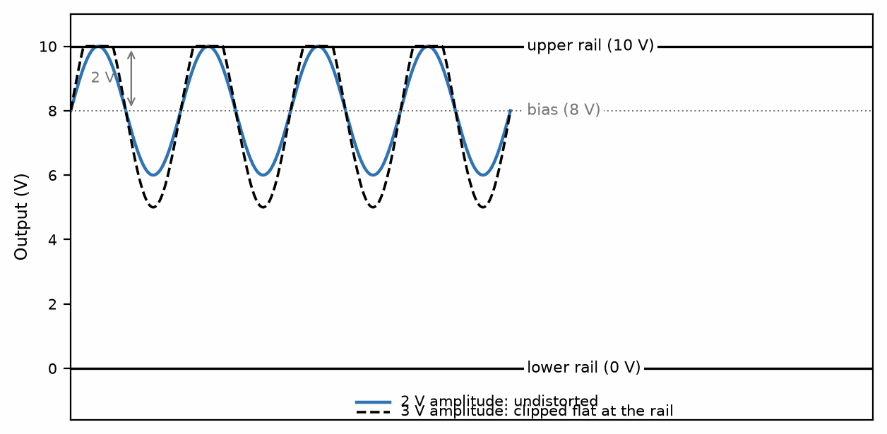
Figure 1.1 — A 2 V amplitude stays within the 8 V bias point's 2 V headroom to the upper rail; a 3 V amplitude clips flat against it.
Worked Example 1.2
Problem: A stage has a gain of 15 and is biased so its output sits at 3 V, with output rails at 0 V and 12 V. An input signal of amplitude 500 mV is applied. Will the output clip, and if so, on which side?
Solution: The demanded output amplitude is gain × input amplitude = 15 × 0.5 = 7.5 V. The headroom to the lower rail is 3 − 0 = 3 V; the headroom to the upper rail is 12 − 3 = 9 V. Since 7.5 V exceeds the 3 V lower headroom but not the 9 V upper headroom, the output clips only on the negative excursions, against the lower rail — an asymmetric clip, unlike the symmetric case in Worked Example 1.1.

1.2 Small-Signal Behavior
Once a bias point is fixed, the circuit's response to a small additional signal can often be treated as linear even when the underlying device is not linear over its full range — a fact Book 3 derives from the device physics when it introduces the transistor; the concept is worth having in hand now. Near any single operating point, a smooth curve looks approximately straight; the smaller the signal, the better that approximation holds. This is why the phrase “small-signal” appears constantly in analog design: it is a promise that the signal is small enough for the surrounding nonlinearity to be ignored, not a claim that the underlying device is actually linear.
Key Idea
Headroom is the available signal range before a circuit hits a limiting mechanism such as clipping; push any real circuit far enough and it becomes nonlinear on its own, sometimes well before it reaches a rail — headroom and the small-signal linear approximation are related but not identical, and a circuit can leave the linear region without yet running out of headroom.

1.3 Gain and Distortion
Gain is the ratio of a stage's output signal to its input signal, and for a well-behaved linear stage it is a single number that does not depend on the size of the input. Distortion is what happens when that stops being true — typically because the signal has grown large enough to reach the edge of the stage's headroom (clipping) or because the underlying device's response was never quite linear to begin with, even for small signals. A clipped waveform is the most visible form of distortion: the peaks of the signal are cut flat at the rail voltage, and the output no longer resembles a scaled copy of the input.
Common Misconception
A higher-gain stage is not automatically a “better” one. Gain and headroom trade against each other for a fixed pair of supply rails: the more a stage amplifies a given input, the sooner an increase in that input drives the output into clipping. Selecting a gain is as much about how large the expected input signal is as it is about how much amplification the application needs.
From the Bench
Measure the bias point before you measure the signal. With no input applied, check the DC voltage at the output of every stage against your calculation; a stage sitting a volt from a rail will clip long before the datasheet says it should, and no amount of signal-chain tuning will fix a wrong bias.

Practice Problems
- A bias point is set at 6 V; the output swings between 1 V and 11 V. Find the largest symmetric AC amplitude the stage can pass without clipping, and identify which rail sets the limit.
- An amplifier stage has a gain of 20 and is biased so its output sits at 2 V, with output rails at 0 V and 5 V. Find the largest input signal amplitude that avoids clipping the output.
- Explain, in one or two sentences, why a small-signal analysis is only trustworthy near the specific bias point it was derived around.
- A stage has a gain of 8, output rails at 0 V and 9 V, and is biased at the center of that range. Find the maximum input amplitude before clipping.
- An amplifier's bias point sits at 1 V, with output rails at 0 V and 5 V. Which rail limits the headroom, and by how much?
- A designer doubles a stage's gain without changing its bias point or output rails. Explain what happens to the maximum undistorted input amplitude.

What You’ll Actually Use
Everyday working tools
- Bias point and headroom to each rail.
- Small-signal gain as the slope at the operating point.
- Clipping as the first sign of a stage leaving its region.
Mostly for exams and deeper study
- Formal small-signal models of every device type.

Chapter 2 — Digital Electronics
Here is a puzzle. A logic gate is made of transistors, and transistors are analog parts. So why does a digital signal arriving slightly noisy leave the gate perfectly clean? The answer is noise margin, and it is the whole reason digital electronics works.
Where you meet this: Microcontroller pins, logic-level translators between 1.8 V, 3.3 V and 5 V parts, I²C and SPI buses, and every 'it works on my desk but not in the car' bug.
Every signal this book has discussed so far is continuous: it can take any value in a range, and that value itself carries the information. A digital signal takes a different approach entirely — it restricts itself to a small number of distinct states, almost always two, and accepts a cost in exchange for a considerable benefit. The cost is that a continuously varying real-world quantity must first be forced into one of those few states. The benefit is not that a digital signal is somehow immune to noise — no real signal is — but that its robustness comes from defining acceptable ranges for each state and regenerating a clean signal at every stage, rather than requiring every voltage to stay exact throughout. That is a strategy no analog signal, which must preserve its exact value all the way through, can fully share, and it is the reason nearly every modern system that can be built digitally, is.

2.1 Logic Levels and the Two-State Idea
A digital signal is defined by two ranges of voltage, not two exact voltages. Any value inside the “high” range is interpreted as a logic 1, and any value inside the “low” range is interpreted as a logic 0, regardless of exactly where within that range the voltage sits. A gap is deliberately left between the two ranges — a forbidden zone a valid signal is never supposed to occupy — and it is this gap that gives digital circuits their noise immunity.
Four voltages define the boundaries a manufacturer guarantees for a given logic family: the minimum output voltage guaranteed to be recognized as high (Vₒₕ, min), the minimum input voltage that will still be read as high (Vᵢₕ, min), the maximum output voltage guaranteed to be recognized as low (Vₒʟ, max), and the maximum input voltage still read as low (Vᵢʟ, max).

2.2 Noise Margin
The noise margin is the gap between what a gate is guaranteed to output and what the next gate down the line is guaranteed to still accept correctly, for each logic level separately:
NMʜ = Vₒₕ(min) − Vᵢₕ(min) NMʟ = Vᵢʟ(max) − Vₒʟ(max)
Any noise, ringing, or voltage drop smaller than the relevant noise margin can be added to a signal anywhere along its path without ever risking a misread bit. This is the source of digital electronics' most valuable property: a signal can pass through dozens of gates, each one imperfect and each one adding a little noise, and come out the other end exactly as clean as it went in — because each gate does not pass along the noisy analog voltage it received, it reads a bit and regenerates a fresh, full-strength output level.
Worked Example 2.1
Problem: A logic family specifies Vₒₕ(min) = 2.4 V, Vᵢₕ(min) = 2.0 V, Vₒʟ(max) = 0.4 V, and Vᵢʟ(max) = 0.8 V. Find both noise margins.
Solution: NMʜ = Vₒₕ(min) − Vᵢₕ(min) = 2.4 − 2.0 = 0.4 V. NMʟ = Vᵢʟ(max) − Vₒʟ(max) = 0.8 − 0.4 = 0.4 V. This circuit can tolerate up to 0.4 V of noise on either a high or a low signal without a single bit being misread — these are, in fact, the standard values for classic TTL logic.
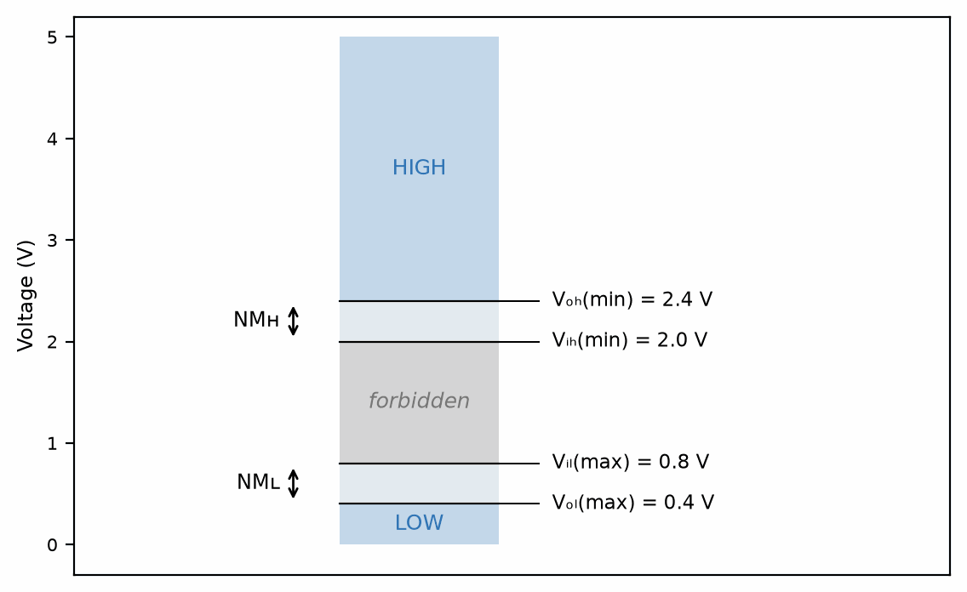
Figure 2.1 — The forbidden zone between Vᵢʟ(max) and Vᵢₕ(min), with the noise margins NMʜ and NMʟ on either side.
Worked Example 2.2
Problem: A 3.3 V logic output (Vₒₕ(min) = 2.8 V, Vₒʟ(max) = 0.2 V) drives the input of a 5 V logic gate (Vᵢₕ(min) = 2.0 V, Vᵢʟ(max) = 0.8 V). Find both noise margins for this mixed-voltage connection.
Solution: NMʜ = Vₒₕ(min) − Vᵢₕ(min) = 2.8 − 2.0 = 0.8 V. NMʟ = Vᵢʟ(max) − Vₒʟ(max) = 0.8 − 0.2 = 0.6 V. The two margins need not match, as they do for a single logic family — mixing families gives an asymmetric result, here more tolerant of high-side noise than low-side.

2.3 Gates as Amplifiers Driven Hard
A logic gate is, at the component level, built from the same amplifying devices Book 3 will introduce — it is not a fundamentally different kind of circuit from the analog stages in Chapter 1. What makes it digital is a design choice: rather than being biased for a well-behaved linear region the way an analog amplifier is, a gate is deliberately driven hard between its two extremes, spending as little time as possible in the in-between region where its behavior would be unpredictable and analog-like. Chapter 1's headroom concept still applies; a digital gate chooses to operate at the very edges of its available range instead of in the comfortable middle.
Key Idea
Digital robustness comes from regeneration, not from the absence of noise. Every gate reads a fuzzy analog input and outputs a fresh, full-strength digital level — noise that entered one stage is thrown away, not carried forward, which is precisely what an analog stage cannot do.
From the Bench
Check thresholds whenever two logic families meet. A 3.3 V output driving a 5 V CMOS input may sit below that input's V_IH(min) of about 3.5 V (0.7 × 5 V) and work only on good days. 5 V TTL-compatible (HCT) inputs accept it; plain HC inputs at 5 V may not. The datasheet's V_IH and V_OH columns settle the question; the logo on the chip doesn't.

Practice Problems
- A logic family specifies Vₒₕ(min) = 3.5 V, Vᵢₕ(min) = 2.0 V, Vₒʟ(max) = 0.2 V, and Vᵢʟ(max) = 0.5 V. Find both noise margins.
- Convert the binary number 1011 to decimal.
- Explain, in a sentence or two, why a long chain of analog amplifier stages degrades a signal while a long chain of digital gates does not.
- A logic family specifies Vₒₕ(min) = 4.4 V, Vᵢₕ(min) = 3.15 V, Vₒʟ(max) = 0.1 V, and Vᵢʟ(max) = 1.35 V. Find both noise margins.
- Convert the binary number 11010 to decimal.
- Two logic families have identical noise margins on paper, but one is used in an electrically noisy industrial environment. Explain why matching noise margins alone doesn't guarantee reliable operation in practice.

What You’ll Actually Use
Everyday working tools
- V_IL, V_IH, V_OL, V_OH and the noise margins between them.
- Treating a gate as a high-gain amplifier driven hard.
Mostly for exams and deeper study
- Detailed transistor-level gate transfer curves.

Chapter 3 — Logic and Boolean Algebra
In 1937 Claude Shannon's master's thesis showed that the algebra George Boole had published in 1854 describes relay switching circuits exactly. Every processor since rests on that observation, and this chapter is the working part of it.
Where you meet this: Writing conditions in firmware, programmable logic (FPGAs and CPLDs), address decoders, and reading someone else's glue logic.
Digital circuits process bits, and bits are combined according to a small, complete algebra first formalized by George Boole a full century before the transistor existed. Boolean algebra gives a digital designer exactly what ordinary algebra gives a circuit analyst working with real numbers: a set of rules for simplifying an expression without having to re-derive its truth table from scratch every time.

3.1 The Three Basic Operations
Every Boolean expression, however complicated, is built from only three operations. AND (written as multiplication, AB) is true only when both A and B are true. OR (written as addition, A + B) is true when either A or B (or both) is true. NOT (written A′, or with an overbar) inverts a single variable. A truth table lists every combination of inputs and the resulting output, and it is the ultimate authority on what a Boolean expression means — two expressions are equal if and only if they produce the same truth table.
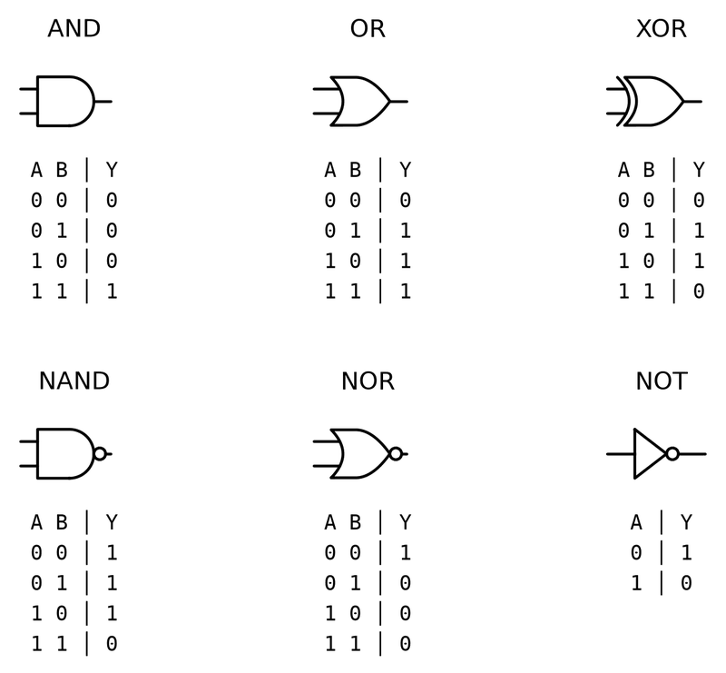
Figure 3.1 — The six gates you meet every day, with their truth tables. The bubble on NAND, NOR and NOT means "invert".

3.2 The Algebra of Simplification
Several laws let an expression be rewritten into an equivalent, simpler form without checking a truth table by hand. The commutative and associative laws work exactly as they do in ordinary algebra. The distributive law holds in both directions: A(B + C) = AB + AC, and, less familiarly to anyone coming from ordinary algebra, A + BC = (A + B)(A + C). The absorption law, A + AB = A, removes a term that adds no new information. De Morgan's laws convert one operation into the other: (A + B)′ = A′B′, and (AB)′ = A′ + B′.
Worked Example 3.1
Problem: Simplify F = AB + AB′ + A′B using Boolean algebra, and confirm the result against a truth table.
Solution: Factor the first two terms: AB + AB′ = A(B + B′) = A·1 = A. That leaves F = A + A′B. By the distributive identity A + A′B = A + B (multiply out (A + A′)(A + B) = 1·(A + B) = A + B, which is exactly A + A′B written the other way), F simplifies to A + B. Checking all four input combinations against the original expression confirms the two agree in every row: F = A + B.
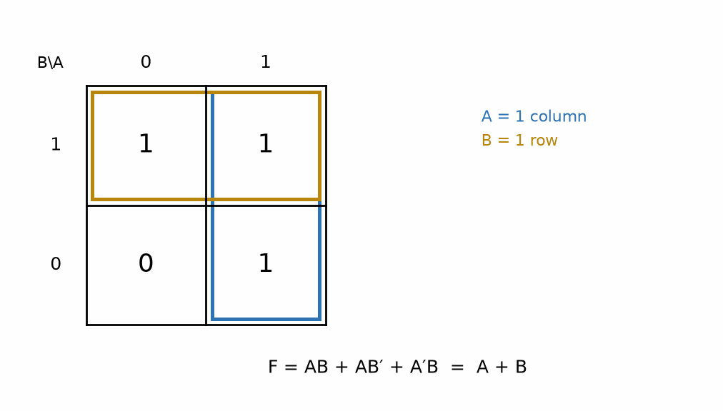
Figure 3.2 — A Karnaugh map for F = AB + AB′ + A′B: the A = 1 column and the B = 1 row each group to a single term, giving F = A + B.
Worked Example 3.2
Problem: Simplify G = AB + A′C + BC using Boolean algebra.
Solution: The term BC is a consensus term of AB and A′C — the consensus theorem states that whenever a variable (here, A) appears uncomplemented in one term and complemented in another, the third term formed from the remaining literals of both (here, BC) is redundant and can be dropped: G = AB + A′C + BC = AB + A′C. Checking all eight input combinations against the original three-term expression confirms the two agree in every row.
Key Idea
De Morgan's laws are the reason NAND and NOR gates are each, individually, universal: since AND, OR, and NOT can all be rebuilt from either one alone, an entire digital system can be constructed from a single type of gate — a principle some minimalist or historical designs take literally, even though modern chips mix many gate types chosen for power, area, and timing.

3.3 Karnaugh Maps
For expressions with more than two or three variables, spotting the right sequence of algebraic simplifications by inspection becomes difficult. A Karnaugh map arranges a truth table's outputs into a grid where every adjacent cell differs in exactly one input bit, so that groups of adjacent 1s can be circled and read off directly as a simplified term — a visual shortcut to the same simplifications the algebra provides, and the standard tool for anything up to about four or five variables.
Common Misconception
Two Boolean expressions that happen to agree for a few input combinations you happened to check are not necessarily equal. Only a full truth table match — every row, not a convenient sample — proves two expressions are the same function; a Karnaugh map or the algebraic laws above are what guarantee that, an ad-hoc spot check does not.
From the Bench
In practice you rarely minimize logic by hand: synthesis tools do it better. Where Boolean algebra pays off on the bench is reading and debugging, such as recognizing that an active-low enable feeding a NAND is really an OR of the true signals, or spotting that a 'mystery' glue-logic chip implements one simple condition.

Practice Problems
- Simplify F = A(A + B) using Boolean algebra, and name the law used.
- Write out the truth table for F = A′B + AB′, and identify the operation this expression represents.
- Apply De Morgan's law to simplify (A + B)′.
- Simplify H = A + AB′C using Boolean algebra, and name the law used.
- Simplify F = A′B′C′ + A′B′C + A′BC′ + A′BC using Boolean algebra.
- Apply De Morgan's law twice to simplify ((A + B)·C)′.

What You’ll Actually Use
Everyday working tools
- AND, OR, NOT and their truth tables.
- De Morgan's theorems, especially for active-low signals.
Mostly for exams and deeper study
- Karnaugh-map minimization of larger functions.
- Formal Boolean proofs.

Chapter 4 — Combinational and Sequential Circuits
Why does a pocket calculator remember the number you typed while you reach for the next key? Combinational logic can only react to what is in front of it. Memory needs feedback, and this chapter is where circuits start to remember.
Where you meet this: Counters and timers in every microcontroller, shift registers driving LED displays, state machines in FPGAs, and the registers inside a processor.
Boolean algebra describes what a circuit computes; this chapter is about the two fundamentally different ways a real circuit can be built around it. A combinational circuit's output depends only on its present inputs — it has no memory of what came before. A sequential circuit's output depends on its present inputs and on its history, which requires the circuit to store state somewhere. Nearly everything a digital system does is some combination of the two.

4.1 Combinational Building Blocks
A half adder adds two single bits, A and B, producing a sum bit S = A ⊕ B (the XOR operation from Chapter 3's practice problems) and a carry bit C = AB. A half adder cannot accept a carry from a previous stage, which is what makes it “half” rather than complete. A full adder fixes this by accepting a third input, a carry-in Cᵢₙ, and can therefore be chained: the carry-out of one full adder becomes the carry-in of the next, building an adder for numbers of any width one bit at a time.
Worked Example 4.1
Problem: Build a full adder from two half adders and a single OR gate, and verify it correctly adds A = 1, B = 1, Cᵢₙ = 1.
Solution: The first half adder combines A and B: S₁ = A ⊕ B = 1 ⊕ 1 = 0, and C₁ = AB = 1. The second half adder combines that sum with the carry-in: S = S₁ ⊕ Cᵢₙ = 0 ⊕ 1 = 1, and C₂ = S₁·Cᵢₙ = 0·1 = 0. The final carry-out is C₁ + C₂ = 1 + 0 = 1 (an OR gate combining the two half-adder carries). The result, sum = 1 and carry = 1, is exactly 1 + 1 + 1 = 3, written in binary as 11 — confirming the circuit.
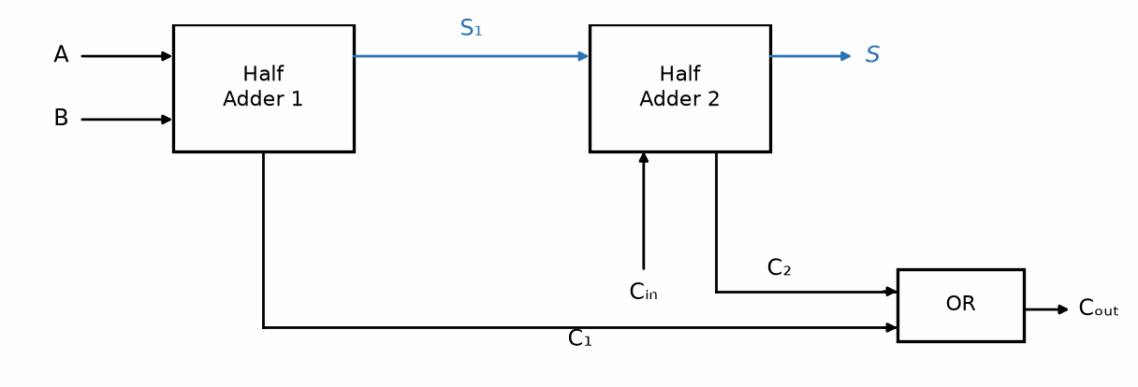
Figure 4.1 — A full adder built from two half adders and an OR gate combining their carry outputs.

4.2 Why Sequential Circuits Need Memory
A combinational adder is stateless by construction: feed it the same two numbers twice, in any order, and it produces the same sum both times. Many useful behaviors cannot be built this way — a counter that increments on each clock pulse must remember what it counted last, and a system that reacts differently to the same input depending on what happened earlier needs somewhere to keep that history. That somewhere is a bistable element: a circuit with two stable states that, left alone, stays in whichever one it is currently in.

4.3 Latches and Flip-Flops
The simplest bistable element, the SR latch, can be built two ways, and the two are not interchangeable in their details. A NOR-gate version uses active-high inputs: setting S = 1 forces the stored output Q to 1, setting R = 1 forces it to 0, and with both inputs at 0 the latch holds whatever value it last stored — but setting both S and R to 1 simultaneously is forbidden, since both cross-coupled gates are then driven to the same output state, and which stable state the latch settles into once both inputs release is not defined by the circuit. A NAND-gate version instead uses active-low inputs, conventionally written S̄ and R̄: a 0 is what sets or resets the latch, and holding both inputs high is what makes it hold its value. There, the forbidden combination is S̄ = R̄ = 0 — the same underlying problem, with the roles of 0 and 1 inverted.
A D flip-flop is the far more common building block in practice: rather than separate set and reset inputs, it has a single data input D and a clock input, and it copies whatever value is on D to its output Q only at the instant the clock transitions (typically low-to-high) — not continuously, the way a latch does. This clocked, edge-triggered behavior is what lets many flip-flops throughout a large digital system change state at exactly the same instant, which is the entire basis of synchronous digital design. A real flip-flop does not sample an arbitrarily changing D at a mathematically precise instant, either: D must actually be stable for a brief setup time before the edge and a brief hold time after it, or the flip-flop's output becomes unpredictable — a timing detail that Chapter 28 treats in full.
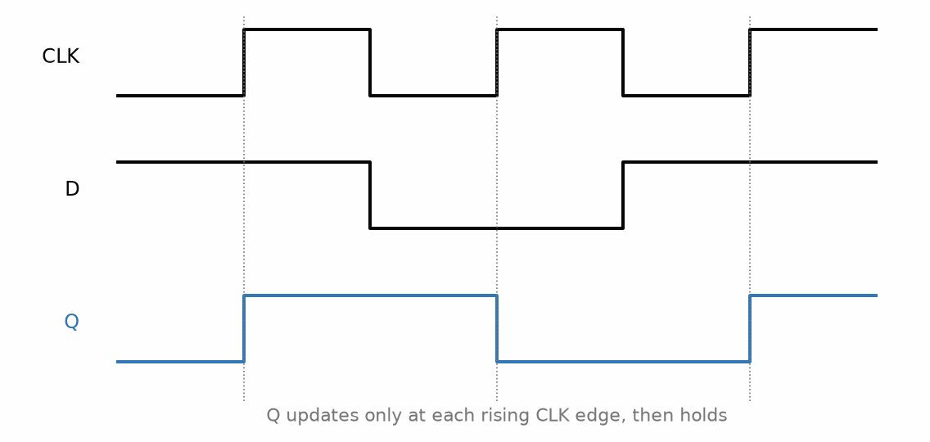
Figure 4.2 — A D flip-flop's timing diagram: Q updates to whatever D holds only at each rising CLK edge, then holds steady.
Key Idea
A flip-flop's output depends on its history, not only on its current inputs — that dependence on the past is the defining property of memory, and the reason sequential circuits can do things no combinational circuit, however large, ever can.

4.4 Registers and Counters
A register is a bank of D flip-flops sharing one clock, storing one bit of a multi-bit value in each — an 8-bit register is eight D flip-flops wide, storing one full byte at every clock edge. A counter is a register wired so that its own output, modified slightly (typically incremented by one), becomes the input for the next clock edge, causing it to step through a sequence of values automatically rather than storing whatever value is handed to it externally. A shift register is a third variant: each flip-flop's output feeds the next flip-flop's input directly, so a bit pattern loaded in at one end moves one position through the chain on every clock edge, rather than being held in place (a plain register) or incremented (a counter).
Worked Example 4.2
Problem: A 2-bit binary counter, built from two D flip-flops, starts at 00 and increments by one on every clock edge. List the sequence of states for the first five clock edges, and identify when it rolls over.
Solution: Counting in 2-bit binary from 00: 00 → 01 → 10 → 11 → 00 → 01. The first five edges therefore produce 01, 10, 11, 00, 01 — and the counter rolls over back to 00 on the fourth edge, since two bits can represent only four distinct values (0 through 3) before the sequence must repeat.
This chapter, and the two before it, cover the digital vocabulary this series needs going forward, but they are not a complete treatment of digital design. Propagation delay (how long a gate takes to respond to an input change), clock skew (different flip-flops receiving the same clock edge at very slightly different times), metastability (what happens when a flip-flop's setup or hold time is violated), fan-out (how many gate inputs one output can safely drive), and the practical differences between logic families (TTL, CMOS, LVDS, and others) all matter enormously in a real digital system — and Chapter 28 returns to propagation delay, skew, setup and hold, and metastability with real numbers, while Section 4.5 meets the 4000 and 7400 families on the bench.

4.5 Logic You Can Build: the 555, the 4000 Series, and the 7400 Series
Everything in Chapters 3 and 4 can be built on a breadboard from chips that have been in catalogs for more than fifty years. The 7400 family began as bipolar TTL; its modern 74HC and 74HCT members are CMOS parts that run from 2 V to 6 V in the same pin-outs. The 4000 family (CD4xxx) is older and slower but runs from 3 V to 15 V and draws almost nothing when idle, which makes it a favorite for battery projects. A 555 timer (Chapter 27) supplies the clock. With those three, a counter, a divider, a debouncer, or an electronic die can be built without a line of code, which is the analog-first rule of Book 1's reader lab applied to logic.
- CD4017: a decade counter with ten decoded outputs, one high at a time. Clocked by a 555, it makes the classic LED chaser of Figure 4.3.
- CD4060: an oscillator and a 14-stage binary divider in one package. With a 32.768 kHz watch crystal, its last output toggles at 2 Hz; one more flip-flop gives the 1 Hz tick of a clock.
- 74HC14: six Schmitt-trigger inverters, the standard cure for slow or bouncing inputs (Section 16.7).
- 74HC595: an 8-bit shift register with output latches, the part that lets three wires drive eight LEDs or a display.
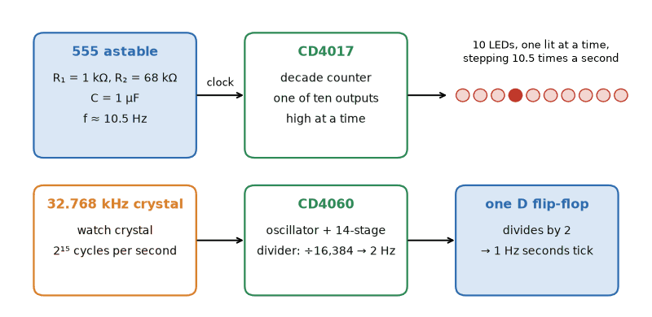
Figure 4.3 — Two classic builds without a controller. Top: a 555 clocks a CD4017, which lights ten LEDs in turn. Bottom: a CD4060 divides a 32.768 kHz watch crystal by 16,384 to 2 Hz, and one D flip-flop halves that to the 1 Hz tick of a clock.
Worked Example 4.3
Problem: A 555 astable uses R₁ = 1 kΩ, R₂ = 68 kΩ, and C = 1 µF to clock a CD4017 LED chaser. Find the clock frequency, the time each LED stays lit, and the time for the light to travel all ten LEDs.
Solution: The 555 runs at f = 1.44/((R₁ + 2R₂)C) = 1.44/(137 kΩ × 1 µF) = 10.5 Hz (Section 27.4 explains the formula). The CD4017 advances one output per clock, so each LED is lit for one period, 1/10.5 = 95 ms, and a full pass of ten LEDs takes 0.95 s. Check: raising C to 2.2 µF gives 4.8 Hz and about 2.1 s per pass, a slower chase from the same circuit.
Two no-controller classics grow from these parts. A Nixie-tube clock is a CD4060 time base, a chain of counters, and decoders driving tubes that need roughly 170 V to light; the high voltage, not the logic, is the hard part (Section 27.6). A relay computer goes one step further back and builds the gates themselves from relays: each relay is a switch whose coil is a logic input, two contacts in series make AND, two in parallel make OR, and a relay whose own contact feeds its coil holds itself on as a latch. It runs at a few operations per second and clicks audibly, which is the point: you can hear the logic of this chapter happen.

4.6 From Gates to Programmable Logic: MCU, FPGA, and ASIC
Past a few dozen chips, a breadboard of logic becomes a bird's nest, and the design moves inside one part. There are three choices, and an analogy keeps them straight (Figure 4.4). A microcontroller (MCU) is a Swiss Army knife: a fixed processor with a fixed set of tools (timers, PWM, converters, serial ports) that you direct with code, one instruction at a time. An FPGA (field-programmable gate array) is a box of Lego: thousands of small lookup tables and flip-flops, wired together at power-up by a configuration file, all running in parallel on every clock. An ASIC (application-specific integrated circuit) is a custom-built machine: its gates are fixed into the silicon at the factory, which makes it the fastest, the lowest in power, and the cheapest per unit, after a mask set and a design effort that only large volumes justify.
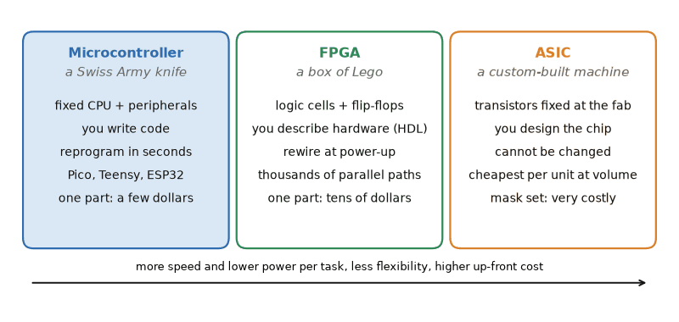
Figure 4.4 — Three ways to put logic in one part. A microcontroller is a Swiss Army knife you direct with code; an FPGA is a box of Lego you rewire at power-up; an ASIC is a custom-built machine fixed at the factory.
A lookup table (LUT) is the truth table of Chapter 3 stored in a tiny memory. A 4-input LUT holds 16 bits, one per row, and the four inputs select which bit appears at the output. Load different bits and the same hardware becomes AND, XOR, a multiplexer, or any of the 2¹⁶ = 65,536 functions of four inputs. Put a D flip-flop after each LUT and the registers and counters of Section 4.4 appear in configurable form.
Nobody draws an FPGA design gate by gate. It is described in a hardware description language such as Verilog or VHDL, and a synthesis tool maps the description onto LUTs and flip-flops. Book 8's chapter HDL: Software That Becomes Hardware (Chapter 26) covers that language side; this book supplies the gates, flip-flops, and timing (Chapter 28) underneath it. Small boards built around Lattice iCE40 FPGAs are inexpensive and can be programmed with a free, open-source toolchain, which makes them a good first FPGA.
The ASIC is no longer out of reach for a student either. Tiny Tapeout, a community project, collects many small designs onto one shared chip made in a commercial foundry from an open-source process design kit, so that a hobbyist or a class can have a small tile of logic built into real silicon for the cost of a hobby project rather than a mask set. The design flow is the FPGA flow with one difference that changes everything: there is no reprogramming after the chips come back.
Worked Example 4.4
Problem: How many configuration bits does a 6-input LUT need, and how many different logic functions can it implement? An FPGA has 5,000 four-input LUTs; how many configuration bits do the LUTs alone hold?
Solution: A k-input LUT stores one bit for each row of its truth table, and there are 2ᵏ rows. For k = 6 that is 2⁶ = 64 bits, and since each of the 64 bits can be 0 or 1 independently, the LUT can implement 2⁶⁴ ≈ 1.8 × 10¹⁹ functions. For the FPGA, each 4-input LUT holds 2⁴ = 16 bits, so 5,000 LUTs hold 80,000 bits, about 10 kB, before the routing switches that wire them together, which in a real device take several times more. Check: a 2-input LUT has 4 bits and 2⁴ = 16 functions, which is the count of every possible two-input truth table: AND, OR, XOR, NAND, NOR, XNOR, and ten others.
Key Idea
Microcontroller, FPGA, ASIC: code on fixed hardware, hardware rewired in the field, hardware fixed at the factory. Choose the most flexible one that is fast enough, cheap enough, and frugal enough with power.
From the Bench
Debounce every mechanical input before it reaches a counter or edge-triggered logic. A switch contact can bounce for a millisecond or more, and a counter will dutifully count every bounce. An RC filter followed by a Schmitt-trigger input, or a few milliseconds of software filtering, fixes it.
On the Job
Digital hardware jobs split along the line of Figure 4.4. Firmware engineers write code for microcontrollers (Book 8). FPGA engineers describe hardware in Verilog or VHDL and spend much of their week in simulation and timing reports (Chapter 28). ASIC engineers do the same at larger scale, beside verification teams that can outnumber the designers. All of them still reach for a 74HC14 or a 555 on a prototype board when a signal needs cleaning up. Learn the gate here, buy the IC at work, and know which of the three parts the job really needs.

Practice Problems
- State the forbidden input combination for a NOR-gate (active-high) SR latch, and explain in one sentence why it is forbidden.
- A D flip-flop has D = 1 when a clock edge arrives. What is Q immediately after the edge?
- How many D flip-flops are needed to build a register that can store any 4-bit binary number?
- A half adder has inputs A = 1, B = 0. Find S and C.
- A NOR-gate SR latch has S = 1, R = 0 applied, and then both inputs are returned to 0. What value does Q hold afterward, and why?
- Explain, in a sentence or two, why every flip-flop in a shift register must share the same clock signal.
- A 555 with R₁ = 1 kΩ, R₂ = 47 kΩ, and C = 2.2 µF clocks a CD4017 LED chaser. Find the clock frequency and the time for the light to pass all ten LEDs.
- A CD4060 divides a 32.768 kHz crystal by powers of two. Which division ratio gives 8 Hz, and what frequency does its last (÷16,384) output give?
- How many configuration bits does a 5-input LUT hold, and how many different logic functions can it implement?
- A design must produce 48 independent PWM outputs, each able to change on every edge of a 100 MHz clock. Do you reach first for a microcontroller, an FPGA, or an ASIC? Explain in a sentence or two.

What You’ll Actually Use
Everyday working tools
- Adders, multiplexers and decoders as building blocks.
- D flip-flops, registers and counters.
- Edge-triggered versus level-sensitive behavior.
- The 555, CD4017, CD4060, and 74HC14 for builds without code; the MCU, FPGA, or ASIC choice.
Mostly for exams and deeper study
- Designing state machines by hand with state tables and excitation equations.

Chapter 5 — Operational Amplifiers
The ideal op-amp is a lie, and a magnificently useful one. With two rules, no current into the inputs and no voltage between them under negative feedback, you can design most of the amplifiers in this book in your head, and then spend the rest of the book learning where the lie breaks down.
Where you meet this: Sensor amplifiers, audio preamps, active filters, current-sense circuits and the analog front end of almost every measurement instrument.
The operational amplifier, or op-amp, is the single most common building block in analog design, and it earns that status by being simple to reason about despite the elaborate transistor circuitry inside it. This chapter treats the op-amp the way Book 1 treated the resistor, capacitor, and inductor: as an ideal element, defined by a small number of assumptions, whose exact behavior in a circuit can be derived from first principles — leaving the transistor-level detail of how an op-amp achieves these properties to Book 3.

5.1 The Ideal Op-Amp and the Golden Rules
An ideal op-amp is defined by three properties: infinite open-loop voltage gain, infinite input impedance, and zero output impedance. From these follow two rules that make analyzing an op-amp circuit almost entirely a matter of algebra, provided — and this proviso matters — the circuit uses negative feedback to keep the op-amp out of saturation:
Golden Rule 1: V₊ = V₋ (a “virtual short”) Golden Rule 2: I₊ = I₋ = 0
Rule 1 does not claim the two input terminals are actually connected together; no current flows between them, and nothing forces their voltages to match except the surrounding feedback circuit actively adjusting the output until they do. Rule 2 follows directly from infinite input impedance: no real current can flow into either input terminal, so any current arriving at a node connected to an op-amp input must go somewhere else entirely.
Common Misconception
The golden rules are not a property of the op-amp in isolation — they are a property of a correctly designed negative-feedback circuit built around one. Remove the feedback path, or feed the output back to the wrong input, and the op-amp instead saturates hard against one supply rail, and neither golden rule describes its behavior anymore.

5.2 The Inverting Amplifier
The most common op-amp configuration grounds the non-inverting input, applies the input signal through a resistor Rᵢₙ to the inverting input, and feeds the output back to that same inverting input through a resistor R_f. By Golden Rule 1, the inverting input sits at 0 V (a “virtual ground”), since the non-inverting input is grounded. By Golden Rule 2, whatever current flows in through Rᵢₙ has nowhere to go but through R_f to the output:
Vₒᵤₜ = −(R_f / Rᵢₙ) · Vᵢₙ
The negative sign is the defining feature of this configuration: the output is an inverted, scaled copy of the input.
Worked Example 5.1
Problem: An inverting amplifier has R_f = 100 kΩ and Rᵢₙ = 10 kΩ. Find the output for an input of 0.5 V, and verify the result directly from the golden rules.
Solution: Gain = −R_f/Rᵢₙ = −100k/10k = −10. Vₒᵤₜ = −10 × 0.5 = −5 V. Checking directly: the inverting input sits at 0 V (virtual ground), so the current into Rᵢₙ is I = (0.5 − 0)/10k = 50 µA. That current has nowhere to go but through R_f, so Vₒᵤₜ = 0 − (50 µA)(100k) = −5 V — matching the formula exactly.
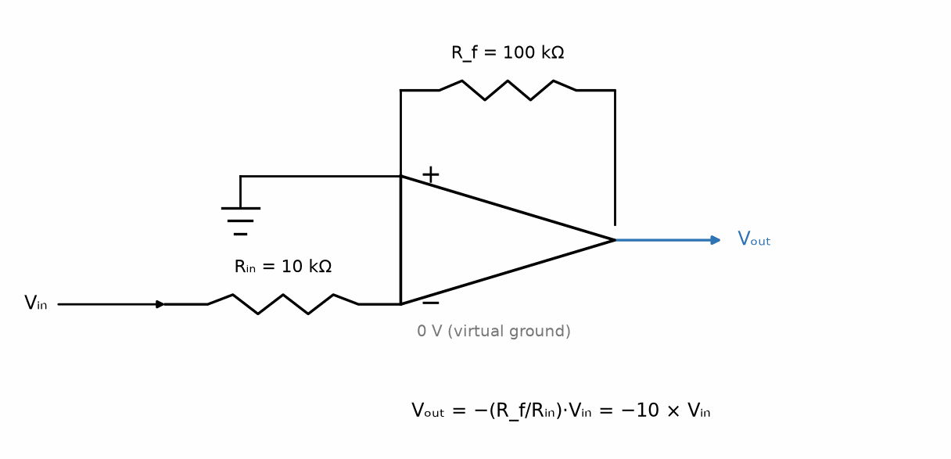
Figure 5.1 — The inverting amplifier: Rᵢₙ from the source to the virtual-ground inverting input, R_f feeding back from the output.

5.3 The Non-Inverting Amplifier
Applying the input directly to the non-inverting terminal, and feeding the output back to the inverting terminal through a voltage divider (R_f from output to the inverting input, Rᵢₙ from the inverting input to ground), gives a gain that is always at least 1 and never inverts the signal:
Vₒᵤₜ = (1 + R_f / Rᵢₙ) · Vᵢₙ
Worked Example 5.2
Problem: A non-inverting amplifier must provide a gain of exactly 6. If Rᵢₙ = 2 kΩ, find R_f.
Solution: 6 = 1 + R_f/Rᵢₙ, so R_f/Rᵢₙ = 5, and R_f = 5 × 2k = 10 kΩ.
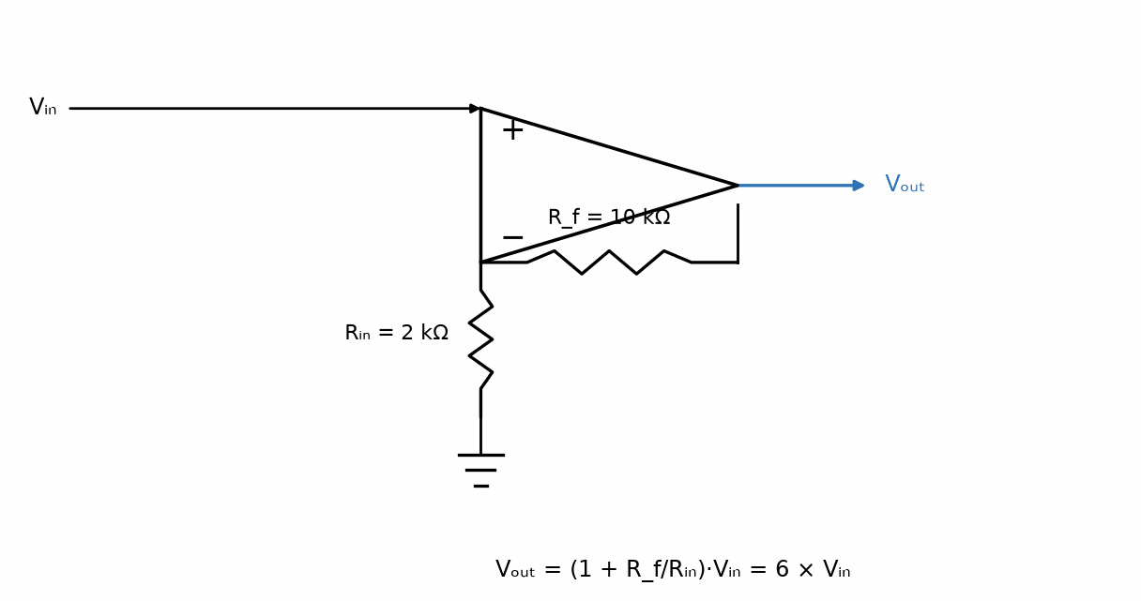
Figure 5.2 — The non-inverting amplifier: the signal drives the non-inverting input directly; R_f and Rᵢₙ form the feedback divider.

5.4 Real Limitations
A real op-amp's open-loop gain is large but finite, and it falls off with frequency — the gain-bandwidth product (GBW) is roughly constant, so a design that needs high gain at high frequency runs out of available gain sooner than one that needs only modest gain. Slew rate limits how fast the output can move at all, regardless of gain, and becomes a hard ceiling on the largest undistorted signal amplitude at high frequency — a close cousin of Chapter 1's headroom limit, but caused by a rate-of-change constraint rather than a voltage constraint. A small input offset voltage, ideally zero, in practice means the output is not exactly zero even when both inputs are nominally at the same voltage.
Worked Example 5.3
Problem: The inverting amplifier from Worked Example 5.1 (R_f = 100 kΩ, Rᵢₙ = 10 kΩ) is powered from ±5 V supply rails. Find the output the ideal gain formula predicts for an input of 1.0 V, and explain what the amplifier actually does instead.
Solution: The ideal formula predicts Vₒᵤₜ = −(R_f/Rᵢₙ)·Vᵢₙ = −10 × 1.0 = −10 V. But no op-amp can output more than its own supply rails allow, and most parts saturate a volt or more short of the rail itself — so instead of reaching −10 V, the output clips at whatever its actual negative saturation voltage is (commonly a volt or two above −5 V for an ordinary, non-rail-to-rail part). This is exactly Chapter 1's headroom limit again, reached here because the demanded gain × input product outran what the supply rails can physically provide, rather than because a small AC signal grew too large around a fixed bias point.

5.5 The Follower Is a Wire
The voltage follower, or unity-gain buffer, has no resistor in the loop at all. The output goes straight to the minus pin, and the signal is on the plus pin. That is the only configuration in which the feedback loop is a pure short. The virtual short forces the output to equal the plus input, so the gain is exactly one. The virtual open means the source sees essentially infinite impedance. The output impedance is near zero, so the stage can drive a heavy load without loading that source. That is the whole point: a high-impedance signal is buffered so the next stage does not drag it down. Because the noise gain is one, the bandwidth is the op-amp's full gain-bandwidth product, the widest bandwidth any closed-loop configuration gets.
The inverting buffer is a different circuit, not a follower with a minus sign. The plus pin is grounded. An input resistor runs from the signal to the minus pin, and a feedback resistor runs from the output back to the minus pin. The loop still closes, but it closes through those two resistors. Equal resistors give a gain of minus one. The source sees only the input resistor, not an open circuit. Use the follower when the source cannot stand a load. Use the inverting buffer when you need the sign flip and can afford that resistor as the load.

5.6 The Bode Limit, and a Declared Picture
The virtual short is exact only at DC. Open-loop gain falls at about twenty decibels per decade and crosses unity at the gain-bandwidth product. Closed-loop bandwidth is that product divided by the noise gain. For a non-inverting stage, noise gain and signal gain are the same number. For an inverter, the signal gain is minus Rf/Rin, but the noise gain is one plus Rf/Rin.
Declared picture, a general-purpose shape: DC gain 100,000 (100 dB), gain-bandwidth product 1 MHz. The dominant pole then sits at 10 Hz. A noise gain of 100 leaves 10 kHz of closed-loop bandwidth. Phase margin is how far the phase still is from minus 180 degrees where loop gain crosses unity. About 60 degrees is comfortable. About 30 degrees rings. Less than that oscillates. Treat those three numbers as a design rule of thumb, not as a theorem.

5.7 A Comparator Is Not a Bad Op-Amp
A comparator is the same input idea with the feedback loop left off on purpose. The virtual short is deliberately broken. The output slams to a rail according to which input is higher. The two ideal rules still apply at the inputs: essentially no current enters either pin. The output is a logic level, not a scaled copy of the input. Never put linear feedback around a comparator. The loop would fight the saturation the part is designed to reach. An open-collector output, the LM311 class, can only pull down; the pull-up sets the high level and may use another supply.

5.8 Bias Current, Offset, and the Resistor's Own Noise
Bipolar inputs draw nanoampere bias currents. CMOS inputs are essentially open gates. JFET sits between them. The output stage is a separate choice. Offset is what remains when the inputs are tied together. Old parts trim it on null pins. New parts laser-trim or chop.
Bias-current compensation puts a resistor in series with the plus input equal to the parallel combination of the two resistors on the minus side, so the DC drops match. It does not cancel that resistor's thermal noise. Johnson density is the square root of 4 k T R. Declared: k = 1.380649×10^−23 J/K, T = 290 K, R = 100 kΩ. Then √(4 k T R) = 40.0 nV/√Hz, which is 40 nV/√Hz for this book. That is why those resistors stay as small as the bias current allows. Bipolar wants them small. CMOS does not.
Key idea. Section 5.1 gave the two rules. This section is where they stop being exact, and where a comparator refuses to be an amplifier.
From the Bench
Check the input common-mode range and output swing before anything else. Many op-amps, particularly older ones, can't get within a volt or two of their rails; a design that is fine on paper can clip or misbehave on a single 3.3 V supply. 'Rail-to-rail' on the front page is worth confirming in the specification tables, at your load current.

Practice Problems
- An inverting amplifier has R_f = 47 kΩ and Rᵢₙ = 4.7 kΩ. Find the gain and the output voltage for an input of 0.2 V.
- A non-inverting amplifier needs a gain of 6 using Rᵢₙ = 2 kΩ (as in Worked Example 5.2) — now find the new gain if R_f is doubled to 20 kΩ while Rᵢₙ stays at 2 kΩ.
- Explain, in a sentence or two, why the “virtual short” of Golden Rule 1 does not mean current can flow between the two input terminals.
- An inverting amplifier has R_f = 220 kΩ and Rᵢₙ = 22 kΩ. Find the gain and the output voltage for an input of 0.15 V.
- A non-inverting amplifier needs a gain of 4. If R_f = 30 kΩ, find Rᵢₙ.
- Explain, in a sentence or two, why an op-amp's output cannot exceed its supply rails, no matter how large the golden-rule-predicted output would be.

What You’ll Actually Use
Everyday working tools
- The golden rules for circuits with negative feedback.
- Inverting gain −R_f/R_in and non-inverting gain 1 + R_f/R_in.
- The follower as a buffer.
Mostly for exams and deeper study
- Derivations with finite open-loop gain carried through every formula.

Chapter 6 — Passive and Active Filters
Your phone separates your voice from the wind noise, your car stereo keeps the bass out of the tweeters, and every ADC needs a fence against frequencies it can't handle. Filters are the quiet majority of analog design, and they mostly come down to a few capacitors and resistors in the right places.
Where you meet this: Anti-aliasing filters before ADCs, audio crossovers and equalizers, power-supply ripple filters, and the reconstruction filter after every DAC.
Book 1 introduced frequency response by way of a single RC low-pass stage and, separately, RLC resonance. This chapter generalizes both ideas into a single design discipline — filtering — and adds the one genuinely new idea an ideal resistor, capacitor, and inductor alone cannot provide: an active filter, built around an op-amp, that can add gain and isolate its response from whatever load it drives.

6.1 First-Order Filters, Revisited
A single-resistor, single-capacitor low-pass filter passes frequencies below its corner frequency largely unchanged and attenuates frequencies above it, with the corner (or cutoff) frequency set by
fᴄ = 1 / (2πRC)
Swapping the positions of the resistor and capacitor produces the complementary high-pass filter, with the identical formula for its corner frequency. Both are first-order filters, and a first-order filter's response falls off at a fixed rate of −20 dB per decade once past the corner — a fact Book 1's Chapter 18 introduced as an asymptote-reading exercise and this chapter now names properly.
Worked Example 6.1
Problem: Find the corner frequency of an RC low-pass filter with R = 10 kΩ and C = 10 nF.
Solution: fᴄ = 1/(2πRC) = 1/(2π × 10×10³ × 10×10⁻⁹) = 1/(2π × 1×10⁻⁴) ≈ 1591.5 Hz, or about 1.59 kHz.
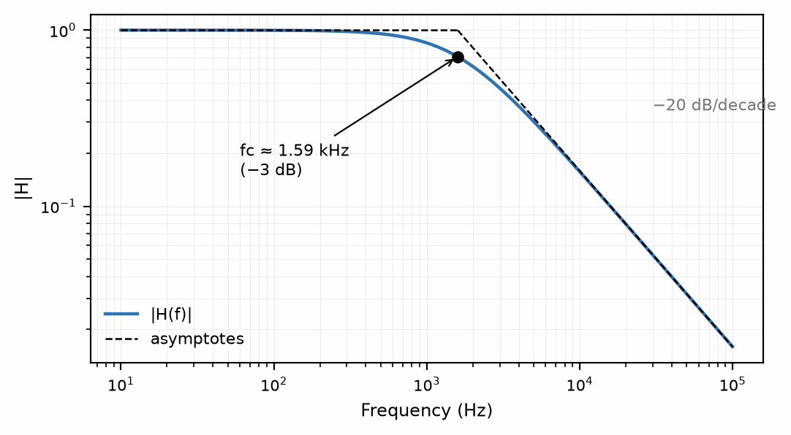
Figure 6.1 — The first-order low-pass response for Worked Example 6.1: flat below fᴄ, falling at −20 dB/decade above it.

6.2 Filter Order and Roll-Off
Cascading filter stages increases the order, and each additional order steepens the roll-off by another −20 dB per decade — a second-order filter falls at −40 dB/decade, a fourth-order filter at −80 dB/decade. Higher order buys a sharper transition between the passband and the stopband, at the cost of a more complex circuit and, for a passive design built from real inductors, often an impractically large or lossy component.
Worked Example 6.2
Problem: The filter from Worked Example 6.1 has fᴄ ≈ 1.59 kHz. Find its attenuation, in dB, at 15.9 kHz — one decade above the corner.
Solution: |H| = 1/√(1 + (f/fᴄ)²) = 1/√(1 + 10²) = 1/√101 ≈ 0.0995. In decibels: 20·log₁₀(0.0995) ≈ −20.0 dB. One decade above the corner, the exact response is already almost indistinguishable from the −20 dB/decade asymptote — confirming why the asymptote is such a reliable shortcut away from the corner itself.

6.3 Band-Pass and Band-Stop Filters
A band-pass filter passes a range of frequencies centered on some frequency of interest and attenuates everything outside that range; the series RLC resonant circuit from Book 1's Chapter 36 already behaves exactly this way, with its bandwidth set by its quality factor Q. A band-stop (or notch) filter does the opposite, rejecting a narrow range of frequencies while passing everything else — the same RLC circuit, connected differently, provides this too.

6.4 Active Filters
Every passive filter discussed so far has one practical drawback: its actual frequency response depends on whatever load impedance is connected to its output, since that load forms part of the circuit the filter's transfer function was derived from. An active filter places an op-amp between the filtering network and the output, using the op-amp's near-zero (though not literally zero) output impedance to strongly isolate the filter's response from the load, and its gain to make up for any signal loss the filtering network introduces — something no arrangement of passive components alone can do, since a real resistor, capacitor, and inductor can only remove energy from a signal, never add it.
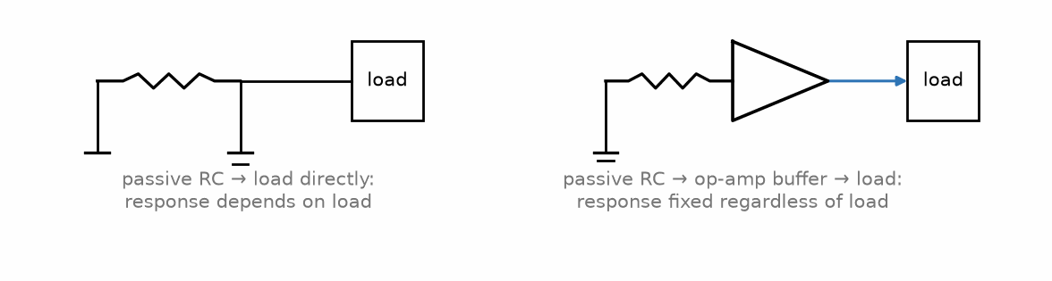
Figure 6.2 — A passive RC stage driving a load directly, versus the same stage buffered by an op-amp before the load.
Key Idea
An active filter's frequency response is largely isolated from whatever load it drives; a passive filter's response is only correct for the specific load it was designed around, and changes — sometimes significantly — if that load changes. “Largely” matters here: a real op-amp's output impedance is small but not zero, and its finite bandwidth limits how well that isolation holds as frequency rises.
Common Misconception
“Active” does not mean “better” in every respect. An active filter needs a power supply and cannot process a signal outside its op-amp's operating voltage range, while a passive filter needs neither and can handle much larger signals — the right choice depends on the application, not a blanket preference for one over the other.
Worked Example 6.3
Problem: Design an RC low-pass filter with a corner frequency of 2 kHz. Choose a practical resistor value first, then compute the capacitor needed, and round to the nearest standard (E12) value.
Solution: Pick a convenient standard resistor value, R = 8.2 kΩ. Solving fᴄ = 1/(2πRC) for C: C = 1/(2π·fᴄ·R) = 1/(2π × 2000 × 8200) ≈ 9.70 nF. The nearest E12 standard capacitor value is 10 nF. Checking the actual corner frequency with the rounded value: fᴄ = 1/(2π × 8200 × 10×10⁻⁹) ≈ 1941 Hz — about 3% below the 2 kHz target, which is well within what a design normally tolerates once component tolerances are considered. Choosing component values is always this last step: solve for the exact value, then round to what a parts bin actually stocks and check the result is still close enough.

6.5 Active Filter Design: Sallen-Key and Multiple Feedback
The first half of this chapter built the vocabulary of filters: order, roll-off, corner frequency, and the reason an op-amp makes a filter independent of its load. It stopped at first-order stages. Real anti-aliasing filters, audio crossovers, and sensor conditioners usually need a sharper transition, which means second-order sections and cascades of them. The rest of this chapter designs those sections from a specification to standard part values, using the two circuits that account for most active filters ever built.

6.6 The Second-Order Section
Every second-order low-pass response, however it is built, has the same transfer function, set by three numbers: a passband gain H₀, a natural frequency ω₀ = 2πf₀, and a quality factor Q:
H(s) = H₀ ω₀² / (s² + (ω₀/Q) s + ω₀²)
Q controls the shape near the corner. At f₀ the gain is exactly Q × H₀. A low Q gives a gentle, droopy knee; a high Q gives a peak. Three values recur often enough to have names. Q = 0.7071 (1/√2) is the Butterworth response, as flat as possible in the passband, with its −3 dB point exactly at f₀. Q = 0.5773 (1/√3) is the second-order Bessel response, which gives up some sharpness in exchange for nearly constant time delay, so a step passes through it with almost no overshoot. Higher values, such as 0.9565 for a Chebyshev response with 1 dB of passband ripple, buy a steeper initial roll-off at the cost of ripple and ringing.
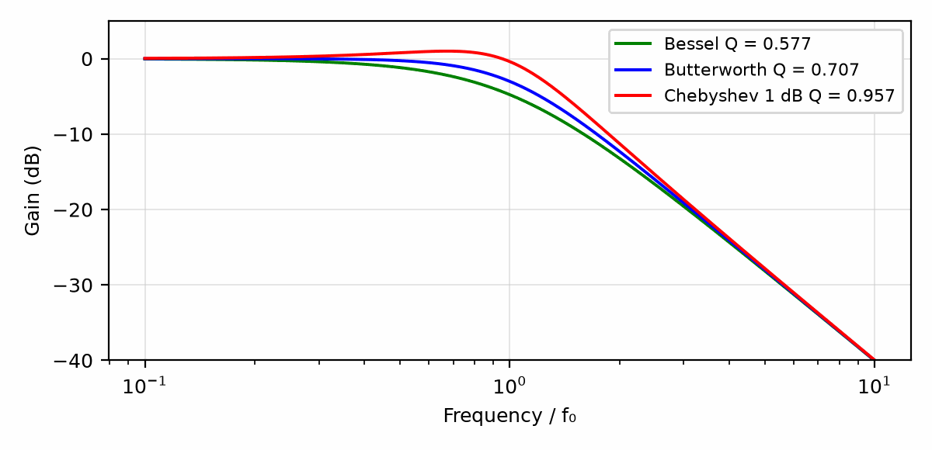
Figure 6.3 — Second-order low-pass magnitude for Bessel (Q = 0.577), Butterworth (Q = 0.707), and 1 dB Chebyshev (Q = 0.957) sections with the same f₀.

6.7 The Unity-Gain Sallen-Key Low-Pass
The Sallen-Key low-pass uses two resistors in series from the input to the non-inverting input of an op-amp wired as a follower. A capacitor C₂ goes from the non-inverting input to ground, and a capacitor C₁ goes from the junction of the two resistors back to the output. That feedback capacitor is what lifts the response near the corner and makes Q larger than a passive RC-RC ladder could achieve. With R₁ and R₂ as the two resistors:
ω₀ = 1/√(R₁R₂C₁C₂), Q = √(R₁R₂C₁C₂) / (C₂(R₁ + R₂))
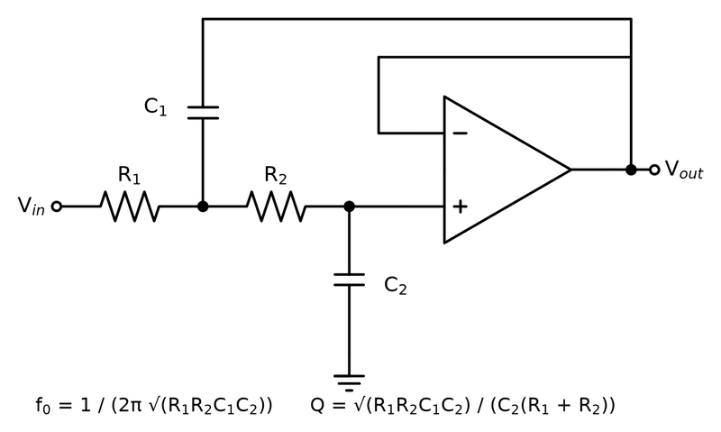
Figure 6.4 — The unity-gain Sallen-Key low-pass: two resistors, two capacitors and a follower. C1 feeds the output back into the middle node, which is what gives the filter its Q.
With equal resistors R₁ = R₂ = R, these simplify to ω₀ = 1/(R√(C₁C₂)) and Q = ½√(C₁/C₂). The capacitor ratio sets Q and the resistor sets the frequency, which is the cleanest way to design one. A Butterworth section needs C₁/C₂ = 2.
Worked Example 6.4
Problem: Design a unity-gain Sallen-Key Butterworth low-pass filter with f₀ = 1 kHz, using E12 capacitors and E96 resistors. Find the resulting f₀ and Q.
Solution: A Butterworth section wants C₁ = 2C₂. The nearest E12 pair is C₂ = 10 nF and C₁ = 22 nF, a ratio of 2.2, giving Q = ½√2.2 ≈ 0.742. The resistor then follows from R = 1/(2πf₀√(C₁C₂)) = 1/(2π × 1000 × √(22×10⁻⁹ × 10×10⁻⁹)) ≈ 10.73 kΩ, and the nearest E96 value is 10.7 kΩ. With those parts, f₀ ≈ 1003 Hz and Q ≈ 0.742. A numerical check of the circuit gives a −3 dB frequency of about 1049 Hz and a peak of only 0.04 dB above the passband, which no application that chose a 5% capacitor would ever notice.
Because the op-amp is a follower, the passband gain is exactly one and the noise gain is one, so the op-amp has its full bandwidth to work with. That makes the unity-gain Sallen-Key the usual choice for low-noise, low-Q sections. A Sallen-Key with gain above one is possible, by adding a divider in the feedback path, but its Q then depends on the gain, and high-Q designs become sensitive to resistor tolerance.

6.8 The Multiple-Feedback Low-Pass
The multiple-feedback (MFB) circuit builds the same response around an inverting op-amp. An input resistor R₁ runs to a node with a capacitor C₁ to ground. From that node, R₂ goes to the output and R₃ goes to the inverting input, and a capacitor C₂ runs from the inverting input to the output. The non-inverting input is grounded.
H₀ = −R₂/R₁, ω₀ = 1/√(R₂R₃C₁C₂), Q = √(R₂R₃C₁C₂) / (C₂(R₂ + R₃ + R₂R₃/R₁))
With all three resistors equal, H₀ = −1 and Q = ⅓√(C₁/C₂), so a Butterworth section needs C₁/C₂ = 4.5. The MFB inverts the signal, which is harmless in most systems, and it has two practical advantages over the Sallen-Key: its inputs sit at a fixed voltage, so common-mode range is not a concern, and its stopband stays deep at high frequency, where a Sallen-Key's attenuation eventually degrades because signal leaks through C₁ into an op-amp output whose impedance is rising.
Worked Example 6.5
Problem: Design an equal-resistor MFB Butterworth low-pass with f₀ = 1 kHz, using C₂ = 4.7 nF and the nearest E12 value for C₁. Find R, the resulting Q, and f₀ with an E96 resistor.
Solution: The ideal C₁ is 4.5 × 4.7 nF ≈ 21.2 nF; the nearest E12 value is 22 nF. Then Q = ⅓√(22/4.7) ≈ 0.721. The resistor is R = 1/(2π × 1000 × √(22×10⁻⁹ × 4.7×10⁻⁹)) ≈ 15.65 kΩ; the nearest E96 value is 15.8 kΩ, giving f₀ ≈ 991 Hz. The passband gain is −1.

6.9 Higher Orders by Cascading
A fourth-order filter is not two identical second-order sections in series. Two identical Butterworth sections would give a response that is −6 dB at f₀, with a droopy knee. Instead, each order has its own table of section Q values that together produce the desired overall shape. For a fourth-order Butterworth, both sections share the same f₀ and have Q = 0.5412 and Q = 1.3066. For a sixth-order Butterworth there are three sections, with Q = 0.5176, 0.7071, and 1.9319. Bessel and Chebyshev tables also shift the f₀ of each section.
The order of the sections in the cascade matters. A common practice puts the low-Q section first. The high-Q section has a gain peak near f₀, and if it came first, a strong signal near f₀ could clip at its output before the gentler section had a chance to attenuate anything; the low-Q section also filters some of the high-frequency noise before it reaches the high-gain region of the next stage.
Key Idea
A second-order section is set by f₀, Q, and H₀; the Butterworth value Q = 0.7071 is the flat-passband choice. In an equal-resistor design, the capacitor ratio sets Q and the resistor sets the frequency: C₁/C₂ = 4Q² for unity-gain Sallen-Key and 9Q² for MFB.

6.10 Tolerance, Parts, and the Op-Amp
In the equal-resistor Sallen-Key, Q depends on the square root of the capacitor ratio, so a 5% error on each capacitor in opposite directions shifts Q by about 5%, while f₀ moves by only about 0.1%, because the two errors nearly cancel in the product C₁C₂. For Butterworth sections that is harmless; for high-Q Chebyshev sections it is visible ripple. Chapter 8 gives the parts rule: use C0G (NP0) ceramic or film capacitors in filters, never Class 2 types such as X7R, whose capacitance changes with DC bias and temperature and whose piezoelectric behavior can even add distortion.
The op-amp must have enough loop gain at the frequencies where the filter is shaping the response, or it adds its own pole and distorts the intended Q. A common rule of thumb asks for a gain-bandwidth product at least 100 times the product of the section's gain and f₀, and more for high-Q sections. For the 1 kHz unity-gain sections above, that means at least 100 kHz, which the declared 1 MHz op-amp comfortably supplies. A 100 kHz anti-aliasing filter would need a much faster part.
Common Misconception
Doubling every capacitor and halving every resistor does not change the filter, but it is not a free choice. Lower resistances load the previous stage and the op-amp's output more heavily, while higher resistances add Johnson noise and bias-current error, as Chapters 14 and 15 show. Resistor values between about 1 kΩ and 100 kΩ, with capacitors chosen to suit, keep both concerns small.
From the Bench
Use C0G (NP0) capacitors in active filters; the voltage and temperature dependence of X7R parts shifts the corner frequency and adds distortion. Pick the capacitors first, because they come in fewer values, and then scale the resistors, which come in many. And check that the op-amp's gain-bandwidth is at least 100 times the section's gain times its corner frequency, with a further factor of Q for high-Q sections (Section 6.10), or the response won't match the textbook curve.

Practice Problems
- Find the corner frequency of an RC filter with R = 2.2 kΩ and C = 47 nF.
- A single first-order filter stage rolls off at −20 dB/decade. What is the roll-off of four such stages cascaded together?
- Explain, in a sentence or two, why an active filter's frequency response stays largely unaffected if the load connected to it changes, while a passive filter's does not.
- Find the corner frequency of a high-pass RC filter with R = 3.3 kΩ and C = 15 nF.
- A second-order filter rolls off at −40 dB/decade. Express this same roll-off rate in dB per octave.
- A designer wants to remove 60 Hz power-line hum from a signal of interest at 1 kHz, using only a single first-order high-pass filter. Explain the practical limitation this creates, given the filter's roll-off rate.
- A second-order low-pass section has Q = 0.7071 and H₀ = 1. What is its gain at f₀, in decibels?
- Design an equal-resistor unity-gain Sallen-Key Bessel section (Q = 0.5773). What capacitor ratio C₁/C₂ is required?
- A unity-gain Sallen-Key uses R₁ = R₂ = 22 kΩ, C₁ = 6.8 nF, and C₂ = 3.3 nF. Find f₀ and Q.
- An equal-resistor MFB section uses C₁ = 47 nF and C₂ = 5.6 nF. Find its Q.
- A fourth-order Butterworth filter at 10 kHz is built from two unity-gain Sallen-Key sections. Using the rule of thumb in Section 6.10, find the minimum gain-bandwidth product, using the higher-Q section as the guide and allowing a further factor equal to its Q.
- Explain in a sentence or two why two identical Butterworth second-order sections in cascade do not form a fourth-order Butterworth filter.

What You’ll Actually Use
Everyday working tools
- First-order corner frequency f_c = 1/(2πRC).
- Roll-off of 20 dB/decade per order.
- Sallen-Key and multiple-feedback sections from design tables.
Mostly for exams and deeper study
- Deriving pole positions for Butterworth, Bessel and Chebyshev responses.
- Filter approximation theory.

Chapter 7 — Resistors
The humblest part on the board is also the one most often blamed for nothing and guilty of plenty. A resistor that runs hot drifts, a resistor hit by a surge cracks, and a current-sense resistor wired the obvious way measures its own solder joints.
Where you meet this: Pull-ups and dividers, gain-setting networks, current shunts in chargers and motor drives, and inrush limiters.
Book 1's resistor was an ideal object obeying V = IR exactly, with no further qualification needed. A real resistor, the physical component a designer actually places on a board, is only an approximation of that ideal — a good one, most of the time, but one with limits worth knowing before they are discovered the hard way.

7.1 Construction and Types
Carbon film and metal film resistors are the ordinary through-hole and surface-mount workhorses, with metal film offering tighter tolerance and lower noise at a modest cost premium. Wirewound resistors, made from a coil of resistive wire, handle far more power than film types of the same size, at the cost of a real disadvantage explored in Section 7.4. Surface-mount chip resistors are a thick- or thin-film resistive layer on a small ceramic substrate, and dominate modern board designs on the basis of size.

7.2 Tolerance and the E-Series
No manufacturing process produces a resistor at exactly its labeled value; a tolerance, typically ±1%, ±5%, or ±10%, specifies how far the actual value may stray from nominal. Book 1's Chapter 15 introduced the E-series of standard values (E12, E24, E96) as a set of geometric progressions chosen so that adjacent standard values are spaced by roughly the tolerance band itself — the same logic explains why a 5%-tolerance parts line stocks noticeably fewer distinct values than a 1%-tolerance line.
Worked Example 7.1
Problem: Two 1 kΩ resistors, each with 5% tolerance, are connected in series. Find the range of possible total resistance.
Solution: Each resistor can independently fall anywhere between 950 Ω and 1050 Ω. In the worst case, both resistors are simultaneously at their low extreme or both at their high extreme, giving a total resistance anywhere from 1900 Ω to 2100 Ω.

7.3 Selecting a Resistor from Its Rating
A resistor dissipates power according to P = I^2 R = V^2/R. Choose a package whose rated power exceeds the calculated dissipation with useful margin, under the datasheet's stated test conditions. Common ratings include 1/8 W, 1/4 W, and 1/2 W. The next section checks a representative LED resistor at the nominal rating; Section 7.6 handles the separate question of temperature derating.
Worked Example 7.2
Problem: An LED circuit runs from a 5 V supply, with the LED's forward voltage at 2 V and a desired current of 20 mA. Find the required series resistor and check whether a 1/8 W (125 mW) resistor is an adequate choice.
Solution: R = (Vₛᵤₚₚₗᵧ − V_f)/I = (5 − 2)/0.02 = 150 Ω. Power dissipated in the resistor: P = I²R = (0.02)² × 150 = 0.06 W = 60 mW. That is within a 1/8 W part's 125 mW rating, but it uses about 48% of that rating, leaving a comparatively modest ~52% margin — a 1/4 W part would leave more comfortable headroom, especially at an elevated ambient temperature.

7.4 Temperature Coefficient and High-Frequency Behavior
A resistor's value drifts slightly with temperature, specified as a temperature coefficient in parts per million per degree Celsius (ppm/°C); metal film types are typically far better in this respect than carbon film. At sufficiently high frequency, no real resistor is purely resistive: a wirewound resistor's coiled construction gives it meaningful parasitic inductance, and any resistor's leads and internal geometry contribute a small parasitic capacitance in parallel with the intended resistance — which is exactly why a wirewound part, excellent for high-power DC and low-frequency AC use, is a poor choice for an RF circuit.
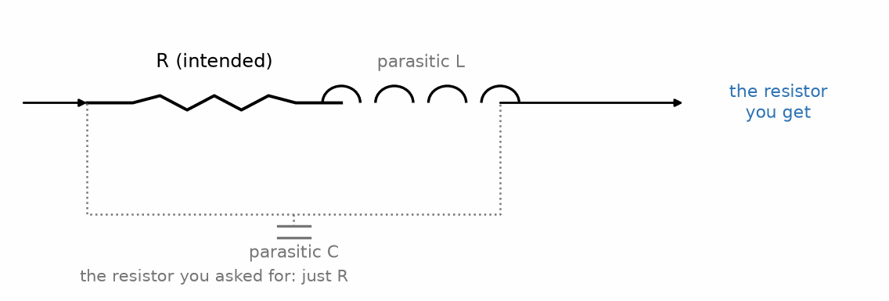
Figure 7.1 — A real resistor: the intended resistance in series with a small parasitic inductance, shunted by a small parasitic capacitance.
Key Idea
Every real component is, at a high enough frequency, secretly a little of the other two as well — a resistor has parasitic inductance and capacitance, precisely as the capacitors and inductors in the next two chapters carry a parasitic resistance of their own.

7.5 Resistors in Practice: Heat, Drift, and Pulses
Sections 7.1 to 7.4 gave the real resistor its tolerance, its power rating, its temperature coefficient, and its parasitic inductance and capacitance. Those are the properties that get a circuit working on the first day. The rest of this chapter is about the properties that decide whether it still works after a year in a hot enclosure: how a rating changes with ambient temperature, how two resistors that each drift a little can make a ratio drift a lot, how a resistor heats itself, and what happens when a short pulse delivers far more power than the rating allows.

7.6 Power Rating Is a Temperature Statement
After the circuit's dissipation is known, check whether the resistor can shed that heat on its actual board at the local ambient temperature. Many chip-resistor series hold the full rating to a knee near 70 degrees C, then reduce it toward zero at the maximum element temperature; the curve varies by series and mounting. The example uses T_knee = 70 degrees C and T_max = 155 degrees C. Use the exact part's datasheet for a design.
P_allowed = P_rated × (T_max − T_amb)/(T_max − T_knee) for T_amb above T_knee
Worked Example 7.3
Problem: A 0603 chip resistor is rated 0.1 W at 70 °C, derating linearly to zero at 155 °C. Find the allowed power at an ambient of 100 °C.
Solution: P_allowed = 0.1 × (155 − 100)/(155 − 70) = 0.1 × 55/85 ≈ 0.065 W. The part has lost about a third of its rating. "Ambient" here means the temperature of the board and air immediately around the part, which near a regulator or a power transistor can be far above the temperature of the room.
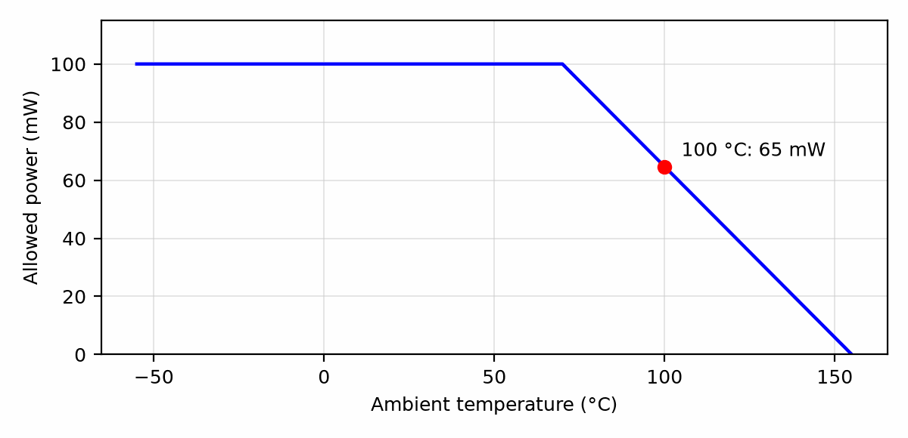
Figure 7.2 — A typical chip-resistor derating curve: full rated power to 70 °C, falling linearly to zero at 155 °C. The marked point is Worked Example 7.3.

7.7 Temperature Coefficient and the Ratio That Matters
Most precision circuits do not depend on the absolute value of any resistor. They depend on a ratio: the gain of an amplifier, the division of a voltage divider, the balance of a bridge. If every resistor in the ratio drifted by the same fraction, the ratio would not change at all. The danger is resistors that drift by different amounts.
Worked Example 7.4
Problem: A divider made of R₁ = 30 kΩ (top) and R₂ = 10 kΩ (bottom) produces 2.5 V from a 10 V reference. Each resistor has a temperature coefficient of ±100 ppm/°C. Find the worst-case output change over a 50 °C temperature rise. Then repeat for a matched network whose resistors track within 5 ppm/°C of each other.
Solution: Over 50 °C each resistor can change by up to ±100 × 50 = ±5000 ppm, or ±0.5%. The worst case has them move in opposite directions. With R₁ up 0.5% and R₂ down 0.5%, V_out = 10 × 9.95k/(30.15k + 9.95k) ≈ 2.4813 V; with the opposite signs, about 2.5188 V. The output can wander by about ±0.75%, or ±19 mV. For a tracking network, the ratio can change by at most 5 × 50 = 250 ppm; applied as a 250 ppm change in R₁ alone, V_out shifts by about 190 ppm, under 0.5 mV. A matched resistor network costs more than two discrete parts, but it improves this ratio's stability forty-fold.
Key Idea
A precision circuit usually needs a stable ratio, not stable resistors. Specify the tracking coefficient between resistors that set a ratio, and place them close together so they share a temperature.

7.8 Self-Heating
Even matched resistors can drift apart if they dissipate different powers, because each one then sits at a different temperature above its surroundings. The temperature rise is the dissipated power times the part's thermal resistance to its surroundings, which for a small chip resistor on a board is often a few hundred degrees Celsius per watt.
Worked Example 7.5
Problem: In the divider of Worked Example 7.4, R₁ and R₂ both have a temperature coefficient of +25 ppm/°C and a thermal resistance of about 500 °C/W. Find the power and temperature rise of each, and the resulting change in output.
Solution: R₁ drops 7.5 V and dissipates 7.5²/30k = 1.875 mW, a rise of about 0.94 °C. R₂ drops 2.5 V and dissipates 2.5²/10k = 0.625 mW, a rise of about 0.31 °C. Their resistances increase by about 23 ppm and 8 ppm respectively, and the output falls by about 12 ppm. That is small, but in a high-resolution measurement it is a real error, and it appears every time the circuit is powered up, not only when the room warms. Using larger resistance values, or resistors that share one substrate, reduces it.

7.9 Voltage Limits
Every resistor has a maximum working voltage, separate from its power rating, set by the spacing between its terminals and the risk of arcing across or breaking down the resistive film. For a 0603 chip resistor it is commonly 50 V to 75 V; for an 1206 about 200 V. A high-value resistor can reach its voltage limit while dissipating very little power. A 10 MΩ resistor across 400 V dissipates only 16 mW, far below any rating, but the voltage exceeds what a small chip can hold. High-voltage dividers are therefore built from several resistors in series, each well within its voltage rating, or from parts specified for high voltage. Resistance values themselves also change slightly with applied voltage, a voltage coefficient, which matters in high-voltage measurement dividers.

7.10 Pulses and Surges
The steady power rating says little about a short pulse. During a pulse of a few microseconds, heat has no time to leave the resistive element, so the limit becomes the energy the element can absorb before it is damaged, and thin, small elements absorb little. Manufacturers publish pulse-load curves showing allowed peak power versus pulse duration. Thick-film chips tolerate pulses better than thin-film parts of the same size, and specialized anti-surge parts better still; wirewound and carbon-composition types, with their large thermal mass, tolerate surges best of all. Inrush limiters, snubbers, and the input resistors of protection circuits are the usual places this matters.

7.11 Current-Sense Resistors
A current-sense resistor, or shunt, converts a current into a small voltage that an amplifier measures. Its value is a compromise: large enough that the voltage stands well above the amplifier's offset, small enough that it wastes little power and drops little voltage.
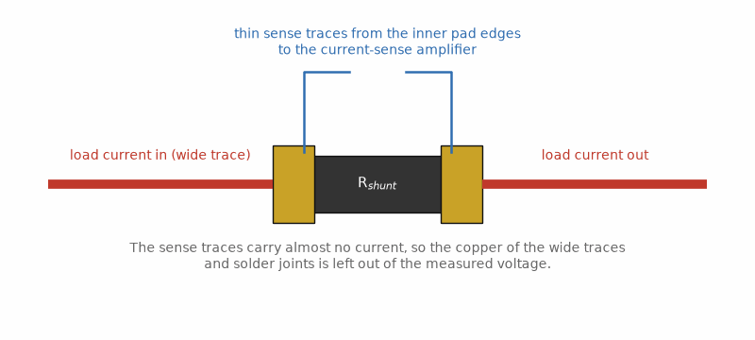
Figure 7.3 — A four-terminal (Kelvin) connection: wide traces carry the load current, thin traces from the inner pad edges carry the measurement.
Worked Example 7.6
Problem: A 10 mΩ shunt measures a 10 A load current. Find the sense voltage and the dissipation. If the sense amplifier has an offset of 100 µV, what current error does that represent?
Solution: The sense voltage is 10 A × 0.01 Ω = 100 mV, and the dissipation is 10² × 0.01 = 1 W, so a 2 W or larger part is appropriate. The 100 µV offset represents 100 µV/0.01 Ω = 10 mA, or 0.1% of full scale. At 100 mA of load current, however, the same 10 mA is a 10% error, which is why current measurement over a wide range often uses a zero-drift amplifier from Chapter 15.
At such low resistances, the solder joints and copper leading to the resistor can have resistance comparable to the part itself, and copper's temperature coefficient is about +3900 ppm/°C. A four-terminal or Kelvin connection solves this: two pads carry the current, and two separate traces from the inner edges of the resistor's pads carry only the sensed voltage to the amplifier.

7.12 Noise and Aging
Chapter 14's Johnson noise depends only on resistance and temperature, but some resistor types add excess noise when current flows through them, caused by the granular structure of the resistive material. Thick-film and carbon-composition resistors have more of it than thin-film or metal-film parts, and it rises as 1/f, like the flicker noise of Chapter 14. In a low-noise amplifier's feedback network, a thin-film part is the safe choice.
Resistors also age. Datasheets quote load-life stability, such as a maximum change of 0.5% after 1000 hours at rated power and 70 °C. Precision thin-film and foil resistors are specified to a few tens of parts per million under similar conditions. For a circuit calibrated once and expected to hold that calibration for years, this number belongs in the error budget alongside temperature coefficient.
Common Misconception
Operating a resistor well below its power rating does not, by itself, make it accurate. Rating margin prevents damage and slows aging, but it does nothing for temperature coefficient, tracking, voltage coefficient, or thermoelectric voltages at its terminals. Precision comes from choosing the right type and arranging the parts, not only from oversizing them.
From the Bench
For any shunt below about 100 mΩ, use a four-terminal (Kelvin) layout: route the sense traces from the inner edges of the pads, as a separate pair, to the amplifier. In a typical design the solder joints and pad copper add a few milliohms, which is a big error against a 10 mΩ shunt.

Practice Problems
- A resistor is rated 1/4 W (250 mW). Find the maximum current it can safely carry if its resistance is 100 Ω.
- Explain, in a sentence or two, why a wirewound resistor is a poor choice for a high-frequency RF circuit even though its DC resistance is perfectly accurate.
- A batch of 1 kΩ resistors is manufactured with 10% tolerance instead of 5%. State the new range of individual resistor values.
- Three 2.2 kΩ resistors, each with 1% tolerance, are connected in series. Find the range of possible total resistance.
- A resistor must dissipate 0.3 W continuously. Standard power ratings available are 1/8 W, 1/4 W, 1/2 W, and 1 W. Which is the smallest rating that gives at least 50% margin above the actual dissipation?
- Explain, in a sentence or two, why a resistor's temperature coefficient matters more in a precision measurement circuit than in a simple LED current-limiting application.
- A 1206 resistor is rated 0.25 W at 70 °C, derating to zero at 155 °C. Find its allowed power at 125 °C.
- Two resistors in a gain-setting ratio each have ±50 ppm/°C temperature coefficients. Over a 40 °C range, what is the worst-case change in their ratio, in ppm?
- A resistor dissipates 20 mW and has a thermal resistance of 400 °C/W. Find its temperature rise and, with a temperature coefficient of 100 ppm/°C, its change in resistance.
- A divider must handle 600 V using 0805 resistors rated 150 V each. What is the minimum number of resistors in series, and why should you use more?
- A 5 mΩ shunt carries 20 A. Find the sense voltage and the dissipation.
- Explain in a sentence or two why a Kelvin connection improves the accuracy of a low-value current-sense resistor.

What You’ll Actually Use
Everyday working tools
- E-series values, tolerance and worst-case ranges.
- Power derating with temperature.
- Kelvin connections for current sensing.
- Ratio tracking in precision dividers.
Mostly for exams and deeper study
- Resistor noise models and long-term aging statistics.

Chapter 8 — Capacitors
Pick up any modern circuit board and count the capacitors. Usually they outnumber everything else. Most of them aren't there to store energy at all; they are there to hold a supply rail steady for the nanoseconds when a chip suddenly wants current.
Where you meet this: Decoupling around every IC, bulk capacitors at power inputs, timing and filter circuits, and the ripple ratings of power supplies.
The ideal capacitor of Book 1 stores charge in exact proportion to voltage, with no further complication. A real capacitor adds two practical concerns almost every design eventually runs into: what type of capacitor actually suits a given job, and how far its behavior departs from ideal once frequency or voltage push it outside its comfortable range.

8.1 Real Capacitor Types
Ceramic capacitors split into two practically different families sharing one name: Class 1 types (commonly labeled C0G or NP0) hold their rated capacitance almost exactly regardless of applied voltage or temperature, while Class 2 types (X7R, Y5V, and similar) pack far more capacitance into the same size at the cost of a capacitance that measurably decreases as DC voltage across it increases — a real, specified effect called DC bias derating, not a manufacturing defect. Electrolytic capacitors (aluminum and tantalum) reach far higher capacitance values than any ceramic in a comparable size, but are polarized — connecting one backwards is not merely ineffective but can destroy the part, sometimes violently — a failure mode both aluminum and tantalum electrolytics are known for. Film capacitors sit between the two extremes: unpolarized, stable, and typically used where ceramics' voltage sensitivity or electrolytics' polarity requirement is undesirable.
Common Misconception
A Class 2 ceramic capacitor's marked capacitance is a nominal value under specific, standardized test conditions, not a promise the part will supply that capacitance at its actual operating voltage. A 10 µF X7R part biased near its rated voltage can easily deliver less than half its marked capacitance in practice — always check a manufacturer's DC bias curve for a Class 2 part in a voltage-sensitive design.
Worked Example 8.1
Problem: A 10 µF X7R ceramic capacitor's datasheet specifies 50% capacitance loss at its rated 25 V DC bias. Find its actual effective capacitance when operated at that voltage.
Solution: Effective capacitance = 10 µF × (1 − 0.50) = 5 µF — only half of the value printed on the part, exactly the kind of DC bias derating the misconception above warns about. A designer who needed a genuine 10 µF at this bias would have to select a physically larger part, a lower-voltage-rated one operated well under its DC bias curve's knee, or a different dielectric class entirely.

8.2 Voltage Rating and Polarity
Every capacitor carries a maximum voltage rating, and exceeding it risks dielectric breakdown — permanent, often catastrophic failure. For a polarized electrolytic, the rating applies specifically to the correct polarity; reverse voltage, even briefly, is a separate and typically much lower limit, if it is tolerated at all. Good design practice, exactly as with a resistor's power rating in Chapter 7, leaves real margin below the voltage rating rather than designing right up against it.
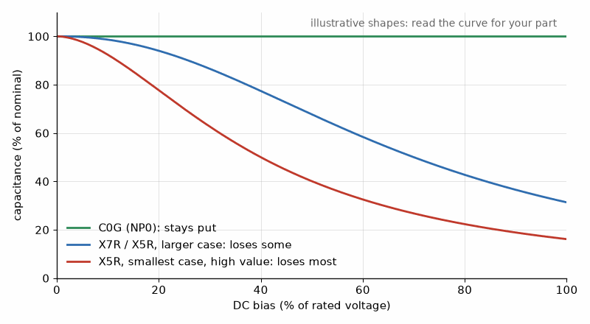
Figure 8.1 — Why a "10 µF" ceramic may not be 10 µF in your circuit: Class 2 ceramics lose capacitance as DC bias rises, and small, high-value parts lose the most. The shapes are illustrative; your part’s datasheet has the real curve.

8.3 ESR, ESL, and Self-Resonant Frequency
A real capacitor is not a pure capacitance: its leads, plates, and internal construction contribute a small equivalent series resistance (ESR) and an equivalent series inductance (ESL) that Book 1's idealized capacitor did not have. At low frequency, the capacitor's own reactance dominates and the part behaves almost exactly as the ideal model predicts. As frequency rises, however, the capacitive reactance 1/(ωC) shrinks while the inductive reactance ωL(ESL) grows, and at one particular frequency — the self-resonant frequency (SRF) — the two cancel exactly:
SRF = 1 / (2π√(L_ESL · C))
Self-resonance marks the transition from capacitive to inductive behavior. Section 8.5 examines the full impedance curve and what that transition means for decoupling.
Worked Example 8.2
Problem: A capacitor has C = 100 nF and an equivalent series inductance of 5 nH. Find its self-resonant frequency.
Solution: SRF = 1/(2π√(LC)) = 1/(2π√(5×10⁻⁹ × 1×10⁻⁷)) = 1/(2π√(5×10⁻¹⁶)) = 1/(2π × 2.236×10⁻⁸) ≈ 7.12 MHz. Above roughly 7 MHz, this part's parasitic inductance, not its 100 nF rating, dominates its behavior.
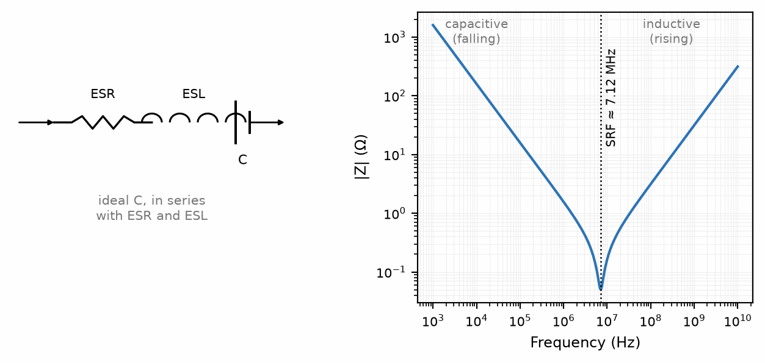
Figure 8.2. A real capacitor's series ESR/ESL/C model and magnitude response across resonance, showing capacitive and inductive regions.

8.4 Practical Capacitor Behavior
The series model is one part of capacitor selection. The following sections use it to set decoupling targets, then check dielectric absorption, leakage, ripple heating, and aging for timing, sampling, and long life.

8.5 The Impedance Curve
The series model of Section 8.3 gives a capacitor's impedance magnitude at any frequency:
|Z| = √( ESR² + (ωL_ESL − 1/(ωC))² )
On a log-log plot, |Z| falls at −20 dB per decade while the capacitance dominates, flattens to the ESR at the self-resonant frequency, and rises at +20 dB per decade once the ESL dominates. Two consequences follow. A capacitor's usefulness for decoupling is bounded on both sides: at low frequency its reactance is too large, and at high frequency its inductance is. And a larger capacitor in the same package does not help at high frequency at all, because above resonance only the ESL matters, and ESL is set by the package and its mounting, not by the capacitance.
Worked Example 8.3
Problem: Declare two mounted ceramic capacitors: 10 µF with ESL = 1.0 nH and ESR = 5 mΩ, and 100 nF with ESL = 0.5 nH and ESR = 20 mΩ. Find each self-resonant frequency and each impedance at 1 MHz and at 100 MHz.
Solution: For the 10 µF part, SRF = 1/(2π√(1.0×10⁻⁹ × 10×10⁻⁶)) ≈ 1.59 MHz. For the 100 nF part, SRF = 1/(2π√(0.5×10⁻⁹ × 100×10⁻⁹)) ≈ 22.5 MHz. At 1 MHz, the 10 µF part is still capacitive and presents about 11 mΩ; the 100 nF part presents about 1.59 Ω. At 100 MHz both are inductive: the 10 µF part presents about 0.63 Ω and the 100 nF part about 0.30 Ω, almost exactly in the ratio of their ESLs. Past resonance, the hundred-times-larger capacitor is the worse of the two.

8.6 Target Impedance
A digital load does not draw a steady current. It draws current in steps, at clock edges and whenever a block of logic wakes up. The rail must hold its voltage within a tolerance while those steps occur, and Ohm's law turns that requirement into an impedance the supply network must stay below over the whole frequency range of the steps:
Z_target = ΔV_allowed / ΔI_step
Worked Example 8.4
Problem: A 1.0 V rail must stay within 3% while its load steps by 2 A. Find the target impedance. Does either capacitor of Worked Example 8.3, used alone, meet it at 10 MHz?
Solution: ΔV_allowed = 0.03 × 1.0 = 30 mV, so Z_target = 0.030/2 = 15 mΩ. At 10 MHz the 10 µF part presents about 61 mΩ and the 100 nF part about 129 mΩ. Neither comes close; meeting 15 mΩ at 10 MHz takes several capacitors in parallel, each mounted with low inductance, plus the capacitance between the board's power and ground planes. The regulator itself takes care of low frequencies, and the package and die of the load take care of the highest. The very large currents of a modern processor, and the impedance targets they imply, are taken up in Book 7; the method is the same.

8.7 Parallel Capacitors and Antiresonance
The obvious way to cover a wide band is to parallel a large capacitor and a small one. It works, but with a trap. Between the two self-resonant frequencies, the large capacitor has turned inductive while the small one is still capacitive. An inductor in parallel with a capacitor is a parallel resonant circuit, and at its resonance the combined impedance rises to a peak, higher than either part alone. This peak is called antiresonance. Its frequency is approximately where the small capacitor resonates with the sum of both inductances:
f_ar ≈ 1 / (2π √((L₁ + L₂) C_small))
Worked Example 8.5
Problem: The two capacitors of Worked Example 8.3 are placed in parallel. Estimate the antiresonant frequency and compare the combined impedance there with each part alone.
Solution: f_ar ≈ 1/(2π√((1.0 + 0.5)×10⁻⁹ × 100×10⁻⁹)) ≈ 13.0 MHz. A numerical evaluation of the parallel combination finds the peak at about 12.9 MHz with |Z| ≈ 0.27 Ω, while at that frequency the 10 µF part alone presents about 0.080 Ω and the 100 nF part alone about 0.085 Ω. Adding the small capacitor made the network more than three times worse at 13 MHz than either capacitor by itself.
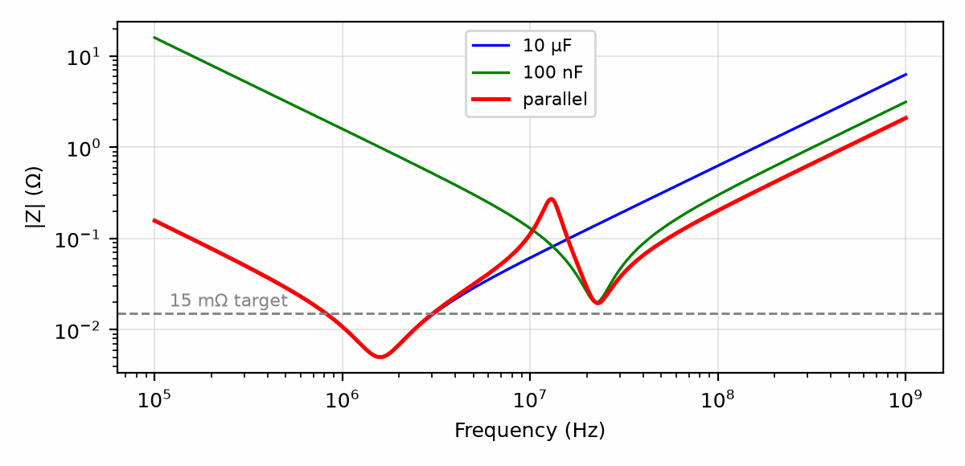
Figure 8.3 — Impedance of the 10 µF and 100 nF capacitors of Worked Example 8.3 alone and in parallel. The parallel combination is lower almost everywhere, but rises to an antiresonant peak near 13 MHz.
Three measures tame antiresonance. Using several capacitors of the same value lowers the impedance everywhere without creating a peak between different values. Spacing values closely, perhaps a factor of three or less apart, makes each peak shallow. And resistance damps the resonance; the low ESR of modern ceramics, so good in other respects, is exactly what makes the peak sharp, and some designs deliberately include a bulk capacitor with higher ESR, or a capacitor specified with controlled ESR, for this reason.
Key Idea
Above its self-resonant frequency a capacitor is an inductor, so mounting inductance, not capacitance, sets high-frequency decoupling. Parallel unlike values with care: between their resonances they form a parallel LC circuit whose antiresonant peak can exceed either part alone.
Common Misconception
The habit of placing "a 100 nF next to every pin" is not a design. It is a reasonable default for slow logic, but for a fast load the questions are what impedance is needed, over what band, and what the mounting inductance of each capacitor is. A capacitor placed at the end of a long, thin trace adds that trace's inductance in series and may do almost nothing above a few megahertz.

8.8 Local Bulk Capacitance
For the slower part of a load step, before the regulator's loop can respond, local bulk capacitance supplies the charge. The required capacitance follows from the definition of capacitance: delivering a current I for a time Δt removes a charge IΔt, and the voltage falls by that charge divided by C.
C ≥ I · Δt / ΔV
Worked Example 8.6
Problem: A regulator needs 10 µs to respond to a 2 A load step. The rail may sag by no more than 50 mV during that time. Find the minimum local capacitance, ignoring ESR.
Solution: C ≥ 2 × 10×10⁻⁶/0.050 = 400 µF. In practice the ESR also produces an instantaneous drop of I × ESR at the moment of the step; with 20 mΩ of total ESR, that alone would be 40 mV, leaving only 10 mV for the capacitive sag, so the low-ESR requirement can matter as much as the capacitance. Longer hold-up times, such as riding through a lost input supply, are a power-system question and belong to Book 6.

8.9 Ripple Current and Heating
Current flowing in and out of a capacitor heats it through its ESR, at a rate I_rms² × ESR. Electrolytic capacitors are given a ripple-current rating at a stated frequency and temperature, and their lifetime falls sharply with temperature; a common rule of thumb for aluminum electrolytics is that life roughly halves for every 10 °C rise in internal temperature. A capacitor carrying 1.5 A rms through 50 mΩ of ESR dissipates 1.5² × 0.05 ≈ 0.11 W, which in a small can is a temperature rise of several degrees and a measurable reduction in life.

8.10 Dielectric Absorption, Leakage, Microphonics, and Aging
Discharge a capacitor briefly to zero, remove the short, and wait: the voltage creeps back up to a fraction of its original value. This dielectric absorption comes from charge that moved slowly into the dielectric and returns slowly. In a sample-and-hold circuit or an integrator it appears as a memory of earlier values. Polypropylene and polystyrene film capacitors and C0G ceramics absorb very little; Class 2 ceramics and electrolytics absorb much more. For timing and sampling capacitors, this is as important a selection criterion as tolerance.
Leakage current flows through every dielectric. It is negligible for film and C0G parts, small for most ceramics, and significant for aluminum electrolytics, where it can reach microamps and rises with temperature and voltage. In a long time-constant circuit, such as a 100 s timer built from a 100 µF electrolytic and a 1 MΩ resistor, leakage comparable to the charging current makes the timing unpredictable.
Class 2 ceramics have two further habits. Their dielectric is piezoelectric, so they can turn mechanical vibration into a voltage, called microphonics, and turn a ripple voltage into audible sound, a whine from a power supply's output capacitors. And their capacitance ages: it falls by roughly one to a few percent per decade of time after the part was last heated above its Curie point, for example during soldering. C0G parts show neither effect to any practical degree, which is one more reason this chapter and Chapter 6 reserve them for filters and timing.
From the Bench
Place decoupling capacitors so the loop from the capacitor, through the IC's power and ground pins, and back is as small as you can make it, with vias right at the pads. A 100 nF capacitor a few centimeters away behind thin traces is mostly inductance at the frequencies that matter. And derate ceramics for DC bias before you count microfarads.
On the Job
On a product team, someone owns the approved-parts list. A component engineer checks each capacitor's DC-bias curve, voltage derating, temperature range, and second source before it reaches production, and a design that relies on a nominal 10 µF that is really 4 µF at its working voltage will be stopped at the design review. Bring the derating curve to the review, not the catalog headline.

Practice Problems
- Find the self-resonant frequency of a 220 nF capacitor with 2 nH of equivalent series inductance.
- An electrolytic capacitor is rated for 16 V. A circuit rail sits at a nominal 12 V DC with a ripple that occasionally peaks to 16.5 V. Is this capacitor an acceptable choice? Explain.
- Explain, in a sentence or two, why a Class 2 (X7R) ceramic capacitor's actual capacitance depends on the DC voltage applied to it.
- Find the self-resonant frequency of a capacitor with C = 10 nF and an equivalent series inductance of 8 nH.
- A tantalum capacitor is rated for 10 V. Manufacturers commonly recommend derating tantalum capacitors to 50% of their rated voltage for reliability. Is a 6 V DC rail acceptable under this guideline, even though it is below the part's absolute 10 V rating?
- Explain, in a sentence or two, why a designer might choose a film capacitor over a higher-capacitance-density ceramic for a precision timing circuit.
- A capacitor has C = 1 µF, ESL = 0.8 nH, and ESR = 10 mΩ. Find its self-resonant frequency and its impedance at that frequency.
- A 3.3 V rail must stay within 5% while its load steps by 0.5 A. Find the target impedance.
- A 4.7 µF capacitor with 1.2 nH of ESL is paralleled with a 22 nF capacitor with 0.4 nH of ESL. Estimate the antiresonant frequency.
- A load step of 1 A must be held for 20 µs with no more than 100 mV of sag. Find the minimum capacitance, ignoring ESR.
- A capacitor with 30 mΩ of ESR carries 2 A rms of ripple. Find its dissipation.
- Explain in a sentence or two why a C0G capacitor is preferred over an X7R capacitor of the same value for the hold capacitor in a sample-and-hold circuit.

What You’ll Actually Use
Everyday working tools
- The ESR/ESL model and the V-shaped impedance curve.
- Voltage derating for ceramics, and polarity for electrolytics.
- Decoupling placement and target impedance.
Mostly for exams and deeper study
- Detailed antiresonance analysis of large capacitor arrays.
- Dielectric physics.

Chapter 9 — Inductors
An inductor in a switching regulator can be perfectly fine at 2 A and nearly useless at 2.5 A. Nothing burns, nothing smells; the core saturates and the inductance quietly collapses. This chapter is about the numbers that tell you where that cliff is.
Where you meet this: Buck and boost converters, EMI filters, ferrite beads on supply lines, and RF matching networks.
Book 1 already derived inductance from Faraday and Ampere: voltage is L di/dt, and a long solenoid is μ0 N² A / ℓ. This chapter does not derive that again. It sizes a catalog part. Declared air solenoid, 100 turns, 20 mm long, 1 cm² of area: L = 62.8 µH. Wound on a closed ferrite core of relative permeability 1000 that carries the whole flux path, and still linear, it would be up to a thousand times that, 62.8 mH; an open rod core gains far less, because most of the flux path is still air. Saturation current is where the core stops being linear. Self-resonant frequency is where winding capacitance takes over and the part stops acting like an inductor. Line-frequency iron, switch-mode ferrite, pulse transformers, and RF baluns are four shelves in Book 6. They are not this chapter.
Book 1's Chapter 10 introduced the solenoid and the effect a ferromagnetic core has on its field, and Book 1's Chapter 36 introduced the ideal inductor's role in a resonant circuit. This chapter, the last of the three component chapters, treats the inductor the way the previous two chapters treated the resistor and capacitor: as a real component with real, specified limitations.

9.1 Real Inductor Types
An air-core inductor — a coil with no core material at all — is simple, perfectly linear regardless of current, and immune to the core-saturation effects of Section 9.2, but achieves relatively little inductance for its size. A ferrite- or iron-core inductor, exactly as Book 1's Chapter 10 described, multiplies the inductance dramatically for the same coil by concentrating the magnetic field in a high-permeability material, at the cost of the saturation behavior that material introduces. A toroidal (ring-shaped) core goes further still, closing the magnetic path on itself so that essentially all of the field stays confined within the core — both increasing inductance per turn beyond an equivalent open rod core and sharply reducing the stray field that would otherwise radiate outward as electromagnetic interference.

9.2 Core Saturation and Losses
A ferromagnetic core's enormous permeability comes from its internal magnetic domains aligning with the applied field; once current is high enough that essentially all of those domains have aligned, the core is saturated, and further increases in current no longer produce a proportional increase in flux. An inductor driven into saturation loses most of its inductance abruptly, right when a circuit's design may most depend on it — a large surge current, for instance, is exactly the situation this failure mode tends to appear in. Beyond saturation, a real core also dissipates a small amount of energy on every cycle as heat, through hysteresis losses (the core's magnetic domains lagging the applied field) and eddy-current losses (small circulating currents induced within the core material itself).
Common Misconception
Core saturation is not a sudden, single threshold so much as it looks like one in practice: inductance falls off increasingly sharply as current approaches the saturation region, so a design with even a small margin below the manufacturer's rated saturation current can behave very differently from one pushed right up against it.
Worked Example 9.1
Problem: An inductor is rated for a saturation current of 3.0 A. In a circuit, it carries a DC bias current of 2.0 A plus an AC ripple with a peak amplitude of 0.8 A. Find the peak instantaneous current and determine whether the inductor risks saturating.
Solution: Peak current = DC bias + AC peak = 2.0 + 0.8 = 2.8 A. This is below the 3.0 A rated saturation current, so the inductor does not saturate — but the margin is only 0.2 A, about 7% of the rating, which is tight enough that a designer would normally choose a higher-Isat part or reduce the ripple rather than rely on so little headroom.

9.3 DCR, Quality Factor, and Self-Resonance
A real inductor's winding has some DC resistance (DCR) — the wire itself is not a perfect conductor — which Book 1's ideal inductor did not include. The quality factor, already introduced in Book 1's Chapter 36 for a resonant circuit as a whole, applies equally to a single real inductor considered on its own:
Q = ωL / R
where R here is the inductor's own DCR (or, more precisely, its total effective series resistance at the frequency of interest, which rises somewhat with frequency due to skin effect). A high-Q inductor stores and returns energy efficiently; a low-Q inductor dissipates a significant fraction of it as heat on every cycle. Exactly as with the capacitor in Chapter 8, a real inductor also has a self-resonant frequency, set this time by its own winding capacitance resonating with its intended inductance, above which it stops behaving like an inductor at all.
Worked Example 9.2
Problem: An inductor has L = 10 µH and a DC resistance of 0.5 Ω, operating at 1 MHz. Find its quality factor.
Solution: ω = 2πf = 2π × 1×10⁶ ≈ 6.283×10⁶ rad/s. ωL = 6.283×10⁶ × 10×10⁻⁶ ≈ 62.83. Q = ωL/R = 62.83/0.5 ≈ 125.7 — a high-Q inductor, storing energy far more efficiently than it dissipates it at this frequency.
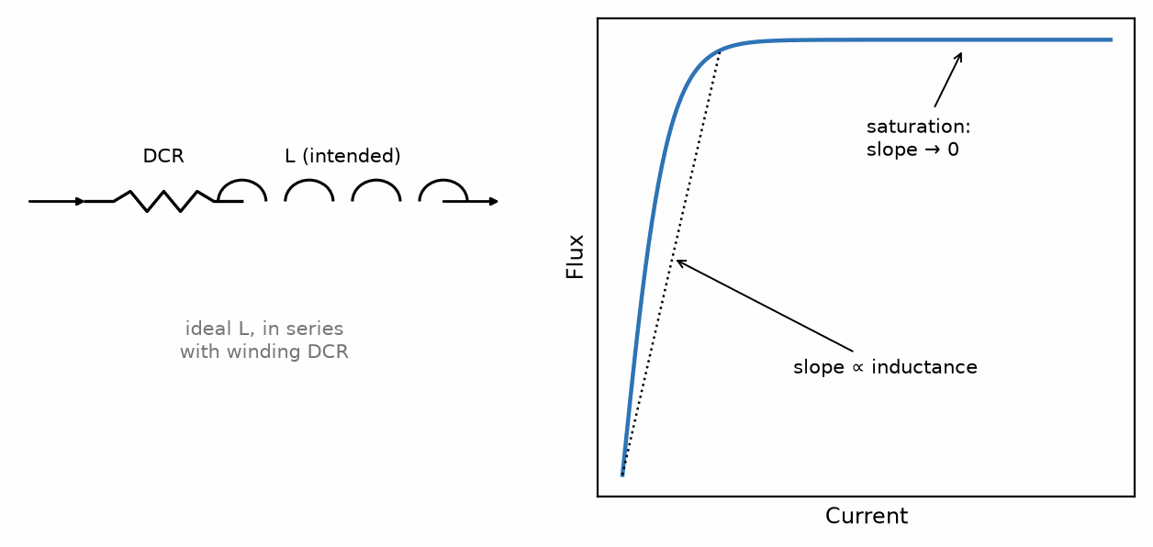
Figure 9.1 — A real inductor's DCR model, and its flux-versus-current curve flattening as the core saturates.

9.4 Inductors in Practice: Reading the Datasheet
Sections 9.1 to 9.3 introduced the real inductor: its core can saturate, its winding has resistance, and its own capacitance gives it a self-resonant frequency. The rest of this chapter takes the next step a designer actually faces, which is choosing one particular part from a catalog of thousands. The physics of inductance stays in Book 1, and the design of the converters that use power inductors belongs to Book 6. What lives here is the datasheet: what each number means, which current waveform each one must be checked against, and which numbers are easiest to misread.

9.5 The Columns of a Power-Inductor Table
A power-inductor datasheet usually gives, for each part number, an inductance value with its tolerance, a DC resistance, two current ratings, and often a self-resonant frequency. The inductance is measured at a small test signal, commonly 100 kHz and 0.1 V or 1 V, with no DC current flowing. Tolerances of ±20% are normal for power parts, and ±30% is not unusual; precision is not what these parts are for.
The two current ratings are the ones most often confused. The saturation current I_sat is the DC current at which the inductance has fallen by a stated amount, commonly 20% or 30% below its zero-current value. It is a magnetic limit, set by the core, and it is checked against the peak current the part will ever carry. The heating current, often labeled I_rms or I_temp, is the current that raises the part's temperature by a stated amount, commonly 40 °C, through losses in its winding. It is a thermal limit, set mostly by the DC resistance, and it is checked against the rms current.
Common Misconception
An inductor's two current ratings do not describe the same thing, and neither is a "maximum current." A part can run comfortably below its heating current while its peak current drives it into saturation on every cycle, or it can sit well below saturation while overheating. Both checks are required, each against its own measure of the current.

9.6 The Current Waveform the Part Must Survive
An inductor in a switching circuit carries a DC current with a triangular ripple on top of it. Section 9.2 checked a peak against I_sat; here the ripple comes from the circuit. In a buck regulator, whose full design is the subject of Book 6, the ripple's peak-to-peak value is set by the voltage across the inductor while the switch is on and the time it is on:
ΔI = (V_in − V_out) · D / (L · f_sw), D = V_out / V_in (ideal)
The peak current is the DC current plus half the ripple. The rms current of a triangle riding on a DC level is only slightly above the DC value:
I_pk = I_DC + ΔI/2, I_rms = √(I_DC² + ΔI²/12)
Worked Example 9.3
Problem: A buck regulator converts 12 V to 3.3 V at 2 A, switching at 500 kHz, with a 10 µH inductor. Find the ripple, the peak current, and the rms current, and state the minimum I_sat and heating-current ratings, allowing 20% margin on I_sat.
Solution: The ideal duty cycle is D = 3.3/12 = 0.275. The ripple is ΔI = (12 − 3.3) × 0.275/(10×10⁻⁶ × 500×10³) = 2.39/5 ≈ 0.479 A peak-to-peak. The peak current is 2 + 0.24 ≈ 2.24 A. The rms current is √(2² + 0.479²/12) ≈ 2.005 A, essentially the DC value. With 20% margin, I_sat should be at least 1.2 × 2.24 ≈ 2.7 A. The heating current should be at least 2 A, and more if the board around the inductor is already warm. Note also that the 10 µH could be as low as 8 µH at its −20% tolerance, which would raise the ripple to about 0.60 A and the peak to about 2.30 A; a careful selection checks the low-tolerance corner as well.

9.7 DC Resistance and Copper Loss
The winding loss is the rms current squared times the resistance. At the frequencies of a typical regulator, skin and proximity effects raise the winding's effective resistance for the ripple component, but because the ripple is small compared with the DC current, the DC resistance gives a good first estimate. Core loss, from the ripple's alternating flux in the ferrite, adds to it and is usually given by the manufacturer as a curve or an online calculator rather than as a single number.
Worked Example 9.4
Problem: The inductor chosen for Worked Example 9.3 has a DC resistance of 30 mΩ. Estimate its copper loss and its share of a 6.6 W output.
Solution: P = I_rms² × DCR = 2.005² × 0.030 ≈ 0.121 W. That is about 1.8% of the 6.6 W output, a significant part of a regulator's total losses. A part with half the DCR is usually physically larger or has lower inductance; trading among size, loss, and ripple is the real substance of choosing a power inductor.

9.8 Soft and Hard Saturation
Not all cores saturate the same way. A ferrite core with a small air gap holds its inductance nearly flat up to I_sat and then falls quickly; it is said to saturate hard. A powdered-iron or metal-composite core, in which the gap is distributed through the material itself, loses inductance gradually from low currents onward; it saturates soft. A hard-saturating part must never see its peak exceed I_sat, because slightly beyond it the ripple grows rapidly, which raises the peak further. A soft-saturating part tolerates brief overloads gracefully but delivers less than its nominal inductance at its rated current.
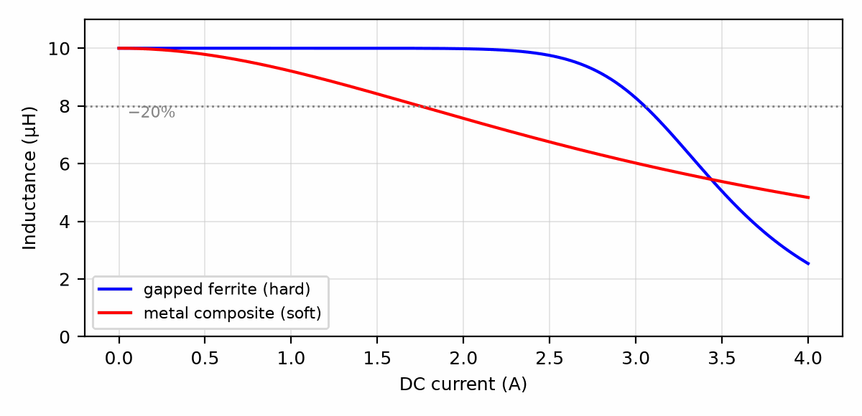
Figure 9.2 — Inductance versus DC current for an illustrative hard-saturating gapped ferrite and a soft-saturating metal-composite part of the same nominal value. Curves are representative shapes, not a specific part.

9.9 Shielded or Unshielded
An unshielded drum-core inductor leaves part of its magnetic field outside the part, where it can couple into nearby traces, other inductors, or a sensitive feedback node. A semi-shielded part adds a magnetic coating, and a fully shielded part encloses the winding in a closed magnetic path. Shielded parts cost a little more and, for the same size, have somewhat lower inductance or current ratings, but in a dense board the reduction in coupled interference usually decides the question. Section 9.1's toroid is the same idea in its oldest form.

9.10 Ferrite Beads Are Not Small Inductors
A ferrite bead looks like a chip inductor and is placed in series with a supply or signal line, but it is designed to be lossy. Its datasheet gives its impedance at 100 MHz, perhaps 600 Ω, and a plot of impedance versus frequency in which a resistive part dominates above some tens of megahertz. A bead therefore absorbs high-frequency noise as heat, rather than reflecting it as an inductor would. Two cautions apply. A bead's impedance falls sharply with DC current, often to a fraction of its rated value at half its current rating. And a bead in series with a supply, followed by a decoupling capacitor, forms an LC circuit at low frequency where the bead is mostly inductive; that circuit can resonate and amplify noise near its resonance instead of removing it.

9.11 Inductors in Signal Filters
When an inductor is used in a filter or resonant circuit rather than a regulator, the important columns change. The quality factor Q at the operating frequency, introduced in Section 9.3, sets the loss and the sharpness of the response. The self-resonant frequency should sit well above the highest frequency the filter must handle, commonly by a factor of ten, because the inductance effectively rises as the SRF is approached. Tolerance matters again: a 5% or 2% part is chosen when the filter's corner frequency must be accurate.
Key Idea
Check peak current against I_sat and rms current against the heating rating, at the low-tolerance corner of the inductance. Then decide among DCR, size, shielding, and saturation style; those trade-offs, not the inductance value, are what distinguish one catalog part from another.
From the Bench
Size a power inductor to the peak current, not the average: the DC load current plus half the peak-to-peak ripple, plus margin for start-up and load steps. Compare that with the saturation current and the heating (RMS) current separately, since datasheets often quote them under different definitions (for example a 20% or 30% inductance drop). And remember that a ferrite bead is mostly a resistor at high frequency, not an inductor.

Practice Problems
- An inductor has L = 100 µH and a DC resistance of 2 Ω, operating at 500 kHz. Find its quality factor.
- Why does an inductor's effective inductance drop sharply once its core saturates, rather than declining gradually from the very first microamp of current?
- A toroidal inductor is often chosen over an air-core solenoid of the same inductance in a compact design with nearby sensitive circuitry. Explain why, referring back to Book 1's discussion of a solenoid's field.
- An inductor has L = 47 µH and a DC resistance of 1.2 Ω, operating at 2 MHz. Find its quality factor.
- An inductor is rated for a saturation current of 1.5 A. A circuit's DC bias current is 1.0 A with an AC ripple peak of 0.6 A. Find the peak instantaneous current and state whether it exceeds the rated saturation current.
- Explain, in a sentence or two, why an inductor's quality factor typically peaks and then decreases at very high frequencies, even though Q = ωL/R alone suggests Q should keep rising with ω.
- A buck regulator converts 5 V to 1.8 V at 3 A, switching at 1 MHz, with a 2.2 µH inductor. Find the ripple current and the peak current.
- For the previous problem, find the rms current and the minimum I_sat with 20% margin.
- An inductor with DCR = 15 mΩ carries 4 A rms. Find its copper loss.
- A 4.7 µH ±20% inductor is used where the ripple was calculated for the nominal value. By what factor can the ripple rise at the low-tolerance corner?
- A filter inductor must operate up to 20 MHz. Using the factor-of-ten guideline, what is the minimum acceptable self-resonant frequency?
- Explain in a sentence or two why a ferrite bead placed in a supply line can sometimes increase noise at a particular frequency.

What You’ll Actually Use
Everyday working tools
- Saturation current versus heating current.
- Peak current = DC + half the ripple.
- DCR and copper loss.
Mostly for exams and deeper study
- Core-loss models such as the Steinmetz equation.
- Winding capacitance calculations.

Chapter 10 — The Loop Under the Model
A thermostat clicking a furnace on and off and a robot arm reaching for a cup look like different worlds. Underneath, both run the same small, unglamorous loop: measure, compare, correct, repeat.
Where you meet this: Thermostats, refrigerators, motor speed control, voltage regulators, drone stabilization, and robot joints.
Book 1 built the sensing layer of a smart thermostat in its Chapter 27: a thermistor in a Wheatstone bridge, a set-point potentiometer, and a comparator that turns a few tens of millivolts into a clean on or off. That circuit measures and compares. This chapter closes the loop: it adds the correction, follows the temperature around the loop over time, and then moves the same loop onto a robot joint. Chapters 17 to 19 give the loop its full theory; this chapter gives it a shape and a sense of speed.
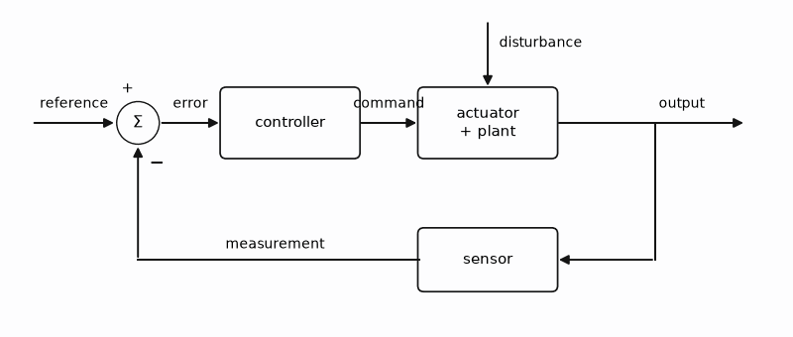
Figure 10.1 — The loop under every controlled machine: measure, compare with the reference, correct, repeat.

10.1 The Four Parts of Every Loop
Every loop in this book has the same four parts. The reference is what you want: 21 °C, or a joint angle of 30°. The sensor reports what you have. The controller compares the two and decides on a command. The plant is the physical thing the command acts on: a room and its heater, or a motor and its arm. The difference between reference and measurement is the error, and every controller in this book is a rule for turning error into command.

10.2 The Thermostat Loop: On, Off, and Hysteresis
The simplest controller is a switch. When the room is too cold, the heater turns fully on; when it is warm enough, fully off. This is bang-bang control, and with a single threshold it fails at once: noise on the sensor flicks the comparator across the threshold many times a second, and the relay chatters. The cure is the hysteresis of Chapter 16. Two thresholds, say 20.5 °C to turn the heater on and 21.5 °C to turn it off, give a band in which nothing changes, and the room temperature rides up and down a sawtooth between them (Figure 10.2).
The band sets the trade. A wide band means slow cycling, long relay and burner life, and a room that swings by the full band. A narrow band holds the temperature tighter and cycles the heater more often. Furnaces, boilers, and refrigerator compressors all enforce a minimum on time and off time for this reason: starting is where they wear.
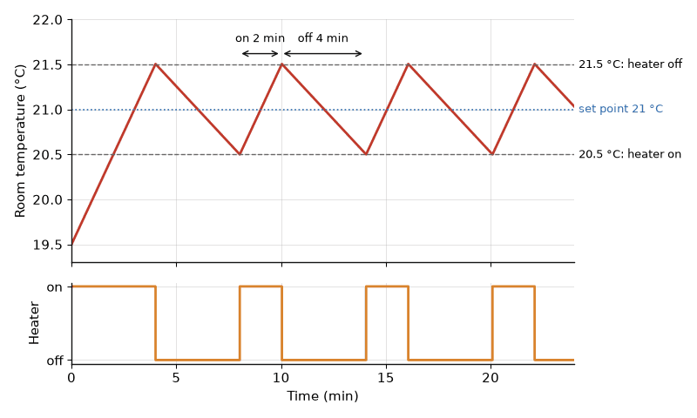
Figure 10.2 — A bang-bang thermostat with a 1 °C band. The room warms at 0.5 °C/min with the heater on and cools at 0.25 °C/min with it off, so the heater runs 2 minutes in every 6 (Worked Example 10.1).
Worked Example 10.1
Problem: A room warms at 0.5 °C per minute with its 1.5 kW heater on and cools at 0.25 °C per minute with it off. The thermostat turns the heater on at 20.5 °C and off at 21.5 °C. Find the on time, the off time, the cycle period, the duty cycle, and the average heater power.
Solution: The band is 1.0 °C. Rising through it at 0.5 °C/min takes 1.0/0.5 = 2 min; falling through it at 0.25 °C/min takes 1.0/0.25 = 4 min. The cycle is 2 + 4 = 6 min, ten cycles an hour, and the duty cycle is 2/6 = 33%. The average power is 0.333 × 1.5 kW = 0.5 kW, which is also the heat the room loses at this temperature: in the steady state the heater's average power matches the loss. Check: halving the band to 0.5 °C halves both times, giving 20 cycles an hour with the same 33% duty and the same 0.5 kW.
The analog-first rule of Book 1's reader lab applies directly. The bridge, a comparator with a resistor of positive feedback, and the relay driver of Section 24.6 make a complete thermostat with no software at all. A smart thermostat adds what code does well: schedules, a display, Wi-Fi, a log, and learning when the house is empty. The loop underneath is the same, and Book 8 is where its firmware lives.
Key Idea
A bang-bang loop with hysteresis never settles; it cycles. The band sets the swing and the cycling rate, and the heater's average power, not its rating, equals the heat the plant loses.

10.3 When On and Off Is Not Enough
On-off control is right for a room, which is slow and forgiving. It is wrong for a motor speed, a power supply, or a joint, where the sawtooth would be a vibration. Those need a command that varies smoothly with the error. The simplest is proportional control: command = K_p × error. Proportional control has a catch, which Chapter 17 derives. If the plant needs a steady command to hold its output, a steady command needs a steady error, so the output settles short of the reference. A thermostat with proportional control and a heat loss to feed holds the room a little cold forever. An integrator removes that error, and Chapter 18 shows how to tune the result; many smart thermostats run this proportional-integral (PI) law, often as a slow PWM of the heater relay or as a modulation command to a boiler.
Worked Example 10.2
Problem: A room loses 100 W for every °C it sits above the 5 °C outdoor temperature. A proportional controller commands heater power P = K_p(21 °C − T) with K_p = 1000 W/°C, and the heater can deliver up to 2 kW. Find the steady room temperature, the error, and the heater power.
Solution: In the steady state the heater supplies exactly the loss: K_p(21 − T) = 100(T − 5). Writing e = 21 − T, the right side is 100(16 − e), so 1000e = 1600 − 100e, 1100e = 1600, and e = 1.45 °C. The room settles at 21 − 1.45 = 19.55 °C, and the heater delivers 1000 × 1.45 = 1455 W, inside its 2 kW limit. Check: the loss at 19.55 °C is 100 × 14.55 = 1455 W. Raising K_p tenfold cuts the error to about 0.16 °C but makes the loop far more sensitive to sensor noise and delay; an integrator removes the error at any K_p.

10.4 The Robot Joint: The Same Loop, Hundreds of Times a Second
A robot arm reaching for a cup looks like intelligence. Underneath each joint is the thermostat's loop, running far faster: an encoder measures the angle, a controller compares it with the commanded angle, and a motor driver (Chapter 24) applies the correction. A joint tracker at 200 Hz has a period of 1/200 s, which is 5 ms. Five milliseconds is slow for a switching regulator and fast for a language model. It is the right speed for a joint that must not wait on a data center.
Book 7 describes the layers of a modern robot: a general model that interprets the scene and the request, a task planner, a motion tracker, and the mechanism. This book owns the tracker, the loop at the bottom. The model proposes where the arm should go; the tracker and an independent safety controller decide how it gets there, and when the two disagree, the safety controller is the one allowed to move the joint. Hobby robots and RC models have the same layers in miniature: a radio receiver or a small computer proposes, and a servo's own internal loop (Section 24.7) disposes.
Worked Example 10.3
Problem: A joint loop samples at 1 kHz on a microcontroller and applies each new command one sample after it reads the encoder. Using the delay rule of Chapter 19 (half a period for the hold plus one period of compute), find the total delay and the phase it costs at a 20 Hz crossover.
Solution: T = 1 ms, so the delay is 0.5 + 1.0 = 1.5 ms. At 20 Hz, ω_c = 2π × 20 = 125.7 rad/s, and the phase cost is ω_c × delay = 125.7 × 0.0015 = 0.189 rad, or 10.8°. That is a noticeable bite out of a typical 45° to 60° phase margin, and it is why joint loops run at 1 kHz or faster even though the arm itself moves at a few hertz. Check: at 200 Hz sampling the same rule gives 7.5 ms and 54°, which would leave almost no margin at a 20 Hz crossover.
Key Idea
Measure, compare, correct, repeat. A thermostat and a robot joint differ in speed by a factor of hundreds of thousands, not in kind, and the sample rate must sit well above the speed the loop is asked to control.
From the Bench
Build the analog thermostat first: the Book 1 bridge, an LM393 comparator with a 1 MΩ resistor from its output back to its non-inverting input for hysteresis, a pull-up on the open-collector output, and an LED in place of the heater. Warm the thermistor between your fingers and watch the LED switch once, cleanly, at each threshold. Then remove the feedback resistor and watch the LED flicker as the temperature crawls through the single threshold. That flicker is the reason Chapter 16 exists.

Practice Problems
- A room warms at 0.4 °C/min with its 2 kW heater on and cools at 0.2 °C/min with it off. The thermostat band is 0.6 °C. Find the on time, the off time, the cycle period, the duty cycle, and the average heater power.
- The band of the previous problem is narrowed to 0.2 °C. Find the new cycle period and the number of cycles per hour, and explain why a furnace maker would object.
- A joint tracker runs at 200 Hz. What is its period, and why is a vision-language model not the thing running at that rate?
- Name the layer that must still work when the vision-language model is wrong, and say what it is allowed to do.
- The room of Worked Example 10.2 is controlled with K_p = 400 W/°C instead. Find the steady room temperature, the error, and the heater power.
- A hobby servo accepts a new position pulse every 20 ms. A joint tracker on the robot's controller runs at 200 Hz. How many tracker updates arrive per servo frame, and what does that say about where the fast loop really sits?

What You’ll Actually Use
Everyday working tools
- The loop vocabulary: reference, error, controller, plant, sensor.
- Hysteresis bands, duty cycle, and the delay a sample rate adds to a loop.
Mostly for exams and deeper study
- Nothing yet; the theory starts in Chapter 17.

Chapter 11 — Negative Feedback
An op-amp's open-loop gain can vary by a factor of three between two parts from the same reel, and drift further with temperature, yet the amplifiers built from them hold their gain to a fraction of a percent. Negative feedback is how you buy precision with gain you didn't need.
Where you meet this: Every op-amp circuit, voltage regulators, audio power amplifiers, and any design that must ignore part-to-part variation.
Chapter 5 used negative feedback as a given: wire the output back to the inverting input, and the golden rules take over. That was a fair shortcut for an ideal op-amp with infinite gain. A real amplifier has a large but finite gain that wanders with temperature, supply voltage, and the individual part pulled from the reel, and the designer still expects the closed-loop gain to land within a fraction of a percent. This chapter answers the question underneath Chapter 5: why does wrapping an imprecise, high-gain amplifier in a precise feedback network produce a precise result, and what does the loop take in exchange?

11.1 The Loop in One Diagram
Every negative-feedback amplifier, whatever its circuit details, reduces to the same three-block picture. A forward amplifier with gain A takes an error signal and produces the output. A feedback network, usually only resistors, samples the output and returns a fraction β of it. A subtractor forms the error as the input minus that returned fraction. In an op-amp circuit the subtractor is the op-amp's own differential input, A is its open-loop gain, and β is set by the resistor divider from the output back to the inverting pin.
Writing the three relations down and eliminating the error signal gives the closed-loop gain:
G = Vₒᵤₜ / Vᵢₙ = A / (1 + Aβ)
The product T = Aβ is the loop gain. It is the gain a signal would see if you broke the loop at any point and traveled once around it. When T is large, the 1 in the denominator hardly matters, and G approaches 1/β. That limit is the whole trick. The closed-loop gain then depends on the feedback network, which is made of resistors you can buy to 0.1%, and hardly at all on A, which may be specified only as "at least 50,000."
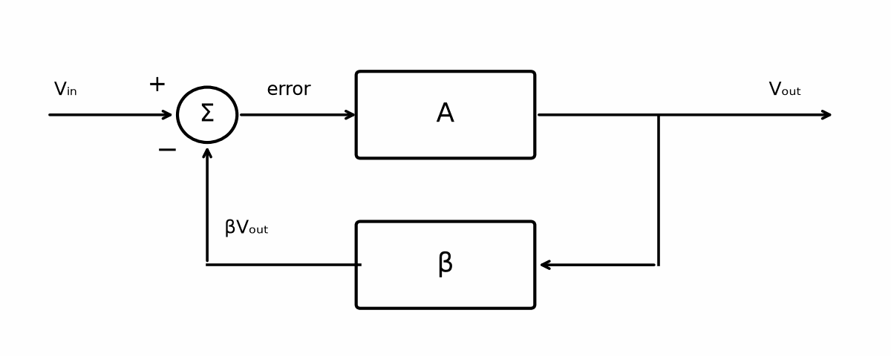
Figure 11.1 — The feedback loop: forward gain A, feedback fraction β, and the subtracting node that forms the error.
Worked Example 11.1
Problem: A non-inverting amplifier uses R_f = 99 kΩ and Rᵢₙ = 1 kΩ around an op-amp with open-loop gain A = 100,000. Find β, the ideal gain, the actual closed-loop gain, and the gain error in percent.
Solution: The feedback divider returns β = Rᵢₙ/(Rᵢₙ + R_f) = 1k/100k = 0.01 of the output. The ideal gain is 1/β = 100. The loop gain is T = Aβ = 100,000 × 0.01 = 1000. The actual gain is G = A/(1 + T) = 100,000/1001 ≈ 99.90. The error is (100 − 99.90)/100 ≈ 0.0999%, or about 1/T. That last observation generalizes: the fractional gain error of a feedback amplifier is roughly one over its loop gain.
Key Idea
The closed-loop gain of a negative-feedback amplifier is approximately 1/β, and its fractional error is approximately 1/T. A loop gain of 1000 buys about 0.1% accuracy; a loop gain of 100 buys about 1%.

11.2 Desensitivity: Why the Wandering Gain Stops Mattering
Suppose the open-loop gain changes by some fraction. How much does the closed-loop gain change? Differentiating G = A/(1 + Aβ) with respect to A and rearranging gives a clean result:
(ΔG / G) ≈ (1 / (1 + T)) · (ΔA / A)
The quantity 1 + T is called the desensitivity factor, or the amount of feedback. Whatever percentage the forward gain wanders, the closed-loop gain wanders by that percentage divided by 1 + T. This is the reason a manufacturer can ship op-amps whose open-loop gain varies by a factor of three from part to part: nobody who uses them with feedback ever sees the difference.
Worked Example 11.2
Problem: The amplifier of Worked Example 11.1 is heated, and its open-loop gain falls by half, from 100,000 to 50,000. Find the new closed-loop gain and its percentage change.
Solution: The loop gain falls to T = 50,000 × 0.01 = 500. The new closed-loop gain is G = 50,000/501 ≈ 99.80. The change from 99.90 is about 0.10%. The open-loop gain changed by 50%; the closed-loop gain changed by a tenth of a percent, almost exactly 50% divided by the original 1 + T = 1001. A designer who needs the gain to hold within 0.2% over temperature can therefore use this part, even though its own gain is anything but stable.
Common Misconception
Feedback does not make the gain "exact." It makes the gain depend on the feedback network instead of the amplifier. If the feedback resistors drift by 1%, the closed-loop gain drifts by 1%, and no amount of loop gain will correct it. Precision moves into the resistors; it does not disappear from the design.

11.3 Feedback Trades Gain for Bandwidth
Chapter 5 declared a general-purpose op-amp whose open-loop gain is 100,000 at DC and falls at 20 dB per decade from a dominant pole at 10 Hz, crossing unity at 1 MHz. Feeding back a fraction β moves that pole. For a single-pole forward amplifier, the closed-loop gain is still single-pole, but its DC value has fallen by the factor 1 + A₀β and its pole has risen by the same factor:
f_cl = f_p · (1 + A₀β) ≈ A₀ f_p β = GBW · β
With β = 0.01, the 10 Hz pole moves to about 10 kHz, and the gain falls from 100,000 to 100. The product of gain and bandwidth stays at 1 MHz. Feedback did not create bandwidth; it spent gain the circuit did not need and bought bandwidth with it. Chapter 13 develops this trade into a working tool under its proper name, noise gain.

11.4 Feedback Moves Impedances
Feedback also changes the impedance a source and a load see, and the direction of the change depends on how the loop connects. A non-inverting amplifier samples the output voltage and subtracts a voltage in series with the input. That arrangement, called series-shunt feedback, multiplies the input impedance by 1 + T and divides the output impedance by 1 + T. The circuit becomes a better voltage amplifier on both ends: it draws less current from the source and holds its output voltage more firmly under load.
Worked Example 11.3
Problem: An op-amp has a differential input resistance of 2 MΩ and an open-loop output resistance of 75 Ω. It is used in the gain-of-100 amplifier from Worked Example 11.1, where T = 1000 at DC. Estimate the closed-loop input and output resistances.
Solution: The input resistance rises to about 2 MΩ × 1001 ≈ 2 GΩ. The output resistance falls to about 75 Ω/1001 ≈ 0.075 Ω, or 75 mΩ. Both improvements shrink as frequency rises, because T falls with the open-loop gain. At 10 kHz, where this amplifier's loop gain has dropped to about 1, the output resistance is back near its open-loop value, and the output looks inductive in between, a fact that matters when Chapter 12 connects a capacitor to it.
The inverting amplifier connects differently. It still samples the output voltage, but it sums currents at the inverting node instead of subtracting a series voltage. The output impedance still drops by 1 + T, but the input impedance becomes Rᵢₙ, because the virtual ground holds one end of that resistor at 0 V. Neither result is wrong; they describe two different loops.

11.5 Distortion Is Divided Too
A forward amplifier that bends its transfer curve adds harmonics the input did not have. Inside a loop, that distortion appears at the output, is fed back, is subtracted from the input, and is driven back out of the output in the opposite direction. To a first approximation, any distortion generated inside the forward path is reduced by the factor 1 + T at the frequency where it appears. An output stage that would produce 5% distortion open-loop, wrapped in a loop with T = 100 at the signal frequency, delivers roughly 0.05%.
The qualification "at the frequency where it appears" matters. Harmonics of a 5 kHz signal land at 10, 15, and 20 kHz, where the loop gain is smaller. A loop that looks generous at the fundamental can be thin at the third harmonic, which is why audio designers chase loop gain at 20 kHz, not at 1 kHz.

11.6 The Sign Is the Whole Contract
Every benefit in this chapter came from one sign: the returned signal is subtracted. Return it with the opposite sign and the denominator becomes 1 − T. When T approaches 1, the gain heads toward infinity, and the circuit latches against a rail or oscillates. That is positive feedback, and Chapter 16 uses it on purpose to build a comparator with hysteresis.
The golden rules of Chapter 5 belong only to the negative case. A virtual short and a virtual open exist because the loop is constantly correcting the error toward zero. Remove the loop, or flip its sign, and the inputs are only two pins at whatever voltages the outside world puts on them.
Common Misconception
A circuit wired for negative feedback is not guaranteed to have negative feedback at every frequency. Each pole in the loop adds phase lag. If the lag reaches 180 degrees at a frequency where T is still at least 1, the subtraction has turned into an addition there, and the amplifier oscillates at that frequency. Chapters 12, 13, and 18 show how to measure how far a loop is from that point.
From the Bench
If the amplifier oscillates or rings, suspect the feedback sign and the phase around the loop before suspecting the part. Swapped op-amp inputs give positive feedback and a stage that sits pinned at a rail. That is one of the most common prototype faults, and it is quick to check with a meter.

Practice Problems
- A non-inverting amplifier has R_f = 49 kΩ and Rᵢₙ = 1 kΩ, and its op-amp has A = 200,000. Find β, the ideal gain, the actual gain, and the gain error in percent.
- An op-amp's open-loop gain falls by 30% over temperature. It is used in a loop with T = 2000. Estimate the percentage change in closed-loop gain.
- A designer needs a closed-loop gain of 20 with an error below 0.05%. What minimum open-loop gain must the op-amp have at the frequency of interest?
- An op-amp with open-loop output resistance 100 Ω is used as a non-inverting amplifier with loop gain 500. Estimate the closed-loop output resistance.
- Explain in a sentence or two why the input resistance of an inverting amplifier is Rᵢₙ rather than a value multiplied by 1 + T.
- An output stage produces 2% distortion open-loop. What loop gain at the signal frequency would reduce it to roughly 0.01%?

What You’ll Actually Use
Everyday working tools
- Closed-loop gain ≈ 1/β.
- Gain error ≈ 1/loop gain.
- Feedback trading gain for bandwidth.
Mostly for exams and deeper study
- Formal two-port feedback topologies.

Chapter 12 — Followers, Buffers, and Loading
Connect a sensor straight to an ADC and the reading can sag the moment the converter samples. Put a follower in between and the problem disappears, until someone adds a long cable and the follower starts to oscillate. Buffers solve one problem and invite another.
Where you meet this: Driving ADC inputs, cables, and reference pins, and buffering high-impedance sensors such as pH probes and piezo elements.
Chapter 5 closed with a short claim: the voltage follower is a wire, and the inverting buffer is a different machine. This chapter earns that claim with numbers. It starts from the problem a buffer exists to solve, a weak source that cannot drive the load it is asked to drive, then shows what the follower gets right, where its accuracy actually comes from, and the one load that can turn a perfectly ordinary follower into an oscillator.

12.1 Why a Source Needs a Buffer
Every real source has an output resistance. A thermocouple amplifier, a high-value voltage divider, a piezo sensor, or a filter built from 100 kΩ resistors all present their signal through a resistance that, together with whatever load is attached, forms a voltage divider. Book 1's divider rule gives the result directly, and it is rarely kind.
Worked Example 12.1
Problem: A sensor produces a signal through a 100 kΩ output resistance. It must drive an analog-to-digital converter input that looks like 10 kΩ. Find the fraction of the signal that reaches the converter, in ratio and in decibels.
Solution: The load and source resistance form a divider: Vₗₒₐd/Vₛ = 10k/(100k + 10k) = 0.0909. In decibels, 20 log₁₀(0.0909) ≈ −20.8 dB. Ninety-one percent of the signal is lost before it is ever measured, and the loss changes whenever the sensor's resistance changes with temperature, which is worse than the loss itself.
The cure is a stage whose input draws almost nothing and whose output can supply the load's current from its own supply rails. That is a buffer. It provides no voltage gain at all; it provides current gain, and in doing so it separates the impedance the source must see from the impedance the load presents.

12.2 The Follower and Where Its Accuracy Comes From
The follower connects the output directly to the inverting input and applies the signal to the non-inverting input. The feedback fraction is β = 1, the largest a passive network can return, so the loop gain equals the open-loop gain and the closed-loop gain is A/(1 + A). With the declared A₀ = 100,000 of Chapter 5, the gain is 0.99999, an error of 10 parts per million at DC.
The input impedance is the op-amp's own input impedance, raised further by the loop as Chapter 11 showed. For a CMOS-input part this is effectively the leakage of its protection diodes, often well above a gigaohm. The output impedance is the open-loop value divided by 1 + A. Applied to Worked Example 12.1, a follower between sensor and converter delivers essentially the full signal: the sensor now sees a gigaohm load instead of 10 kΩ, and the converter sees a fraction of an ohm instead of 100 kΩ.
The follower has one accuracy limit the inverting stages do not share. Both of its inputs move with the signal, so the whole signal appears as common-mode voltage at the op-amp's inputs. Two specifications therefore matter more for a follower than for any other configuration: the input common-mode range, which must include every value the signal can take, and the common-mode rejection ratio (CMRR), which converts that common-mode swing into an input-referred error.
Worked Example 12.2
Problem: A follower carries a signal that swings 2 V. The op-amp's CMRR is 90 dB. Estimate the worst-case input-referred error caused by common-mode swing.
Solution: Converting from decibels, 90 dB is a ratio of 10^(90/20) ≈ 31,600. The error is about 2 V/31,600 ≈ 63 µV, or roughly 32 parts per million of the 2 V swing. That is small, but it is larger than the 10 ppm gain error from finite open-loop gain, and it grows quickly if the signal approaches the edge of the common-mode range, where CMRR collapses.
Key Idea
A follower's accuracy is limited first by common-mode behavior, not by open-loop gain. Check the input common-mode range against the full signal swing, including any overshoot, before trusting the follower's 10 ppm gain error.

12.3 The Inverting Buffer Loads Its Source
An inverting amplifier with R_f = Rᵢₙ has a gain magnitude of one, and it is tempting to call it a buffer. It is not one in the same sense. Its inverting input is a virtual ground, so the source sees Rᵢₙ to ground, not an open circuit. Any source resistance adds to Rᵢₙ and changes the gain.
Worked Example 12.3
Problem: The 100 kΩ sensor of Worked Example 12.1 drives an inverting unity-gain stage built with Rᵢₙ = R_f = 10 kΩ. Find the actual gain from the sensor's internal voltage to the output.
Solution: The source resistance is in series with Rᵢₙ, so the effective input resistor is 110 kΩ. The gain is −R_f/(Rₛ + Rᵢₙ) = −10k/110k ≈ −0.0909. The inverting stage has reproduced exactly the same 91% loss as connecting the converter directly; it has only flipped the sign. Raising both resistors to 10 MΩ would reduce the loss, but Chapters 14 and 15 will show the noise and bias-current price of resistors that large.
The inverting stage still has real virtues. Its inputs sit at a fixed voltage, so common-mode range and CMRR hardly matter. It can sum several inputs at the virtual-ground node. Its noise gain is two rather than one, which halves its bandwidth compared with the follower. Choose it when you need the sign, a summing node, or a signal that would otherwise exceed the common-mode range, and when the source can afford to drive Rᵢₙ.

12.4 The Capacitive Load
The follower's most common failure is not inaccuracy. It is oscillation when driving a capacitor: a long cable, a converter's sampling capacitor, a reference pin's bypass capacitor, or a MOSFET gate. The cause is the op-amp's open-loop output resistance r_o. Together with the load capacitance C_L, it forms an RC low-pass filter inside the feedback loop, with a pole at
f₂ = 1 / (2π r_o C_L)
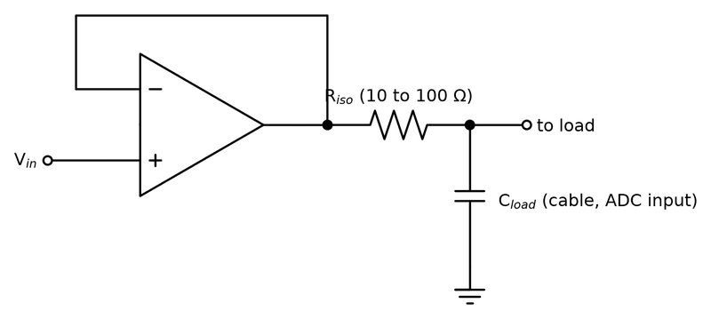
Figure 12.1 — The standard cure for a follower that rings into a cable: a small isolation resistor between the op-amp output and the capacitive load.
A follower's loop gain already crosses unity near the full gain-bandwidth product, where the op-amp's dominant pole has used up 90 degrees of phase. The new pole adds more lag, and the phase margin, the distance from −180 degrees at the crossover frequency, shrinks.
Worked Example 12.4
Problem: The declared op-amp (GBW = 1 MHz, single dominant pole) has r_o = 50 Ω and is used as a follower. Estimate the phase margin when it drives 1 nF and when it drives 10 nF.
Solution: For 1 nF, f₂ = 1/(2π × 50 × 1×10⁻⁹) ≈ 3.18 MHz. The loop gain crosses unity at about 0.96 MHz, slightly below 1 MHz because the second pole has begun to reduce the gain. The extra lag there is arctan(0.96/3.18) ≈ 17°, leaving a phase margin of about 73°, which is comfortable. For 10 nF, f₂ ≈ 318 kHz, a third of the crossover frequency. Solving for the new crossover gives about 520 kHz, where the extra lag is arctan(520/318) ≈ 59°, leaving about 31° of phase margin. Chapter 5's rule of thumb says roughly 30° rings, and a step response will show exactly that: a sharp overshoot with several cycles of ringing before it settles.
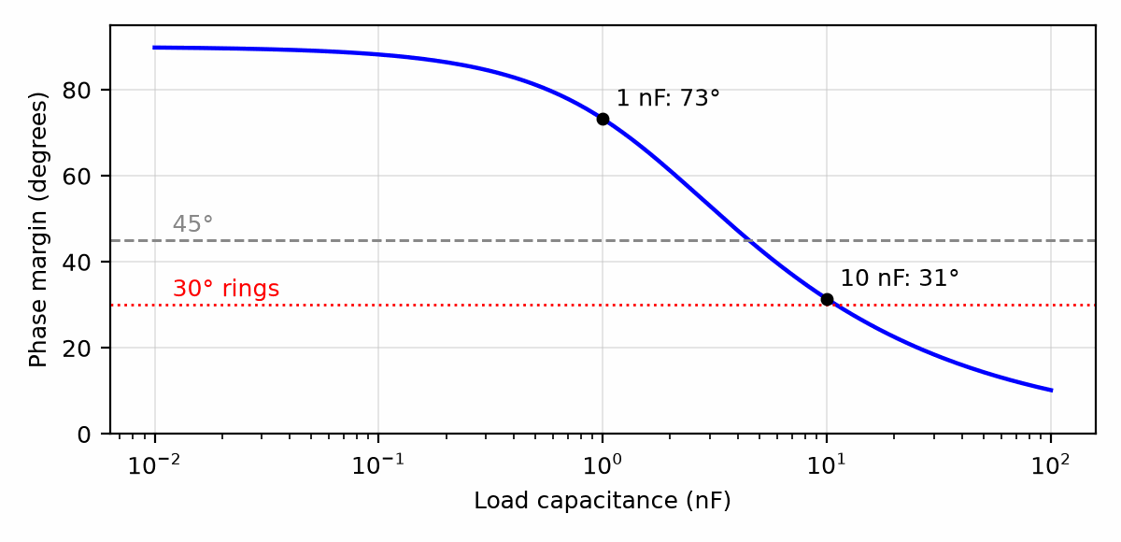
Figure 12.2 — Phase margin of a follower (GBW = 1 MHz, r_o = 50 Ω) versus load capacitance; the margin drops below 45° near 4.7 nF.
Three remedies are standard. The first is an isolation resistor of a few tens of ohms between the op-amp output and the capacitor, outside the feedback loop. The loop then sees a resistive load at high frequency and keeps its margin, at the cost of a small DC error if the load draws current and a slower edge at the capacitor. The second, used when the capacitor's voltage must be exact, closes a DC feedback path from the far side of the isolation resistor and a high-frequency path from the op-amp output through a small capacitor. The third is to choose an op-amp specified as stable into the load in question; many datasheets quote the largest capacitance a unity-gain follower can drive.
Common Misconception
A follower is not automatically the most stable configuration. It is the configuration with the least phase margin to spare, because its loop gain is the highest a passive network allows and therefore crosses unity at the highest frequency. A gain-of-ten stage driving the same capacitor crosses unity a decade lower and tolerates far more load capacitance.

12.5 Choosing Between the Two
The decision usually takes four questions. Can the source tolerate a resistive load? If not, use the follower. Does the signal stay inside the op-amp's common-mode range with margin? If not, use the inverting stage, or an op-amp with rail-to-rail inputs. Is a sign inversion acceptable or wanted? Is the load capacitive? If it is, budget an isolation resistor before the first prototype, not after the first oscillation.

12.6 Driving LEDs and Optocouplers
An LED is a current device. Its forward voltage varies from part to part and falls as it warms, so a voltage across it sets a current only loosely; a series resistor is the simple fix, and a current source is the precise one. A series resistor from a supply V_s gives I = (V_s − V_F)/R: from a 3.3 V pin, a red LED at V_F ≈ 2.0 V with 150 Ω draws about 8.7 mA. For a string of LEDs, a power LED, or a brightness that must not drift, an op-amp turns the follower of this chapter into a current sink (Figure 12.3). The loop forces the set voltage onto a sense resistor R_s, so the current through R_s, the MOSFET, and the LEDs is V_set/R_s, whatever the LEDs' forward voltage. The op-amp drives only the MOSFET's gate, and the loop makes the transistor's own variations disappear in the same way Chapter 11 made the op-amp's gain variations disappear.
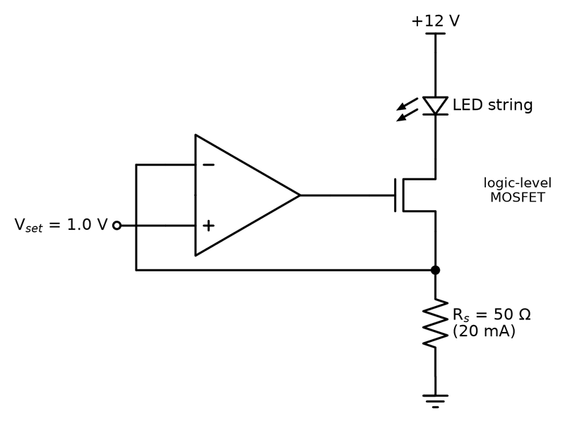
Figure 12.3 — An op-amp current sink for LEDs. The loop holds the sense resistor at V_set, so the LED current is V_set/R_s = 1.0 V/50 Ω = 20 mA, independent of the LEDs' forward voltage.
Dimming is done with PWM rather than by lowering the current, because an LED's color shifts with current. Switch the MOSFET on and off at a few hundred hertz or more, above visible flicker, and the eye averages the duty cycle. Dedicated LED-driver ICs do all of this in one package, often as switching converters for efficiency; this circuit is how they work inside.
An optocoupler puts an LED and a phototransistor in one package with no electrical path between them, so a signal can cross between two circuits whose grounds differ by hundreds of volts, or from a noisy motor supply to a microcontroller. Its key number is the current transfer ratio, CTR = I_C/I_F, the collector current obtained per unit of LED current. The CTR spreads widely: the common PC817 is specified anywhere from 50% to 600% at 5 mA, and it falls as the LED ages. Design for the minimum. The output transistor is usually a switch with a pull-up, and the design condition is that the current it must sink, (V_pull-up − V_CE(sat))/R, stays below the minimum CTR times I_F.
Worked Example 12.5
Problem: A PC817 optocoupler (minimum CTR 50% at I_F = 5 mA) carries a signal from a 3.3 V GPIO to a 5 V logic input. The LED has V_F ≈ 1.2 V. Choose the LED resistor and the smallest output pull-up that keeps the phototransistor saturated at V_CE(sat) = 0.2 V, then choose a practical value.
Solution: LED: R = (3.3 − 1.2)/5 mA = 420 Ω; the standard 390 Ω gives (3.3 − 1.2)/390 = 5.4 mA. The guaranteed collector current is at least 0.5 × 5 mA = 2.5 mA. Saturation needs (5 − 0.2)/R_pu ≤ 2.5 mA, so R_pu ≥ 1.92 kΩ. Choose 4.7 kΩ: it asks for only 1.0 mA, which leaves room for the CTR to fall with age and temperature. Check the cost: the larger the pull-up, the slower the rising edge, so this circuit suits signals up to a few kilohertz; faster signals use logic-output optocouplers or digital isolators.
Key Idea
Set an LED's current, not its voltage, and dim it with PWM. Size an optocoupler's pull-up to its minimum CTR, with margin for aging.
From the Bench
When an op-amp must drive a capacitive load such as a cable or an ADC input, add a small series isolation resistor (often 10 to 100 Ω) at its output, inside or outside the feedback loop as the datasheet recommends. Many op-amp datasheets include a stability-versus-load-capacitance plot; check it, because a few hundred picofarads is enough to make some parts ring.

Practice Problems
- A 47 kΩ source drives a 4.7 kΩ load directly. Find the fraction of the signal that reaches the load, in ratio and in decibels.
- A follower uses an op-amp with A₀ = 250,000. Find its DC gain error in parts per million.
- A follower's signal swings 3 V, and the op-amp's CMRR is 80 dB. Estimate the input-referred error from common-mode swing.
- A 22 kΩ source drives an inverting stage with Rᵢₙ = R_f = 100 kΩ. Find the actual gain from the source's internal voltage to the output.
- An op-amp with r_o = 40 Ω drives a 2.2 nF capacitor. Find the frequency of the pole this load adds to the loop.
- Explain in a sentence or two why an isolation resistor placed outside the feedback loop restores phase margin when a follower drives a large capacitor.
- An op-amp LED current sink uses V_set = 0.5 V. Find R_s for 350 mA and its dissipation, then the current and dissipation with the nearest standard 1.5 Ω part.
- A PC817 (minimum CTR 50%) is driven from a 5 V pin through 390 Ω, with V_F ≈ 1.2 V. Its output pulls up to 3.3 V. Find I_F and the smallest pull-up that keeps V_CE(sat) = 0.2 V.

What You’ll Actually Use
Everyday working tools
- Follower accuracy and its limits.
- Isolation resistors for capacitive loads.
- LED current sinks and optocoupler pull-ups sized to the minimum CTR.
Mostly for exams and deeper study
- Detailed phase-margin calculations for capacitive loading.

Chapter 13 — Noise Gain, Bandwidth, and Slew Rate
An op-amp with a 1 MHz gain-bandwidth product gives you a 1 MHz unity-gain buffer, or a gain of 100 up to only about 10 kHz. That trade, plus a speed limit called slew rate, explains most cases of 'the amplifier works on a sine but not on my signal'.
Where you meet this: Audio stages, sensor amplifiers, video and fast-pulse circuits, and every op-amp selection table.
An op-amp circuit that works perfectly at 100 Hz can quietly lose accuracy at 5 kHz and distort badly at 20 kHz, with no change to its schematic. Two separate limits are responsible. One is small-signal: the open-loop gain falls with frequency, so the loop has less gain to spend on accuracy. The other is large-signal: the output can only move so many volts per microsecond. This chapter turns both limits into numbers you can compute before choosing a part.

13.1 The Declared Op-Amp
This book uses one declared open-loop shape, first given in Chapter 5, and it is worth restating as the starting point for every calculation here. The DC gain is A₀ = 100,000. A single dominant pole sits at f_p = 10 Hz. Above that pole the gain falls at 20 dB per decade:
A(f) = A₀ / (1 + j f/f_p), |A(f)| ≈ GBW / f for f ≫ f_p
The gain-bandwidth product is GBW = A₀ f_p = 1 MHz. At 1 kHz the open-loop gain is about 1000; at 10 kHz it is 100; at 1 MHz it is 1. Every result in this chapter follows from that one straight line on a Bode plot.

13.2 Noise Gain Sets the Bandwidth
Chapter 11 showed that the closed-loop bandwidth is the gain-bandwidth product multiplied by the feedback fraction β. The reciprocal 1/β has its own name, the noise gain, because it is also the gain that the op-amp's own input noise and offset see on their way to the output. For both basic configurations it is the same expression:
NG = 1/β = 1 + R_f / Rᵢₙ, f_cl ≈ GBW / NG
For a non-inverting amplifier the noise gain equals the signal gain. For an inverting amplifier it does not: an inverter with signal gain −R_f/Rᵢₙ has noise gain 1 + R_f/Rᵢₙ, one more than the magnitude of its signal gain. The bandwidth follows the noise gain, never the signal gain.
Worked Example 13.1
Problem: Using the declared op-amp, find the closed-loop −3 dB bandwidth of (a) a non-inverting amplifier with gain 100, (b) an inverting amplifier with gain −1, and (c) an inverting amplifier with gain −10.
Solution: (a) NG = 100, so f_cl = 1 MHz/100 = 10 kHz. This is the one-home figure of this book: a noise gain of 100 leaves 10 kHz. (b) NG = 1 + 1 = 2, so f_cl = 500 kHz, half the follower's 1 MHz even though both have unity gain magnitude. (c) NG = 1 + 10 = 11, so f_cl = 1 MHz/11 ≈ 90.9 kHz, not the 100 kHz a careless reading of "gain 10" would suggest.
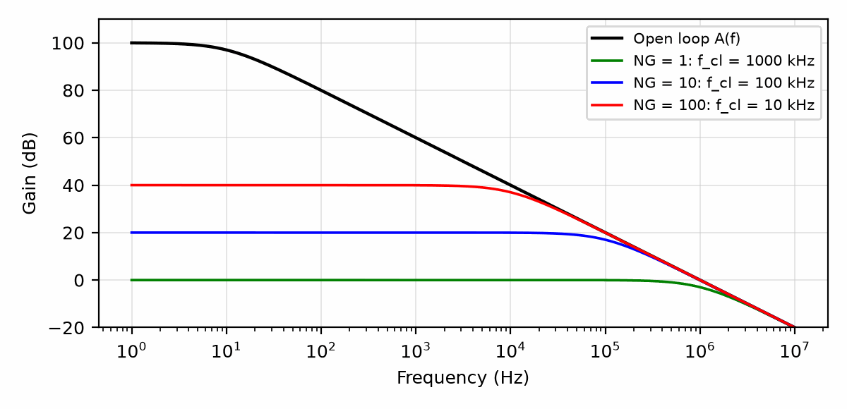
Figure 13.1 — The declared open-loop response (A₀ = 100,000, pole at 10 Hz) with closed-loop responses for noise gains of 1, 10, and 100.
Common Misconception
The −3 dB bandwidth is not the usable bandwidth. At f_cl the gain is already 29% low. If a design needs the gain to be right, it needs to know how far below f_cl it must stay, which is the subject of the next section.

13.3 Accuracy Below the Corner
With a single-pole loop, the closed-loop magnitude falls as |G(f)| = G₀/√(1 + (f/f_cl)²). Setting the fractional error to a specification and solving for frequency gives a useful rule. For a 1% magnitude error, f/f_cl = √(1/0.99² − 1) ≈ 0.142. For 0.1%, it is about 0.045. In words: to keep the gain within 1%, stay below about one seventh of the closed-loop bandwidth; to keep it within 0.1%, stay below about one twenty-second.
Worked Example 13.2
Problem: A non-inverting stage with gain 10 is built on the declared op-amp. Over what frequency range does its gain magnitude stay within 1% of 10?
Solution: NG = 10, so f_cl = 1 MHz/10 = 100 kHz. The 1% limit is 0.142 × 100 kHz ≈ 14.2 kHz. A designer who reads the 100 kHz bandwidth and expects a flat response to 20 kHz audio will find the gain about 2% low at 20 kHz. Phase shift arrives sooner still: at 14.2 kHz the output lags the input by arctan(0.142) ≈ 8°, which matters if two channels must stay matched.
Key Idea
Bandwidth follows noise gain, and accuracy needs a factor of about seven below that bandwidth for 1%. Compute f_cl = GBW/NG first, then divide again for the accuracy the application actually needs.

13.4 One Stage or Two
When a single stage cannot provide both the gain and the bandwidth, the gain can be split. Two stages of gain 10, each with f_cl = 100 kHz, give a total gain of 100. Each stage's response is single-pole, so the cascade is down 3 dB where each stage is down 1.5 dB. For n identical single-pole stages the overall corner is f_cl √(2^(1/n) − 1); for two stages that factor is 0.644, so the pair reaches about 64 kHz. One stage of gain 100 would have reached only 10 kHz. Splitting the gain bought more than six times the bandwidth, at the price of a second op-amp and a second set of offset and noise contributions.

13.5 Slew Rate and Full-Power Bandwidth
Everything so far assumed small signals. A real output stage can only change its voltage at a finite maximum rate, the slew rate SR, set inside the op-amp by how fast an internal current can charge its compensation capacitor. A sine wave of peak amplitude V_p and frequency f has a maximum rate of change 2πf V_p, at its zero crossings. If that exceeds the slew rate, the output cannot follow, and the sine wave turns into a triangle. The highest frequency at which a full-amplitude sine survives is the full-power bandwidth:
f_FP = SR / (2π V_p)
Worked Example 13.3
Problem: A general-purpose op-amp has a slew rate of 0.5 V/µs. Find its full-power bandwidth for a 10 V peak output and for a 1 V peak output.
Solution: For 10 V peak, f_FP = 0.5×10⁶/(2π × 10) ≈ 7.96 kHz. For 1 V peak, f_FP ≈ 79.6 kHz. The same op-amp in the same circuit has a small-signal bandwidth of, say, 100 kHz, but cannot deliver a full 10 V sine above about 8 kHz. Which limit applies depends on the amplitude, not on the circuit.
Common Misconception
Raising the closed-loop bandwidth does not raise the slew rate. Slew rate is a large-signal property of the op-amp's internal circuitry, independent of the feedback network. Lowering the noise gain helps small signals; only a different op-amp, or a smaller output swing, helps a slew-limited one.

13.6 A Short Design Procedure
Given a gain, a signal frequency range, an accuracy, and an output amplitude, the selection runs in four steps. First compute the noise gain from the resistor values, not from the signal gain. Second, divide the required accuracy into a minimum f_cl using the factor from Section 13.3, and multiply by the noise gain to get a minimum GBW. Third, compute 2πf_max V_p and require a slew rate comfortably above it, commonly by a factor of two. Fourth, check that the chosen op-amp is stable at the noise gain in use, since some fast parts are "decompensated" and are stable only above a minimum noise gain.

13.7 The Transimpedance Amplifier for Photodiodes
A photodiode turns light into current, about 0.6 A per watt of near-infrared light for a silicon part such as the BPW34, proportional to the light over many decades. It is the eye in the human-senses picture of Book 1's reader lab. The right circuit for a current source is a transimpedance amplifier (TIA): the photodiode feeds the inverting input of an op-amp, a feedback resistor R_f carries the photocurrent to the output, and V_out = I_ph R_f (Figure 13.2). The virtual ground holds the photodiode at 0 V, so its capacitance never charges and its response stays linear.
That capacitance returns inside the loop. The photodiode's capacitance, about 70 pF for a BPW34 at zero bias, plus the op-amp's input capacitance, forms the total input capacitance C_in, and with R_f it makes the noise gain 1 + sR_fC_in climb with frequency until it meets the open-loop gain falling from the GBW. Where the two meet, the phase margin is close to zero, and a bare TIA rings or oscillates. A small capacitor C_f across R_f fixes it. Two results cover most designs: the usable bandwidth is about f₋₃dB ≈ √(GBW/(2πR_fC_in)), and C_f ≈ √(C_in/(2πR_f·GBW)) places the feedback pole at that same frequency for a nearly flat response.
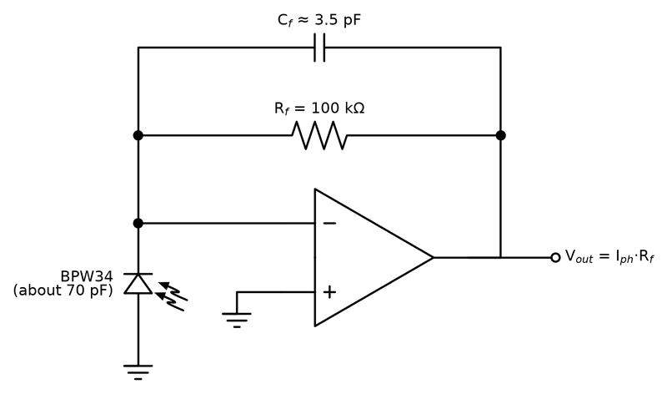
Figure 13.2 — A photodiode transimpedance amplifier. The virtual ground holds the photodiode at 0 V; the photocurrent flows through R_f, so V_out = I_ph R_f, and C_f across R_f keeps the loop stable against the photodiode's capacitance.
Worked Example 13.4
Problem: A BPW34 (C_d ≈ 70 pF) feeds a TIA with R_f = 100 kΩ on an op-amp with GBW = 10 MHz and 5 pF of input capacitance. Find the output for 10 µW of light at 0.6 A/W, the usable bandwidth, and the feedback capacitor.
Solution: I_ph = 0.6 A/W × 10 µW = 6 µA, so V_out = 6 µA × 100 kΩ = 0.60 V. C_in = 70 + 5 = 75 pF. f₋₃dB ≈ √(10⁷/(2π × 10⁵ × 75 × 10⁻¹²)) = √(2.12 × 10¹¹) ≈ 461 kHz. C_f ≈ √(75 × 10⁻¹²/(2π × 10⁵ × 10⁷)) ≈ 3.45 pF; use 3.3 pF. Check: the feedback pole 1/(2πR_fC_f) = 1/(2π × 10⁵ × 3.45 pF) ≈ 461 kHz, the same frequency, as the design intends. Reverse-biasing the photodiode cuts its capacitance several times and buys bandwidth, at the cost of more dark current.
The Smart Weather Station of Book 1 uses the same circuit slowly, to log daylight. A BPW34 in full sun delivers on the order of 100 µA; at dusk, a fraction of a microamp. One R_f cannot serve five decades of light on a 12-bit converter, so the station either switches R_f between two or three ranges or replaces the resistor with a diode, making a logarithmic amplifier whose output rises by a fixed step for each decade of light.
Key Idea
A TIA turns current into voltage at a virtual ground. Its input capacitance makes it ring unless a small C_f across R_f, sized from the GBW, restores the phase margin.
From the Bench
Slew rate catches people out on large signals. Full-power bandwidth is SR/(2πV_peak): a 0.5 V/µs part can deliver a 10 V peak sine only up to about 8 kHz. Above that the output turns into a triangle wave whatever the small-signal bandwidth says. Test with a full-amplitude signal, not only a small one.
On the Job
Analog and mixed-signal engineers spend days on what this chapter does in minutes: they simulate the loop with the vendor's SPICE model, build it, and measure the step response and noise on the bench. At work a photodiode front end is usually a precision op-amp chosen with this chapter's arithmetic, or an integrated optical sensor with the TIA built in. Learn it here, buy the IC at work, and use the numbers to check the datasheet's claims.

Practice Problems
- Using the declared op-amp, find the closed-loop bandwidth of an inverting amplifier with gain −4.
- A non-inverting amplifier with gain 25 must keep its gain within 1% up to 5 kHz. Find the minimum gain-bandwidth product.
- Find the open-loop gain of the declared op-amp at 2 kHz.
- Three identical single-pole stages each have f_cl = 50 kHz. Estimate the −3 dB bandwidth of the cascade, using f_cl √(2^(1/n) − 1).
- An op-amp with SR = 13 V/µs must deliver a 5 V peak sine. Find its full-power bandwidth.
- Explain in a sentence or two why an inverting amplifier with gain −1 has half the bandwidth of a follower built on the same op-amp.
- Redesign the TIA of Worked Example 13.4 with R_f = 1 MΩ, keeping C_in = 75 pF and GBW = 10 MHz. Find the usable bandwidth and C_f.
- A weather-station light sensor delivers up to 80 µA. Choose R_f so full sun gives 90% of a 3.3 V converter's range, pick the nearest E24 value, and find the output at 80 µA and at 0.5 µA.

What You’ll Actually Use
Everyday working tools
- Closed-loop bandwidth ≈ GBW / noise gain.
- Full-power bandwidth = SR/(2πV_peak).
- The photodiode TIA: V_out = I_ph R_f, with C_f sized from the GBW.
Mostly for exams and deeper study
- Second-pole effects and detailed frequency-compensation theory.

Chapter 14 — Noise in Op-Amp Circuits
Turn an audio amplifier all the way up with nothing plugged in and you hear a hiss. That hiss is physics, not bad workmanship: resistors and transistors generate noise by being warm. The engineer's job is to keep it below the signal.
Where you meet this: Microphone and sensor preamps, precision measurement, medical front ends (ECG, EEG), and radio receivers.
Turn the gain of a quiet amplifier all the way up with nothing connected and you will still hear a hiss, and an oscilloscope set to its most sensitive range will show a fuzzy band instead of a flat line. That is noise: random fluctuations produced by the components themselves, present even in a circuit that is perfectly designed and perfectly built. Noise sets the smallest signal a circuit can resolve. This chapter shows where it comes from in an op-amp stage, how to add the pieces together, and how to turn a datasheet's noise densities into the microvolts you will actually see.

14.1 Three Sources
Every resistor at a temperature above absolute zero produces Johnson noise, a random voltage caused by the thermal motion of its charge carriers. Its spectral density is flat with frequency and depends only on resistance and temperature:
e_R = √(4 k T R) (V/√Hz)
With Boltzmann's constant k = 1.380649×10⁻²³ J/K and the standard noise temperature T = 290 K, a 100 kΩ resistor produces 40.0 nV/√Hz, the value Chapter 5 declared for this book. Because the density goes as the square root of R, the other values follow by scaling: 10 kΩ gives 12.7 nV/√Hz and 1 kΩ gives 4.0 nV/√Hz.
The op-amp contributes two sources of its own, both quoted on its datasheet and both referred to its input. Its voltage noise density e_n behaves like a small noisy voltage source in series with one input. Its current noise density i_n behaves like a noisy current source at each input, which becomes a voltage only when it flows through a resistance. Bipolar-input parts tend to have low e_n and relatively high i_n; CMOS and JFET parts the reverse.

14.2 Adding Noise Correctly
Independent random sources do not add like DC voltages. Their instantaneous values are uncorrelated, so it is their powers that add, and the combined density is the root of the sum of the squares (RSS). This has a pleasant consequence: the largest source dominates. A source a third the size of the largest adds only about 5% to the total, and a source a tenth the size adds half a percent.
e_total = √(e₁² + e₂² + e₃² + …)
The standard procedure refers every source to the non-inverting input, combines them there by RSS, and multiplies the total by the noise gain to get the output density. The sources for a non-inverting stage with source resistance Rₛ, feedback resistor R_f, and ground resistor R_g are: the Johnson noise of Rₛ; e_n; i_n flowing through Rₛ; i_n flowing through the parallel combination R_f ‖ R_g; and the Johnson noise of R_f ‖ R_g.
Worked Example 14.1
Problem: A non-inverting amplifier with gain 11 uses R_f = 10 kΩ and R_g = 1 kΩ. It is driven from a 1 kΩ source. The op-amp has e_n = 10 nV/√Hz, i_n = 1 pA/√Hz, and the declared GBW of 1 MHz. Find the input-referred noise density, the output noise density, and the total output noise in microvolts rms. Use T = 290 K.
Solution: The five contributions, referred to the input, are: source resistor √(4kT·1kΩ) ≈ 4.00 nV/√Hz; op-amp voltage noise 10.0 nV/√Hz; i_n through Rₛ, 1 pA × 1 kΩ = 1.00 nV/√Hz; i_n through R_f ‖ R_g = 909 Ω, about 0.91 nV/√Hz; and the Johnson noise of 909 Ω, about 3.82 nV/√Hz. RSS: √(4.00² + 10.0² + 1.00² + 0.91² + 3.82²) = √132.4 ≈ 11.5 nV/√Hz. Multiplying by the noise gain of 11 gives 127 nV/√Hz at the output. The closed-loop bandwidth is 1 MHz/11 ≈ 90.9 kHz, and Section 14.3 shows that a single-pole response integrates noise over 1.571 times that, about 143 kHz. The output noise is 127 nV/√Hz × √(143,000 Hz) ≈ 47.8 µV rms.
The answer carries a design lesson. The op-amp's 10 nV/√Hz dominates; the resistors together add only about 15% to it. Replacing the op-amp with a 4 nV/√Hz part would roughly halve the noise. Replacing the resistors with lower values would barely move it.

14.3 Noise Bandwidth
A density, in nV/√Hz, becomes a voltage only when multiplied by the square root of a bandwidth. That bandwidth is not quite the −3 dB bandwidth, because a real filter does not stop abruptly; noise above the corner still leaks through the gradually falling skirt. The equivalent noise bandwidth (ENBW) is the width of an ideal brick-wall filter that would pass the same noise power. For a single-pole response it is π/2 ≈ 1.571 times the −3 dB frequency. For a second-order Butterworth it is 1.11 times; steeper filters approach 1.
Engineers often quote noise as peak-to-peak rather than rms, because a peak-to-peak number is what an oscilloscope shows. Gaussian noise has no hard maximum, so the conversion is a convention: about 6.6 times the rms value contains the waveform 99.9% of the time. The 47.8 µV rms of Worked Example 14.1 therefore looks like roughly 320 µV peak-to-peak on a screen.

14.4 Flicker Noise and the 1/f Corner
At low frequencies, both e_n and i_n rise above their flat values. This flicker, or 1/f, noise has a density whose square rises inversely with frequency below a corner frequency f_c that the datasheet either states or shows on a plot. For precision DC measurements, a scale, a thermocouple, or a strain gauge, the band of interest often sits entirely below f_c, and the flat-band density is the wrong number to use.
e_rms = e_n √( f_c ln(f_H / f_L) + (f_H − f_L) )
This expression integrates a density that is e_n² f_c/f below the corner and e_n² above it, from a low limit f_L to a high limit f_H. The low limit is not zero, because the logarithm would diverge; in practice it is set by how long the measurement lasts. The standard datasheet band is 0.1 Hz to 10 Hz.
Worked Example 14.2
Problem: An op-amp has e_n = 10 nV/√Hz with a 1/f corner at 100 Hz. Find its input-referred noise from 0.1 Hz to 10 Hz, rms and approximate peak-to-peak.
Solution: The flicker term is f_c ln(f_H/f_L) = 100 × ln(100) ≈ 460.5 Hz. The white term is 10 − 0.1 = 9.9 Hz. The sum is 470.4 Hz, so e_rms = 10 nV/√Hz × √470.4 ≈ 217 nV rms, or about 1.4 µV peak-to-peak. If the 1/f corner were ignored, the same band would seem to contain only 10 nV × √9.9 ≈ 31 nV rms, seven times less. Zero-drift (chopper) op-amps exist largely to remove this low-frequency term.
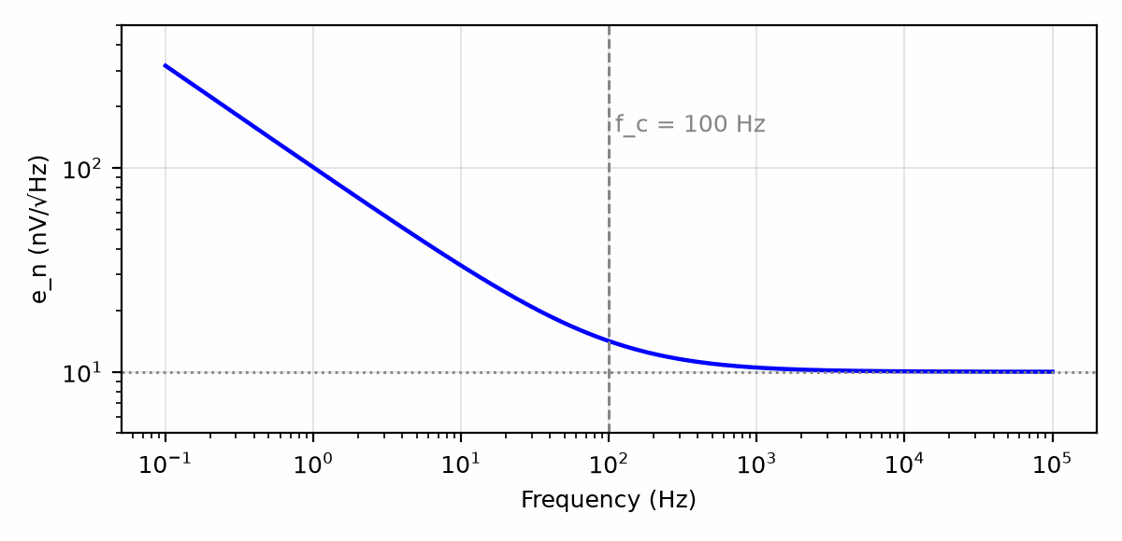
Figure 14.1 — Voltage noise density of the declared example op-amp: flat at 10 nV/√Hz above a 100 Hz corner, rising as 1/√f below it.

14.5 Matching the Op-Amp to the Source
For a given source resistance, the op-amp's voltage noise matters most when Rₛ is small, and its current noise matters most when Rₛ is large, because i_n Rₛ grows in proportion to Rₛ while the source's own Johnson noise grows only as √Rₛ. The two op-amp terms are equal at Rₛ = e_n/i_n, sometimes called the optimum source resistance; for the op-amp of Worked Example 14.1 that is 10 kΩ. A low-impedance source such as a 50 Ω microphone wants a low-e_n bipolar part. A megohm source such as a pH electrode or a photodiode's feedback network wants a CMOS or JFET part with femtoamp current noise, even if its e_n is several times higher.
Key Idea
Add noise as powers, and fix the largest term first. A density becomes a voltage only after multiplying by the square root of the noise bandwidth, which is 1.571 × f₋₃dB for a single pole.
Common Misconception
Making every resistor smaller is not always quieter. Below the point where e_n dominates, smaller resistors buy nothing, while they load the op-amp's output and the source more heavily. And the source's own resistance is usually fixed by physics, not by the designer; the right move is to pick the op-amp that suits that resistance.
From the Bench
Noise sources add as root-sum-of-squares, so the largest one dominates: halve the biggest contributor before touching the small ones. Remember that resistors make noise too; a 10 kΩ resistor produces about 13 nV/√Hz at room temperature, more than many low-noise op-amps, so a low-noise amplifier surrounded by large resistors has been wasted.

Practice Problems
- Find the Johnson noise density of a 4.7 kΩ resistor at 290 K.
- Three uncorrelated noise sources of 6, 8, and 2 nV/√Hz act at the same node. Find their combined density.
- An amplifier has an output noise density of 50 nV/√Hz and a single-pole −3 dB bandwidth of 20 kHz. Find its rms output noise.
- An op-amp has e_n = 5 nV/√Hz and i_n = 0.5 pA/√Hz. Find the source resistance at which its voltage and current noise contributions are equal.
- An op-amp has e_n = 8 nV/√Hz with a 1/f corner at 1 kHz. Find its rms noise from 0.1 Hz to 10 Hz.
- Explain in a sentence or two why a low-noise bipolar op-amp can be noisier than a CMOS op-amp when the source resistance is 10 MΩ.

What You’ll Actually Use
Everyday working tools
- Adding noise sources in quadrature.
- Resistor thermal noise, √(4kTR).
- Noise bandwidth of a filter.
Mostly for exams and deeper study
- Noise-figure theory and correlated noise sources.

Chapter 15 — DC Errors: Offset, Bias Current, and Drift
A thermocouple produces about 41 µV per degree. Feed it to an op-amp with 2 mV of input offset and you have a thermometer that is wrong by fifty degrees before you have even switched it on. DC errors are small numbers that matter enormously at the bottom of the scale.
Where you meet this: Thermocouple and strain-gauge amplifiers, precision current sensing, integrators, and any measurement near zero.
Ground the input of a high-gain amplifier and measure its output with a good voltmeter. It will not read zero. It may read a few millivolts, or a few hundred, and the reading will creep as the board warms up. None of this is noise in the sense of Chapter 14; it is a steady error that would be there on every measurement, and it can be budgeted, predicted, and in many cases removed. This chapter builds that budget from three datasheet numbers: input offset voltage, input bias current, and their temperature drift.

15.1 Input Offset Voltage
The two input transistors of an op-amp are never perfectly matched. The result behaves exactly as if a small DC voltage source, the input offset voltage V_os, were connected in series with one input of an otherwise perfect op-amp. Because it sits at the input, it is amplified by the noise gain from Chapter 13, not by the signal gain:
V_out,os = V_os × NG = V_os × (1 + R_f / Rᵢₙ)
General-purpose bipolar op-amps have V_os in the range of 1 to 5 mV. Precision bipolar parts reach tens of microvolts. Zero-drift parts, which continually measure and cancel their own offset, reach a few microvolts.
Worked Example 15.1
Problem: An inverting amplifier with gain −100 uses R_f = 1 MΩ and Rᵢₙ = 10 kΩ. The op-amp has V_os = 2 mV. Find the output error with the input grounded.
Solution: The noise gain is 1 + 1M/10k = 101. The output error is 2 mV × 101 = 202 mV. Against a full-scale output of perhaps 10 V, that is 2% of full scale before a signal has been applied, far larger than any gain error from Chapter 11.

15.2 Input Bias Current and Offset Current
Bipolar input transistors need base current to operate, and even FET inputs leak a little through their protection structures. This input bias current I_b flows into (or out of) both inputs. At the inverting input it has only one path, through the resistors connected there, and because the inverting node is held near ground, the current flows through R_f and appears at the output as a voltage I_b R_f.
The standard compensation adds a resistor R_c in series with the non-inverting input, equal to the parallel combination R_f ‖ Rᵢₙ. The bias current at that pin then produces a matching drop, and the two errors cancel to the extent that the two bias currents are equal. What remains is set by their difference, the input offset current I_os, which is typically a fraction of I_b:
Uncompensated: V_out,b ≈ I_b R_f Compensated: V_out,b ≈ I_os R_f
Worked Example 15.2
Problem: The amplifier of Worked Example 15.1 uses an op-amp with I_b = 80 nA and I_os = 20 nA. Find the output error from bias current without compensation, the value of R_c, and the error with compensation.
Solution: Without compensation, 80 nA × 1 MΩ = 80 mV. The compensation resistor is R_c = 1M ‖ 10k ≈ 9.90 kΩ, and a standard 9.76 kΩ or 10 kΩ part is close enough. With it, the error falls to I_os R_f = 20 nA × 1 MΩ = 20 mV. Chapter 5 pointed out the price: R_c adds its own Johnson noise, about 12.6 nV/√Hz at 290 K, which a low-noise design may not be able to afford. A bypass capacitor across R_c removes that noise at signal frequencies while keeping the DC correction.

15.3 Drift and the Worst-Case Budget
Both V_os and I_b change with temperature, and an initial offset can be trimmed out at the factory, while drift cannot. Datasheets give the offset drift as a coefficient in µV/°C, and bias current often roughly doubles for every 10 °C rise in a FET-input part. A worst-case DC budget adds all contributions with their signs aligned, because nothing guarantees they will cancel:
V_out,err = NG × (V_os + ΔT · dV_os/dT) + I_os R_f + (other terms)
Worked Example 15.3
Problem: The op-amp of Worked Example 15.1 has an offset drift of 10 µV/°C. The board operates from 25 °C to 75 °C. Assuming the initial 2 mV offset has been trimmed out at 25 °C and bias-current compensation is used, estimate the worst-case output error at 75 °C, ignoring the drift of I_os.
Solution: The offset drifts by 10 µV/°C × 50 °C = 0.5 mV, which appears at the output as 0.5 mV × 101 ≈ 50.5 mV. The compensated bias-current term adds 20 mV. The worst-case total is about 70.5 mV. Trimming removed the larger initial term, but drift and offset current together still produce about 0.7% of a 10 V full scale.
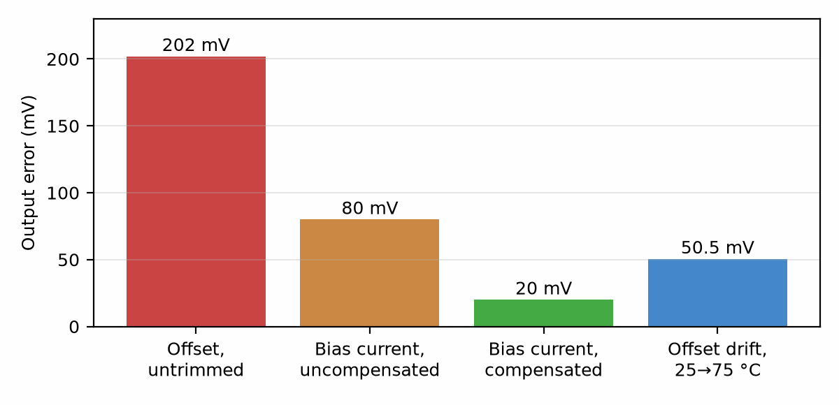
Figure 15.1 — The DC error budget of Worked Examples 15.1 to 15.3: untrimmed offset dominates, bias-current compensation removes three quarters of its term, and drift remains after trimming.

15.4 Supply and Common-Mode Terms
Two more specifications behave like extra offset. The power-supply rejection ratio (PSRR) states how much a change in supply voltage shifts the input offset; 80 dB means 100 mV of supply ripple acts like 10 µV at the input. The common-mode rejection ratio from Chapter 12 does the same for common-mode voltage. Both terms are usually small in an inverting stage and should be checked in a follower or a stage running from a noisy supply.

15.5 The Integrator Is a DC-Error Magnifier
An ideal integrator, a capacitor C in the feedback path and a resistor R at the input, has infinite gain at DC. Its noise gain at DC is therefore infinite too, and any offset or bias current does not produce a fixed error; it produces a ramp.
Worked Example 15.4
Problem: An integrator uses R = 100 kΩ and C = 1 µF with an op-amp having V_os = 1 mV and I_b = 10 nA. With the input grounded, how fast does the output drift, and how long until it reaches a 10 V rail?
Solution: The offset forces a current V_os/R = 1 mV/100 kΩ = 10 nA through R, which must flow through C. The bias current adds another 10 nA in the worst-case direction. The capacitor charges at I/C = 20 nA/1 µF = 0.02 V/s. The output reaches 10 V in 10/0.02 = 500 s, a little over eight minutes. A practical integrator therefore needs one of three things: a reset switch across C, a large resistor across C that gives it a finite DC gain, or an outer feedback loop, such as the control loops of Chapter 17, that keeps its input centered.
Key Idea
An offset is amplified by the noise gain, and a bias current is converted to voltage by the feedback resistor. Trim the initial value if you must, but budget the drift, because drift is what remains in the field.
Common Misconception
A zero-drift op-amp does not make the whole circuit drift-free. Its own V_os may be a microvolt, but resistor ratios, thermocouple voltages at dissimilar-metal junctions on the board, and leakage across a dirty board surface can each add tens of microvolts. In precision work the op-amp is often no longer the dominant DC error once it has been chosen well.

15.6 Removing What Cannot Be Budgeted
When a signal carries no information at DC, AC coupling removes every DC error at once: a series capacitor and a resistor to ground form a high-pass filter whose corner sits below the lowest frequency of interest. When DC matters, the remaining choices are a better op-amp, smaller resistors where bias current dominates, a trim performed at calibration, or a chopper or auto-zero technique that measures the error periodically and subtracts it. Each choice trades cost, noise, or bandwidth; the budget tells you which term to attack first.

15.7 Reading an Op-Amp Datasheet
A datasheet is a contract with fine print. Its first table, the absolute maximum ratings, says what the part survives, not what it does: a part held at an absolute maximum is outside its specifications. The electrical characteristics tables say what it does, and every line holds only under the test conditions printed above the table and beside the line. The three columns are not equal. A minimum or maximum is guaranteed, by test or by design and characterization. A typical value is the middle of a distribution, and the curves that follow the tables are typical too: Microchip's own note on its curves says they are a statistical summary of a limited number of samples and are not tested or guaranteed.
Here is the MCP6002 of the reader lab, read line by line from the Microchip MCP6001/2/4 datasheet (DS20001733L). The common test conditions are T_A = 25 °C, V_DD = 1.8 V to 5.5 V, V_CM = V_DD/2, R_L = 10 kΩ to V_DD/2, and, for the AC lines, C_L = 60 pF. Each line names the part of this book that uses it.
- Input offset voltage V_OS: ±4.5 mV maximum at V_CM = V_SS. There is no typical value in the table, only a histogram among the curves. Section 15.1.
- Offset drift: ±2.0 µV/°C typical from −40 °C to +125 °C, with no maximum, so a worst-case budget (Section 15.3) needs margin or a measurement.
- Input bias current I_B: ±1 pA typical at 25 °C, 19 pA at 85 °C, and 1100 pA at 125 °C. A CMOS input's bias current is the leakage of its protection diodes, and it rises more than a thousandfold over that range. Input offset current: ±1 pA typical. Section 15.2.
- Input impedance: 10¹³ Ω in parallel with 6 pF common-mode and 3 pF differential. The capacitances set the noise gain of the photodiode amplifier of Section 13.7.
- Common-mode input range: V_SS − 0.3 V to V_DD + 0.3 V. The application section adds the fine print: two input pairs hand over near V_CM = V_DD − 1.1 V, and the offset changes there.
- CMRR: 60 dB minimum, 76 dB typical, for V_CM from −0.3 V to 5.3 V at V_DD = 5 V. PSRR: 86 dB typical. Section 15.4.
- Open-loop gain A_OL: 88 dB minimum, 112 dB typical, measured with the output between 0.3 V and V_DD − 0.3 V. Chapter 11.
- Output swing: within 25 mV of each rail at V_DD = 5.5 V with R_L = 10 kΩ; a curve shows the headroom growing with output current. Short-circuit current: ±6 mA at 1.8 V and ±23 mA at 5.5 V. Chapter 1.
- Gain-bandwidth product 1.0 MHz typical; phase margin 90° typical at a gain of +1 with 60 pF, and, on the front page, 45° with 500 pF. Chapter 13 and Section 12.4.
- Slew rate 0.6 V/µs typical. Section 13.5.
- Noise: 28 nV/√Hz at 1 kHz, 6.1 µV peak to peak from 0.1 Hz to 10 Hz, and 0.6 fA/√Hz of current noise. Chapter 14.
- Quiescent current: 100 µA typical, 50 µA to 170 µA, per amplifier.
Three habits follow. Design with the minimum and maximum, and treat typical as the likely case, not the promise. Check that the test conditions match your circuit: the CMRR above is specified over a 5.6 V common-mode span, and A_OL with the output away from the rails. And where a line has only a typical value, budget margin or measure it. Book 9, Test and Measurement Instruments, shows how each of these lines is measured on the bench.
Worked Example 15.5
Problem: An MCP6002 follower buffers a sensor whose output spans 0.3 V to 4.7 V on a 5 V supply, into a 12-bit converter with a 5 V reference. Using the datasheet limits, find the worst-case input error from offset and common-mode rejection, in LSB, and compare with the typical CMRR.
Solution: The offset is at most 4.5 mV. The common-mode voltage moves by 4.7 − 0.3 = 4.4 V, and a CMRR of 60 dB is a ratio of 1000, so the offset can change by 4.4 V/1000 = 4.4 mV across the span. Worst case: 4.5 + 4.4 = 8.9 mV. One LSB is 5 V/4096 = 1.22 mV, so the error is 7.3 LSB. With the typical 76 dB (a ratio of 6310) the CMRR term is only 0.70 mV, six times smaller: the guarantee and the typical part are far apart. The span also crosses V_DD − 1.1 V = 3.9 V, where the input stages hand over and the offset steps. A one-point calibration (Section 15.6) removes the fixed offset; it does not remove the CMRR term or the step.

15.8 From Datasheet to SPICE: the Macromodel
Nearly every op-amp has a vendor SPICE model, and every vendor warns, as Microchip does in this datasheet, that the model is an initial design tool whose results must be checked against the datasheet. The model is not the chip's hundreds of transistors. It is a macromodel: a small circuit of ideal sources, resistors, and capacitors whose values are chosen so that its behavior at the pins reproduces the datasheet. The idea goes back to Boyle, Cohn, Pederson, and Solomon in 1974, who built one from a handful of transistors and controlled sources; modern vendor models are mostly behavioral, but every element value is still computed from a datasheet line (Figure 15.2).
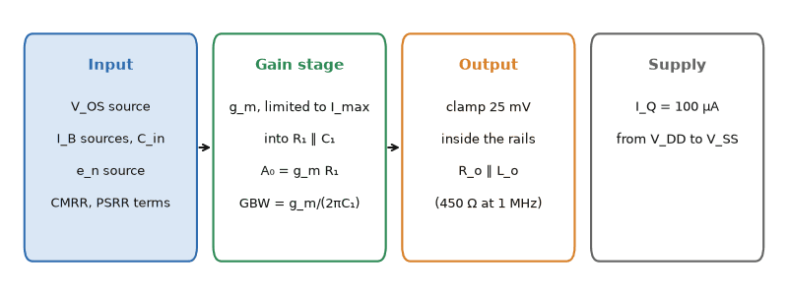
Figure 15.2 — The blocks of an op-amp macromodel. Each element is set from one datasheet line, at that line's test conditions; the values are fitted, not measured inside the chip.
The mapping from datasheet line to model element:
- V_OS: a DC voltage source in series with one input. A model of the typical part often sets it to zero, so the simulation shows no offset unless you add the maximum yourself.
- I_B and I_OS: current sources at the inputs. Input impedance: resistors and capacitors at the inputs.
- CMRR and PSRR: controlled sources that add V_CM/CMRR and the supply change divided by PSRR to the input.
- A_OL and GBW: a transconductance g_m driving R₁ in parallel with C₁, so that A₀ = g_mR₁, the dominant pole is f_p = 1/(2πR₁C₁), and GBW = g_m/(2πC₁).
- Slew rate: a limit on the transconductor's current, I_max = SR × C₁, because C₁ can charge no faster than I_max/C₁.
- Phase margin and capacitive-load behavior: further poles, or an output impedance that forms a pole with the load.
- Output swing and short-circuit current: clamps and current limits at the output. Noise: voltage and current noise sources. Quiescent current: a current source between the supply pins.
Worked Example 15.6
Problem: Build the gain stage of a macromodel from the MCP6002's typical A_OL = 112 dB, GBW = 1 MHz, and SR = 0.6 V/µs, using g_m = 1 mS. Then choose the output resistance R_o so that the phase margin with 500 pF is 45°, as the datasheet states.
Solution: A₀ = 10^(112/20) = 398,000, so R₁ = A₀/g_m = 398 MΩ. C₁ = g_m/(2π × GBW) = 1 mS/(2π × 1 MHz) = 159 pF, which puts the dominant pole at f_p = GBW/A₀ = 2.5 Hz. I_max = SR × C₁ = 0.6 V/µs × 159 pF = 95.5 µA. With the dominant pole alone the loop phase is −90° near crossover; R_o and C_L add a pole at f_o = 1/(2πR_oC_L). For 45° of margin that pole must sit at the crossover, and there the loop magnitude is (GBW/f)/√2 = 1, so the crossover falls to GBW/√2 = 707 kHz. R_o = 1/(2π × 707 kHz × 500 pF) = 450 Ω. The choice of g_m was arbitrary; any value gives the same behavior at the pins, which is a reminder that these elements describe the datasheet, not the silicon.
The complete model, written for ngspice 44 and run there, is below, followed by the deck that measures its open-loop response. The names follow the blocks of Figure 15.2; the parameters in the first line are the fitted values. The output resistance is shorted at DC by L_o, because 450 Ω is a fit to the 500 pF phase margin, not a real DC output resistance, and a real 450 Ω would contradict the 25 mV output-swing line.
* OPFIT: a datasheet-fitted behavioral op-amp macromodel (Book 2, Section 15.8).
* Fitted to the TYPICAL values of the Microchip MCP6001/2/4 datasheet (DS20001733L):
* AOL 112 dB, GBWP 1 MHz, SR 0.6 V/us, PM 90 deg (G=+1, CL=60 pF), PM 45 deg with 500 pF (fixes RO = 450 ohm),
* CMRR 76 dB, PSRR 86 dB, eni 28 nV/rtHz (white part only), output 25 mV from the rails, IQ 100 uA.
* A fit, not the part: valid near VDD = 5 V, 25 C, light loads, VCM below VDD - 1.1 V.
.subckt OPFIT inp inn vdd vss out params: VOS=0 GM=1m AOL=398107 GBW=1Meg SR=0.6Meg RO=450 CMRR=6310 PSRR=19953
.param R1={AOL/GM} C1={GM/(6.2831853*GBW)} IMAX={SR*GM/(6.2831853*GBW)}
* input: offset source, noise from a 47.3k resistor copied into the input by Enz (gives 28 nV/rtHz at 27 C, the ngspice default), bias currents, input capacitances
Rn nz vss 47.3k
Enz inp inp0 nz vss 1
Vos inp0 inp1 DC {VOS}
Ibp inp1 vss DC 1p
Ibn inn vss DC 1p
Cdif inp1 inn 3p
Ccmp inp1 vss 6p
Ccmn inn vss 6p
* common-mode and supply rejection as an extra input-referred error
Bcm inx inp1 V = ((V(inp1)+V(inn))/2)/{CMRR} + V(vdd,vss)/{PSRR}
* mid-supply reference
Rm1 vdd mid 1Meg
Rm2 mid vss 1Meg
* gain stage: transconductance with a smooth slew limit into R1 || C1
Bgm mid n1 I = {IMAX}*tanh({GM}*V(inx,inn)/{IMAX})
R1 n1 mid {R1}
C1 n1 mid {C1}
* output stage: clamp 25 mV inside the rails, open-loop output impedance
Bout n2 vss V = max(min(V(n1,vss), V(vdd,vss)-0.025), 0.025)
Ro n2 out {RO}
* the 450 ohm is a fitted high-frequency value: Lo shorts it at DC so the swing spec still holds
Lo n2 out {RO/(6.2831853*10k)}
* quiescent current
Iq vdd vss DC 100u
.ends OPFIT
* open-loop gain and phase, follower biased at 2.5 V, CL = 60 pF and 500 pF
.include opfit.lib
.param CL=60p
Vdd vdd 0 5
Vin inp 0 DC 2.5 AC 1
X1 inp inn vdd 0 out OPFIT
Lfb out inn 1T
Cg inn 0 1
Cl out 0 {CL}
Rl out 0 10k
.control
ac dec 50 0.01 100Meg
let phd = 180/pi*vp(out)
meas ac fu when vdb(out)=0
meas ac ph find phd at=fu
meas ac a0 find vdb(out) at=0.1
wrdata ol_60p.txt vdb(out) phd
alterparam CL = 500p
reset
ac dec 50 0.01 100Meg
let phd = 180/pi*vp(out)
meas ac fu5 when vdb(out)=0
meas ac ph5 find phd at=fu5
wrdata ol_500p.txt vdb(out) phd
.endc
.end
Run in ngspice, the model reproduces what it was fitted to (Figure 15.3): A_OL = 112.0 dB, a unity-gain crossover of 947 kHz (the 10 kΩ load pulls it slightly below 1 MHz), 46° of phase margin with 500 pF, an output swing to 25 mV from each rail, and 28.0 nV/√Hz at 1 kHz. Its slew rate comes out at 0.58 V/µs, because the smooth limit rounds the corners of the step. It also predicts 81° of phase margin with 60 pF, where the datasheet says 90°. One output resistance cannot satisfy both load conditions, because the real output stage is not a resistor; the fit is right where it was made and approximate elsewhere.
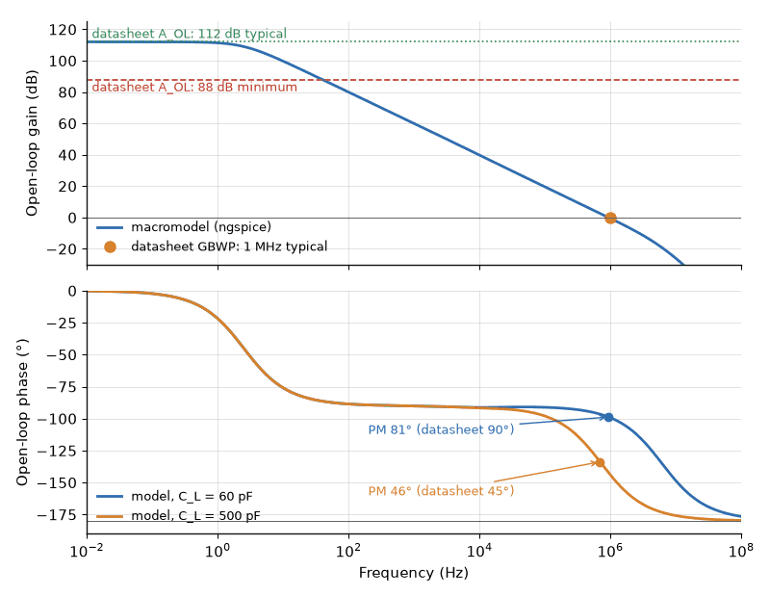
Figure 15.3 — The fitted macromodel (ngspice) against the MCP6002 datasheet. Top: open-loop gain with the typical and minimum A_OL and the 1 MHz GBWP. Bottom: open-loop phase with 60 pF and 500 pF loads; the model meets the 45° point it was fitted to and misses the 90° point by 9°.
Key Idea
A SPICE model is not the physical truth. It is a best fit of a few parameters to the model's equations, and the equations are approximations. The parameters are fitting constants, valid only over the conditions they were fitted to. Inside that range a good model is excellent; outside it, it is confidently wrong, and nothing in the simulation warns you.
This model knows nothing it was not fitted to. Outside its range:
- Low-frequency noise: it has no 1/f noise, so from 0.1 Hz to 10 Hz it integrates to 88 nV rms, about 0.58 µV peak to peak, ten times less than the datasheet's 6.1 µV.
- Temperature: its bias current is 1 pA at every temperature; the datasheet gives 1100 pA at 125 °C.
- Common-mode range: it has no input-stage handover near V_DD − 1.1 V, so it shows no offset step there.
- Load and overload: its output headroom does not grow with current, it has no short-circuit limit, and it does not model recovery from saturation.
- Spread: it is one typical part, with V_OS = 0, A_OL = 112 dB, and GBW = 1 MHz; a real batch spreads around those values within the datasheet limits.
Vendor models are more complete than this one, but each has the same kind of boundary, usually stated in a note like Microchip's. Check the model against the datasheet curves your circuit depends on, and measure what the datasheet does not give (Book 9). Book 3, Semiconductor Physics and Devices, takes the same approach to the diode, transistor, and MOSFET models built into SPICE itself.
From the Bench
A perfect simulation fails on the bench most often outside the model's fitted range. A photodiode amplifier with R_f = 10 MΩ, simulated with a typical model at 25 °C, shows a 10 µV error from 1 pA of bias current. In a sealed enclosure at 85 °C the datasheet's 19 pA gives 0.19 mV, and at 125 °C its 1100 pA gives 11 mV. A slow sensor buffer simulates at 0.6 µV peak to peak of noise and shows 6 µV on the scope, because the model has no 1/f noise. Before trusting a simulation, list the conditions your circuit will see, temperature, common-mode range, load, frequency band, and the worst part rather than the typical one, and compare each with the conditions the model was fitted to. Where they differ, the bench is the reference, not the simulator.
From the Bench
Build the DC error budget before choosing the part: offset, bias current through the source resistance, drift over temperature, and CMRR and PSRR terms, each in microvolts referred to the input. Many designs then reveal one dominant term, which tells you whether you need a precision op-amp, a zero-drift (chopper) part or a calibration step.
On the Job
Applications engineers at analog chip companies write the datasheets and the SPICE models in this section, and spend much of their time answering one question from customers: why does the circuit not do what the simulation showed? The answer is usually a test condition, a typical value read as a guarantee, or a model used outside its range. Engineers who can read a datasheet line by line, and check a model against it, are trusted with the parts that matter.

Practice Problems
- A non-inverting amplifier has gain 50 and its op-amp has V_os = 3 mV. Find the output offset.
- An inverting amplifier uses R_f = 470 kΩ and Rᵢₙ = 4.7 kΩ. Find the value of the bias-current compensation resistor.
- The amplifier of the previous problem uses an op-amp with I_b = 50 nA and I_os = 5 nA. Find the output error from bias current with and without compensation.
- An op-amp has an offset drift of 3 µV/°C and is used at a noise gain of 200 over a 60 °C range. Find the drift-induced output change.
- An op-amp has PSRR = 90 dB, and its supply carries 200 mV of ripple. Find the equivalent input-referred offset.
- An integrator uses R = 1 MΩ and C = 100 nF with an op-amp of V_os = 0.5 mV and negligible bias current. Find the output drift rate with the input grounded.
- An MCP6002 follower sees its common-mode input change from 0.5 V to 3.5 V. Using the datasheet's CMRR of 60 dB minimum and 76 dB typical, find the worst-case and typical change in the input-referred offset.
- An op-amp datasheet gives A_OL = 100 dB, GBW = 10 MHz, and SR = 8 V/µs. With g_m = 1 mS, find R₁, C₁, the dominant pole, and I_max for the gain stage of its macromodel.

What You’ll Actually Use
Everyday working tools
- Offset, bias current and drift as input-referred errors.
- Worst-case error budgets.
- Reading an op-amp datasheet by its limits and test conditions, and checking a vendor macromodel against it.
Mostly for exams and deeper study
- Statistical (RSS) error budgeting for production.

Chapter 16 — Comparators, Hysteresis, and Open-Collector Outputs
A thermostat that clicks on and off ten times a second as the room crosses the set point is the comparator problem in miniature. The cure is the same in both: two thresholds instead of one.
Where you meet this: Button inputs, zero-crossing detectors, battery-low indicators, overcurrent trips and open-drain interrupt lines.
Somewhere in almost every analog system, a continuous voltage has to become a decision: the battery is low, the temperature is too high, the zero crossing has arrived. A comparator makes that decision. Chapter 5 introduced it as an op-amp-shaped part with the feedback deliberately left off. This chapter shows why a bare comparator misbehaves on slow, noisy signals, how a little positive feedback fixes that, and how the open-collector output lets several comparators, or several chips, share one wire.

16.1 What Makes a Comparator Different
A comparator and an op-amp share a symbol and a differential input, but they are optimized for opposite jobs. An op-amp is internally compensated so that it stays stable under negative feedback, and that compensation slows it down. A comparator has no such compensation; its output stage is designed to swing hard from one logic level to the other and to recover quickly when the inputs cross. Its datasheet quotes a propagation delay, the time from the input crossing to the output changing state, rather than a gain-bandwidth product.
An op-amp can be used as a comparator in a pinch, and for slow signals it often works. Its weaknesses are real, though: it is slow to come out of saturation, its output levels may not match logic thresholds, and some op-amps have input protection diodes between the two inputs that conduct when a large differential voltage appears, which a comparator's inputs are built to tolerate.
Common Misconception
Never put linear negative feedback around a comparator to "make it more accurate." Its lack of compensation means it will oscillate. The only feedback a comparator should see is the positive feedback of Section 16.3, which pushes it further in the direction it is already going.

16.2 Chatter on a Slow Edge
Feed a comparator a slowly rising voltage that carries even a few millivolts of noise. As the signal approaches the threshold, the noise carries it back and forth across the threshold many times, and the output toggles every time. Instead of one clean transition, the output produces a burst of edges, called chatter. A counter connected to that output counts dozens of events instead of one; a motor driver switches on and off at kilohertz rates and heats up. Faster comparators make chatter worse, because they respond to every crossing.

16.3 Hysteresis: Two Thresholds Instead of One
The cure is to give the comparator two thresholds: a higher one that the input must rise above to switch the output high, and a lower one that it must fall below to switch it back. Once the output has switched, noise smaller than the gap between the thresholds cannot switch it back. A circuit with this behavior is called a Schmitt trigger, and the gap is its hysteresis.
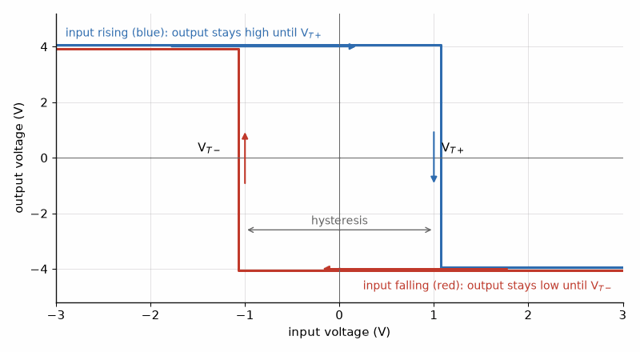
Figure 16.1 — An inverting Schmitt trigger has two thresholds, so noise smaller than the gap between them can’t make the output chatter.
A comparator acquires hysteresis through positive feedback. In the inverting form, the input signal drives the inverting pin, and a divider sets the non-inverting pin from both a reference voltage V_ref (through R₁) and the comparator's own output (through R₂). Superposition gives the non-inverting pin's voltage, which is the threshold:
V_th = V_ref · R₂/(R₁ + R₂) + V_out · R₁/(R₁ + R₂)
Because the threshold depends on the output, it has two values, one for each output state. The hysteresis is the output swing multiplied by R₁/(R₁ + R₂).
Worked Example 16.1
Problem: A comparator runs from 5 V with a push-pull output that swings 0 V to 5 V. The input drives the inverting pin. The non-inverting pin connects to V_ref = 2.5 V through R₁ = 10 kΩ and to the output through R₂ = 100 kΩ. Find the two thresholds and the hysteresis.
Solution: The reference contributes 2.5 × 100k/110k ≈ 2.273 V. The output contributes 5 × 10k/110k ≈ 0.455 V when high and 0 V when low. With the output high (input below threshold), the upper threshold is 2.273 + 0.455 ≈ 2.727 V; the input must rise above this to drive the output low. With the output low, the lower threshold is 2.273 V; the input must fall below this to drive the output high again. The hysteresis is 0.455 V, centered on 2.5 V. Noise up to about 0.45 V peak-to-peak can no longer cause chatter.
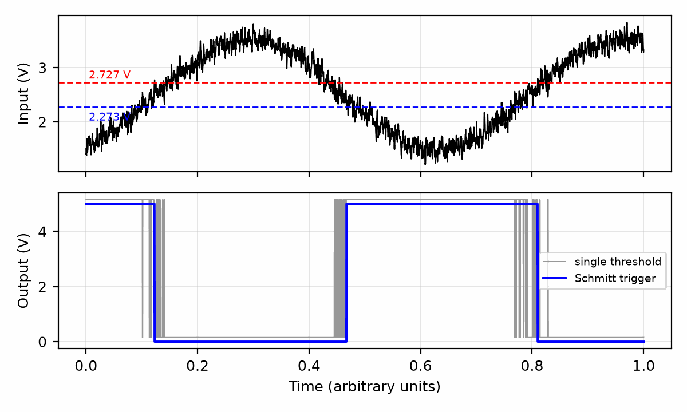
Figure 16.2 — Top: a slow, noisy input with the two thresholds of Worked Example 16.1. Bottom: the Schmitt trigger output switches once per crossing, where a single-threshold comparator would chatter.
Key Idea
Hysteresis trades a small, known threshold error for immunity to noise smaller than the gap. Size the gap larger than the peak-to-peak noise on the input and smaller than the error the application can tolerate.
Positive feedback is entirely legitimate here. The golden rules do not apply; the two inputs are not at the same voltage except at the instant of switching, and nothing in the circuit is trying to make them so. This is the same sign change Chapter 11 warned about, used deliberately to make the circuit decisive.

16.4 The Open-Collector Output
Many comparators, including the long-lived LM311 and LM339 families, have an open-collector output: a single transistor that can pull the output pin low, and nothing that can pull it high. The high level is supplied by an external pull-up resistor to whatever supply the next circuit needs. That one feature makes the part a level translator for free: a comparator powered from 12 V can drive a 3.3 V logic input by returning its pull-up to 3.3 V. CMOS parts with the same arrangement are called open-drain.
The pull-up resistor sets two competing quantities. When the transistor is on, the resistor wastes a current V_pu/R_pu. When it turns off, the resistor alone must charge the capacitance of the wire and the inputs on it, so the rising edge is an RC exponential with time constant R_pu C, and its 10% to 90% rise time is 2.2 R_pu C. Falling edges are fast, because the transistor sinks current actively.
Worked Example 16.2
Problem: An open-drain output pulls up to 3.3 V through 4.7 kΩ into a line with 50 pF of total capacitance. Find the rise time and the low-state current. What largest pull-up gives a 100 ns rise time, and what current does it draw?
Solution: The time constant is 4.7 kΩ × 50 pF = 235 ns, so the rise time is 2.2 × 235 ns ≈ 517 ns. The low-state current is 3.3 V/4.7 kΩ ≈ 0.70 mA, ignoring the small output-low voltage. For a 100 ns rise, R_pu ≤ 100 ns/(2.2 × 50 pF) ≈ 909 Ω; a standard 820 Ω part gives 90 ns and draws about 4.0 mA when low. Check that the output transistor can sink that current while still meeting the receiver's maximum input-low voltage; the datasheet's V_OL at a stated sink current is the number to compare.

16.5 Wired Logic on One Line
Several open-collector or open-drain outputs can share one pull-up resistor and one wire. If any output turns on, the line goes low; the line is high only if every output is off. For active-low signals, such as a "fault" line that any of several monitors may assert, this is a wired-OR: the line is asserted if any monitor asserts it. In positive logic the same connection is a wired-AND. Push-pull outputs cannot be connected this way, because one driving high while another drives low creates a short circuit between the supply and ground through two output stages.
The arrangement is common far beyond comparators. Interrupt lines shared by several chips use it, and the I²C bus uses it for both its clock and data lines, so any device can hold the clock low to stretch it. The rise-time arithmetic of Worked Example 16.2 is exactly what limits how fast such a bus can run and how many devices it can carry.

16.6 The Window Comparator
Two comparators with open-collector outputs tied together make a window comparator: one fires when the input exceeds an upper limit, the other when it falls below a lower limit, and the shared line goes low if either fires. A supply monitor that flags both overvoltage and undervoltage on one pin is built exactly this way, with the two thresholds set by a single resistor ladder from a reference.

16.7 Debouncing a Switch: the Refrigerator Door
A mechanical switch does not close once. Its contacts bounce for a few milliseconds, and a logic input or a microcontroller interrupt sees a burst of edges. The Smart Refrigerator Monitor of Book 1 counts door openings, and every bounce would count as one. The analog-first cure is an RC filter feeding a Schmitt-trigger input such as a 74HC14: the capacitor smooths the bounces, and the hysteresis of this chapter turns the slow, smoothed edge into one clean transition.
With the switch to ground and a pull-up R to V_DD, closing the switch discharges C almost at once through the contacts, and each bounce open lets it recharge only slowly through R. The output must not change until the capacitor charges from near 0 V to the Schmitt input's upper threshold. With that threshold at a fraction k of V_DD, the time is t = RC ln(1/(1 − k)), and it must exceed the longest bounce. Schmitt inputs typically put the upper threshold between about 0.6 and 0.7 of V_DD; design with the lower value, which gives the shorter time.
Worked Example 16.3
Problem: The refrigerator door switch bounces for up to 5 ms. It pulls a 10 kΩ pull-up low, and the Schmitt input's upper threshold lies between 0.6 and 0.7 of V_DD. Choose C.
Solution: With k = 0.6, t = RC ln(1/0.4) = 0.916 RC, so RC ≥ 5 ms/0.916 = 5.46 ms and C ≥ 5.46 ms/10 kΩ = 546 nF. Choose 680 nF: RC = 6.8 ms and t = 6.2 ms. Check: at k = 0.7, t = 6.8 ms × ln(1/0.3) = 8.2 ms; both exceed 5 ms, and a response delay under 10 ms is invisible for a door counter. A microcontroller can debounce in code instead (Book 8, Chapter 6, GPIO, Buttons, and Interrupts), but the RC and Schmitt version needs no code and spares the interrupt input a burst of edges.
Key Idea
Debounce with an RC that outlasts the bounce and a Schmitt input that turns the slow edge into one clean transition: t = RC ln(1/(1 − k)) must exceed the longest bounce.

16.8 Reading a Comparator Datasheet and Its Model
The LM393 of the reader lab, read from the TI datasheet (SLCS005AH, LM393 without suffix) at V_CC = 5 V and 25 °C, has a shorter list than an op-amp, and almost every line matters:
- Input offset voltage V_IO: 2 mV typical, 5 mV maximum, and 9 mV maximum over 0 °C to 70 °C. It is the threshold error before anything else.
- Input bias current I_IB: −25 nA typical, −250 nA maximum, −400 nA over temperature. The minus sign means the current flows out of the pin, from the PNP input stage, into whatever resistance drives it. Input offset current: 5 nA typical, 50 nA maximum.
- Common-mode input range: 0 V to V_CC − 1.5 V, and V_CC − 2 V over temperature. Only one input needs to be inside it for a correct output.
- Voltage gain A_VD: 50 V/mV minimum, 200 V/mV typical, so a millivolt of input is enough to switch the output.
- Output: an open collector. Leakage when off: 0.1 nA typical at 5 V and 1 µA maximum at 30 V over temperature. Low level V_OL: 130 mV typical and 400 mV maximum at 4 mA; at least 6 mA of sink current at V_OL = 1.5 V.
- Supply current: 0.45 mA typical, 1 mA maximum, for the package.
- Response time: 1.3 µs typical for a 100 mV input step with 5 mV of overdrive, and 0.3 µs for a TTL-level step, with 5.1 kΩ to 5 V and 15 pF, measured to the moment the output crosses 1.4 V. There is no maximum.
Overdrive is how far the input goes past the threshold. A small overdrive drives the internal stages with a small current, so they take longer to swing; a large one saturates them, and the delay stops improving. A single response time is one point on that curve, valid at its own overdrive and load.
Worked Example 16.4
Problem: An LM393 compares a sensor voltage with a reference made by a 100 kΩ/100 kΩ divider from 5 V. Find the worst-case threshold error from offset and bias current at 25 °C and over 0 °C to 70 °C, and repeat at 25 °C for a 10 kΩ/10 kΩ divider.
Solution: The divider's Thévenin resistance is 100 kΩ ∥ 100 kΩ = 50 kΩ. Up to 250 nA flows out of the pin into it, raising the reference by 250 nA × 50 kΩ = 12.5 mV. Adding the 5 mV offset gives 17.5 mV of worst-case threshold error at 25 °C. Over 0 °C to 70 °C it is 400 nA × 50 kΩ + 9 mV = 29 mV. With 10 kΩ/10 kΩ the Thévenin resistance is 5 kΩ, the bias term falls to 1.25 mV, and the total is 6.25 mV, set mostly by the offset. Hysteresis (Section 16.3) deals with noise; accuracy comes from these two lines.
A comparator macromodel has the same input sources as an op-amp model, a gain stage whose current is limited and whose capacitor is clamped, and an output switch whose on-resistance is fitted to V_OL: 130 mV/4 mA = 32.5 Ω. Its timing has two parameters, the current limit I_max and the capacitor C, and the datasheet gives exactly two timing points. Fitting both, with ngspice, gives the model below. Figure 16.3 shows the result: the model meets 1.30 µs at 5 mV of overdrive and 0.30 µs for the TTL step, and predicts 3.2 µs at 2 mV. That prediction is the model extrapolating; no datasheet line constrains it, and it should be checked against the datasheet's response-time curves or measured (Book 9) before a design depends on it.
* CMPFIT: a datasheet-fitted behavioral comparator macromodel (Book 2, Section 16.8).
* Fitted to TYPICAL values of the TI LM393 datasheet (SLCS005AH, LM393 without suffix, VCC = 5 V, 25 C):
* VIO 2 mV typ (5 mV max), IIB 25 nA typ flowing out of the inputs, response time 1.3 us
* (100 mV step, 5 mV overdrive) and 0.3 us (TTL step), RL = 5.1k to 5 V, CL = 15 pF,
* VOL 130 mV at 4 mA, output leakage 0.1 nA, ICC 0.45 mA.
* Two timing parameters (IMAX, C) are fitted to the two response times; nothing else about timing is known.
.subckt CMPFIT inp inn vcc gnd out params: VIO=0 GM=0.470m IMAX=10u C=5.66p
Vio inp inp1 DC {VIO}
Iop inp1 vcc DC 25n
Ion inn vcc DC 25n
* integrating stage: limited transconductance into C, clamped at +-0.5 V
Bgm 0 n1 I = {IMAX}*tanh({GM}*V(inp1,inn)/{IMAX})
Cint n1 0 {C}
Rint n1 0 425Meg
Dcl1 n1 cp DCL
Vcp cp 0 0.5
Dcl2 cm n1 DCL
Vcm cm 0 -0.5
.model DCL D(IS=1e-15 N=0.05)
* open-collector output: switch on when n1 < 0 (output low), Ron fitted to VOL = 130 mV at 4 mA
Sout out gnd 0 n1 SOC
.model SOC SW(VT=0 VH=0 RON=32.5 ROFF=50G)
Icc vcc gnd DC 0.45m
.ends CMPFIT
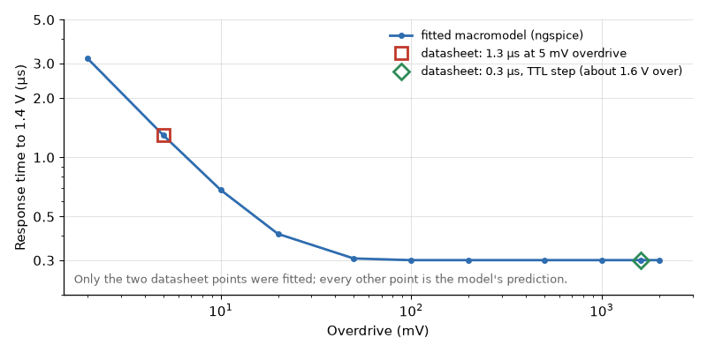
Figure 16.3 — Response time against overdrive for the fitted LM393 macromodel (ngspice), with the two datasheet points it was fitted to. Between and beyond them the curve is the model's prediction, not a datasheet value.
Key Idea
Two datasheet points can fit two model parameters, and no more. Everything else the model says is a prediction, as good as the model's equations and no better.
From the Bench
Don't use an op-amp as a comparator unless its datasheet allows it. Many op-amps recover slowly from saturation, and some have input clamp diodes that misbehave with large differential voltages. Comparators are cheap and much faster out of saturation. And always add some hysteresis; a few millivolts stops chatter on slow, noisy edges.

Practice Problems
- A Schmitt trigger has a 0 V to 3.3 V output, V_ref = 1.65 V, R₁ = 10 kΩ, and R₂ = 220 kΩ, connected as in Worked Example 16.1. Find the two thresholds and the hysteresis.
- Using the same circuit form with a 0 V to 5 V output, choose R₂ for 100 mV of hysteresis if R₁ = 1 kΩ.
- An open-collector line has a 10 kΩ pull-up and 100 pF of capacitance. Find its 10% to 90% rise time.
- The output transistor of a comparator can sink 4 mA while meeting V_OL ≤ 0.4 V. What is the smallest pull-up allowed to a 5 V rail?
- Explain in a sentence or two why a faster comparator chatters more readily than a slower one on a slow, noisy input.
- Explain why two push-pull outputs must not be tied together, while two open-drain outputs may be.
- A rain-gauge reed switch on the Smart Weather Station bounces for up to 2 ms. With a 47 kΩ pull-up and a worst-case Schmitt threshold of 0.6 V_DD, find the smallest capacitor and choose a standard value with margin.
- An LM393's reference comes from a 47 kΩ/47 kΩ divider on 5 V. Find the worst-case threshold error at 25 °C from V_IO and I_IB, using the datasheet maxima of 5 mV and 250 nA.
- An LM393 output is pulled up to 3.3 V. Using the datasheet's 1 µA maximum output leakage and its 400 mV maximum V_OL at 4 mA, find the range of pull-up resistance that keeps the high level within 0.1 V of 3.3 V and the low level at or below 0.4 V.

What You’ll Actually Use
Everyday working tools
- Hysteresis thresholds from a resistor divider.
- Open-drain outputs with pull-ups and wired logic.
- RC plus Schmitt debouncing, t = RC ln(1/(1 − k)).
- Comparator datasheet lines: offset, bias current through the divider, and response time at your overdrive.
Mostly for exams and deeper study
- Comparator propagation-delay modeling.

Chapter 17 — Feedback Control: Plant, Sensor, and Controller
Cruise control holds your car at 65 mph uphill and downhill without anyone working the pedal. It measures speed, compares it with the target and adjusts the throttle, many times a second. That loop, and how to keep it from overshooting or hunting, is the subject of this chapter.
Where you meet this: Motor drives, heaters and ovens, battery chargers, power supplies and every closed-loop actuator.
Chapter 11 wrapped an amplifier in a loop and found that the loop made the result depend on a precise resistor instead of an imprecise gain. A control system uses exactly the same idea on something that is not an amplifier at all: a motor, a heater, a joint of a robot arm. The forward path now contains a physical machine whose behavior is slow, uncertain, and sometimes nonlinear, and the feedback path contains a sensor. This chapter introduces the vocabulary and works one plant from start to finish, so that Chapters 18 and 19 can shape and then digitize the controller.

17.1 The Blocks and Their Names
The thing being controlled is the plant, P(s). The quantity you want, a speed or a temperature or an angle, is the reference r. A sensor H measures the actual output y. The controller C(s) takes the error e = r − Hy and computes a command u for an actuator, such as a motor driver or a heater switch. Disturbances d, such as a load torque or a draft of cold air, push on the plant from outside. With a perfect sensor, H = 1, the closed-loop relations take the same form as Chapter 11:
Y/R = C P / (1 + C P), Y/D = P / (1 + C P)
The first expression says the output follows the reference when the loop gain C P is large. The second says the loop divides the effect of a disturbance by the same 1 + C P. Tracking and disturbance rejection are two faces of one quantity.
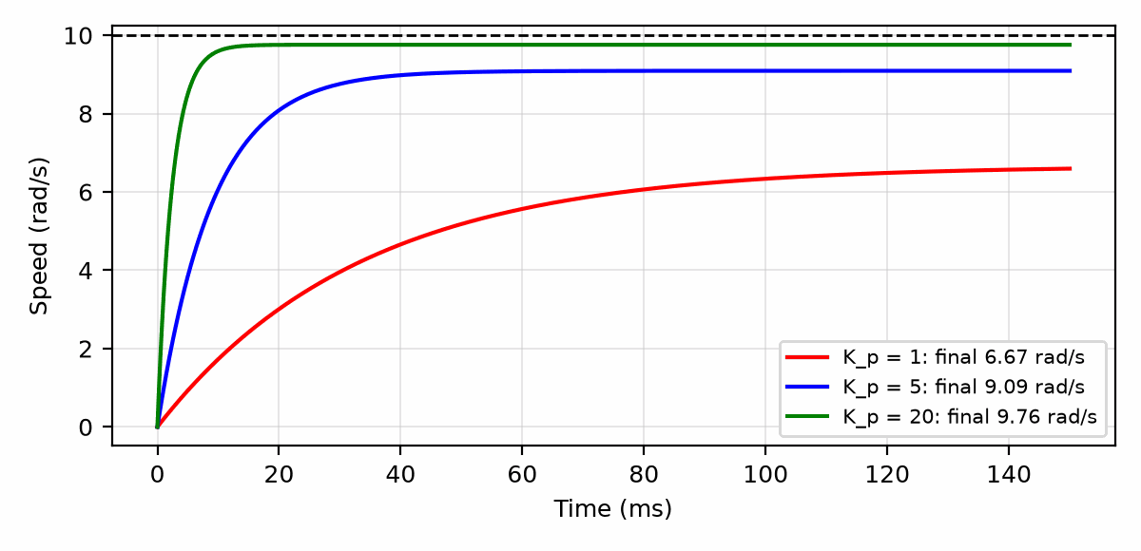
Figure 17.1 — Step responses of the motor-speed loop of this chapter under proportional control with K_p = 1, 5, and 20, against a 10 rad/s reference. Higher gain is faster and closer, but never exact. Linear model; the ±12 V actuator limit is ignored here.

17.2 A First-Order Plant
Many plants, over the range a controller cares about, behave like a single time constant. A small DC motor driven by a voltage, viewed from voltage to shaft speed, is one: apply a step of voltage and the speed rises exponentially toward a final value. Two numbers describe it, a DC gain K and a time constant τ:
P(s) = K / (τ s + 1)
For this chapter, declare a motor with K = 2 (rad/s)/V and τ = 0.1 s, driven from a supply that can provide at most ±12 V. Open-loop, 5 V gives a final speed of 10 rad/s, reached to 63% after 0.1 s and to within 2% after about 0.4 s. Open-loop control works only as well as K is known; if the load or the temperature changes K by 20%, the speed changes by 20%.

17.3 Proportional Control
The simplest controller multiplies the error by a gain: u = K_p e. Substituting into the closed-loop expression gives another first-order system, with a new DC gain and a new time constant:
Y/R = K_p K / (τ s + 1 + K_p K): DC gain K_p K/(1 + K_p K), τ_cl = τ/(1 + K_p K)
The product K_p K is the loop gain at DC. The steady-state error, the fraction of the reference the output never reaches, is 1/(1 + K_p K).
Worked Example 17.1
Problem: For the declared motor, find the steady-state error and the closed-loop time constant for K_p = 1, 5, and 20 V per rad/s. For a 10 rad/s step, find the initial drive voltage each gain demands.
Solution: For K_p = 1, the loop gain is 2, the steady-state error is 1/3, or 33%, and τ_cl = 0.1/3 ≈ 33 ms. For K_p = 5, the loop gain is 10, the error is 1/11 ≈ 9.1%, and τ_cl ≈ 9.1 ms. For K_p = 20, the loop gain is 40, the error is 1/41 ≈ 2.4%, and τ_cl ≈ 2.4 ms. At the instant of the step the error is the full 10 rad/s, so the command is K_p × 10: 10 V, 50 V, and 200 V. Only the first is inside the ±12 V the driver can supply. The other two saturate the driver, and the response is slower than the linear formula predicts until the error has shrunk enough for the command to come back inside the rails.
Key Idea
Proportional gain shortens the time constant and shrinks the steady-state error by the same factor, 1 + K_p K, but never removes the error. Large gains also demand large initial commands, so actuator saturation, not the formula, often sets the real response time.

17.4 Integral Action Removes the Error
The steady error remains because a proportional controller needs a nonzero error to produce the nonzero command that holds the motor at speed. An integrator removes that need. If the controller adds a term proportional to the accumulated error, u = K_p e + K_i ∫e dt, then the only way for the output to be steady is for the error to be zero; any remaining error keeps the integral growing. A loop with one integrator in it is called a type-1 system, and it tracks a constant reference with zero steady-state error regardless of the exact value of K.
The cost is phase. An integrator contributes 90 degrees of lag at every frequency, and the loop can ring or oscillate if that lag is not managed. Chapter 18 shows how a PI controller places its zero so that the integrator's lag disappears at the frequencies that matter for stability.

17.5 Disturbances and the Load
Suppose a constant load torque slows the motor by an amount equivalent to a 2 V reduction in drive. Open-loop, the speed drops by K × 2 = 4 rad/s. Under proportional control with K_p = 5, the loop divides that by 1 + K_p K = 11, and the speed drops by about 0.36 rad/s. With an integrator, the speed returns exactly to the reference once the integral has built up the extra 2 V of command. This is often the stronger argument for feedback: a controller that tracks a reference well is useful, but a controller that holds the reference while the world pushes on the plant is what a machine needs.

17.6 How Fast Must the Loop Be?
A loop can correct only disturbances slower than its own bandwidth. As a first estimate, the closed-loop bandwidth in radians per second is 1/τ_cl; for K_p = 5 above, that is 110 rad/s, or about 17.5 Hz. The sensor must measure faster than this, and if the controller is digital, as almost every modern controller is, it must sample considerably faster. Chapter 19 makes that precise. Chapter 10 has already declared the joint tracker of this series, a 200 Hz loop with a 5 ms period; a common rule of thumb places such a loop's closed-loop bandwidth between about a tenth and a thirtieth of its sample rate, so roughly 7 Hz to 20 Hz.
Common Misconception
A higher-bandwidth controller is not automatically a better one. It amplifies sensor noise further, demands more from the actuator, and approaches the frequencies where the plant model, with its single time constant, stops describing the real machine: shaft resonances, gear backlash, and sensor delay all live up there. A controller should be fast enough to reject the disturbances that matter and no faster.

17.7 Limits and the Safety Layer
Every real actuator saturates, every real sensor can fail, and every model is wrong somewhere. A control loop therefore sits inside limits it cannot override: current limits in the driver, position limits on the joint, and in a robot an independent safety controller that can stop motion regardless of what the loop commands. Chapter 10 stated the rule for this series and it bears repeating here: when the safety layer and the controller disagree, the safety layer wins.
From the Bench
Before tuning a loop, measure the plant open-loop: apply a small step to the actuator and record the response. The gain and time constant you read off that one plot are worth more than any model, and they reveal saturations, dead bands and delays that a model forgets.

Practice Problems
- A heater has a first-order thermal response with K = 5 °C per watt and τ = 300 s. Under proportional control with K_p = 2 W/°C, find the steady-state error as a fraction of the reference and the closed-loop time constant.
- For the declared motor, what K_p gives a steady-state error of 1%?
- For the gain found in the previous problem, find the initial command for a 5 rad/s step and state whether the ±12 V driver saturates.
- A disturbance would shift a plant's output by 3 units open-loop. Under proportional control with a loop gain of 29, by how much does it shift the output?
- Explain in a sentence or two why an integrator in the controller removes the steady-state error to a constant reference.
- A digital loop samples at 1 kHz. Using the rule of thumb in Section 17.6, estimate the range of closed-loop bandwidth it can support.

What You’ll Actually Use
Everyday working tools
- Proportional control and its steady-state error.
- Integral action to remove the error.
- Loop speed relative to the plant.
Mostly for exams and deeper study
- Formal stability proofs for the general case.

Chapter 18 — PID, Lead, and Lag: Shaping the Loop
PID control runs much of the world's industrial machinery, and most PID loops in the field are tuned by someone adjusting three numbers until it 'looks right'. This chapter explains what each number actually does, so you can be the person who knows.
Where you meet this: Temperature controllers, motor and servo drives, drones, process control, and firmware loops everywhere.
Chapter 17 ended with two facts in tension. Proportional control alone leaves a steady error, and an integrator that removes the error adds phase lag that can make the loop ring. Compensation is the art of resolving that tension: adding gain where the loop needs accuracy, removing phase lag where the loop needs stability, and doing both with a small number of parts or lines of code whose settings have physical units. This chapter covers the PID controller, its cousins the lead and lag networks, and the margins that tell you how close a loop is to oscillation.

18.1 PID as Three Knobs with Units
The PID controller computes its command from the present error, its accumulated history, and its rate of change:
u(t) = K_p e(t) + K_i ∫ e dt + K_d de/dt
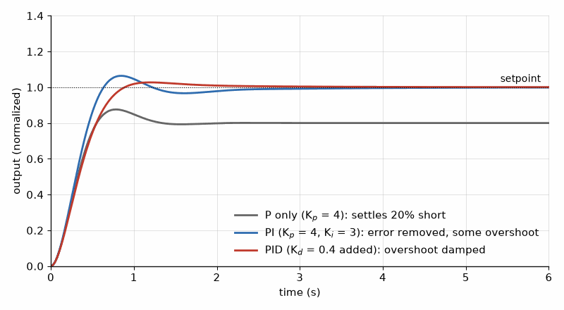
Figure 18.1 — Three controllers on the same plant. Proportional alone settles short of the target; adding integral action removes the error at the cost of overshoot; derivative action calms the overshoot.
For the motor of Chapter 17, the error is in rad/s and the command in volts, so K_p is in V per rad/s, K_i in V per rad (because integrating rad/s gives rad), and K_d in V·s² per rad. Writing the units down is not pedantry: it shows immediately that the three gains cannot be compared with one another, and it catches the common mistake of tuning K_i in one sample period's units and then changing the sample rate. An equivalent form, popular in industrial controllers, uses an integral time T_i = K_p/K_i and a derivative time T_d = K_d/K_p, both in seconds.

18.2 Designing a PI Controller by Cancellation
For a first-order plant P = K/(τs + 1), a PI controller C = K_p (1 + 1/(T_i s)) can be written as K_p (T_i s + 1)/(T_i s). Its zero sits at s = −1/T_i. Choosing T_i = τ places that zero exactly on the plant's pole, and the two cancel. The loop gain then collapses to a pure integrator:
L(s) = C P = K_p K / (τ s), crossover ω_c = K_p K / τ
A loop gain that is a pure integrator crosses unity once, with exactly 90 degrees of lag, so its phase margin is 90 degrees, and the closed loop is a first-order system with time constant 1/ω_c. The design reduces to one decision: how fast should the loop be?
Worked Example 18.1
Problem: Design a PI controller for the declared motor (K = 2 (rad/s)/V, τ = 0.1 s) that gives a closed-loop time constant of 10 ms with zero steady-state error. State K_p, T_i, and K_i with units, and the crossover frequency.
Solution: Cancel the plant pole: T_i = τ = 0.1 s. A closed-loop time constant of 10 ms means ω_c = 100 rad/s. From ω_c = K_p K/τ, K_p = 100 × 0.1/2 = 5 V per rad/s. Then K_i = K_p/T_i = 5/0.1 = 50 V per rad. The crossover is 100 rad/s, about 15.9 Hz, inside the 7 Hz to 20 Hz range Chapter 17 suggested for a 200 Hz digital loop. With an ideal continuous controller the step response has no overshoot. Chapter 19 will show what sampling does to that promise.

18.3 Derivative Action and Its Filter
The derivative term reacts to how fast the error is changing, and so it acts before the error has grown: it adds damping. In the frequency domain it is a zero that adds up to 90 degrees of phase lead. Two practical rules make it usable. First, a pure derivative has gain that rises without limit with frequency, so it amplifies sensor noise; every real implementation adds a low-pass filter, commonly with a corner five to twenty times above the derivative's own corner 1/T_d. Second, applying the derivative to the measurement rather than to the error avoids a huge spike in command each time the reference steps, because a step reference has an infinite derivative but a real measurement does not.

18.4 The Lead Compensator
A lead network is a derivative with its gain capped: a zero at ω_z followed by a pole at a higher frequency ω_p = α ω_z. Between them, the network's phase rises to a maximum and falls again:
C_lead(s) = (1 + s/ω_z)/(1 + s/ω_p), φ_max = arcsin((α − 1)/(α + 1)) at ω = √(ω_z ω_p)
At the frequency of maximum phase, the network's gain is √α. The usual design places that frequency at the desired crossover, so the phase arrives exactly where the loop needs it, and then lowers the proportional gain by √α so that the crossover does not move.
Worked Example 18.2
Problem: A loop has 25 degrees of phase margin at its 50 rad/s crossover and needs about 60 degrees. Design a lead network centered on the crossover.
Solution: The loop needs about 35 degrees more phase, plus a few degrees of allowance because the network will shift the crossover slightly; aim for about 37 degrees. Solving arcsin((α − 1)/(α + 1)) = 37° gives α ≈ 4: with α = 4, φ_max = arcsin(3/5) ≈ 36.9°. Center the network at 50 rad/s: ω_z = 50/√4 = 25 rad/s and ω_p = 50 × √4 = 100 rad/s. The network adds a gain of √4 = 2 (6 dB) at 50 rad/s, so reduce K_p by a factor of 2 to keep the crossover in place. A larger α, such as 10 for 55 degrees, would buy more phase at the cost of a high-frequency gain ten times its low-frequency gain instead of four times, and therefore 2.5 times more sensor noise in the command.
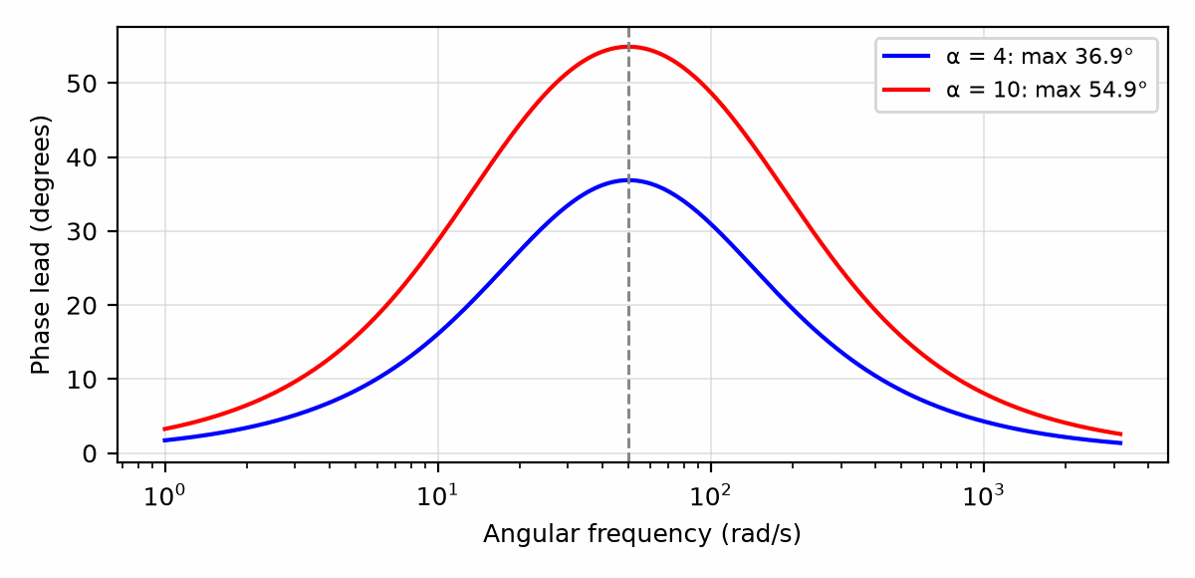
Figure 18.2 — Phase contributed by lead networks with α = 4 and α = 10, centered on 50 rad/s: the maximum lead sits at the geometric mean of the zero and the pole.

18.5 The Lag Compensator
A lag network is the mirror image: a pole at a low frequency followed by a zero a factor α higher. It raises the low-frequency gain by α, reducing steady-state error, while leaving the gain near crossover unchanged. Its cost is a small amount of phase lag that leaks up toward crossover; placing the zero a decade or more below the crossover keeps that cost to a few degrees. A PI controller is the limiting case of a lag network whose pole has moved all the way to zero frequency.

18.6 Margins You Can Measure
Two numbers summarize how close a loop is to oscillation. The phase margin is 180 degrees plus the phase of the loop gain at the frequency where its magnitude is 1. The gain margin is how much the loop gain could rise, at the frequency where its phase reaches −180 degrees, before its magnitude reached 1. Both can be read from a Bode plot of the loop gain, and both can be measured on the bench by injecting a small sine wave at a summing point inside the loop and comparing the signals on either side of it.
Phase margin also predicts the step response. For a loop whose closed-loop behavior is dominated by two poles, a phase margin of about 60 degrees corresponds to a damping ratio near 0.6 and an overshoot near 9%. About 45 degrees corresponds to an overshoot near 23%, and about 33 degrees to an overshoot near 37%. These are the numbers behind Chapter 5's rule of thumb that 60 degrees is comfortable and 30 degrees rings.
Key Idea
A loop's phase margin is its distance from oscillation, and it predicts overshoot. Aim for 45 to 60 degrees, and measure it on the real hardware, because the real plant always has delay and resonance the model left out.

18.7 Integrator Windup and the Safety Layer
When the actuator saturates, the loop is effectively open: the command no longer changes with the controller output. The integrator does not know that. It keeps accumulating error for as long as the plant lags behind, and by the time the plant catches up, the integral holds a large stored value that drives the output well past the reference before it can unwind. This is windup, and it turns a well-damped loop into one that overshoots badly after every large step.
Anti-windup stops the integrator from accumulating while the actuator is saturated. The simplest form, conditional integration, freezes the integral whenever the computed command is outside the actuator's limits. A second form, back-calculation, feeds the difference between computed and applied command back into the integrator to bleed it down. Either way the principle is the one Chapter 17 ended with: the physical limit is the authority, and the controller must respect what the actuator and the safety layer actually did, not what it asked for.
Worked Example 18.3
Problem: The PI controller of Worked Example 18.1 receives a 10 rad/s step. Its initial command is K_p × 10 = 50 V, but the driver saturates at 12 V. Describe what happens with and without anti-windup.
Solution: In both cases the motor accelerates at full drive, approaching the 24 rad/s that 12 V would eventually give, and crosses 10 rad/s after about τ ln(24/14) ≈ 54 ms. Without anti-windup, the integrator has meanwhile accumulated about 0.25 rad of error, worth K_i × 0.25 ≈ 12 V of stored command, which holds the drive near the rail after the crossing; a simulation of the continuous loop shows the speed overshooting to about 11.1 rad/s, 11% above the reference, before the integral unwinds. With the PI design's own 90-degree phase margin, that overshoot is caused entirely by windup. With conditional integration, the integral stays near zero during saturation, the command leaves the rail as soon as the proportional term alone falls below 12 V, and the speed approaches 10 rad/s without overshoot.
Common Misconception
Windup is not a tuning problem. Lowering K_i reduces the overshoot only by making the loop slower everywhere, including in normal small-signal operation. The correct fix is structural: tell the integrator when the actuator is saturated.
From the Bench
Always include anti-windup. When the actuator saturates, for example a heater at full power, the integrator keeps accumulating error and then overshoots badly once the output recovers. Clamp the integrator, or stop integrating while the output is saturated. Filter the derivative term too, or it will amplify sensor noise into the actuator.
On the Job
Most PID loops in industry are tuned on site, not on paper. Motor-drive and process-control engineers log a step response, adjust the gains, check the margins, and record the result; the gains end up in a parameter file that a technician can change, not in the source code. The paper design of this chapter tells them where to start and what a physically plausible result looks like.

Practice Problems
- State the units of K_p, K_i, and K_d for a temperature loop whose error is in °C and whose command is in watts.
- Design a PI controller for a plant with K = 0.5 (m/s)/V and τ = 0.2 s, giving a crossover of 40 rad/s. Find T_i, K_p, and K_i.
- Find the maximum phase lead and the frequency at which it occurs for a lead network with ω_z = 10 rad/s and ω_p = 90 rad/s.
- A loop needs 45 degrees of added phase. Find the α of a lead network that provides it at its center frequency.
- A loop's measured phase at its unity-gain frequency is −128°. Find the phase margin and estimate whether the step response will overshoot noticeably.
- Explain in a sentence or two why the derivative term is often applied to the measurement rather than to the error.

What You’ll Actually Use
Everyday working tools
- The three PID terms and their units.
- Anti-windup and derivative filtering.
- Lead for phase margin, lag for low-frequency gain.
Mostly for exams and deeper study
- Analytic PID design methods beyond pole-zero cancellation.

Chapter 19 — Digital Control: Sample, Hold, and Delay
Move a control loop from analog parts into a microcontroller and it often gets slightly worse, not better. The cause is delay: sampling and holding the output costs on average half a sample period, plus whatever time the code takes. This chapter puts a number on that cost.
Where you meet this: Firmware control loops in motor drives, power supplies, drones and anything with a microcontroller in the loop.
The controllers of Chapters 17 and 18 were written as continuous equations, and for decades they were built that way, from op-amps, resistors, and capacitors. Today nearly every controller is a few lines of code running in a microcontroller: it reads a sensor through an analog-to-digital converter, computes a command, and writes it to a PWM generator or a digital-to-analog converter, then waits for the next tick. The arithmetic is easy. What changes is time. The controller sees the plant only at sampling instants, and it answers each one late. This chapter shows how to account for that lateness and how to translate a continuous design into code that behaves like it.

19.1 What Happens in One Period
In each sampling period T, a digital controller does four things in order: the converter samples the sensor, the processor computes the new command, the output stage updates, and the output holds that value until the next update. That last step is called a zero-order hold, because it holds a constant (zeroth-order) value between samples, and it turns a sequence of numbers into a staircase waveform the plant can respond to.
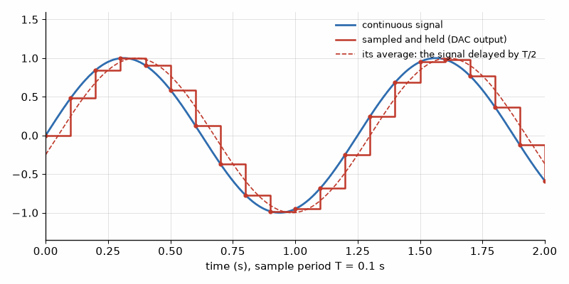
Figure 19.1 — A sampled-and-held output follows the signal in steps, and on average it lags by half a sample period. That half period is phase the loop has to pay for.
Seen from the plant, the staircase is a delayed copy of the smooth command a continuous controller would have produced. A zero-order hold contributes, on average, half a sample period of delay. If the processor computes during one period and applies the result at the start of the next, as is common because it makes the timing deterministic, that adds a full period more.
Total delay ≈ T/2 (hold) + T_compute, phase lag at ω: φ = ω × delay (radians)
A delay is unlike a pole. It does not reduce the gain at all, and its phase lag grows without limit as frequency rises. That is why sampling sets a ceiling on how fast a loop can be, however clever the controller.

19.2 The Phase Cost at Crossover
Worked Example 19.1
Problem: The PI design of Worked Example 18.1 (crossover 100 rad/s, phase margin 90° in continuous form) is implemented on the 5 ms joint tracker declared in Chapter 10, with the command applied one period after the sample is taken. Estimate the total delay, the phase lost at crossover, and the remaining phase margin. Repeat for a crossover of 50 rad/s.
Solution: The hold contributes 2.5 ms and the one-period compute delay 5 ms, a total of 7.5 ms. At 100 rad/s the lag is 100 × 0.0075 = 0.75 rad ≈ 43°, so the phase margin falls from 90° to about 47°. A simulation of the sampled loop shows a step overshoot of about 27%, somewhat more than Chapter 18's two-pole estimate for 47° would suggest, because a delay is not a pole. Halving the crossover to 50 rad/s (K_p = 2.5 V per rad/s, K_i = 25 V per rad) halves the lag to about 21°, leaves a margin near 69°, and the simulated step shows no measurable overshoot, at the cost of a loop half as fast.
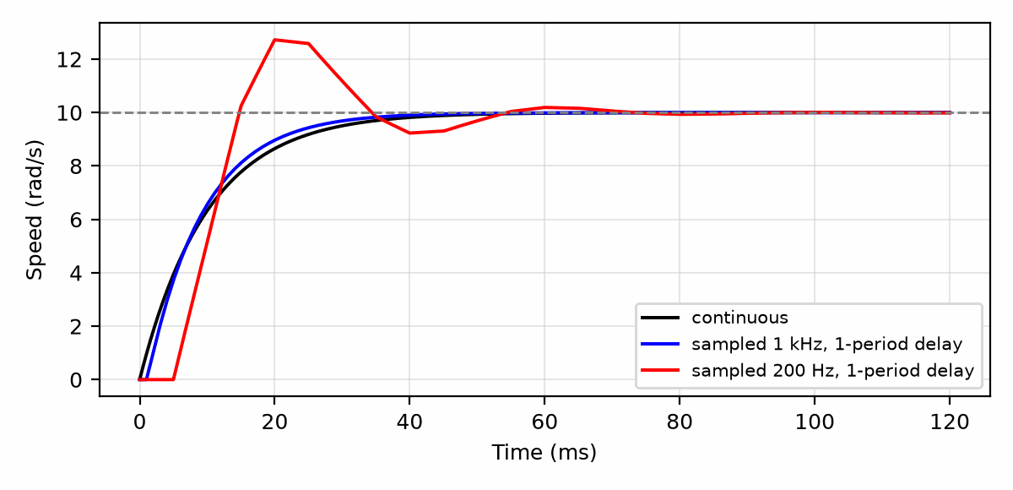
Figure 19.2 — Step response of the motor-speed PI loop (crossover 100 rad/s): continuous controller, sampled at 1 kHz, and sampled at 200 Hz with a one-period compute delay.
Key Idea
Every sample period of delay costs ω_c × T radians of phase at crossover. Choose the sample rate from the phase margin you can afford to lose, not from the Nyquist rate of the signal.
The example also shows where the rule of thumb in Chapter 17 comes from. A 200 Hz loop is 1257 rad/s in angular terms. A crossover of 100 rad/s is about one twelfth of that, and it already costs over 40 degrees. Faster sampling is the direct cure: at 1 kHz with the same one-period compute delay, the total delay is 1.5 ms, the lag at 100 rad/s is under 9 degrees, and the response in Figure 19.2 is nearly indistinguishable from the continuous one.

19.3 Turning the PI Controller into Code
The continuous PI law u = K_p e + K_i ∫e dt becomes a difference equation by replacing the integral with a running sum. The simplest, called the backward-Euler form, adds the present error times the period to an accumulator each sample:
I[k] = I[k−1] + T · e[k], u[k] = K_p · e[k] + K_i · I[k]
In code this is three lines: compute the error, update the accumulator, compute and clamp the command. The clamp is where anti-windup from Chapter 18 lives: if the computed command exceeds the actuator's limit, apply the limit and do not add this sample's error to the accumulator. Book 8, Firmware and Software for Electronics, writes this loop as real C and MicroPython, and Section 19.6 gives the hardware numbers that decide whether it can keep up.
Worked Example 19.2
Problem: Implement the PI controller of Worked Example 18.1 (K_p = 5 V per rad/s, K_i = 50 V per rad) at T = 5 ms. The present error is 0.4 rad/s, and the accumulator holds 0.30 rad. Find the new accumulator value and the command.
Solution: The accumulator gains T × e = 0.005 × 0.4 = 0.002 rad, becoming 0.302 rad. The command is 5 × 0.4 + 50 × 0.302 = 2.0 + 15.1 = 17.1 V. That exceeds the 12 V driver limit, so the output is clamped to 12 V and, under conditional integration, the accumulator is restored to 0.30 rad. Note that K_i T = 0.25 V per (rad/s) is the gain the integrator applies to one sample's error. If the sample rate changes, K_i T changes with it unless K_i is stated in true per-second units, which is why this book writes the gains with units.

19.4 Other Discretizations
Backward Euler is simple and robust, but it is only an approximation of the continuous integral, and its accuracy depends on the sample rate being well above the loop's bandwidth. The trapezoidal, or Tustin, method averages the present and previous error in the integral, which matches the continuous frequency response more closely up to about a quarter of the sample rate. For the derivative term, the backward difference (e[k] − e[k−1])/T is the usual choice, always followed by the low-pass filter Chapter 18 recommended, because a raw difference of noisy samples is mostly noise.

19.5 The Converter Front End
The analog-to-digital converter sees only the samples, and the sampling theorem applies: any signal content above half the sample rate folds back into the band below it as an alias. A motor current sensor sampled at 200 Hz that carries a 10 kHz PWM ripple can alias that ripple into a slow wobble the controller dutifully tries to correct. An analog anti-alias filter before the converter prevents this, but its phase lag at the loop's crossover is part of the loop too and must be counted along with the hold and the compute delay. A common compromise samples the sensor much faster than the control rate, averages several samples in software, and runs the control law on the average.
Quantization matters as well. A 12-bit converter spanning a 24 rad/s speed range resolves steps of about 6 mrad/s. An integrator acting on errors smaller than one step can drift between two codes and produce a small, persistent oscillation called a limit cycle. Adequate resolution, a small dead band around zero error, or added dither are the usual remedies.
Common Misconception
Sampling well above the Nyquist rate of the signal is not enough for a control loop. Nyquist guarantees that a signal can be reconstructed from its samples, not that a loop acting on those samples is stable. A loop's sample rate is set by the phase delay it can tolerate at crossover, and that usually means ten to thirty times the closed-loop bandwidth.

19.6 PID on a Pico or a Teensy
The code version of the loop runs on the boards of the reader lab. A Raspberry Pi Pico (the RP2040: two Cortex-M0+ cores at 125 MHz by default, with no floating-point unit) and a Teensy 4.x (a 600 MHz Cortex-M7 with a hardware floating-point unit) bracket the range. The Pico is inexpensive and has unusually flexible PWM and programmable I/O blocks; the Teensy has the speed to run a floating-point PID loop at tens of kilohertz. The ESP32-S3 of Book 1's kit sits between them. Three hardware choices decide how well any of them closes a loop.
- A fixed sample rate. Run the control law from a hardware timer interrupt, not from a loop that runs as fast as it can; the delay arithmetic of Section 19.2 assumes a constant T.
- PWM resolution. A PWM counter clocked at f_clk and wrapping at f_PWM has f_clk/f_PWM steps. On the RP2040 at 125 MHz, a 20 kHz PWM, above hearing, has 6250 steps, about 12.6 bits; at 100 kHz it has only 1250.
- Arithmetic. Without a floating-point unit, floating-point math runs in software and is many times slower; fixed-point integer math is the usual answer on the Pico, and Book 8's chapter Fixed-Point Math and DSP (Chapter 15) shows how.
The code itself, the timer setup, the interrupt, and the clamp and anti-windup of Section 19.3 written as real C and MicroPython, lives in Book 8: Chapter 7 for timers and PWM, Chapter 12 for structuring a control loop as a state machine, and Chapter 13 for running it beside other tasks under a real-time operating system. This book keeps the numbers that decide whether that code can work.
Worked Example 19.3
Problem: A motor loop on a Pico uses 20 kHz PWM from the 125 MHz system clock into a 12 V H-bridge, and runs a PI law at 1 kHz from a timer interrupt. The law takes 60 µs in software floating point. Find the number of PWM steps and the average voltage per step, the fraction of each control period the law consumes, and the loop delay and its phase cost at a 20 Hz crossover.
Solution: Steps = 125 MHz/20 kHz = 6250, which is log₂ 6250 = 12.6 bits, and each step is 12 V/6250 = 1.92 mV of average bridge voltage. The control period is 1 ms, so the law uses 60/1000 = 6% of it. The command is applied at the next sample, so the delay is T/2 + T = 1.5 ms, which costs 2π × 20 × 0.0015 = 0.19 rad, about 11°, at a 20 Hz crossover. Check: a Teensy 4.x with its floating-point unit runs the same law in a few microseconds, so the loop could sample ten times faster and cut the delay to 0.15 ms; on the Pico the same gain comes from fixed-point code.
Key Idea
A digital loop needs a fixed sample rate, enough PWM steps, and arithmetic that fits inside the period. Count all three before writing the code.
From the Bench
As a rule of thumb, sample a control loop at least 10 to 20 times faster than its crossover frequency, and keep the computation delay fixed by updating the output at a fixed point in each period. Jitter in the loop timing behaves like a varying delay, and it is easier to prevent than to analyze.

Practice Problems
- A digital loop samples at 500 Hz and applies its output one period after sampling. Find the total delay, including the hold.
- For the loop of the previous problem, find the phase lag at a crossover of 60 rad/s.
- A continuous design has 70° of phase margin at a crossover of 30 Hz. What is the slowest sample rate, with a one-period compute delay, that keeps at least 50° of margin?
- A backward-Euler PI controller has K_p = 2, K_i = 40, T = 1 ms. The accumulator holds 0.10, and the error is 0.5. Find the new accumulator value and the command, assuming no saturation.
- A 10-bit converter spans 0 to 3.3 V. Find its step size.
- Explain in a sentence or two why an anti-aliasing filter's phase lag must be included in the loop's phase budget.
- An RP2040 at 125 MHz drives a motor bridge with 25 kHz PWM. Find the number of PWM steps, the resolution in bits, and the average voltage per step on a 24 V bridge.
- A Teensy runs a PI loop at 2 kHz and applies each command at the next sample. Find the loop delay and the phase it costs at a 50 Hz crossover.

What You’ll Actually Use
Everyday working tools
- Half-sample delay of a zero-order hold.
- Sampling rate relative to crossover.
- Discretizing a PI controller.
- PWM steps = f_clk/f_PWM; a timer-driven, fixed-rate control loop.
Mostly for exams and deeper study
- z-transform theory beyond the basic substitutions.

Chapter 20 — The Instrumentation Amplifier
A strain gauge on a bridge produces a few millivolts of signal riding on 2.5 V of common-mode voltage, with mains hum on top. The instrumentation amplifier's job is to amplify the millivolts and throw the rest away.
Where you meet this: Strain gauges and load cells, thermocouples, ECG electrodes, current shunts on the high side, and bridge sensors of all kinds.
Chapter 15 measured the errors an op-amp adds to a signal that arrives referenced to ground. Many of the signals worth measuring do not. A strain-gauge bridge, a current-sense resistor in the high side of a supply, and a thermocouple bonded to a grounded machine frame all present a small difference between two wires, and both wires sit at a large voltage that carries no information. This chapter builds the amplifier for that job in two steps: first the single op-amp difference amplifier, whose weakness is resistor matching, then the three-op-amp instrumentation amplifier that fixes it.

20.1 Differential and Common-Mode Signals
Any pair of input voltages V₊ and V₋ can be rewritten as two new quantities. The differential voltage is V_d = V₊ − V₋, and it carries the measurement. The common-mode voltage is V_cm = (V₊ + V₋)/2, the level both wires share. An ideal differential amplifier responds only to V_d. A real one responds a little to V_cm as well, and the figure of merit is the ratio of the two gains.
V_out = A_d · V_d + A_cm · V_cm, CMRR = A_d / A_cm, CMRR(dB) = 20 log₁₀(A_d / A_cm)
Worked Example 20.1
Problem: A 350 Ω strain-gauge bridge is excited from 5 V and has a sensitivity of 2 mV/V at full load. Find the full-scale differential signal and the common-mode voltage at the bridge outputs.
Solution: Full scale is 2 mV/V × 5 V = 10 mV differential. Each bridge output sits at half the excitation, so V_cm = 2.5 V. The information is 10 mV riding on 2.5 V, a ratio of 250 to 1. An amplifier that converted even 1% of the common-mode level into output would produce 25 mV of error, more than twice the full-scale signal.

20.2 The Difference Amplifier and Its Matching Problem
One op-amp and four resistors make a difference amplifier. R₁ runs from V₋ to the inverting input, R₂ from the inverting input to the output, R₃ from V₊ to the non-inverting input, and R₄ from the non-inverting input to a reference node, usually ground. When R₂/R₁ = R₄/R₃, the output is exactly (R₂/R₁)·V_d and the common-mode level cancels. Superposition gives the general result, which shows where the cancellation fails.
A_cm = (R₁R₄ − R₂R₃) / (R₁(R₃ + R₄))
The cancellation is a subtraction of two nearly equal products, so it depends on matching, not on the op-amp. If each resistor can deviate from its nominal value by a fractional tolerance t, the worst case puts the errors in the directions that add, and for a difference gain G the common-mode rejection falls to roughly the following.
CMRR_worst ≈ (1 + G) / (4t)
Worked Example 20.2
Problem: A unity-gain difference amplifier is built from four 0.1% resistors. Find its worst-case CMRR, and the output error it produces on the 2.5 V common-mode level of Worked Example 20.1.
Solution: CMRR ≈ (1 + 1)/(4 × 0.001) = 500, or 54.0 dB. The common-mode gain is A_d/CMRR = 1/500 = 0.002, so the 2.5 V common-mode level produces 2.5 × 0.002 = 5 mV at the output. Against a 10 mV full-scale signal at unity gain, that is a 50% error before any amplification is applied. Tighter resistors help in proportion: 0.01% parts give 74.0 dB and 0.5 mV.
The difference amplifier has a second weakness. Its input resistances are the resistors themselves, of order R₁ and R₃ + R₄, so the source must drive them. A 10 kΩ input loading a bridge whose output resistance is 175 Ω (two 350 Ω arms in parallel) attenuates the signal by 10k/10.175k = 0.983, a 1.7% gain error that changes with the bridge resistance. And unequal source resistances on the two inputs add directly to R₁ and R₃, which destroys the matching that set the CMRR.
Common Misconception
A precision op-amp does not rescue a difference amplifier. Its CMRR of 120 dB applies to the op-amp's own inputs. The circuit's rejection is set by the four resistors and by any resistance in series with the inputs or the reference node, and with ordinary 1% parts at a gain of ten it is about 49 dB no matter which op-amp is used.

20.3 The Three-Op-Amp Instrumentation Amplifier
The instrumentation amplifier puts a follower-like stage in front of each input of a difference amplifier and lets the two front-end stages share one gain resistor. Each input drives a non-inverting input, so the source sees the op-amps' input impedance, typically gigaohms. Each front-end op-amp has a feedback resistor R from its output to its inverting input, and a single resistor R_G connects the two inverting inputs. Because each inverting input follows its own non-inverting input, the whole differential voltage appears across R_G, and the current it drives flows through both resistors R.
V₁ − V₂ = (1 + 2R/R_G) · V_d, G = (1 + 2R/R_G) · (R₂/R₁)
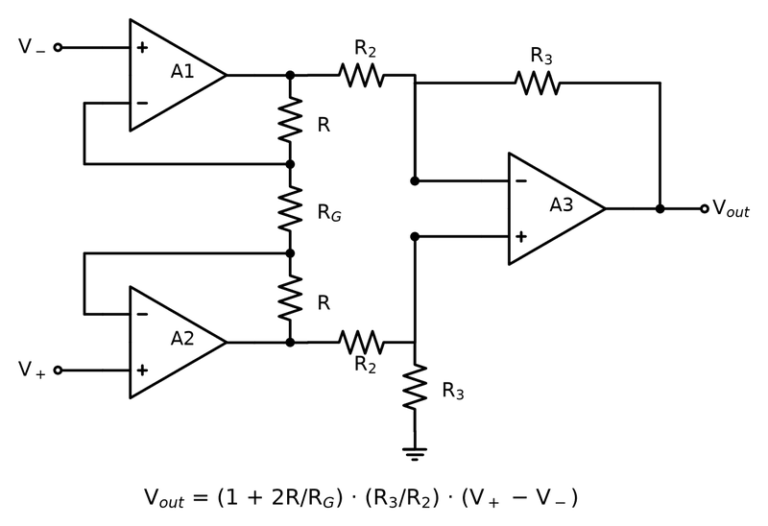
Figure 20.1 — The classic three-op-amp instrumentation amplifier. One resistor, R_G, sets the gain; the difference stage on the right throws away the common-mode voltage.
The common-mode level does not drive any current through R_G, because both ends of R_G move together. The front end therefore passes V_cm through at unity gain while multiplying V_d by its gain G₁ = 1 + 2R/R_G. The difference stage that follows sees a signal that has already grown by G₁ against an unchanged common-mode level, so the rejection of the complete amplifier is approximately the front-end gain times the rejection of the difference stage.
CMRR_total ≈ G₁ · CMRR_diff
Worked Example 20.3
Problem: An instrumentation amplifier uses R = 25 kΩ in each front-end stage and a unity-gain difference stage with 0.1% resistors. Find the R_G that gives a total gain of 100, the resulting CMRR, and the output error from the bridge's 2.5 V common-mode level.
Solution: With the difference stage at unity gain, 1 + 2R/R_G = 100, so R_G = 50 kΩ/99 = 505 Ω; the nearest 0.1% E192 value is 505 Ω. The difference stage alone gives 54.0 dB from Worked Example 20.2, and the front-end gain of 100 adds 40 dB, so CMRR ≈ 50,000, or 94.0 dB. The common-mode gain is 100/50,000 = 0.002 and the output error is 2.5 V × 0.002 = 5 mV. The full-scale output is now 100 × 10 mV = 1 V, so the error is 0.5% of full scale instead of 50%, and it is a fixed offset that a one-time zero calibration removes.
Integrated instrumentation amplifiers laser-trim the difference stage, so their datasheets quote CMRR directly, typically 80–90 dB at a gain of one and 110–130 dB at a gain of 100 or more. The rise with gain is the mechanism above. A discrete build from good parts can match this only with resistor networks whose elements are matched to each other, which is why precision designs buy the amplifier rather than build it.
Key Idea
An instrumentation amplifier rejects common-mode voltage by amplifying the difference before it subtracts. The front end raises the signal against an untouched common-mode level, so every factor of gain placed in the front end multiplies the rejection of the imperfect difference stage that follows.
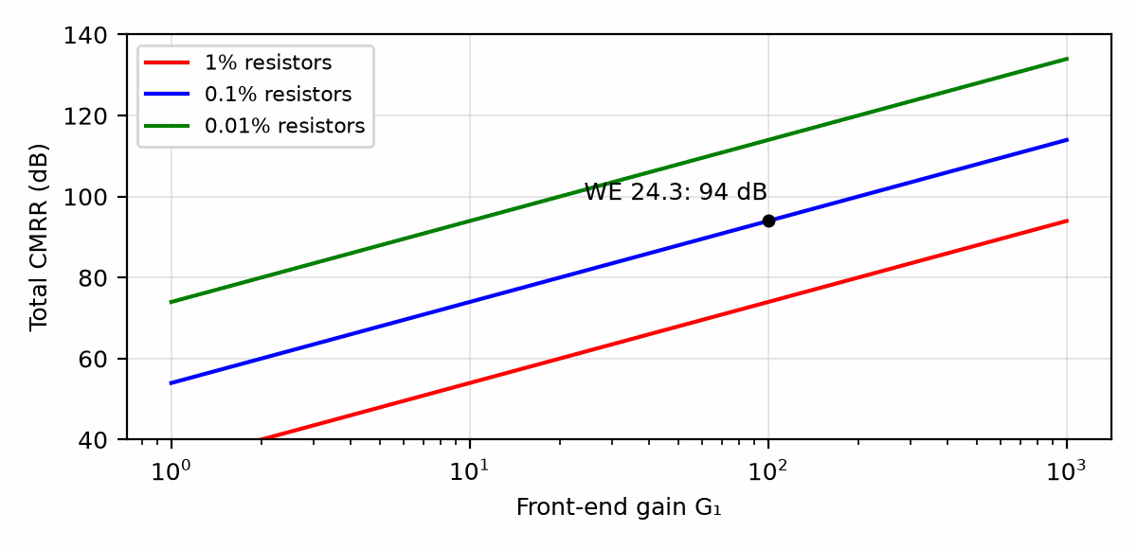
Figure 20.2 — Total CMRR of a three-op-amp instrumentation amplifier versus front-end gain, for difference stages built from 1%, 0.1%, and 0.01% resistors.

20.4 Headroom Inside the Amplifier
The front-end outputs carry the common-mode level plus half the amplified difference each, V_cm ± G₁V_d/2. Those internal nodes are invisible on the package, but they clip like any other op-amp output. A part can show a perfectly legal output voltage while one of its internal amplifiers is saturated, and the output is then wrong. Datasheets publish the allowed region as a plot of common-mode voltage against output voltage, usually a hexagon or diamond, and that plot, not the input common-mode specification alone, is the test of a design.
Worked Example 20.4
Problem: A 5 V single-supply instrumentation amplifier with rail-to-rail front-end outputs (allow 0.1 V from each rail) is set to a front-end gain of 100. It senses a 20 mV differential signal at a common-mode level of 4.0 V. Check the internal headroom.
Solution: The front-end outputs are 4.0 ± (100 × 0.020)/2 = 4.0 ± 1.0 V, so one internal node must reach 5.0 V. The allowed maximum is 4.9 V, so that amplifier saturates. Three fixes are possible: lower the front-end gain and take the remaining gain later, bring the common-mode level toward mid-supply, or run the part from a higher supply. With the common-mode level at 2.5 V the nodes span 1.5 to 3.5 V and the design is comfortable.

20.5 The Reference Pin
The difference stage's reference node, brought out as the REF pin, sets the output level that corresponds to zero differential input. On a single supply it is usually driven to mid-supply so that the output can swing both ways. The REF pin is the bottom end of resistor R₄, so any source resistance driving it adds to R₄ and unbalances the bridge of four resistors. Applying the common-mode formula with all resistors equal to R and a source resistance R_s in series with R₄ gives A_cm = R_s/(2R + R_s).
Worked Example 20.5
Problem: A difference stage uses four matched 10 kΩ resistors. The REF pin is driven from a divider whose Thévenin resistance is 10 Ω. Find the CMRR this alone allows.
Solution: A_cm = 10/(20,000 + 10) = 5.0 × 10⁻⁴, and with unity differential gain the CMRR is 2,001, or 66.0 dB. Ten ohms in the wrong place undoes a 0.01% resistor network, which would otherwise give about 74 dB. The REF pin must be driven by a low-impedance source, typically a follower whose closed-loop output resistance is milliohms.
Common Misconception
The REF pin is not a ground connection that can be returned anywhere. Its current is the output current of the difference stage divided among the resistors, and any resistance or ground-return voltage between REF and the point the load measures from appears directly in the output.

20.6 Choosing Between Them
Use a difference amplifier when the signal source is low impedance, the common-mode voltage may exceed the supply rails (high-side current sensing, where an integrated difference amplifier with a divider ahead of its inputs tolerates tens of volts), and the required CMRR is modest. Use an instrumentation amplifier when the source is high impedance or unbalanced, the signal is small, or the rejection must exceed about 70 dB. In both, keep the two input paths symmetrical: equal source resistances, equal filter components, and matched layout, because any asymmetry converts common-mode voltage into a differential error before the amplifier can reject it.

20.7 Sensor Front Ends and the Human Senses
Book 1's reader lab paired each sensor with a human sense. Each sense needs a front end that matches what the sensor delivers, a voltage, a current, or a charge, and most of them are in this book:
- Sight: a photodiode, a current source, read by the transimpedance amplifier of Section 13.7.
- Touch, pressure, and weight: a strain-gauge bridge or load cell, a small differential voltage, read by the instrumentation amplifier of this chapter.
- Feeling a knock or a vibration: a piezoelectric sensor, a charge source, read by the charge amplifier of Section 20.8.
- Warmth: a thermistor bridge with a comparator (Book 1, Chapter 27) or an instrumentation amplifier; at a distance, a PIR sensor, whose pyroelectric element is another charge source.
- Hearing: a microphone, read by a low-noise preamplifier designed with the noise budget of Chapter 14.
- A sense people lack, electricity itself: a current transformer or a shunt, read for the Home Energy Dashboard in Section 20.9.

20.8 The Charge Amplifier for Piezoelectric Sensors
A piezoelectric sensor (an accelerometer, a knock sensor, a hydrophone, a guitar's under-saddle pickup) produces charge, not voltage: q = S·a, where S is its sensitivity in picocoulombs per unit of input. Read with a voltage amplifier, that charge divides between the sensor's own capacitance and the cable's, so the reading changes whenever the cable is moved or replaced. A charge amplifier removes the dependence. The sensor feeds the inverting input, and the feedback element is a capacitor C_f (Figure 20.3). The virtual ground keeps the sensor and cable at 0 V, so their capacitance never charges, and all of q flows onto C_f: V_out = −q/C_f. A large resistor R_f across C_f gives the op-amp's bias current a path and sets a low-frequency corner f_L = 1/(2πR_fC_f); below it the amplifier forgets, which is why piezo sensors cannot measure a static force.
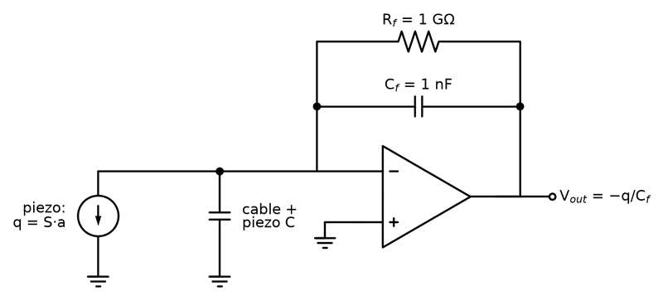
Figure 20.3 — A charge amplifier. The piezo sensor is a charge source in parallel with its own and the cable's capacitance; the virtual ground keeps that capacitance at 0 V, so V_out = −q/C_f, and R_f sets the low-frequency corner.
Worked Example 20.6
Problem: An accelerometer has S = 10 pC/g. The charge amplifier uses C_f = 1 nF and R_f = 1 GΩ. Find the sensitivity in mV/g, the output for a 5 g shock, and the low-frequency corner.
Solution: V/a = S/C_f = 10 pC/1 nF = 10 mV/g, so a 5 g shock gives 50 mV (inverted). f_L = 1/(2π × 10⁹ Ω × 10⁻⁹ F) = 0.159 Hz. Check: a longer cable adds capacitance at the inverting input, which changes the noise gain but not V_out = −q/C_f; with a voltage amplifier, doubling the total capacitance would halve the reading. The op-amp must be a low-bias-current FET-input or CMOS part, because 1 pA through 1 GΩ is already 1 mV of offset.

20.9 Measuring Mains Current: the Home Energy Dashboard
The Home Energy Dashboard of Book 1 reads the current into a house with a clip-on current transformer (CT), which needs no break in the wiring and isolates the mains from the electronics. A CT with N secondary turns delivers I_p/N into a burden resistor R_b, and the burden turns that current into a voltage. A single-supply converter cannot read a negative voltage, so the burden's other end sits at a mid-supply bias of V_DD/2, made by a resistor divider and a capacitor or, better, by the follower of Chapter 12.
Worked Example 20.7
Problem: A 100 A : 50 mA CT (N = 2000) feeds a 3.3 V converter biased at 1.65 V. The largest current to measure is 100 A rms. Choose the burden resistor, and find the primary current per count of a 12-bit converter.
Solution: The peak primary current is 100√2 = 141.4 A, so the peak secondary current is 141.4/2000 = 70.7 mA. The swing must stay within ±1.65 V, so R_b ≤ 1.65/0.0707 = 23.3 Ω; choose 22 Ω, which gives ±1.56 V at 100 A. One count of a 12-bit converter is 3.3/4096 = 0.81 mV, which is 0.81 mV/22 Ω = 36.6 µA of secondary current, or 73 mA of primary current. Check: at 100 A rms the burden dissipates (0.050 A)² × 22 Ω = 55 mW, comfortable for a 0.25 W part. Never unclip the burden while the CT sits on a live conductor: an open secondary can rise to a dangerous voltage.
Key Idea
Match the front end to what the sensor delivers: a voltage to an instrumentation amplifier, a current to a transimpedance amplifier, a charge to a charge amplifier.
From the Bench
Check the internal headroom, not only the input range. In a three-op-amp in-amp, the first-stage outputs carry the common-mode voltage plus the amplified difference, and they can clip while the output looks fine. Many manufacturers publish 'diamond plot' tools for exactly this. And drive the reference pin from a low impedance; a resistor divider there spoils CMRR.
On the Job
Test and measurement engineers live in this chapter. A production tester, a strain-gauge rig, or a sensor qualification lab is a row of instrumentation amplifiers, references, and converters, and the daily work is chasing a reading that is a few counts wrong to a ground loop, a common-mode problem, or an unmatched filter. At work the instrumentation amplifier is a single chip with laser-trimmed resistors; this chapter is how you know what its CMRR figure will and will not protect you from.

Practice Problems
- An instrumentation amplifier's inputs sit at 2.512 V and 2.488 V. Find the differential and common-mode voltages.
- A difference amplifier with a gain of 10 uses 1% resistors. Find its worst-case CMRR in decibels.
- An integrated instrumentation amplifier has a gain equation G = 1 + 49.4 kΩ/R_G. Find R_G for a gain of 50.
- A difference stage gives 60 dB of CMRR. It follows a front end with gain 200. Estimate the total CMRR in decibels.
- A front end with gain 50 sees V_d = 30 mV at V_cm = 1.0 V on a 0–5 V supply with 0.1 V output limits. Is the design within its internal headroom?
- Explain in a sentence or two why an RC filter placed ahead of an instrumentation amplifier should use matched capacitors on both inputs.
- A piezo accelerometer of 10 pC/g feeds a charge amplifier with C_f = 470 pF. Find the sensitivity in mV/g and the R_f that puts the low-frequency corner at 1 Hz.
- The CT of Worked Example 20.7 is used to measure up to 30 A rms. Choose the burden from E12 values and find the peak burden voltage at 30 A.

What You’ll Actually Use
Everyday working tools
- Gain = 1 + 2R/R_G for the three-op-amp form.
- Common-mode rejection and resistor matching.
- Internal headroom checks.
- Charge amplifiers for piezo sensors; CT burden resistors for mains current.
Mostly for exams and deeper study
- Deriving CMRR as a function of each resistor's mismatch.

Chapter 21 — State Feedback and Observers
Some of the quantities a controller needs can't be measured cheaply: the speed of a motor with no encoder, the temperature deep inside a battery. State feedback with an observer estimates them from the ones you can measure, and then uses the estimate as if it were real.
Where you meet this: Sensorless motor control, drone attitude estimation, battery state-of-charge estimation and advanced servo drives.
Chapters 17 and 18 shaped a loop by looking at one signal, the error, and filtering it with proportional, integral, and derivative terms. This chapter looks at the plant from the inside instead. A motor or a moving mass has a small number of internal quantities, its states, whose present values completely determine what it will do next. Feeding every state back with its own gain lets a designer place the closed-loop poles exactly where they are wanted, and an observer supplies the states that no sensor measures. The method is the foundation of modern control, and for the second-order plants in this book it turns out to be a precise form of something already familiar.

21.1 States and the State Equation
A state is a variable whose current value, together with the future inputs, is enough to predict the system's future. For a mass m pushed by a force u along a frictionless track, position x and velocity v are the states: knowing both at one instant, and the force from then on, fixes the motion. Newton's law gives two first-order equations, which are collected into a vector form.
ẋ = v, v̇ = u/m → d/dt [x; v] = A [x; v] + B u, A = [0 1; 0 0], B = [0; 1/m]
Every linear plant in this book can be written as ż = Az + Bu with an output y = Cz. The poles of the open-loop plant are the eigenvalues of A, the roots of det(sI − A) = 0. For the mass both eigenvalues are zero: a double integrator, which drifts away from any position under the smallest constant force.

21.2 Pole Placement
State feedback makes the input a weighted sum of all the states, u = −Kz + k_r·r, where K is a row of gains and r is the reference. Substituting gives ż = (A − BK)z + Bk_r·r, so the closed-loop poles are the eigenvalues of A − BK. For a second-order plant the characteristic polynomial has two free coefficients and K has two gains, so any pair of poles can be reached. For the mass, with u = −k₁x − k₂v + k₁r, the closed-loop polynomial is s² + (k₂/m)s + k₁/m, and matching it to the standard second-order form s² + 2ζωₙs + ωₙ² gives the gains directly.
k₁ = m ωₙ², k₂ = 2 ζ ωₙ m
Worked Example 21.1
Problem: A 2 kg carriage on an air-bearing track is driven by a linear motor. Choose state-feedback gains that give ωₙ = 10 rad/s and ζ = 0.7, and predict the step response.
Solution: k₁ = 2 × 10² = 200 N/m and k₂ = 2 × 0.7 × 10 × 2 = 28 N·s/m. The closed-loop polynomial is s² + 14s + 100. A damping ratio of 0.7 gives an overshoot of 100·exp(−ζπ/√(1 − ζ²)) = 4.6%. A simulation of the loop settles to within 2% in 0.60 s; the familiar 4/(ζωₙ) estimate gives 0.57 s. The reference gain k_r = k₁ makes the steady-state position equal r exactly, because at rest v = 0 and the force −k₁x + k₁r must be zero.
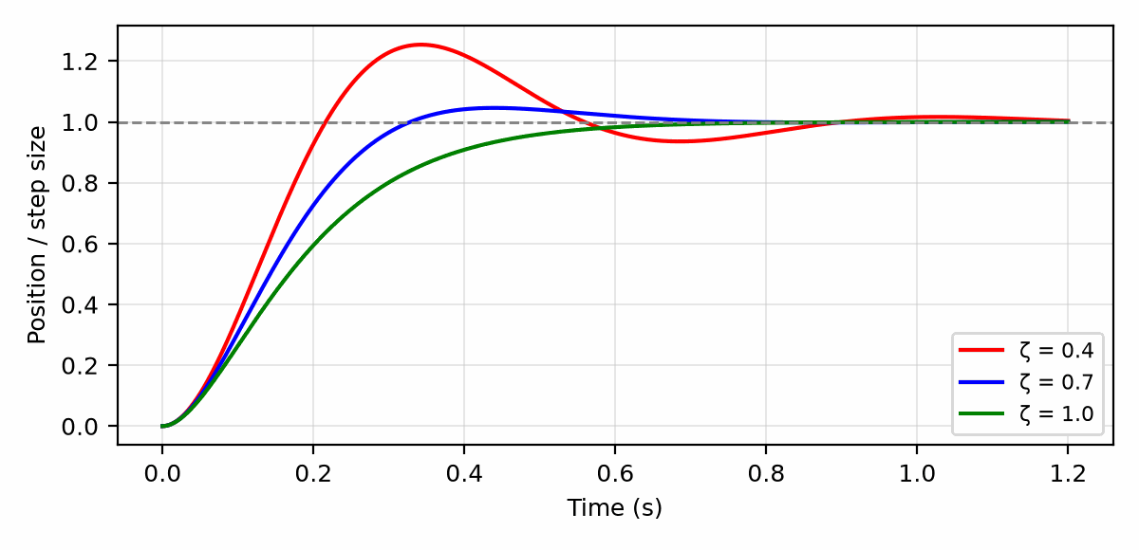
Figure 21.1 — Step response of the state-feedback carriage (ωₙ = 10 rad/s) for damping ratios 0.4, 0.7, and 1.0.
Key Idea
For a plant whose states are a position and its velocity, state feedback is PD control with a measured derivative. The gain on position is the proportional gain and the gain on velocity is the derivative gain, but the velocity comes from a sensor or an estimator instead of from differentiating a noisy error signal.
The same algebra works when the plant has its own dynamics. A small DC motor driving a light load is well approximated by θ̈ = −(1/τ)θ̇ + (K/τ)u, with mechanical time constant τ and gain K from volts to steady speed. State feedback u = −k₁θ − k₂θ̇ + k₁r produces the closed-loop polynomial s² + (1 + Kk₂)/τ · s + Kk₁/τ.
Worked Example 21.2
Problem: A motor has τ = 50 ms and K = 20 (rad/s)/V. Find position and velocity gains that give ωₙ = 40 rad/s and ζ = 0.8.
Solution: The target polynomial is s² + 64s + 1600. Matching the constant term, Kk₁/τ = 1600, so k₁ = 1600 × 0.05/20 = 4.0 V/rad. Matching the middle term, (1 + 20k₂)/0.05 = 64, so 20k₂ = 2.2 and k₂ = 0.11 V/(rad/s). The roots of s² + 64s + 1600 are −32 ± j24, which have magnitude 40 and damping 32/40 = 0.8, as required.

21.3 Controllability
Pole placement works only if the input can influence every state. A plant is controllable when the matrix [B AB A²B …], built from as many columns as there are states, has full rank. For the carriage, B = [0; 1/m] and AB = [1/m; 0], which are independent, so the plant is controllable. A counterexample is two identical carriages driven by the same command: their difference is never affected by the input, the controllability matrix loses rank, and no choice of gains can move the poles that describe that difference. The practical message is to check controllability before spending effort on gains, because a plant that fails it needs another actuator, not a better controller.

21.4 Observers: Estimating What Is Not Measured
State feedback needs every state, and most systems measure only some. An encoder gives position but not velocity, and differentiating encoder counts amplifies their quantization into a noisy velocity. An observer runs a model of the plant in software and corrects it continuously with the measured output.
dẑ/dt = A ẑ + B u + L (y − C ẑ)
The estimation error e = z − ẑ obeys ė = (A − LC)e, so the observer gain L places the error poles in exactly the way K places the control poles. For the carriage with position measured, C = [1 0] and L = [l₁; l₂], and the error polynomial is s² + l₁s + l₂. Observer poles are usually placed three to five times faster than the control poles, so that the estimate converges before the controller depends on it, but not so fast that the observer passes sensor noise straight through.
Worked Example 21.3
Problem: Design a position-measuring observer for the carriage of Worked Example 21.1 with observer poles at ωₙ = 40 rad/s, ζ = 0.7.
Solution: The target error polynomial is s² + 2 × 0.7 × 40 s + 40² = s² + 56s + 1600, so l₁ = 56 s⁻¹ and l₂ = 1600 s⁻². The roots are −28 ± j28.6, four times the natural frequency of the control poles. The controller then uses u = −200x̂ − 28v̂ + 200r with the estimated states.
The separation principle makes this combination safe for linear plants: the closed-loop poles of controller plus observer are the control poles together with the observer poles, each set placed independently. What separation does not protect is robustness. A model that is wrong, for example a mass that doubles when the carriage picks up a load, shifts both sets of poles, and the margins of Chapter 18 must still be checked on the complete loop. In firmware, an observer with a noise model becomes the Kalman filter; Book 8 implements one for an IMU in its Chapter 16, Sensor Fusion.
Common Misconception
An observer is not a filter that can be made arbitrarily fast for free. Faster observer poles mean larger gains on the measurement error y − Cẑ, and every bit of sensor noise and quantization in y passes into the state estimate scaled by L. The observer bandwidth is a trade between tracking a changing state and rejecting a noisy sensor.

21.5 Integral Action and Disturbances
State feedback on position and velocity has the same weakness as PD control: a constant disturbance force leaves a constant error. In the steady state the feedback force must cancel the disturbance d, so k₁x = d and the error is d/k₁. The cure is to add a third state, the integral of the position error z_i = ∫(r − x)dt, and feed it back with a gain k_i. The closed-loop polynomial becomes third order, s³ + (k₂/m)s² + (k₁/m)s + k_i/m, and the extra pole is placed alongside the others.
Worked Example 21.4
Problem: A constant 5 N force acts on the 2 kg carriage of Worked Example 21.1. Find the steady error without integral action. Then add an integral state and choose gains that keep the poles of Worked Example 21.1 and add a real pole at −10 s⁻¹.
Solution: Without integral action the error is 5/200 = 25 mm, permanently. With the integral state, the target polynomial is (s² + 14s + 100)(s + 10) = s³ + 24s² + 240s + 1000. Matching coefficients with m = 2 gives k₂ = 48 N·s/m, k₁ = 480 N/m, and k_i = 2000 N/(m·s). A simulation with the 5 N force applied at t = 0 shows a peak deflection of 8.5 mm, after which the integral state builds up exactly 5 N of opposing force and the error returns to zero.
The integral state needs the anti-windup protection of Chapter 18. When the actuator saturates, the integrator must stop accumulating, or it will drive a large overshoot when the actuator comes back into its linear range.

21.6 Gains Meet Actuators
Pole placement will return any gains asked of it, and the actuator then has to deliver them. A step in the reference demands an immediate force k₁·Δr. For the carriage with k₁ = 200 N/m, a 0.1 m step asks for 20 N at the first instant. If the motor is rated for 10 N, the loop saturates and the response is no longer the linear one designed. Two remedies keep the design honest: shape the reference into a ramp or S-curve that the actuator can follow, or choose slower poles. Pushing poles further left buys speed only until saturation, measurement noise, or unmodeled dynamics such as a flexible mount, a current-loop delay, or a sample period becomes the limit, and the linear-quadratic regulator (LQR), the usual next step beyond pole placement, chooses gains by weighing state error against control effort for exactly this reason.
From the Bench
An observer is only as good as its model. Validate it by logging the estimate next to a real measurement during commissioning, even if the production unit won't have that sensor. A model error usually shows up as a steady offset between the two.

Practice Problems
- A 0.5 kg mass on a frictionless track is to have ωₙ = 20 rad/s and ζ = 0.7 under state feedback. Find k₁ and k₂.
- For the gains of the previous problem, find the steady-state error caused by a constant 2 N disturbance force without integral action.
- A motor with τ = 0.1 s and K = 10 (rad/s)/V is to have closed-loop poles with ωₙ = 30 rad/s and ζ = 1. Find k₁ and k₂.
- An observer for a double integrator measured in position is to have both error poles at −50 s⁻¹. Find l₁ and l₂.
- The carriage of Worked Example 21.1 is commanded with a 0.03 m step. Find the initial force demanded, and state whether a 10 N actuator saturates.
- Explain in a sentence or two why measuring velocity directly or estimating it with an observer is preferable to differentiating the encoder position.

What You’ll Actually Use
Everyday working tools
- The state-space idea and pole placement in software tools.
- Observers as estimators of unmeasured states.
Mostly for exams and deeper study
- Controllability and observability proofs.
- Hand calculation of gain matrices.

Chapter 22 — The Sample-and-Hold Circuit
Taking a snapshot of a voltage sounds simple: close a switch, charge a capacitor, open the switch. In practice the capacitor is noisy, the switch injects charge as it opens, and the held voltage sags while you look at it. This chapter is about how to take a clean snapshot.
Where you meet this: The input stage of most ADCs, especially successive-approximation types, peak detectors and sampling oscilloscopes.
Chapter 19 treated the hold as a mathematical step: a value is captured and held as a staircase. This chapter opens the box. A sample-and-hold is a switch, a capacitor, and a buffer, and each of those three parts limits the accuracy of every analog-to-digital converter built on it. The useful skill is to put a number on each limit, compare it with one least significant bit (LSB), and choose the hold capacitor that balances them.

22.1 The Circuit and Its Two Modes
In track mode the switch is closed and the capacitor voltage follows the input through the switch's on-resistance and the driving source's output resistance. At the hold command the switch opens and the capacitor keeps the last value while the converter measures it, through a buffer whose input draws almost no current. Most modern converters use the converter's own capacitor array as the hold capacitor, so the circuit is inside the chip, but its limits still appear in the datasheet and still dictate how the input must be driven.
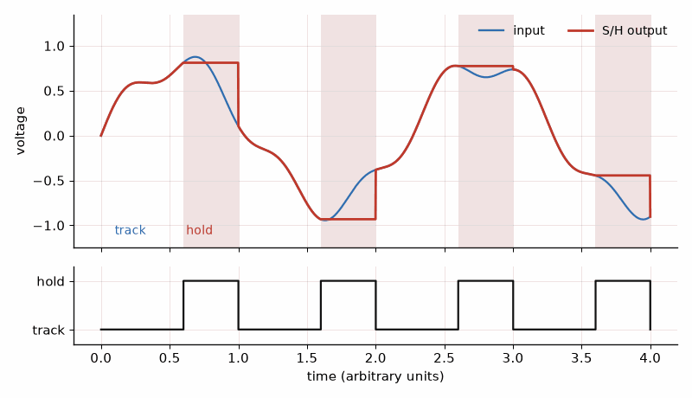
Figure 22.1 — Track, hold, track, hold: the output follows the input while the switch is closed and freezes when it opens, giving the converter a still target.
The errors fall into four groups: how long tracking takes to settle (acquisition), what happens at the instant the switch opens (pedestal and aperture effects), what happens during the hold (droop and feedthrough), and the noise frozen onto the capacitor. Nearly every one of them improves with a larger capacitor except acquisition, which gets worse. That single tension sets the design.

22.2 Acquisition Time
While tracking, the capacitor charges through the total series resistance R as a single RC network. After an input step, the remaining error falls as exp(−t/RC). To settle within half an LSB of an N-bit converter, the error must fall by a factor of 2^(N+1).
t_acq = R C ln(2^(N+1)) = R C (N + 1) ln 2
Worked Example 22.1
Problem: A 12-bit converter's hold capacitor is 100 pF, the switch has 100 Ω on-resistance, and the source driving it has 50 Ω output resistance. Find the time constant and the acquisition time to ½ LSB.
Solution: R = 150 Ω and RC = 150 × 100 pF = 15 ns. The settling factor is ln(2¹³) = 9.01, so t_acq = 9.01 × 15 ns = 135 ns. At 16 bits the factor rises to ln(2¹⁷) = 11.8 and the time to 177 ns. Each extra bit adds 0.69 time constants, so resolution is cheap in settling time; it is expensive in everything else below.
The same formula sets the driver's requirement. An op-amp driving the hold capacitor must itself settle within the acquisition window, and its closed-loop output resistance and bandwidth from Chapter 13 are part of R. A driver that slews during a full-scale step loses time before the exponential settling even begins.

22.3 kT/C Noise
Any resistor charging a capacitor leaves a random voltage on it when the switch opens. Integrating the resistor's thermal noise over the RC bandwidth gives a result that does not depend on the resistance at all: a larger resistor is noisier but narrows the bandwidth by exactly the same factor.
v_n,rms = √(kT / C)
Worked Example 22.2
Problem: Find the sampled noise at 290 K for hold capacitors of 1 pF, 10 pF, and 100 pF, and compare each with the LSB of a 16-bit converter spanning 5 V.
Solution: With k = 1.381 × 10⁻²³ J/K, kT = 4.00 × 10⁻²¹ J. The noise is 63 µV rms at 1 pF, 20 µV at 10 pF, and 6.3 µV at 100 pF. The 16-bit LSB is 5/65,536 = 76 µV. A 1 pF capacitor adds noise comparable to an LSB on every sample, and 10 pF is marginal; precision 16- and 18-bit converters use tens of picofarads or more for this reason.
Key Idea
kT/C noise depends only on the capacitor and the temperature. The resistance that charges a hold capacitor cannot be chosen to reduce the noise frozen on it; only a larger capacitor, or averaging several samples, does that.

22.4 What Happens When the Switch Opens
A MOSFET switch holds charge in its channel while it is on. When it turns off, part of that charge is pushed onto the hold capacitor, and the gate-drive edge couples more through the gate-to-drain capacitance. The result is a step, the pedestal, of size ΔV = Q/C. It is largely constant and appears as an offset, but the channel charge depends on the input voltage, so a residual signal-dependent part appears as gain error and distortion. Differential sampling, where two matched switches inject nearly equal charge into two capacitors and the difference cancels, removes most of it.
ΔV_pedestal = Q_inj / C
The switch also does not open at a perfectly defined instant. Random variation in the sampling instant, aperture jitter, converts a changing signal's slope into voltage error. For a full-scale sine wave of frequency f and an rms jitter σ_t, the best achievable signal-to-noise ratio is set by the jitter alone.
SNR_jitter = −20 log₁₀(2π f σ_t)
Worked Example 22.3
Problem: An ideal 12-bit converter has SNR = 6.02N + 1.76 = 74.0 dB. Find the largest rms jitter that keeps the jitter-limited SNR at this level for input frequencies of 10 MHz and 100 MHz.
Solution: Setting −20 log₁₀(2πfσ_t) = 74.0 gives 2πfσ_t = 10^(−74.0/20) = 2.0 × 10⁻⁴. At 10 MHz, σ_t = 2.0 × 10⁻⁴/(2π × 10⁷) = 3.2 ps. At 100 MHz, σ_t = 0.32 ps. A 1 ps clock at 100 MHz input limits the converter to 64 dB, about 10.3 effective bits, no matter how good the rest of it is. At audio frequencies the same arithmetic allows nanoseconds, which is why jitter is a radio-frequency and high-speed-converter problem.

22.5 Droop and Feedthrough During Hold
During the hold, leakage currents from the switch, the buffer input, and the board discharge or charge the capacitor at a constant rate, droop = I_leak/C. Signal also couples across the open switch through its off-capacitance, so that a large, fast input partly appears on the held value; this hold-mode feedthrough is quoted in decibels and improves with a larger hold capacitor in the ratio C_off/(C_off + C).
Worked Example 22.4
Problem: A discrete sample-and-hold for a 16-bit, 5 V system uses a 1 nF C0G capacitor charged through 50 Ω (switch plus driver). The switch injects 2 pC and total leakage is 100 pA. The converter takes 5 µs to measure the held value. Find the acquisition time, the noise, the pedestal, and the droop over the conversion, and compare each with the 76 µV LSB.
Solution: Acquisition: RC = 50 ns, and 11.8 × 50 ns = 0.59 µs. Noise: √(kT/C) = 2.0 µV rms, negligible. Pedestal: 2 pC/1 nF = 2 mV, about 26 LSB, but almost entirely a constant offset that calibration removes. Droop: 100 pA/1 nF = 0.1 V/s, which over 5 µs is 0.5 µV, also negligible. With 100 pF instead, acquisition would shrink to 59 ns, but the pedestal would grow to 20 mV, the droop to 1 V/s (5 µV over the conversion), and the noise to 6.3 µV. The larger capacitor is the right choice whenever the sample rate allows its acquisition time. The C0G dielectric matters as much as the value, for the reasons given in Chapter 8.
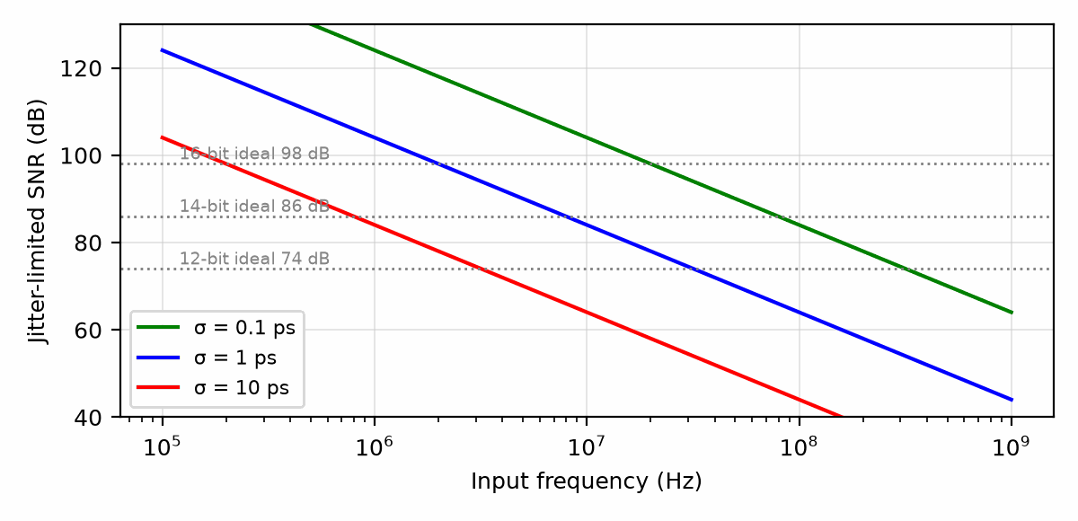
Figure 22.2 — Jitter-limited SNR versus input frequency for rms aperture jitter of 0.1, 1, and 10 ps, with the ideal 12-, 14-, and 16-bit SNR levels marked.

22.6 Driving a Switched-Capacitor Converter Input
A successive-approximation converter samples onto its internal capacitor array, often 20–60 pF. At the start of each acquisition that array still holds the previous sample, so connecting it to the input is a step of charge sharing, not a gentle tracking. The standard input network is a small resistor and a large capacitor between the driving op-amp and the converter pin. The external capacitor supplies the sudden charge, and the op-amp then restores the external capacitor within the acquisition time.
Worked Example 22.5
Problem: A 16-bit SAR converter spanning 5 V has a 30 pF sampling array. An external 2.7 nF capacitor sits at its input. Find the worst-case charge-sharing kick and how many time constants the driver network needs to recover it to ½ LSB.
Solution: In the worst case the array held 0 V and the input is at 5 V. Sharing charge drops the input by 5 × 30/(2700 + 30) = 55 mV, which is about 1,440 times the ½-LSB level of 38 µV. Recovering requires ln(1,440) = 7.3 time constants of the external RC and driver within the acquisition window. A larger external capacitor reduces the kick but slows recovery and loads the op-amp's output, and Chapter 12 showed what a capacitive load does to the phase margin; the series resistor exists to isolate it. Datasheets of precision converters recommend specific values because the trade is particular to each array.
Common Misconception
Sampling a slow signal does not make the input-driving problem go away. A 1 Hz thermocouple voltage still meets the switched capacitor's charge kick once every conversion. A high-impedance source without a driver amplifier and input capacitor cannot recover from it, and the result is a gain error that looks like a calibration problem.
From the Bench
An ADC with a switched-capacitor input needs a driver that can recharge the sampling capacitor within the acquisition time. A small RC 'charge bucket' filter between op-amp and ADC, often tens of ohms and a capacitor much larger than the sampling capacitor, is common; the ADC datasheet usually recommends values. Skipping it is a classic cause of readings that depend on the previous channel.

Practice Problems
- A 14-bit converter's hold capacitor is charged through 200 Ω total and is 20 pF. Find the acquisition time to ½ LSB.
- Find the kT/C noise of a 5 pF capacitor at 290 K.
- A switch injects 0.5 pC into a 50 pF hold capacitor. Find the pedestal.
- A 14-bit converter (ideal SNR 86.0 dB) samples a 5 MHz full-scale sine. Find the largest rms jitter that keeps the jitter-limited SNR at 86 dB.
- A 470 pF hold capacitor has 1 nA of leakage. Find the droop in V/s and the change during a 2 µs conversion.
- Explain in a sentence or two why a larger hold capacitor is not always better.

What You’ll Actually Use
Everyday working tools
- Acquisition time and settling.
- kT/C noise as a floor.
- Driving switched-capacitor ADC inputs.
Mostly for exams and deeper study
- Detailed charge-injection models.

Chapter 23 — The Voltage Reference and the Bandgap
Every ADC measures against something, and that something is a voltage reference. A clever trick from the 1970s balances one voltage that falls with temperature against another that rises, and lands at about 1.2 V, give or take very little, from freezing to boiling.
Where you meet this: ADC and DAC references, precision regulators, battery monitors and calibration standards.
Every converter, regulator, and calibrated measurement in this book compares something against a voltage that is assumed to be known. That voltage comes from a reference, and the reference's errors pass straight into every result measured against it. This chapter explains how a stable voltage is made from parts that all drift with temperature, the bandgap circuit, and then reads a reference datasheet the way an error budget needs it read. The device physics behind the base-emitter voltage belongs to Book 3; here the junction is used as a part with two well-behaved properties.

23.1 Two Voltages That Drift in Opposite Directions
A forward-biased base-emitter junction at a fixed current has a voltage V_BE of about 0.65 V at room temperature, and it falls by roughly 2 mV for each kelvin of temperature rise. It is complementary to absolute temperature (CTAT). The difference between the V_BE values of two junctions run at different current densities behaves the other way. If one transistor has N times the emitter area of the other and both carry the same current, the difference is exactly proportional to absolute temperature (PTAT), because the logarithmic diode law leaves only the thermal voltage kT/q multiplied by a ratio of areas.
ΔV_BE = (kT/q) ln N, d(ΔV_BE)/dT = (k/q) ln N
The PTAT slope does not depend on process details, transistor size, or current, only on the area ratio and fundamental constants. That is the property that makes the bandgap possible: one voltage with a known negative slope, one with a known positive slope, and a resistor ratio to weigh them.
Worked Example 23.1
Problem: Two transistors with an area ratio N = 8 carry equal currents at 300 K. Find ΔV_BE and its temperature coefficient.
Solution: kT/q at 300 K is 1.381 × 10⁻²³ × 300/1.602 × 10⁻¹⁹ = 25.85 mV, and ln 8 = 2.079, so ΔV_BE = 53.8 mV. The coefficient is (k/q) ln 8 = 86.17 µV/K × 2.079 = 0.179 mV/K. The value at −40 °C is 41.8 mV and at 85 °C is 64.2 mV, a straight line through zero at absolute zero.

23.2 Adding Them: The Bandgap Voltage
To cancel a V_BE slope of −2 mV/K, the PTAT voltage must be multiplied by a gain K such that K × 0.179 mV/K = 2 mV/K, and the reference is V_REF = V_BE + K·ΔV_BE. The sum comes out close to 1.2 V regardless of the details, because it extrapolates to the bandgap energy of silicon, about 1.2 eV, divided by the electron charge. That coincidence gives the circuit its name.
V_REF = V_BE + K (kT/q) ln N, K = |dV_BE/dT| / ((k/q) ln N)
Worked Example 23.2
Problem: Using V_BE = 0.65 V with a slope of −2.0 mV/K and the N = 8 pair of Worked Example 23.1, find the gain K that gives zero slope at 300 K and the resulting reference voltage.
Solution: K = 2.0/0.179 = 11.16. The PTAT term contributes 11.16 × 53.8 mV = 0.600 V, so V_REF = 0.65 + 0.60 = 1.25 V. A larger area ratio reduces the gain needed but costs silicon area; N = 24 would need K = 7.30.
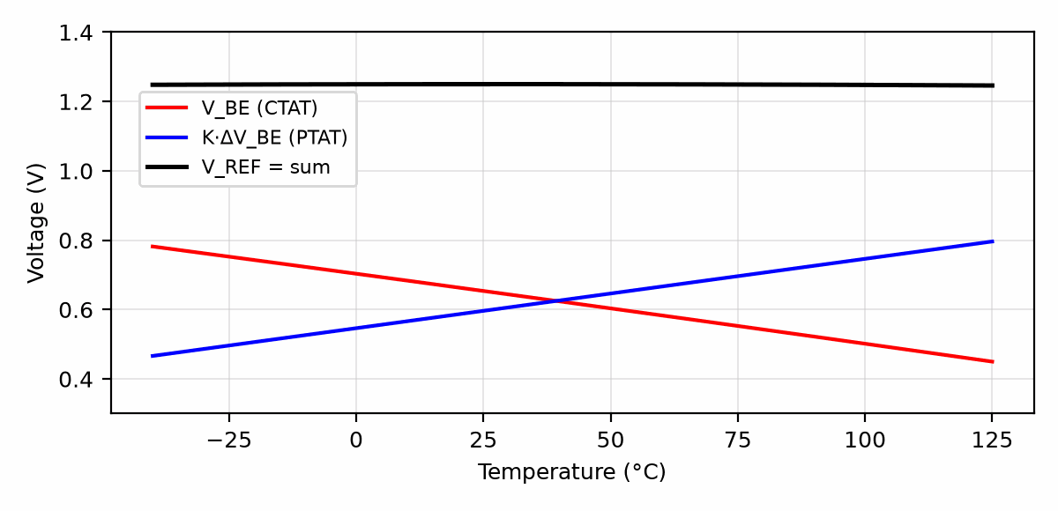
Figure 23.1 — V_BE falling at about 2 mV/K, the scaled PTAT term K·ΔV_BE rising at the same rate, and their sum, which is flat near 1.25 V at 300 K.

23.3 A Working Circuit
One common arrangement uses an op-amp to force equal voltages at the top of two equal resistors R₂, so that both branches carry the same current I. The left branch ends in a unit transistor Q₁. The right branch passes through a resistor R₁ and then an N-times transistor Q₂. Because the op-amp holds the two branches at the same voltage, the extra V_BE of Q₁ appears across R₁: I·R₁ = ΔV_BE. The current is therefore PTAT, and the output, measured at the top of the left branch, is V_BE₁ + I·R₂.
I = ΔV_BE / R₁, V_REF = V_BE₁ + (R₂/R₁) ΔV_BE
Worked Example 23.3
Problem: Design the resistors for the circuit above with N = 8 and a branch current of 10 µA at 300 K, using K = 11.16 from Worked Example 23.2.
Solution: R₁ = ΔV_BE/I = 53.8 mV/10 µA = 5.38 kΩ, and R₂ = K·R₁ = 11.16 × 5.38 kΩ = 60.0 kΩ. The output is 0.65 + 10 µA × 60 kΩ = 1.25 V. Only the ratio R₂/R₁ enters the output, so integrated references use matched resistors of the same material, and their absolute tolerance, often ±20%, does not matter. The op-amp's offset does: it adds to ΔV_BE and is multiplied by K, so a 1 mV offset shifts the output by about 11 mV and adds a slope of its own.
Key Idea
A bandgap reference is accurate because it depends on ratios. The PTAT slope depends on an area ratio, and the gain on a resistor ratio, so the circuit can be made stable from parts whose absolute values vary widely.
The cancellation is exact at only one temperature. V_BE is not a perfectly straight line; it bends by a few millivolts over the industrial range, and the residual output looks like a shallow parabola. Uncompensated bandgaps reach 20–50 ppm/°C; curvature-corrected designs reach 2–5 ppm/°C, and the best buried-zener references, which use a subsurface zener breakdown instead of a bandgap and run from higher supplies, reach below 1 ppm/°C with lower noise.

23.4 Reading a Reference Datasheet
A reference's temperature coefficient is normally specified by the box method: the difference between the highest and lowest output over the temperature range, divided by the nominal voltage and by the width of the range. It describes a box that the curve fits inside, not a slope at any one temperature.
TC (ppm/°C) = (V_max − V_min) / (V_nom × (T_max − T_min)) × 10⁶
Worked Example 23.4
Problem: A 1.25 V reference varies by 1.5 mV between −40 °C and 85 °C. Find its box-method temperature coefficient.
Solution: TC = 1.5 × 10⁻³/(1.25 × 125) × 10⁶ = 9.6 ppm/°C. Because the curve is a parabola, the actual change between 20 °C and 30 °C may be far smaller than 9.6 × 10 = 96 ppm; the box guarantees only the worst case over the full range.
The other specifications that enter a budget are initial accuracy (the tolerance at 25 °C, removable by calibration), line regulation (change with supply voltage), load regulation (change with output current), output noise (usually given peak-to-peak from 0.1 to 10 Hz, because low-frequency noise cannot be filtered without impractically large capacitors), long-term drift in ppm per 1,000 hours, and thermal hysteresis, the shift that remains after a temperature cycle. Hysteresis and long-term drift cannot be calibrated out once, which is why precision instruments re-calibrate.
Worked Example 23.5
Problem: A 12-bit converter uses a 2.5 V reference rated at 0.1% initial accuracy, 10 ppm/°C, and 10 µV peak-to-peak noise. The instrument operates from 25 °C to 75 °C. Express each error in LSB.
Solution: One LSB is 2.5/4096 = 610 µV, or 244 ppm of the reference. Initial accuracy: 0.1% is 2.5 mV, or 4.1 LSB, removed by a one-time calibration. Temperature: 10 ppm/°C × 50 °C = 500 ppm, which is 1.25 mV or 2.0 LSB, not removable by a single room-temperature calibration. Noise: 10 µV is 0.016 LSB, negligible. The temperature coefficient dominates the uncalibrated budget, and a 12-bit system that must stay within 1 LSB over this range needs a reference better than about 5 ppm/°C.
Common Misconception
A 0.1% reference does not make a 0.1% instrument. Initial accuracy is the specification that matters least once the system is calibrated. Temperature drift, hysteresis, and long-term drift remain after calibration, and over a wide temperature range they usually exceed the initial tolerance.

23.5 Series and Shunt References
A series reference behaves like a precision regulator: it sits between supply and load and supplies the load current. A shunt reference behaves like a precision zener: a resistor from the supply feeds it, and it sinks whatever current the load does not take, so the resistor must deliver the load current plus the reference's minimum operating current at the lowest supply voltage.
R_s ≤ (V_s,min − V_REF) / (I_load,max + I_K,min)
Worked Example 23.6
Problem: A 2.5 V shunt reference needs at least 0.5 mA to regulate. The supply ranges from 4.5 V to 5.5 V, and the load draws 0 to 1 mA. Choose the series resistor and find the maximum reference current and resistor dissipation.
Solution: R_s ≤ (4.5 − 2.5)/(1.0 + 0.5) mA = 1.33 kΩ; choose 1.30 kΩ. At 4.5 V and full load the reference receives 2.0/1.30 kΩ − 1 mA = 0.54 mA, above its minimum. At 5.5 V with no load it must sink 3.0/1.30 kΩ = 2.31 mA, dissipating 2.5 × 2.31 = 5.8 mW, and the resistor dissipates 3.0²/1300 = 6.9 mW. Shunt references are simple and tolerate any supply, but they waste the full current at all times, which is why battery equipment prefers series references.
From the Bench
Read the reference datasheet for temperature coefficient, long-term drift and thermal hysteresis, not only initial accuracy. Initial error can be calibrated out; drift after soldering and thermal hysteresis usually can't. Many references also need a specific output capacitor to stay stable, sometimes within a range.

Practice Problems
- Two transistors with an area ratio of 24 carry equal currents at 300 K. Find ΔV_BE and its temperature coefficient.
- For the pair of the previous problem, find the gain K that cancels a V_BE slope of −2.0 mV/K.
- In the circuit of Section 23.3 with N = 8 and R₁ = 10.0 kΩ, find the branch current at 300 K and the R₂ that gives K = 11.16.
- A 2.048 V reference changes by 0.8 mV between 0 °C and 70 °C. Find its box-method temperature coefficient.
- A 16-bit converter uses a 4.096 V reference rated at 3 ppm/°C. Find the drift in LSB over a 40 °C temperature change.
- Explain in a sentence or two why an op-amp offset inside a bandgap circuit is multiplied by roughly K at the output.

What You’ll Actually Use
Everyday working tools
- Reading a reference datasheet: accuracy, tempco, drift, noise.
- Series versus shunt references.
Mostly for exams and deeper study
- The full bandgap derivation with second-order curvature terms.

Chapter 24 — The H-Bridge and Motor as a Plant
Four switches and a motor can drive forward, drive backward, brake or coast, and if two of them are on at the wrong moment, short the supply. The H-bridge is simple to draw and unforgiving to get wrong.
Where you meet this: Robot and toy motors, electric vehicles, stepper drivers, class-D audio amplifiers and inverters.
Chapters 17 to 19 controlled a motor through a block labeled "actuator" that turned a command into a voltage. This chapter builds that block and then writes down the plant it drives. An H-bridge of four switches turns a logic-level duty cycle into a motor voltage of either polarity, and in doing so it adds current ripple, a dead-time error, and a path for energy to flow back into the supply. Each of those is a number, and together with the motor's two time constants they determine how the current and speed loops above them must be designed.

24.1 Four Switches and Their States
The bridge has two legs, each a high-side and a low-side switch in series across the supply V_s, with the motor connected between the two leg midpoints. Turning on the high switch of the left leg and the low switch of the right leg puts +V_s across the motor; the opposite diagonal puts −V_s across it; both low switches (or both high switches) short the motor terminals together, which lets the current circulate at zero applied voltage. The one forbidden state turns on both switches of one leg, a direct short across the supply called shoot-through. Real switches take tens to hundreds of nanoseconds to turn off, so the driver inserts a dead time between turning one switch off and its partner on, during which the inductive motor current flows through the switches' body diodes.
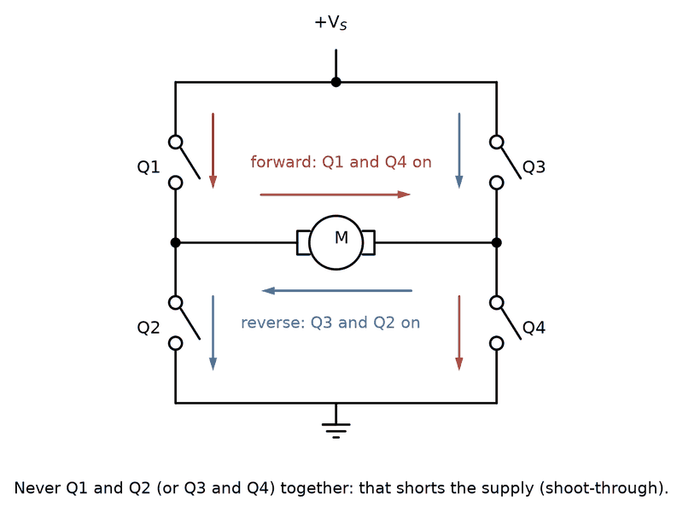
Figure 24.1 — An H-bridge: close Q1 and Q4 and the motor turns one way; close Q3 and Q2 and it turns the other. Close both switches on one side and you have built a short circuit.

24.2 Two Ways to Modulate
In bipolar (locked anti-phase) PWM both diagonals alternate every period, so the motor sees +V_s for a fraction D of the period and −V_s for the rest; the average is (2D − 1)V_s, and zero average voltage occurs at D = 0.5. In sign-magnitude PWM one leg is held to set the direction while the other leg switches, so the motor sees V_s for a fraction D and zero for the rest, and the average is D·V_s. The motor's inductance L averages the switched voltage into a current with a triangular ripple, and the two schemes produce very different ripple.
Bipolar: Δi_pp = 2 V_s D(1 − D)/(L f_sw), Sign-magnitude: Δi_pp = V_s D(1 − D)/(L f_sw)
Worked Example 24.1
Problem: A 24 V bridge switches at 20 kHz into a motor with L = 1 mH. Find the peak-to-peak current ripple at zero average voltage for bipolar PWM, and the worst-case ripple for sign-magnitude PWM.
Solution: Bipolar PWM reaches zero average voltage at D = 0.5, where the ripple is 2 × 24 × 0.25/(10⁻³ × 2 × 10⁴) = 0.6 A peak to peak. Sign-magnitude PWM reaches its worst ripple at D = 0.5 as well, with half the value, 0.3 A, and at zero speed it applies D = 0 and has no ripple at all. The bipolar bridge therefore heats a stationary motor with 0.6/√12 = 0.17 A rms of ripple current that produces no torque. Its compensating advantage is a duty-to-voltage relation that passes smoothly through zero, with no change of switching pattern when the direction reverses.
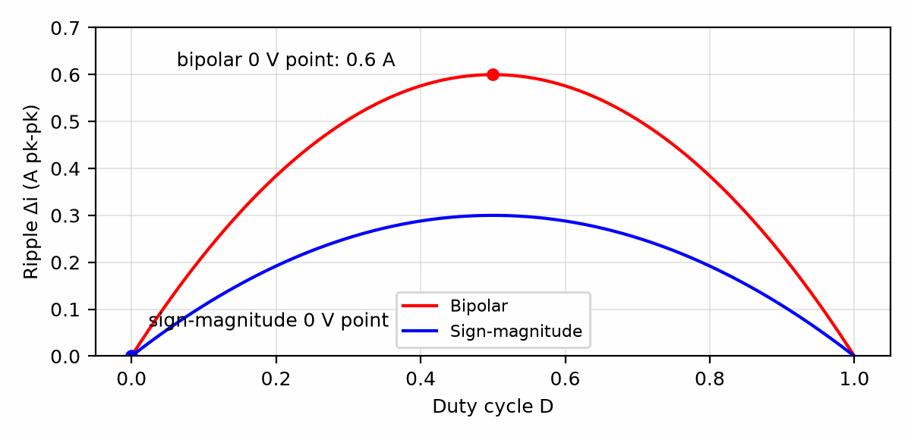
Figure 24.2 — Peak-to-peak current ripple versus duty cycle for bipolar and sign-magnitude PWM (V_s = 24 V, L = 1 mH, f_sw = 20 kHz), with each scheme's zero-voltage operating point marked.
The dead time produces a small voltage error. During each dead interval the leg's output follows the diode that conducts, and that depends on the direction of the current, not on the command. For a switching leg the average error is about V_s·t_d·f_sw, always opposing the current. With 24 V, 500 ns, and 20 kHz it is 0.24 V, 1% of the supply. It barely matters at speed, but near zero speed, where the commanded voltage is itself a few hundred millivolts, it appears as a dead band that the current loop must overcome.
Key Idea
The bridge is a voltage amplifier with a gain of V_s per unit of duty cycle (2V_s for bipolar). Every controller gain computed in volts must be divided by this gain to become a gain in duty cycle, and the gain changes whenever the supply voltage does, which is why good drives measure V_s and compensate.

24.3 The Motor's Two Equations
A permanent-magnet DC motor has an electrical side and a mechanical side, coupled by one constant. In SI units the torque constant K_t (N·m/A) and the back-EMF constant K_e (V·s/rad) are numerically equal. With winding resistance R, inductance L, rotor inertia J, viscous friction b, and load torque T_L, the motor obeys two equations.
V = R i + L di/dt + K_e ω, J dω/dt = K_t i − b ω − T_L
When friction is small, the plant from voltage to speed has two time constants: the electrical τ_e = L/R and the mechanical τ_m = JR/(K_tK_e). When τ_m is much longer than τ_e, as it nearly always is, the transfer function is well approximated by two separate poles.
ω(s)/V(s) ≈ (1/K_e) / ((τ_m s + 1)(τ_e s + 1))
Worked Example 24.2
Problem: A motor has R = 1 Ω, L = 1 mH, K_t = K_e = 0.05, J = 1.0 × 10⁻⁴ kg·m², and negligible friction. Find both time constants, the no-load speed at 24 V, and the stall current.
Solution: τ_e = 1 mH/1 Ω = 1 ms. τ_m = 10⁻⁴ × 1/(0.05 × 0.05) = 40 ms, forty times longer. The no-load speed is V/K_e = 24/0.05 = 480 rad/s, or 4,580 rpm. At stall there is no back-EMF, so the current is 24/1 = 24 A, typically several times the continuous rating. Any drive that can apply full voltage to a stationary motor must limit its current, and the clean way to do that is a current loop.

24.4 Cascaded Current and Speed Loops
Standard drives nest two loops. The inner loop controls current, and therefore torque, through the plant 1/(Ls + R), and its output is the bridge voltage. The outer loop controls speed and produces the current command, which is clamped to the motor's rating. Each loop is designed as in Chapter 18, with the outer loop crossing over well below the inner loop so that, seen from outside, the current loop looks like an ideal current source.
A PI current controller can cancel the electrical pole by placing its zero at R/L, that is K_i/K_p = R/L. The loop gain then reduces to K_p/(Ls), which crosses unity at ω_c = K_p/L. The digital delay of Chapter 19, half a period of hold plus one period of computation, costs ω_c × 1.5T of phase at crossover.
Worked Example 24.3
Problem: Design a PI current loop for the motor of Worked Example 24.2, sampled and updated at the 20 kHz switching frequency with one period of compute delay. Compare a 2 kHz and a 1 kHz crossover, then give the gains in duty cycle per ampere for a bipolar 24 V bridge.
Solution: The delay is 1.5 × 50 µs = 75 µs. At 2 kHz the lag is 2π × 2000 × 75 µs = 0.94 rad = 54°, leaving about 36° of phase margin from the 90° of the integrator-like loop, too little for a clean step. At 1 kHz the lag is 27° and the margin about 63°. Choose 1 kHz: K_p = ω_c L = 2π × 1000 × 10⁻³ = 6.28 V/A, and K_i = K_p R/L = 6,283 V/(A·s). Dividing by the bipolar bridge gain 2V_s = 48 V gives K_p = 0.131 per ampere and K_i = 131 per ampere-second in duty-cycle units.
The speed loop sees the current loop as a near-ideal current source, and the plant from current to speed is K_t/(Js), an integrator. For a crossover of 100 Hz, a decade below the current loop, K_p,ω = Jω_c/K_t = 10⁻⁴ × 628/0.05 = 1.26 A per rad/s, with the PI zero a factor of five below crossover, K_i,ω = 158 A/rad. The clamp on the current command sets the largest acceleration: at 5 A the torque is 0.25 N·m and the acceleration 2,500 rad/s², so the motor reaches 480 rad/s from rest in 0.19 s while the speed controller is saturated, and its integrator must be held by the anti-windup of Chapter 18 during that time.
Common Misconception
A current loop is not an optional refinement for large drives only. Without it, a speed controller that commands full voltage to a stalled or reversing motor drives the stall current, or twice that when the back-EMF adds to the supply during a reversal, through the bridge and the windings. The current loop is what makes the bridge's switches and the motor's magnets survive the controller's mistakes.

24.5 Energy That Comes Back
When the speed loop decelerates the motor, the current reverses while the back-EMF keeps its sign, and the bridge transfers the rotor's kinetic energy, less the copper loss, into the supply. A battery absorbs it. A rectified supply cannot, so the energy lands on the bus capacitor and raises its voltage. This bus pumping is the most common way that a correctly designed controller destroys a drive.
Worked Example 24.4
Problem: The motor of Worked Example 24.2 runs at 480 rad/s and is braked to rest at the 5 A current limit. The 24 V bus has 470 µF of capacitance and a supply that cannot sink current. Find the energy returned to the bus, the bus voltage it would reach with no protection, and the capacitance needed to keep the bus below 30 V.
Solution: The kinetic energy is E = 1/2 J omega^2 = 1/2 x 1e-4 x 480^2 = 11.52 J. At a 5 A braking current, alpha = Kt I/J = 2500 rad/s^2 and the stop takes 0.192 s. Winding loss is I^2 R t = 4.80 J, so the net energy added to the bus is 6.72 J. With 470 uF, the unprotected voltage is sqrt(24^2 + 2 x 6.72/470 uF) = 171 V. Holding the bus below 30 V by capacitance alone requires C = 2 x 6.72/(30^2 - 24^2) = 41.5 mF. A brake chopper is the usual remedy, but size its resistor at the actual clamp threshold, not at the bus ceiling. Initial regenerative power is I(Ke omega - I R) = 5(24 - 5) = 95 W. At a 28 V clamp threshold, absorbing that peak immediately requires R <= 28^2/95 = 8.25 ohm; a 9.5 ohm resistor dissipates only 82.5 W at 28 V, so the bus would keep rising. A 7.5 ohm +/-5% example dissipates at least 99.6 W at 28 V and as much as 126 W and 4.21 A at 30 V. Under the stated constant-current stop, regenerative power falls to zero at 100 rad/s and about 7.22 J of positive energy is returned before then; 6.72 J is the net bus-energy increase over the full stop. Check the actual resistor pulse-energy and repeated-stop average-power ratings, drive-specific resistance limits, switch voltage/current ratings, and clamp tolerance and overshoot. Verify on the selected drive and load that the bus remains below 30 V; this example is not a brake-resistor design approval.
The plant, then, is the bridge's duty-to-voltage gain, the electrical pole at R/L, the mechanical pole at K_tK_e/(JR), a sample delay, a current clamp, and a bus that rises when energy is returned. Chapter 10's tracker, and every robot joint built on it, sits on top of that stack and inherits each of those limits.

24.6 Relays, Solenoids, and the Flyback Diode
A relay is a switch moved by an electromagnet; a solenoid valve or a door lock is the same electromagnet moving a plunger instead of a contact. Both are inductors, and switching an inductor off is where they bite. The coil current cannot stop instantly, so when the driving transistor turns off, v = L di/dt drives the collector far above the supply, often to hundreds of volts, until something breaks down, usually the transistor. A diode across the coil, cathode to the supply (Figure 24.3), gives the current a path: it circulates through the coil and diode and decays with the coil's own time constant L/R, and the collector rises only one diode drop above the supply.
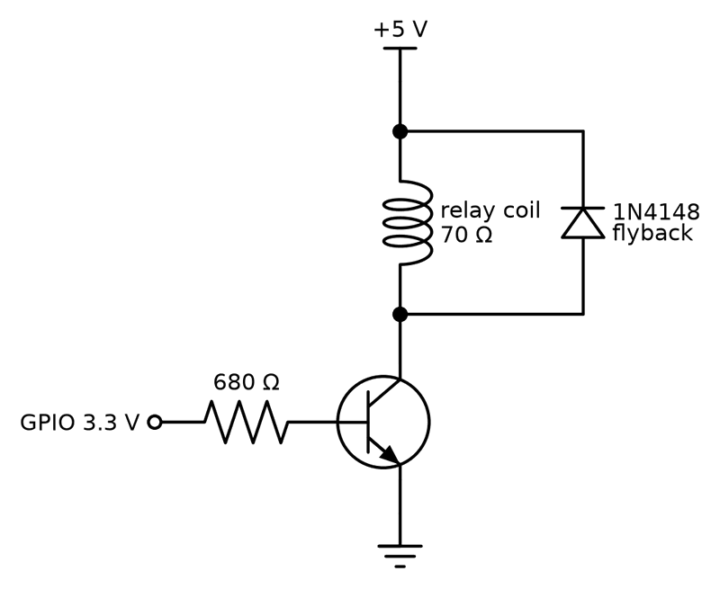
Figure 24.3 — A relay driven from a 3.3 V GPIO. The NPN transistor sinks the coil current; the flyback diode gives that current a path when the transistor turns off, so the collector rises only one diode drop above 5 V.
The diode slows the release, because the current that holds the armature now decays gradually instead of stopping. Where release speed matters, a Zener diode in series with the flyback diode, or a TVS diode, lets the voltage rise to a chosen clamp and removes the energy faster. The same protection belongs across every inductive load a logic circuit switches: a brushed motor driven by one transistor, a solenoid valve, or the coil of a contactor. The water valve of a smart garden controller is exactly such a load.
Worked Example 24.5
Problem: A 5 V relay (the common SRD-05VDC-SL-C) has a 70 Ω coil and must be driven from a 3.3 V GPIO through an NPN transistor with β ≥ 100. Find the coil current, choose the base resistor for a forced β of 20, and size the flyback diode.
Solution: The coil current is 5 V/70 Ω = 71 mA, ignoring the transistor's 0.1 to 0.2 V of saturation voltage. A forced β of 20, well below the minimum of 100, guarantees saturation: I_B = 71/20 = 3.6 mA, and R_B = (3.3 − 0.7)/3.6 mA = 730 Ω; the standard 680 Ω gives 3.8 mA, within a typical GPIO's drive. The flyback diode carries the full 71 mA at the instant of turn-off, decaying from there, so a small-signal 1N4148 is adequate; a 1N4007 is the usual choice for coils of half an amp or more. Check: without the diode, interrupting 71 mA in a fraction of a microsecond in a coil of tens of millihenries would demand thousands of volts; in practice the transistor breaks down first and degrades a little each time.

24.7 Servos, Steppers, and Small Robots
A hobby servo is a complete position loop in a box: a small DC motor, a gearbox, a potentiometer on the output shaft, and a control chip that compares the potentiometer with the command and drives an H-bridge. The command is a pulse, typically 1.0 to 2.0 ms long, repeated every 20 ms (Figure 24.4); 1.5 ms is center, and the ends map to roughly ±45° to ±90° depending on the servo. The servo's own loop runs inside, so the controller's only job is to produce accurate pulses, which any microcontroller's PWM block does in hardware.
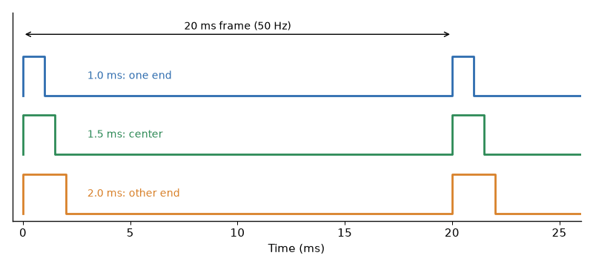
Figure 24.4 — Servo command pulses. The frame repeats every 20 ms; the pulse width, from about 1.0 to 2.0 ms, sets the angle, with 1.5 ms at center.
A stepper motor needs no position sensor at all. Its rotor moves one step, 1.8° (200 steps per revolution) for the most common type, each time the driver advances the current pattern in its windings, so counting steps counts position, as long as the load never demands more torque than the motor can give; when it does, the motor skips steps without telling anyone. Stepper drivers chop the winding current to a set limit, the current loop of Section 24.4 in miniature, and microstep by setting intermediate currents: at 1/16 microstepping, a 200-step motor takes 3200 microsteps per revolution. A star-tracker telescope mount and a 3D printer depend on this open-loop counting; the inexpensive 28BYJ-48 geared stepper of many starter kits is a slow, low-torque version of the same idea.
Robots and RC models combine all three motor types. A rover drives its wheels with DC motors through H-bridges (a dual-bridge chip such as the DRV8833 for small motors), pans a sensor with a servo, and positions an arm with steppers. An RC car's electronic speed controller (ESC) is an H-bridge or a three-phase brushless driver that accepts the same 1 to 2 ms servo pulse as its throttle command. The code that generates the pulses and step trains with hardware timers rather than software delays is in Book 8, Chapter 7, Timers and PWM.
Worked Example 24.6
Problem: A Raspberry Pi Pico runs its RP2040 at 125 MHz. Configure one PWM slice for a servo: choose the clock divider and wrap value for a 50 Hz frame with 1 µs resolution, and find the counter level for a 1.5 ms pulse.
Solution: A divider of 125 makes the counter tick at 125 MHz/125 = 1 MHz, so one count is 1 µs (the RP2040's PWM divider accepts values up to 255). A 20 ms frame is then 20,000 counts; the counter runs from 0 to its wrap value inclusive, so wrap = 19,999. The level for 1.5 ms is 1500 counts, and the full 1.0 to 2.0 ms range spans 1000 counts. Check: 1 MHz/20,000 = 50 Hz. If the 1.0 to 2.0 ms range maps to 90° of travel, each count is 0.09°, finer than the servo's own gearbox can resolve.
Worked Example 24.7
Problem: A stepper with 200 steps per revolution drives an 8 mm-per-revolution lead screw through a driver set to 1/16 microstepping. Find the distance per microstep and the microstep rate for 25 mm/s.
Solution: There are 200 × 16 = 3200 microsteps per revolution, so each moves 8 mm/3200 = 2.5 µm. 25 mm/s is 25/8 = 3.125 rev/s, or 3.125 × 3200 = 10,000 microsteps per second. Check: 10,000 × 2.5 µm = 25 mm/s. Whether the motor can follow at 3.1 rev/s depends on its torque-speed curve and supply voltage: the winding inductance limits how fast the current can reverse, the same L di/dt that the flyback diode handles.
Key Idea
Every coil a transistor switches needs a path for its current at turn-off. Servos close their own loop from a pulse width; steppers count steps with no sensor and lose position silently if overloaded.
From the Bench
Insert dead time between turning one switch off and its partner on, so the two in a leg are never on together, even briefly. The required time depends on the switching speed of the actual transistors and gate drivers, and is typically hundreds of nanoseconds for MOSFETs. Then check with a current probe on the supply that no shoot-through spikes remain.
On the Job
Motor-drive engineering is a field of its own, spanning robots, e-bikes, pumps, and electric vehicles. At work the H-bridge is usually an integrated motor-driver or gate-driver IC (a DRV8833-class part for small motors, a dedicated stepper driver with current chopping), and the engineering is choosing it, protecting it with flyback paths, current limits, and thermal margin, and proving it on the bench with a current probe. Learn the bridge here, buy the IC at work.

24.8 Audio Power Amplifiers: AB, D, G, and H
An audio power amplifier must deliver a low-distortion voltage and current to a speaker. Class AB uses complementary output devices biased slightly on, reducing the crossover notch of ideal class B while wasting more power at idle. Its output devices dissipate the difference between the supply voltage and the speaker voltage, so heat sinking and safe operating area matter.
Class D switches its output devices between supply rails. A modulator, often pulse-width modulation, makes the switching pattern represent the audio waveform; the output network and speaker recover the audio band. The required filter depends on the amplifier topology, switching frequency, load, and emissions limits. Some products are specified for filterless use, but that is a device-level design condition, not a general rule. Switching edges, dead time, layout, speaker cable, and load impedance affect distortion and electromagnetic interference.
Classes G and H describe ways to reduce the loss of a linear output stage by changing its supply rails. A common class-G design selects a higher rail when the signal needs more headroom; a common class-H design tracks or modulates the rail more continuously. Naming and implementation vary across products. These supply strategies can be combined with a linear output stage; they do not describe the same switching operation as class D. Class T was Tripath's trade name for a proprietary class-D implementation, not a separate basic output conduction class.
Worked Example 24.8
A bridge-tied-load (BTL) amplifier produces a 10 V peak differential sine wave across an 8 ohm speaker. Find ideal output power and peak and rms speaker current.
The load sees the difference between two active outputs, so use differential voltage: P = Vpk^2/(2R) = 10^2/(2 x 8) = 6.25 W. The peak current is Ipk = Vpk/R = 1.25 A, and the sine-wave rms current is Ipk/sqrt(2) = 0.884 A. This is ideal load power; real output is limited by supply headroom, device current and thermal limits, distortion, and protection. Neither BTL speaker terminal is ground; connecting a grounded instrument or load there can short an output.
Treat this as an output-stage and load calculation, not a complete amplifier design. Choose an actual IC or discrete topology from its datasheet and reference design, including its load, output network, supply, layout, thermal, and protection conditions. Book 6 covers the energy conversion that supplies amplifier rails; this chapter covers how the output stage drives the speaker.

Practice Problems
- A 12 V bridge using bipolar PWM at 25 kHz drives a motor with L = 0.5 mH. Find the ripple current at zero average voltage.
- The same bridge is switched to sign-magnitude PWM. Find the worst-case ripple current and the duty cycle at which it occurs.
- A motor has R = 2 Ω, L = 3 mH, K_t = K_e = 0.1, and J = 5 × 10⁻⁴ kg·m². Find τ_e, τ_m, and the no-load speed at 48 V.
- For the motor of the previous problem, design a PI current loop with a 500 Hz crossover. Give K_p in V/A and K_i in V/(A·s).
- A 48 V drive with 1 µs dead time switches at 16 kHz. Estimate the dead-time voltage error of one switching leg.
- Explain in a sentence or two why a brake chopper is unnecessary when the drive runs from a battery but essential on a rectified mains supply.
- A 12 V relay with a 400 Ω coil is driven from a 3.3 V GPIO through an NPN transistor. Find the coil current and choose a standard base resistor for a forced β of about 20.
- A 12 V solenoid valve for a smart garden controller draws 0.5 A through a logic-level MOSFET with R_DS(on) = 50 mΩ. Find the MOSFET's dissipation and choose a flyback diode.
- Using the PWM setup of Worked Example 24.6, find the levels for 1.0 ms and 1.25 ms pulses, and the angle at 1.25 ms if 1.0 to 2.0 ms spans 0° to 180°.
- A 200-step motor at 1/8 microstepping turns a 2 mm-per-revolution lead screw. Find the distance per microstep and the microstep rate for 5 mm/s.

What You’ll Actually Use
Everyday working tools
- The four switch states and which are forbidden.
- Dead time.
- Motor back-EMF and torque constants.
- Flyback diodes on every coil; servo pulse timing; stepper microstep arithmetic.
Mostly for exams and deeper study
- Detailed regenerative-braking energy analysis.

Chapter 25 — The Root Locus
Turn up a loop's gain and its poles move. Where they go decides whether the system settles, rings or runs away. The root locus draws that journey on one plot, and Walter Evans introduced it in 1948. He later sold a small plastic calculating aid, the Spirule, to help engineers draw it by hand.
Where you meet this: Control design tools, servo tuning, and reasoning about how gain changes affect stability.
Chapters 17 and 18 designed loops by choosing gains and checking the result. The root locus shows, in one picture, where every closed-loop pole goes as one gain is raised from zero to infinity. It was introduced by Walter Evans in 1948 and remains the quickest way to see whether a loop can be made fast and well damped by gain alone, or whether it needs the lead, lag, or PID shaping of Chapter 18. This chapter states the rules that sketch the locus and uses them on two plants whose numbers recur in the next chapter.

25.1 The Characteristic Equation
With a controller gain K in series with a plant G(s) and unity feedback, the closed-loop transfer function is KG/(1 + KG). Its poles are the roots of 1 + KG(s) = 0. Writing G(s) = N(s)/D(s), the poles satisfy D(s) + K N(s) = 0. At K = 0 they are the open-loop poles, the roots of D. As K grows they move, and as K → ∞ they approach the open-loop zeros, the roots of N, or go off to infinity along straight lines. The locus is the set of all points the poles can occupy.
1 + K G(s) = 0 ⇔ D(s) + K N(s) = 0
A point s lies on the locus if the angle of G(s) is 180° (an odd multiple of it). The gain that places a pole there is then K = 1/|G(s)|. Those two conditions, angle and magnitude, are all the rules below encode.

25.2 Sketching Rules
Five rules give a sketch good enough for design. First, the locus has as many branches as the plant has poles, starting at the poles and ending at the zeros or at infinity. Second, on the real axis the locus lies to the left of an odd number of real poles and zeros. Third, the branches that go to infinity follow asymptotes at angles (2k + 1)180°/(n − m), where n and m are the numbers of poles and zeros, and the asymptotes meet at the centroid σ = (Σ poles − Σ zeros)/(n − m). Fourth, where two branches meet on the real axis and leave it, the breakaway point is a root of dK/ds = 0. Fifth, the crossing of the imaginary axis, if any, is found from the Routh-Hurwitz test, as in Worked Example 25.2, or by substituting s = jω.
asymptote angles = (2k + 1)·180°/(n − m), σ = (Σp − Σz)/(n − m)
Worked Example 25.1
Problem: A position loop has the plant G(s) = 1/(s(s + 4)). Sketch the locus, find the gain at the breakaway point, and find K for a damping ratio of 0.707.
Solution: The characteristic equation is s² + 4s + K = 0. At K = 0 the poles are at 0 and −4; on the real axis the locus lies between them. They meet at s = −2 when K = 4 and then leave the axis vertically, along the line Re(s) = −2, since the sum of the roots is fixed at −4. For ζ = 0.707, 2ζω_n = 4 gives ω_n = 2.83 rad/s and K = ω_n² = 8. The overshoot is 4.3% and the 2% settling time 4/(ζω_n) = 2 s. No gain makes it settle faster than 2 s, because the real part of the poles cannot pass −2: speed must come from shaping, not from gain.

25.3 A Third Pole
Most real plants have more poles than the two of a textbook motor, and the third pole changes the picture: with three poles and no zeros, the asymptotes leave at ±60°, and the two dominant branches eventually cross into the right half-plane. There is now a largest stable gain, and the useful range of gain lies well below it.
Worked Example 25.2
Problem: For G(s) = 1/(s(s + 2)(s + 10)), find the asymptotes, the breakaway point, the gain at which the loop becomes unstable, and the frequency of oscillation there.
Solution: There are three poles and no zeros, so the asymptotes are at ±60° and 180°, meeting at σ = (0 − 2 − 10)/3 = −4. The real-axis locus lies between 0 and −2 and to the left of −10. The breakaway point solves d/ds[s(s + 2)(s + 10)] = 3s² + 24s + 20 = 0, giving s = −0.945 (the other root, −7.06, is not on the locus), with K = 0.945 × 1.055 × 9.055 = 9.03. The characteristic polynomial is s³ + 12s² + 20s + K. The Routh array's s¹ entry is (240 − K)/12, which vanishes at K = 240, and the auxiliary equation 12s² + 240 = 0 gives s = ±j4.47 rad/s. Above K = 240 the loop oscillates and grows.
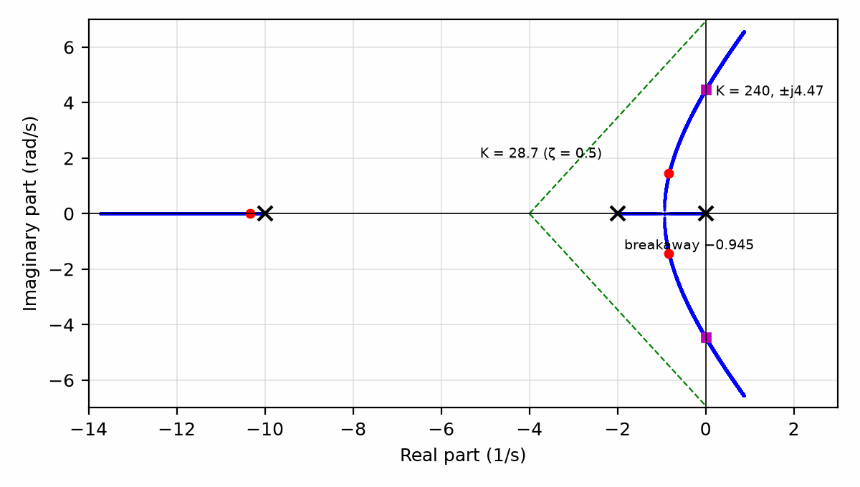
Figure 25.1 — Root locus of G(s) = 1/(s(s + 2)(s + 10)), with the breakaway at −0.945, the asymptotes from σ = −4, the ζ = 0.5 operating point at K ≈ 28.7, and the imaginary-axis crossing at K = 240.
Worked Example 25.3
Problem: For the same plant, find the gain that gives the dominant poles a damping ratio of 0.5, and check that the third pole is far enough away to be ignored.
Solution: Searching along the ζ = 0.5 line, where the poles are at angles of 120° from the positive real axis, the angle condition is met at s = −0.833 ± j1.443, so ω_n = 1.67 rad/s, and the magnitude condition gives K = 28.7. The third root is at −10.33, more than twelve times further from the origin than the real part of the dominant pair, so the step response is very nearly second order: about 16% overshoot and a settling time of 4/0.833 = 4.8 s. The gain margin at this K is 240/28.7 = 8.4, or 18.4 dB, a number Chapter 26 will return to.
Key Idea
The locus shows what gain can and cannot do. If the desired closed-loop poles lie on the locus, a gain alone achieves them; if they do not, a zero from lead or PD control must bend the locus toward them, and a pole from lag or PI control near the origin improves accuracy without moving the locus much elsewhere.

25.4 Bending the Locus
Adding a zero pulls the locus toward it. A lead compensator places a zero closer to the origin than its pole, so the net effect near the dominant poles is a zero, and the asymptotes move left. In the plant of Worked Example 25.2, a compensator zero at −2 cancels the pole there, leaving the poles at 0 and −10 and the compensator's own pole, placed here at −20; the dominant branches then break away at −4.23, the root of 3s² + 60s + 200 = 0, instead of −0.945 and the settling time can fall several-fold. A lag compensator places a pole and zero close together near the origin, which leaves the locus almost unchanged but raises the low-frequency gain, reducing the steady-state error of Chapter 17. These are the same compensators Chapter 18 introduced through the Bode plot, now seen through the poles they move.
Common Misconception
Cancelling a plant pole with a compensator zero does not remove the pole from the system. The cancelled pole still governs how the plant responds to disturbances that enter at its input, and an exact cancellation is never achieved in practice. Cancelling a slow, stable pole is common and safe; cancelling an unstable or lightly damped one is not, because the hidden mode remains and grows or rings.
From the Bench
Today the locus is drawn by software, so the value of the sketching rules is judgment: knowing that adding a pole bends the locus toward instability and adding a zero pulls it back. Use the plot to choose gain ranges, then confirm on the real system with a step test.

Practice Problems
- For G(s) = 1/(s(s + 6)), find the gain that gives ζ = 0.707.
- For the same plant, find the breakaway point and the gain there.
- Find the asymptote centroid and angles for G(s) = 1/(s(s + 1)(s + 5)).
- Find the gain and frequency at which the loop of the previous problem becomes unstable.
- What overshoot does a second-order system with ζ = 0.5 have?
- On what parts of the real axis does the locus of G(s) = 1/(s(s + 2)(s + 10)) lie?

What You’ll Actually Use
Everyday working tools
- Reading a computed root locus.
- How poles and zeros bend the locus.
Mostly for exams and deeper study
- The full set of hand-sketching rules and their proofs.

Chapter 26 — Stability Margins, Nyquist, and the Sensitivity Peak
A loop can be stable on paper and still ring every time someone bumps it. Stability margins measure how close a loop is to the edge, and the sensitivity peak tells you how much it will amplify disturbances on the way.
Where you meet this: Power-supply loop measurements, servo tuning, and any specification that says 'phase margin of at least 45°'.
The root locus of Chapter 25 asks where the poles are. The frequency-response view asks how close the loop is to becoming unstable, and that question has a practical edge: the plant on the bench is never exactly the model, so the designer needs to know how much error the loop can absorb. Gain margin, phase margin, delay margin, and the peak of the sensitivity function are four answers. This chapter defines them, connects them through the Nyquist criterion, and computes them for the plant of Chapter 25, following the treatment in Åström and Murray.

26.1 The Nyquist Criterion in Words
Plot the loop transfer function L(jω) = KG(jω) as ω runs from −∞ to +∞; the curve is the Nyquist plot. The closed loop 1/(1 + L) has a pole wherever L = −1, so the point −1 is critical. Nyquist's theorem counts: the number of unstable closed-loop poles Z equals the number of clockwise encirclements N of −1 plus the number of unstable open-loop poles P. For the usual stable plant, P = 0, and the loop is stable exactly when the curve does not encircle −1. For an unstable plant, such as an inverted pendulum, the curve must encircle −1 counterclockwise once for each unstable pole.
Z = N + P (closed-loop RHP poles = clockwise encirclements of −1 + open-loop RHP poles)
The theorem's practical value is that it works from measured frequency response. A loop whose model is uncertain but whose L(jω) has been measured with a network analyzer, as Section 18.6 described, can be judged without ever writing its poles.

26.2 Gain, Phase, and Delay Margins
The gain margin is the factor by which the gain could rise before the curve passes through −1; it is read at the phase-crossover frequency, where the phase is −180°. The phase margin is the extra phase lag that would bring the curve through −1 at the gain-crossover frequency ω_c, where |L| = 1. Because a pure time delay τ adds phase lag ωτ without changing the gain, the phase margin also sets how much unmodeled delay the loop can tolerate: the delay margin is the phase margin in radians divided by ω_c.
GM = 1/|L(jω₁₈₀)|, PM = 180° + ∠L(jω_c), τ_max = PM(rad)/ω_c
Worked Example 26.1
Problem: For L(s) = K/(s(s + 2)(s + 10)), find the gain margin, crossover frequency, phase margin, and delay margin for K = 28.7, the ζ = 0.5 gain of Chapter 25, and for K = 60.
Solution: The phase reaches −180° at ω = √20 = 4.47 rad/s, where |s(s + 2)(s + 10)| = 240, so GM = 240/K. For K = 28.7, GM = 8.4 (18.4 dB); |L| = 1 at ω_c = 1.22 rad/s, where the phase is −128.3°, so PM = 51.7°, and the delay margin is 0.903 rad/1.22 rad/s = 0.74 s. For K = 60, GM = 4.0 (12.0 dB), ω_c = 2.05 rad/s, PM = 32.7°, and the delay margin falls to 0.28 s. Doubling the gain made the loop about 1.7 times faster at crossover but cut its tolerance to delay by a factor of 2.7.

26.3 The Sensitivity Function
The sensitivity function S = 1/(1 + L) tells how much the loop reduces disturbances and plant variations at each frequency: where |S| < 1, feedback helps; where |S| > 1, it amplifies. Its peak, M_s, is the inverse of the shortest distance from the Nyquist curve to −1, so it is a single number that captures both margins at once. Bode's integral shows that the area of ln|S| over frequency is zero for most stable loops, so pushing the sensitivity down at low frequency must push it up somewhere else, a fact sometimes called the waterbed effect.
S = 1/(1 + L), M_s = max|S(jω)| = 1/min|1 + L(jω)|
A bound on M_s guarantees both margins. If the curve stays at least 1/M_s from −1, then GM ≥ M_s/(M_s − 1) and PM ≥ 2 arcsin(1/(2M_s)). Åström and Murray recommend M_s between about 1.2 and 2 for most designs.
Worked Example 26.2
Problem: Find M_s for the loop of Worked Example 26.1 at K = 28.7, 60, and 120, and the margins it guarantees for M_s = 2.
Solution: Computing |1/(1 + L(jω))| over frequency gives M_s = 1.55 at K = 28.7, 2.20 at K = 60, and 4.21 at K = 120. For M_s = 2, the guaranteed margins are GM ≥ 2 (6.0 dB) and PM ≥ 29.0°. The K = 28.7 design, with M_s = 1.55, guarantees GM ≥ 2.82 (9.0 dB) and PM ≥ 37.6°; its actual margins of 18.4 dB and 51.7° are better than the bound, as they must be. At K = 120, an M_s of 4.2 means that a disturbance near 3 rad/s is amplified four times: the loop is still stable, with a 6 dB gain margin, but it is no longer doing its job near crossover.
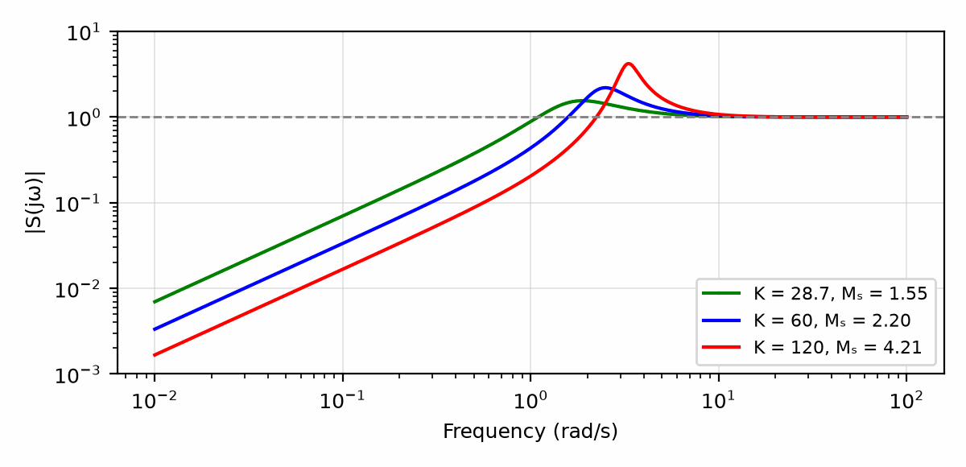
Figure 26.1 — Sensitivity magnitude |S(jω)| for L = K/(s(s + 2)(s + 10)) at K = 28.7, 60, and 120. The peaks M_s = 1.55, 2.20, and 4.21 lie near crossover; all three curves are below 1 at low frequency.
Key Idea
The sensitivity peak is the margin that matters. Gain and phase margins each test one direction of error; M_s, the inverse of the closest approach of the Nyquist curve to −1, bounds both and also measures how much the loop amplifies disturbances near crossover.

26.4 Delay in Digital Loops
Chapter 19 showed that a sampled controller adds about 1.5 sample periods of delay. The delay margin turns that into a design rule: the loop's phase margin, in radians, divided by its crossover frequency must exceed the total delay of sampling, computation, filtering, and the actuator, with room to spare. A loop with 45° of phase margin at 10 rad/s tolerates 79 ms of delay; at 100 rad/s it tolerates 7.9 ms. The faster the loop, the faster the sample rate it needs, which is why the current loop of Chapter 24 runs at the switching frequency and the speed loop above it can run slower.
Common Misconception
A large gain margin does not by itself mean a robust loop. A loop can have a gain margin of 20 dB and still pass close to −1 at some other frequency, with a small phase margin or a large M_s, especially when the plant has lightly damped resonances. Always look at the closest approach to −1, not only at the two crossover frequencies.
From the Bench
Measure loop gain on the real hardware by injecting a small signal into the loop through a resistor (often 10 to 50 Ω) and comparing the signal on either side with a network or frequency-response analyzer. Simulations miss parasitic delays and component tolerances that a measurement catches.

Practice Problems
- What do Z, N, and P stand for in the Nyquist relation, and what must hold for a stable plant?
- Find the gain margin of L(s) = K/(s(s + 2)(s + 10)) at K = 48, in decibels.
- A loop has a phase margin of 45° at ω_c = 10 rad/s. Find its delay margin.
- Find the gain and phase margins guaranteed by M_s = 1.4.
- Find the delay margin for the K = 28.7 loop of Worked Example 26.1.
- Why does the Bode sensitivity integral imply a waterbed effect?

What You’ll Actually Use
Everyday working tools
- Gain and phase margin from a Bode plot.
- Delay as lost phase margin.
- Peak sensitivity as a robustness number.
Mostly for exams and deeper study
- The Nyquist criterion in its full complex-analysis form.

Chapter 27 — Oscillators: Feedback That Is Meant to Ring
Every engineer's first oscillator is an accident: an amplifier that rings because its feedback came back in phase. This chapter does it on purpose, which is harder than it sounds, because a good oscillator must start reliably and then stop growing.
Where you meet this: Clocks in every digital system, crystal oscillators, function generators, and the RC oscillators inside microcontrollers.
Chapters 11 to 18 worked to keep loops away from the point where the loop gain is −1. An oscillator is a loop designed to sit exactly there. Every clock in Chapter 2's digital circuits, every carrier in a radio, and every timer that blinks a light comes from a circuit that turns its own noise into a steady waveform. This chapter states the condition for oscillation, builds the two families of oscillator, linear and relaxation, and sizes each with numbers.

27.1 The Barkhausen Condition
Break a feedback loop and send a sine wave around it. If it returns with exactly the same amplitude and phase, the loop can sustain it without any input. That is the Barkhausen condition: the loop gain Aβ equals one, with a total phase shift of 0° or a multiple of 360°. A practical oscillator is designed with a loop gain slightly above one at the wanted frequency, so that noise grows into an oscillation, and some nonlinearity then limits the amplitude, reducing the effective gain to exactly one.
A(jω₀) β(jω₀) = 1 (|Aβ| = 1, ∠Aβ = 0° or 360°)
The frequency is set by the network β, which has the right phase at only one frequency. The amplifier supplies the gain to make up the network's loss. The quality of the oscillator, its frequency stability and its phase noise as Book 4 measures it, depends on how sharply β's phase changes with frequency near ω₀: an RC network changes slowly, an LC tank faster, and a quartz crystal, with a Q of tens of thousands, fastest of all.

27.2 The Wien-Bridge Oscillator
The Wien network is a series RC in the forward path and a parallel RC to ground. At ω₀ = 1/(RC) its phase shift is zero and its gain is exactly 1/3. A noninverting op-amp stage with a gain of 3, set by R_f = 2R_g, completes the loop. Because the required gain is exact, a fixed resistor ratio either fails to start or grows until the output clips; real Wien oscillators use a lamp, a thermistor, a JFET, or diodes to reduce the gain as the amplitude grows. Hewlett's 1939 audio oscillator, the first product of Hewlett-Packard, used a small incandescent lamp for exactly this purpose.
f₀ = 1/(2πRC), β(f₀) = 1/3, A = 1 + R_f/R_g = 3
Worked Example 27.1
Problem: A Wien-bridge oscillator uses R = 10 kΩ and C = 10 nF. Find its frequency and the feedback resistor needed with R_g = 4.7 kΩ.
Solution: f₀ = 1/(2π × 10⁴ × 10⁻⁸) = 1,592 Hz. R_f = 2R_g = 9.4 kΩ for a gain of exactly 3. In practice R_f is made slightly larger, perhaps 10 kΩ, so the oscillation starts reliably, and a pair of back-to-back diodes in series with a resistor across part of R_f lowers the gain as the amplitude grows, holding the output at a level set by the diode drops.

27.3 Phase-Shift and LC Oscillators
Three cascaded RC sections with an inverting amplifier form the phase-shift oscillator. Each section adds lag until the total is 180° at f₀ = 1/(2π√6·RC), where the network attenuates by a factor of 29, so the amplifier needs a gain of at least 29. At radio frequencies, an LC tank provides the frequency. In the Colpitts oscillator, the tank's capacitance is split into two capacitors in series, whose midpoint supplies the feedback; the frequency is that of L with the series combination of C₁ and C₂. Book 4 treats these oscillators' phase noise; here the point is that the same Barkhausen condition governs them all.
Phase shift: f₀ = 1/(2π√6·RC), |A| ≥ 29; Colpitts: f₀ = 1/(2π√(L·C₁C₂/(C₁ + C₂)))
Worked Example 27.2
Problem: Find the frequency of a phase-shift oscillator with R = 10 kΩ and C = 10 nF, and of a Colpitts oscillator with L = 1 µH and C₁ = C₂ = 200 pF.
Solution: The phase-shift oscillator runs at 1/(2π × 2.449 × 10⁴ × 10⁻⁸) = 650 Hz, with an amplifier gain of at least 29. For the Colpitts, the series capacitance is 100 pF, so f₀ = 1/(2π√(10⁻⁶ × 10⁻¹⁰)) = 15.9 MHz.

27.4 Relaxation Oscillators
A relaxation oscillator does not use a resonant network. It charges a capacitor until a threshold is reached, switches, and discharges it to a second threshold. The Schmitt trigger of Chapter 16 provides the two thresholds. With an op-amp comparator whose positive feedback divider has ratio β = R₂/(R₁ + R₂), and an RC from output to the inverting input, the capacitor swings between +βV and −βV, and each half cycle takes RC ln((1 + β)/(1 − β)).
T = 2RC ln((1 + β)/(1 − β)); β = 0.5 gives T = 2.197 RC
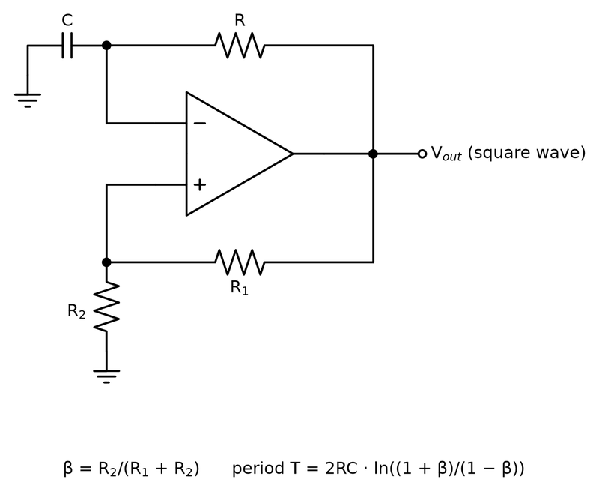
Figure 27.1 — The op-amp relaxation oscillator: a Schmitt trigger that keeps flipping because its own output charges a capacitor toward the other threshold.
Worked Example 27.3
Problem: An op-amp relaxation oscillator uses R = 10 kΩ, C = 100 nF, and a hysteresis divider with β = 0.5. Find the period and frequency.
Solution: T = 2 × 10⁴ × 10⁻⁷ × ln(1.5/0.5) = 2 × 10⁻³ × 1.0986 = 2.197 ms, so f = 455 Hz. The frequency depends on the ratio of thresholds, not on the supply voltage, as long as the output swings symmetrically.
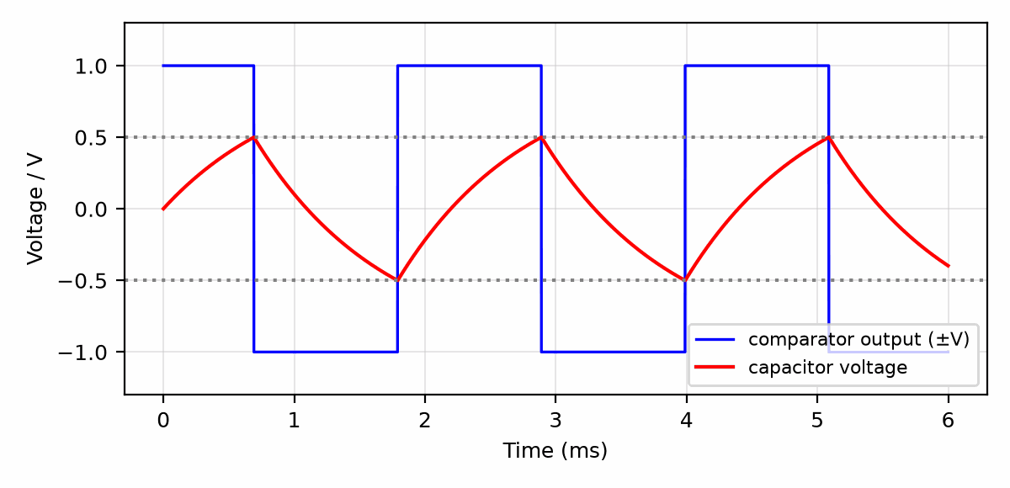
Figure 27.2 — Relaxation oscillator waveforms for R = 10 kΩ, C = 100 nF, β = 0.5: the capacitor voltage ramps exponentially between ±βV while the comparator output switches between ±V, with a period of 2.197 ms.
The 555 timer, introduced in 1972 and still in production from several makers, is a packaged relaxation oscillator. Two comparators at one-third and two-thirds of the supply, a flip-flop, and a discharge transistor charge C through R₁ + R₂ and discharge it through R₂. Its frequency is 1.44/((R₁ + 2R₂)C), and its duty cycle (R₁ + R₂)/(R₁ + 2R₂) is always above 50% in the basic circuit. With R₁ = 1 kΩ, R₂ = 10 kΩ, and C = 10 nF it runs at 6,857 Hz with a duty cycle of 52.4%.
Key Idea
An oscillator is a loop with a gain of exactly one and a phase of exactly zero at one frequency. The network sets the frequency, the amplifier makes up the loss, and a nonlinearity holds the amplitude; the sharper the network's phase versus frequency, the more stable the oscillator.

27.5 The Crystal Oscillator
Most microcontroller clocks that need accuracy start from a quartz crystal in a Pierce oscillator: an inverting gate biased into its linear region, the crystal across it, and two capacitors to ground. The crystal is cut to resonate at its marked frequency when it sees a specified load capacitance C_L, typically 8 to 20 pF. The two capacitors appear in series, plus the stray capacitance of the pins and traces. With 22 pF on each side and 5 pF of stray, C_L = 22 × 22/44 + 5 = 16 pF. Choosing them wrong pulls the frequency by tens of parts per million, enough to break a UART at the edge of its tolerance or a radio's channel accuracy in Book 5.
Common Misconception
An oscillator that works on the bench is not proven. The startup gain margin shrinks at low temperature and low supply voltage, the crystal's drive level can be exceeded, and a scope probe's capacitance can pull or even start an oscillator that would otherwise fail. Verify startup at the corners of temperature and supply, and measure frequency with a buffered output or a low-capacitance probe.

27.6 Projects Without a Controller: Synthesizers, Pedals, Amplifiers, and Nixies
The oscillators of this chapter are the heart of a family of projects that need no microcontroller at all, and they remain some of the most satisfying builds in electronics. A 555 astable with a potentiometer in R₂ is a one-chip synthesizer voice; two 555s, one modulating the other through its control-voltage pin, make the classic noise box known as the Atari Punk Console. A CD40106 hex Schmitt inverter makes six relaxation oscillators from one resistor and one capacitor each. A full analog synthesizer is built from three ideas: an oscillator whose frequency follows a control voltage (a VCO), a filter whose corner follows another (the sections of Chapter 6 with a variable element), and an amplifier whose gain follows a third.
Guitar effects pedals use this book's op-amp circuits on purpose outside their linear range. An overdrive or fuzz is a gain stage driving a pair of diodes that clip the peaks, the headroom of Chapter 1 made musical; a tremolo is a low-frequency oscillator modulating a gain; and a delay repeats the sample-and-hold of Chapter 22 thousands of times, in a bucket-brigade chip or a converter and memory. A small audio power amplifier such as the LM386 completes the chain to a speaker. A Nixie-tube clock combines the CD4060 time base of Section 4.5 with a high-voltage supply: its tubes need roughly 170 V to strike and then run at a few milliamps through an anode resistor. That supply can deliver a painful and dangerous shock; Book 6 covers the converter that makes it.
Worked Example 27.4
Problem: Tune a 555 synthesizer voice to concert A, 440 Hz, with C = 10 nF and R₁ = 1 kΩ. Find R₂, choose a standard value, and find the resulting frequency and duty cycle.
Solution: From f = 1.44/((R₁ + 2R₂)C), R₁ + 2R₂ = 1.44/(440 × 10⁻⁸) = 327.3 kΩ, so R₂ = (327.3 − 1)/2 = 163 kΩ. The nearest E24 value, 160 kΩ, gives f = 1.44/(321 kΩ × 10 nF) = 449 Hz, about 34 cents sharp, so a real synthesizer uses 150 kΩ in series with a 20 kΩ trimmer and tunes by ear or with a tuner. The duty cycle is (1 + 160)/(1 + 320) = 50.2%, close to a square wave, which is rich in odd harmonics. Check: 1.44/(327.3 kΩ × 10 nF) = 440 Hz.
Key Idea
An oscillator, a filter, and a gain stage, each with a knob, are a synthesizer; a gain stage with diodes is a pedal. No code is needed, and the analog-first rule says to build them first.
From the Bench
Crystal oscillators fail in quiet ways. Use the load capacitance the crystal is specified for (including about 2 to 5 pF of board stray), keep the traces short and guarded by ground, and check start-up at cold temperature and low supply voltage, where gain margin is smallest.

Practice Problems
- Find the frequency of a Wien-bridge oscillator with R = 4.7 kΩ and C = 22 nF.
- Find the frequency of a relaxation oscillator with R = 10 kΩ, C = 10 nF, and β = 1/3.
- Find the frequency and duty cycle of a 555 with R₁ = R₂ = 10 kΩ and C = 100 nF.
- Find the frequency of a Colpitts oscillator with L = 10 µH and C₁ = C₂ = 1 nF.
- Find the load capacitance of a Pierce oscillator with 33 pF capacitors and 4 pF of stray.
- Why does a Wien-bridge oscillator need amplitude control?
- A 555 voice uses C = 22 nF and R₁ = 1 kΩ. Find R₂ for 262 Hz (middle C), and the frequency with the nearest E24 value.
- An IN-14 Nixie tube runs at about 2.5 mA and sustains about 140 V once lit. Find the anode resistor from a 180 V supply, its dissipation, and the tube's own dissipation.

What You’ll Actually Use
Everyday working tools
- The Barkhausen condition.
- Relaxation oscillator period.
- Crystal load capacitance.
- The 555 as a tone generator; diode clipping in pedals.
Mostly for exams and deeper study
- Nonlinear amplitude-stabilization analysis.

Chapter 28 — Timing: Setup, Hold, and Metastability
A flip-flop asked to decide whether data changed immediately before or immediately after the clock can, rarely, fail to decide for a while. That state, metastability, can't be eliminated, only made rare enough, and 'rare enough' can be calculated.
Where you meet this: FPGA timing reports, microcontroller inputs from buttons and other clock domains, and every bus crossing between chips.
Chapter 4 built sequential circuits from flip-flops as if each one sampled its input at an instant. A real flip-flop needs its input to be steady for a short time before and after the clock edge, its output changes a little after the edge, and the logic between flip-flops takes time to settle. Those few numbers set the fastest clock a design can use and decide whether it works at all. When an input is not synchronized to the clock, as with a button, a sensor, or a signal from another clock domain, a flip-flop can be caught halfway and take an unpredictable time to decide. This chapter puts numbers on both problems.

28.1 Setup and Hold
A flip-flop's datasheet gives three times. The setup time t_su is how long before the clock edge the input must be stable; the hold time t_h is how long after the edge it must remain stable; the clock-to-output delay t_cq is how long after the edge the output changes. Between two flip-flops sits combinational logic with a longest (propagation) delay t_pd and a shortest (contamination) delay t_cd. Clock skew t_skew, the difference in clock arrival time between the two flip-flops, can help one check and hurt the other.
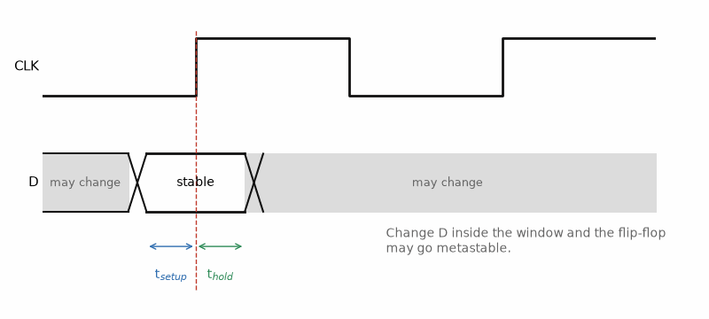
Figure 28.1 — The rule a flip-flop lives by: data must be stable for the setup time before the clock edge and the hold time after it.
The setup check asks whether data launched at one edge arrives before the next edge, less the setup time. The hold check asks whether data launched at an edge arrives too soon, corrupting the value the receiving flip-flop is still capturing from the same edge. A setup failure can be fixed by slowing the clock; a hold failure cannot, because it does not depend on the clock period, which is why hold violations are the more dangerous of the two.
Setup: T_clk ≥ t_cq + t_pd + t_su + t_skew, Hold: t_cq + t_cd ≥ t_h + t_skew
Worked Example 28.1
Problem: A path has t_cq = 0.5 ns, t_pd = 6.0 ns, t_su = 0.3 ns, and 0.2 ns of adverse skew. Find the minimum clock period and the maximum frequency. If the same flip-flops have t_h = 0.2 ns and the shortest path has t_cq = 0.3 ns and t_cd = 0.1 ns with 0.3 ns of skew in the other direction, does the hold check pass?
Solution: T_clk ≥ 0.5 + 6.0 + 0.3 + 0.2 = 7.0 ns, so f_max = 142.9 MHz. For hold, t_cq + t_cd = 0.4 ns must be at least t_h + t_skew = 0.5 ns; it is not, so the path fails hold by 0.1 ns at every clock frequency. The cure is to add delay, a buffer or two, to the short path, or to reduce the skew.

28.2 Slack and the Critical Path
Timing tools report slack: the margin by which each path meets its requirement. Positive slack means the path passes; negative slack means it fails. The path with the least slack is the critical path, and it alone limits the clock. Shortening it, by moving logic, adding a pipeline register, or choosing faster gates, raises the clock until another path becomes critical. Pipelining splits a long path into stages with registers between them, which raises the clock rate at the cost of latency, the same trade that Chapter 19's digital controller makes when it accepts one period of compute delay.
Key Idea
The clock period is set by the slowest path; correctness is set by the fastest one. Setup failures yield to a slower clock, hold failures do not, so hold must be checked with minimum delays and worst-case skew at every corner.

28.3 Metastability
If the input of a flip-flop changes inside its setup-hold window, the internal latch can be left balanced between 0 and 1, like a ball on a hill. It will fall to one side, but the time it takes is random, with a probability of still being undecided that decays exponentially with a time constant τ, a property of the latch's transistors that is typically tens of picoseconds in modern logic. If the next stage samples the output before it has resolved, the undecided value can propagate as different values to different parts of the logic, which is a failure that no simulation of ideal flip-flops will show.
The mean time between failures for a synchronizer depends on the time t_r allowed for resolution, the latch's τ, the width of its vulnerable window T_w, the clock frequency, and the rate at which the asynchronous input changes. The exponential makes the result extraordinarily sensitive to t_r.
MTBF = e^(t_r/τ) / (T_w · f_clk · f_data)
Worked Example 28.2
Problem: A flip-flop with τ = 50 ps and T_w = 100 ps samples an asynchronous signal that changes 10 million times per second, on a 200 MHz clock. Find the MTBF if the logic after it leaves 1.0 ns for resolution, and if a second flip-flop is added so that nearly a full period, 4.5 ns, is available.
Solution: The denominator is 10⁻¹⁰ × 2 × 10⁸ × 10⁷ = 2 × 10⁵ per second. With t_r = 1.0 ns, e^(20) = 4.85 × 10⁸, so MTBF = 2,426 s, about 40 minutes: the product fails many times a day. With t_r = 4.5 ns, e^(90) = 1.22 × 10³⁹, so MTBF = 6.1 × 10³³ s, about 1.9 × 10²⁶ years. The second flip-flop costs one clock period of latency and buys a factor of 10³⁰.
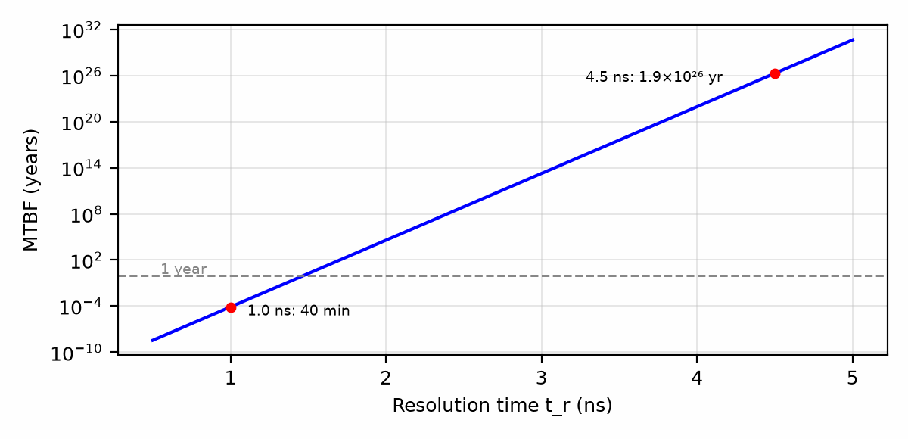
Figure 28.2 — Synchronizer MTBF versus resolution time for τ = 50 ps, T_w = 100 ps, f_clk = 200 MHz, and f_data = 10 MHz. Each 115 ps of added resolution time multiplies the MTBF by ten; the single-flop (1.0 ns) and two-flop (4.5 ns) cases of Worked Example 28.2 are marked.

28.4 Crossing Clock Domains
The two-flip-flop synchronizer is safe for one bit. For a multi-bit value, such as a counter or a FIFO pointer, synchronizing each bit separately is not safe: if several bits change at once, some may be captured before the change and some after, giving a value that never existed. The standard fixes are Gray-code counters, in which only one bit changes per step, so that a captured value is either the old one or the new one; handshakes, in which a single synchronized flag announces that a multi-bit bus is stable; and dual-clock FIFOs, which combine Gray-coded pointers with memory. Every input from a button, a sensor, or another chip with its own oscillator is a clock-domain crossing and needs one of them. Book 8's chapter HDL: Software That Becomes Hardware (Chapter 26) writes these synchronizers and FIFOs in Verilog.
Common Misconception
A synchronizer does not remove metastability; it makes it rare. MTBF is a statistical figure. With fixed clock and data rates and an exponential failure-time model, a 40-minute MTBF implies a failure probability of 1 - exp(-60/40) ≈ 77.7% during a one-hour test, not just an occasional glitch. A short run may miss it; a long run can expose it, and the symptom is often blamed on noise. Compute MTBF from the device data sheet's tau and T_w at worst-case temperature and supply, then add synchronizer stages until the predicted MTBF exceeds the product life by many orders of magnitude.
From the Bench
Every signal entering a clock domain from outside, including buttons, other chips and other clocks, needs a synchronizer: at least two flip-flops in series in the receiving domain. Multi-bit values need a handshake or a FIFO with Gray-coded pointers, not one synchronizer per bit, or the bits can arrive on different clocks.
On the Job
FPGA and ASIC engineers meet this chapter every day as timing closure. A static timing analysis tool reports the worst slack of every path, and a design is not done until all of it is positive at the slowest process corner; clock-domain crossings are checked by a separate lint tool that flags every unsynchronized signal. Reading those reports, and knowing which violations are real, is a large share of the job.

Practice Problems
- Find the maximum clock frequency for t_cq = 0.4 ns, t_pd = 4.0 ns, t_su = 0.2 ns, and 0.1 ns of skew.
- A short path has t_cq = 0.35 ns and t_cd = 0.05 ns; the flip-flop has t_h = 0.25 ns, and the skew is 0.2 ns. Does it pass hold?
- For the synchronizer of Worked Example 28.2, find the MTBF with t_r = 1.5 ns.
- By what factor does the MTBF grow for each additional τ of resolution time?
- Why are FIFO pointers passed between clock domains in Gray code?
- A path needs 7.0 ns and the clock period is 10 ns. What is its slack?

What You’ll Actually Use
Everyday working tools
- Setup and hold times and slack.
- Two-flip-flop synchronizers.
- Handshakes and FIFOs for multi-bit crossings.
Mostly for exams and deeper study
- MTBF calculations from metastability parameters.

Appendix A — Formula Reference
Concept — Formula
Noise margins — NMʜ = Vₒₕ(min) − Vᵢₕ(min) NMʟ = Vᵢʟ(max) − Vₒʟ(max)
Inverting amplifier — Vₒᵤₜ = −(R_f / Rᵢₙ) · Vᵢₙ
Non-inverting amplifier — Vₒᵤₜ = (1 + R_f / Rᵢₙ) · Vᵢₙ
RC filter corner frequency — fᴄ = 1 / (2πRC)
Capacitor self-resonant frequency — SRF = 1 / (2π√(L_ESL · C))
Inductor quality factor — Q = ωL / R
Inductor self-resonant frequency — SRF = 1 / (2π√(L · C_wind))
Feedback closed-loop gain — G = A / (1 + Aβ) ≈ 1/β
Gain sensitivity — ΔG/G ≈ (ΔA/A) / (1 + T)
Capacitive-load pole — f₂ = 1 / (2π r_o C_L)
Closed-loop bandwidth — f_cl ≈ GBW / NG, NG = 1 + R_f/Rᵢₙ
Full-power bandwidth — f_FP = SR / (2π V_p)
Johnson noise density — e_R = √(4kTR)
Noise sum (uncorrelated) — e_total = √(e₁² + e₂² + …)
Single-pole noise bandwidth — ENBW = (π/2) f₋₃dB
Offset at output — V_out = V_os (1 + R_f/Rᵢₙ)
Bias-current compensation — R_c = R_f ‖ Rᵢₙ; residual ≈ I_os R_f
Schmitt threshold — V_th = V_ref R₂/(R₁+R₂) + V_out R₁/(R₁+R₂)
Pull-up rise time (10–90%) — t_r = 2.2 R_pu C
Closed-loop tracking — Y/R = CP/(1 + CP)
First-order plant, P control — τ_cl = τ/(1 + K_p K); e_ss = 1/(1 + K_p K)
PID law — u = K_p e + K_i ∫e dt + K_d de/dt
Lead network maximum phase — φ_max = arcsin((α−1)/(α+1)) at √(ω_z ω_p)
Sampled-loop delay — t_d ≈ T/2 + T_compute; φ = ω_c t_d
Discrete PI (backward Euler) — I[k] = I[k−1] + T e[k]; u[k] = K_p e[k] + K_i I[k]
Buck inductor ripple — ΔI = (V_in − V_out) D / (L f_sw)
Triangle-on-DC rms — I_rms = √(I_DC² + ΔI²/12)
Second-order low-pass — H(s) = H₀ω₀²/(s² + (ω₀/Q)s + ω₀²)
Unity-gain Sallen-Key, equal R — ω₀ = 1/(R√(C₁C₂)); Q = ½√(C₁/C₂)
MFB low-pass, equal R — H₀ = −1; ω₀ = 1/(R√(C₁C₂)); Q = ⅓√(C₁/C₂)
Linear power derating — P = P_rated (T_max − T_amb)/(T_max − T_knee)
Self-heating — ΔT = P θ; ΔR/R = TCR × ΔT
Capacitor impedance — |Z| = √(ESR² + (ωL − 1/(ωC))²)
Target impedance — Z_target = ΔV / ΔI
Antiresonance (approx.) — f_ar ≈ 1/(2π√((L₁+L₂)C_small))
Bulk capacitance — C ≥ I Δt / ΔV
Differential and common mode — V_d = V₊ − V₋, V_cm = (V₊ + V₋)/2
Difference-amplifier CMRR (worst case) — CMRR ≈ (1 + G)/(4t)
Three-op-amp INA gain — G = (1 + 2R/R_G)(R₂/R₁)
INA rejection — CMRR_total ≈ G₁ · CMRR_diff
State equation — ż = Az + Bu, y = Cz
State-feedback gains for a mass — k₁ = mωₙ², k₂ = 2ζωₙm
Observer — dẑ/dt = Aẑ + Bu + L(y − Cẑ), error poles: eig(A − LC)
Acquisition to ½ LSB — t_acq = RC (N + 1) ln 2
Sampled noise — v_n = √(kT/C)
Jitter-limited SNR — SNR = −20 log₁₀(2πfσ_t)
Pedestal and droop — ΔV = Q/C, dV/dt = I_leak/C
PTAT voltage — ΔV_BE = (kT/q) ln N
Bandgap output — V_REF = V_BE + (R₂/R₁)ΔV_BE
Box-method TC — TC = ΔV/(V_nom ΔT) × 10⁶ ppm/°C
Shunt-reference resistor — R_s ≤ (V_s,min − V_REF)/(I_load,max + I_K,min)
Bridge average voltage — Bipolar (2D − 1)V_s; sign-magnitude D·V_s
PWM current ripple — Bipolar 2V_sD(1 − D)/(Lf); sign-magnitude V_sD(1 − D)/(Lf)
DC motor — V = Ri + L di/dt + K_eω; J dω/dt = K_ti − bω − T_L
Motor time constants — τ_e = L/R, τ_m = JR/(K_tK_e)
PI current loop — K_i/K_p = R/L, ω_c = K_p/L
Root-locus asymptotes — angles (2k + 1)180°/(n − m); centroid (Σp − Σz)/(n − m)
Locus gain — K = 1/|G(s)| at a point satisfying ∠G(s) = 180°
Second-order specs — overshoot exp(−πζ/√(1 − ζ²)); t_s(2%) ≈ 4/(ζω_n)
Nyquist criterion — Z = N + P
Margins — GM = 1/|L(jω₁₈₀)|; PM = 180° + ∠L(jω_c); τ_max = PM/ω_c
Sensitivity bounds — GM ≥ M_s/(M_s − 1); PM ≥ 2 arcsin(1/(2M_s))
Wien bridge — f₀ = 1/(2πRC); gain 3
Relaxation oscillator — T = 2RC ln((1 + β)/(1 − β))
555 astable — f = 1.44/((R₁ + 2R₂)C); duty (R₁ + R₂)/(R₁ + 2R₂)
Setup and hold — T_clk ≥ t_cq + t_pd + t_su + t_skew; t_cq + t_cd ≥ t_h + t_skew
Synchronizer MTBF — e^(t_r/τ)/(T_w f_clk f_data)
Bang-bang cycle — t_on = band/heating rate; t_off = band/cooling rate
Proportional thermostat error — e = (heat needed at the set point)/(K_p + loss coefficient)
LUT configuration — 2ᵏ bits; 2^(2ᵏ) functions of k inputs
LED series resistor — R = (V_s − V_F)/I; current sink I = V_set/R_s
Optocoupler pull-up — R_pu ≥ (V_pu − V_CE(sat))/(CTR_min × I_F)
Photodiode TIA — V_out = I_ph R_f; f₋₃dB ≈ √(GBW/(2πR_fC_in)); C_f ≈ √(C_in/(2πR_f GBW))
RC debounce — t = RC ln(1/(1 − k)) > bounce time
PWM steps — N = f_clk/f_PWM; bits = log₂ N
Charge amplifier — V_out = −q/C_f; f_L = 1/(2πR_fC_f)
CT burden — R_b ≤ (V_DD/2)/(√2 I_p,rms/N)
Relay drive — I_B = I_coil/β_forced; R_B = (V_GPIO − V_BE)/I_B
Stepper resolution — distance per microstep = lead/(steps × microsteps)
Macromodel gain stage — A₀ = g_mR₁; f_p = 1/(2πR₁C₁); GBW = g_m/(2πC₁); I_max = SR × C₁
Offset change from CMRR — ΔV_OS = ΔV_CM/10^(CMRR/20)
Comparator threshold error — ΔV = V_IO + I_IB R_th

Appendix B — Practice Problem Solutions
Every practice problem in the book is worked here in full, chapter by chapter: the idea, the formula, the numbers, and a check. Attempt each problem before you read its solution.

Chapter 1 Solutions
1. The largest symmetric swing is set by the smaller of the two headrooms. Headroom to the lower rail: 6 − 1 = 5 V. Headroom to the upper rail: 11 − 6 = 5 V. The two are equal, so the stage passes a 5 V amplitude, and neither rail limits before the other: the bias point is centered. Check: 6 ± 5 V spans exactly 1 V to 11 V.
2. Find the output headroom, then divide by the gain to refer it to the input. Output headroom = min(2 − 0, 5 − 2) = min(2, 3) = 2 V, set by the lower rail. The input amplitude that produces 2 V at the output is 2 V/20 = 0.1 V, or 100 mV. Check: 20 × 100 mV = 2 V, so the output swings from 0 V to 4 V and touches the lower rail.
3. A small-signal model replaces a curved transfer characteristic by its tangent line at the bias point, and the gain is that line's slope. Close to the bias point the curve and the tangent agree; far from it the curve bends away, so the slope, and every gain or impedance derived from it, no longer describes the circuit. The analysis is trustworthy only while the signal stays small compared with the curvature.
4. A centered bias sits at 9/2 = 4.5 V, so both headrooms are 4.5 V. The maximum input amplitude is the output headroom divided by the gain: 4.5 V/8 = 0.5625 V, about 563 mV. Check: 8 × 0.5625 = 4.5 V, so the output swings from 0 V to 9 V.
5. Headroom to the lower rail: 1 − 0 = 1 V. Headroom to the upper rail: 5 − 1 = 4 V. The lower rail limits, with only 1 V of headroom; the stage clips on negative peaks first. Moving the bias toward 2.5 V would raise the symmetric swing from 1 V to 2.5 V.
6. The output headroom is fixed by the bias point and the rails, not by the gain. The output amplitude is gain × input amplitude, so doubling the gain means the same output headroom is reached with half the input. The maximum undistorted input amplitude is therefore halved. Example: with 2 V of headroom, a gain of 10 allows 200 mV at the input and a gain of 20 allows 100 mV.

Chapter 2 Solutions
1. Each noise margin is the gap between what a driver guarantees and what a receiver needs. NM_H = V_OH(min) − V_IH(min) = 3.5 − 2.0 = 1.5 V. NM_L = V_IL(max) − V_OL(max) = 0.5 − 0.2 = 0.3 V. The low margin is the weak one: only 0.3 V of noise on a low signal can cause a misread.
2. Weight each bit by its power of two, from the right: 1011₂ = 1×8 + 0×4 + 1×2 + 1×1 = 11₁₀. Check: 11 = 8 + 2 + 1.
3. Every digital gate decides whether its input is high or low and then drives a fresh, full-strength output level, so noise that did not cross a threshold is discarded at each stage. An analog stage amplifies whatever it receives, signal and noise together, so each stage adds its own noise to everything before it and the degradation accumulates instead of resetting.
4. NM_H = V_OH(min) − V_IH(min) = 4.4 − 3.15 = 1.25 V. NM_L = V_IL(max) − V_OL(max) = 1.35 − 0.1 = 1.25 V. The margins are equal, which is typical of CMOS logic with thresholds near 30% and 70% of a 4.5 V supply.
5. 11010₂ = 1×16 + 1×8 + 0×4 + 1×2 + 0×1 = 26₁₀. Check: 16 + 8 + 2 = 26.
6. A noise margin is a static figure: it says how much steady offset a level can tolerate. Real industrial noise arrives as fast spikes, ground bounce, and coupled bursts whose peak can exceed the margin for a few nanoseconds, which is all a fast gate needs to switch falsely. Equal margins on paper therefore guarantee equal static tolerance only; layout, grounding, shielding, filtering, and slower or Schmitt inputs decide reliability in the noisy environment.

Chapter 3 Solutions
1. Distribute, then absorb. F = A(A + B) = AA + AB = A + AB, because AA = A. Then A + AB = A(1 + B) = A·1 = A. This is the absorption law. Check with the truth table: F equals A in all four rows.
2. Evaluate F = A′B + AB′ row by row. A = 0, B = 0: 0 + 0 = 0. A = 0, B = 1: 1 + 0 = 1. A = 1, B = 0: 0 + 1 = 1. A = 1, B = 1: 0 + 0 = 0. The output is 1 when the inputs differ: this is exclusive-OR, F = A ⊕ B.
3. De Morgan's law turns the complement of an OR into the AND of the complements: (A + B)′ = A′B′. Check: the left side is 1 only when A + B = 0, that is, when both A and B are 0, which is exactly when A′B′ = 1.
4. Factor A out of both terms: H = A + AB′C = A(1 + B′C) = A·1 = A. This is absorption again: A OR (A AND anything) equals A. Check: if A = 1, H = 1; if A = 0, both terms are 0.
5. Factor out A′: F = A′(B′C′ + B′C + BC′ + BC). Group in pairs: B′(C′ + C) + B(C′ + C) = B′ + B = 1. So F = A′·1 = A′. The four terms list every combination of B and C, so together they are always 1. Check: F is 1 exactly in the four rows where A = 0.
6. Apply De Morgan's law to the outer AND first: ((A + B)·C)′ = (A + B)′ + C′. Apply it again to the OR: (A + B)′ = A′B′. So the result is A′B′ + C′. Check: with C = 0 the expression is 1, as it must be, since the original AND is then 0.

Chapter 4 Solutions
1. For an active-high NOR latch the forbidden input is S = 1 and R = 1. Both NOR outputs are then forced to 0, so Q and Q′ are no longer complements, and when both inputs return to 0 together the latch falls into whichever state the faster gate wins: the final state is not determined by the circuit.
2. A D flip-flop copies D to Q at the active clock edge, so Q = 1 immediately after the edge (after its clock-to-output delay). It then holds 1 until a later edge samples a different D.
3. Each flip-flop stores one bit, so a 4-bit register needs four D flip-flops, holding any of 2⁴ = 16 values from 0000 to 1111.
4. A half adder computes the sum S = A ⊕ B and the carry C = AB. With A = 1, B = 0: S = 1 ⊕ 0 = 1 and C = 1·0 = 0. Check: 1 + 0 = 1 in binary, with no carry.
5. S = 1, R = 0 sets the latch, forcing Q = 1. When both inputs return to 0, neither gate is forced, and the cross-coupled feedback holds the last state, so Q stays at 1. That memory is the point of a latch.
6. In a shift register each flip-flop must capture its neighbor's old value at the same instant. With a common clock every stage samples before any stage's output changes, so the data moves exactly one place per edge. If one stage were clocked late, it could capture its neighbor's new value instead, skipping or duplicating a bit; Chapter 28 treats this as clock skew and hold time.
7. The 555 frequency is f = 1.44/((R₁ + 2R₂)C) = 1.44/((1 kΩ + 94 kΩ) × 2.2 µF) = 1.44/(95 kΩ × 2.2 µF) = 6.89 Hz. Each LED is lit for one period, 1/6.89 = 145 ms, so the light passes all ten LEDs in 1.45 s. Check: 10 × 145 ms = 1.45 s.
8. The ratio is 32,768/8 = 4096 = 2¹², so the ÷4096 output (the twelfth stage, Q12) gives 8 Hz. The last output divides by 16,384 = 2¹⁴, giving 32,768/16,384 = 2 Hz. Check: 2¹⁵ = 32,768, so a fifteenth stage, the extra flip-flop of Figure 4.3, gives 1 Hz.
9. A k-input LUT stores one bit per truth-table row, 2ᵏ rows. For k = 5: 2⁵ = 32 bits. Each bit is free to be 0 or 1, so the number of functions is 2³² = 4,294,967,296, about 4.3 × 10⁹. Check against a 2-input LUT: 4 bits and 2⁴ = 16 functions.
10. Reach for an FPGA. Forty-eight independent counters, each able to change on every 10 ns clock edge, is parallel logic: an FPGA builds 48 copies of a small PWM counter that all run at once. A microcontroller has a limited number of hardware PWM channels and cannot update 48 of them every 10 ns in software. An ASIC would do it at lower power and cost per unit, but only a high-volume product justifies its mask cost and its lack of changes.

Chapter 5 Solutions
1. For an inverting amplifier, gain = −R_f/R_in = −47 kΩ/4.7 kΩ = −10. V_out = −10 × 0.2 V = −2.0 V. Check: the input current 0.2 V/4.7 kΩ = 42.6 µA flows on through R_f, dropping 42.6 µA × 47 kΩ = 2.0 V, with the output 2.0 V below the virtual ground.
2. A non-inverting gain is 1 + R_f/R_in. Worked Example 5.2 used R_f = 10 kΩ and R_in = 2 kΩ for a gain of 6. With R_f doubled to 20 kΩ: gain = 1 + 20/2 = 11. Doubling R_f does not double the gain, because of the fixed 1 in the formula.
3. The two inputs draw no current (Golden Rule 2), so no current can pass between them. Their voltages are equal only because the feedback network keeps adjusting the output until the difference is negligible; the virtual short is a result of the loop, not a physical connection.
4. Gain = −R_f/R_in = −220 kΩ/22 kΩ = −10. V_out = −10 × 0.15 V = −1.5 V. Check: the ratio, not the absolute values, sets the gain, so this is the same −10 as Problem 1.
5. Set 1 + R_f/R_in = 4, so R_f/R_in = 3 and R_in = R_f/3 = 30 kΩ/3 = 10 kΩ. Check: 1 + 30/10 = 4.
6. The output stage is powered from the rails and cannot produce a voltage outside them; most op-amps cannot even reach the rails. When the golden-rule formula asks for more, the output saturates, the loop loses control, and the virtual short no longer holds. This is the headroom limit of Chapter 1 applied to the op-amp.

Chapter 6 Solutions
1. f_c = 1/(2πRC) = 1/(2π × 2200 Ω × 47 × 10⁻⁹ F) = 1/(6.497 × 10⁻⁴ s) ≈ 1539 Hz, about 1.54 kHz. Check: RC = 103.4 µs, and 1/(2π × 103.4 µs) ≈ 1.54 kHz.
2. Each first-order stage contributes −20 dB/decade above its corner, and cascaded stages multiply their responses, so their decibels add: 4 × (−20) = −80 dB/decade, the slope of a fourth-order filter.
3. An active filter's output comes from the op-amp, whose closed-loop output impedance is a small fraction of an ohm, so a load draws its current without disturbing the RC network that sets the response. A passive filter's output is the network itself, so the load forms a divider with it and shifts both the gain and the corner frequency.
4. f_c = 1/(2πRC) = 1/(2π × 3300 Ω × 15 × 10⁻⁹ F) = 1/(3.110 × 10⁻⁴ s) ≈ 3215 Hz, about 3.22 kHz. The formula is the same for a high-pass as for a low-pass section; only which side passes changes.
5. A decade is log₂ 10 = 3.32 octaves, so −40 dB/decade ÷ 3.32 ≈ −12 dB/octave. Check with the rule of thumb: 6 dB per octave per order, times two orders, is 12 dB/octave.
6. 60 Hz is only log₁₀(1000/60) = 1.22 decades below 1 kHz. A single pole placed at, say, 500 Hz to leave the signal mostly untouched attenuates 60 Hz by only about 20 log₁₀(500/60) ≈ 18 dB, while already costing the 1 kHz signal about 1 dB. Moving the corner up removes more hum but eats into the signal. A higher-order high-pass or a 60 Hz notch gives far more rejection without touching 1 kHz.
7. At f₀ a second-order low-pass section has gain Q × H₀ = 0.7071 × 1 = 0.7071, and 20 log₁₀(0.7071) = −3.0 dB. This is why Q = 0.7071 defines the Butterworth response: its corner is the −3 dB point.
8. For the equal-resistor unity-gain Sallen-Key, Q = ½√(C₁/C₂), so C₁/C₂ = 4Q² = 4 × 0.5773² = 4 × 0.3333 = 1.33. Check: ½√1.333 = 0.577.
9. f₀ = 1/(2πR√(C₁C₂)) = 1/(2π × 22 kΩ × √(6.8 nF × 3.3 nF)). √(22.44 × 10⁻¹⁸) = 4.737 nF, so f₀ = 1/(2π × 22 × 10³ × 4.737 × 10⁻⁹) ≈ 1527 Hz. Q = ½√(6.8/3.3) = ½ × 1.435 ≈ 0.718, close to Butterworth.
10. For the equal-resistor MFB section, Q = ⅓√(C₁/C₂) = ⅓√(47/5.6) = ⅓ × 2.897 ≈ 0.966. At f₀ the gain is Q = 0.966, or −0.3 dB, but because Q is above 0.707 the response peaks slightly below f₀, at Q/√(1 − 1/(4Q²)) ≈ 1.13, about +1.0 dB: a little peaked compared with Butterworth.
11. The rule of Section 6.10 asks for GBW ≥ 100 × H₀ × f₀, with a further factor of Q for high-Q sections. The higher-Q section of a fourth-order Butterworth has Q = 1.3066, and H₀ = 1, so GBW ≥ 100 × 1 × 10 kHz × 1.3066 ≈ 1.3 MHz. Choose an op-amp with at least that, and preferably more.
12. Each second-order Butterworth section is already 3 dB down at f₀, so two identical sections are 6 dB down there and the knee is rounded. A true fourth-order Butterworth uses two sections with different Q values, 0.5412 and 1.3066, whose peaking and droop cancel to give a maximally flat response that is 3 dB down at f₀.

Chapter 7 Solutions
1. From P = I²R, I = √(P/R) = √(0.25 W/100 Ω) = √0.0025 = 0.050 A = 50 mA. Check: (0.05)² × 100 = 0.25 W. In practice derate further for temperature (Section 7.5).
2. A wirewound resistor is a coil of wire, so it carries series inductance, often microhenries. At RF that inductance's reactance 2πfL can exceed the resistance itself, and the part behaves more like an inductor than a resistor. Film resistors have far smaller parasitics.
3. ±10% of 1 kΩ is ±100 Ω, so individual values may lie anywhere from 900 Ω to 1100 Ω.
4. Each resistor lies within 2200 ± 22 Ω, from 2178 Ω to 2222 Ω. In the worst case all three err the same way: 3 × 2178 = 6534 Ω to 3 × 2222 = 6666 Ω, which is still ±1% of 6600 Ω. Random errors would usually partly cancel, but the worst case is what a design must survive.
5. 50% margin means a rating of at least 1.5 × 0.3 W = 0.45 W. 1/8 W and 1/4 W are below even the actual 0.3 W. 1/2 W = 0.5 W clears 0.45 W, so it is the smallest acceptable rating.
6. In a precision measurement, every part per million of resistance drift becomes a part per million of error in the reading, so the temperature coefficient sits directly in the error budget. An LED limiter only needs a current that is roughly right; a 1% current change shifts brightness invisibly, so the same drift has no consequence.
7. Above the 70 °C knee the rating falls linearly to zero at 155 °C: P = 0.25 W × (155 − 125)/(155 − 70) = 0.25 × 30/85 ≈ 0.088 W. At 125 °C the part may dissipate barely a third of its headline rating.
8. Each resistor can drift by ±50 ppm/°C × 40 °C = ±2000 ppm. If they drift in opposite directions, the ratio changes by up to 2000 + 2000 = 4000 ppm, or 0.4%. Resistors that track each other, from one network on one substrate, cut this to a few ppm per °C.
9. Temperature rise ΔT = Pθ = 0.020 W × 400 °C/W = 8 °C. Resistance change ΔR/R = TCR × ΔT = 100 ppm/°C × 8 °C = 800 ppm, or 0.08%.
10. 600 V/150 V = 4 resistors, each then sitting exactly at its limit, with no allowance for tolerance in how the voltage divides or for transients. Use 5 or 6 so that each sees 100 to 120 V, comfortably below its rating, with creepage between pads also checked.
11. V = IR = 20 A × 0.005 Ω = 0.100 V = 100 mV. P = I²R = 400 × 0.005 = 2.0 W. Check: P = VI = 0.1 × 20 = 2 W. A 2 W shunt needs a rating of 3 W or more with margin and good copper to carry its heat away.
12. With four terminals, the load current flows through one pair and the sense voltage is taken from the other pair, right at the resistive element. The sense leads carry almost no current, so the drop in solder joints and copper, which at milliohm values can rival the shunt itself and drifts strongly with temperature, stays out of the measurement.

Chapter 8 Solutions
1. SRF = 1/(2π√(L_ESL C)) = 1/(2π√(2 × 10⁻⁹ × 2.2 × 10⁻⁷)) = 1/(2π × 2.098 × 10⁻⁸) ≈ 7.59 MHz. Above that frequency the capacitor behaves as an inductor.
2. No. The 16.5 V peaks exceed the 16 V rating outright, whatever the 12 V average. An electrolytic's rating applies to the peak voltage, ripple included. Use a 25 V part, which also improves lifetime and leakage.
3. A Class 2 dielectric such as X7R gets its high permittivity from a ferroelectric ceramic, and the DC field partly locks its polarization domains in place, so they contribute less to the response to further changes. The permittivity, and with it the capacitance, falls as the DC voltage rises, often by half or more at rated voltage, which is why manufacturers publish DC-bias curves.
4. SRF = 1/(2π√(8 × 10⁻⁹ × 1 × 10⁻⁸)) = 1/(2π × 8.944 × 10⁻⁹) ≈ 17.8 MHz.
5. No. A 50% derating of a 10 V part allows 5 V, and the 6 V rail exceeds that, even though it is below the absolute 10 V rating. Choose a 16 V tantalum (8 V derated) or a different capacitor type.
6. A film capacitor's value barely changes with applied voltage, temperature, or time, and it has low dielectric absorption, so an RC timing circuit built with it stays at its designed frequency. A Class 2 ceramic of the same nominal value can lose a large fraction of its capacitance with DC bias and drift with temperature, moving the timing by tens of percent.
7. SRF = 1/(2π√(0.8 × 10⁻⁹ × 1 × 10⁻⁶)) = 1/(2π × 2.828 × 10⁻⁸) ≈ 5.63 MHz. At resonance the inductive and capacitive reactances cancel, so |Z| = ESR = 10 mΩ, the minimum of the impedance curve.
8. Allowed deviation ΔV = 0.05 × 3.3 V = 0.165 V. Z_target = ΔV/ΔI = 0.165 V/0.5 A = 0.33 Ω. The decoupling network must stay below 0.33 Ω over the whole frequency range of the load's current steps.
9. Between the two self-resonances the large capacitor is inductive (1.2 nH) and the small one capacitive; they resonate in parallel near f_ar ≈ 1/(2π√((L₁ + L₂)C_small)) = 1/(2π√(1.6 × 10⁻⁹ × 22 × 10⁻⁹)) = 1/(2π × 5.933 × 10⁻⁹) ≈ 26.8 MHz. The impedance peaks there, so check it against the target impedance.
10. From I = C dV/dt, C ≥ IΔt/ΔV = 1 A × 20 µs/0.1 V = 200 µF. With ESR, part of the 100 mV is used by the instantaneous I × ESR step, so a real design needs more capacitance or lower ESR.
11. P = I_rms² × ESR = (2 A)² × 0.030 Ω = 0.12 W. Check this against the capacitor's ripple-current rating, which exists because this heat shortens an electrolytic's life.
12. A hold capacitor must keep exactly the charge it was given. C0G has negligible dielectric absorption, so the held voltage does not creep back toward earlier values, and its capacitance does not change with voltage, temperature, or age, so the pedestal and droop are predictable. X7R would add memory effects, voltage-dependent capacitance, and aging.

Chapter 9 Solutions
1. ωL = 2π × 5 × 10⁵ Hz × 100 × 10⁻⁶ H = 314.2 Ω. Q = ωL/R = 314.2/2 ≈ 157. Check: Q is the ratio of reactance to resistance, so a higher frequency or lower DCR raises it.
2. The core multiplies the inductance because its magnetic domains align with the field. As the current rises, more domains are already aligned, and near saturation almost none remain to respond, so additional current adds little flux and the inductance, the slope of flux against current, collapses. Below that point the core is nearly linear, so the drop is sharp rather than gradual.
3. A solenoid's field, as Book 1 showed, closes through the space around it, so an air-core coil spreads flux into nearby circuits. A toroid's closed ring keeps nearly all the flux inside the core, which gives more inductance per turn and almost no stray field to couple into sensitive circuitry.
4. ωL = 2π × 2 × 10⁶ × 47 × 10⁻⁶ = 590.6 Ω. Q = 590.6/1.2 ≈ 492, on the basis of DC resistance alone; at 2 MHz skin effect and core loss will lower the real Q.
5. Peak current = DC bias + ripple peak = 1.0 + 0.6 = 1.6 A, which exceeds the 1.5 A saturation rating. The inductance will collapse at each peak; choose a part rated above about 1.9 A with margin, or reduce the ripple.
6. Q = ωL/R assumes R is constant. In reality skin effect, proximity effect, and core losses make the effective series resistance rise faster than ω at high frequency, and near the self-resonant frequency the winding capacitance cancels the inductance. Q therefore rises, peaks, and falls.
7. Duty cycle D = V_out/V_in = 1.8/5 = 0.36. Ripple ΔI = (V_in − V_out)D/(L f_sw) = (5 − 1.8) × 0.36/(2.2 × 10⁻⁶ × 10⁶) = 1.152/2.2 = 0.524 A peak to peak. Peak current = 3 + 0.524/2 = 3.26 A.
8. For a triangle on DC, I_rms = √(I_DC² + ΔI²/12) = √(9 + 0.524²/12) = √9.0229 = 3.004 A, only slightly above 3 A. Minimum I_sat with 20% margin = 1.2 × 3.26 ≈ 3.9 A; the heating rating need only exceed about 3.0 A.
9. Copper loss P = I_rms² × DCR = (4 A)² × 0.015 Ω = 0.24 W.
10. The ripple ΔI = (V_in − V_out)D/(L f) is inversely proportional to L. At the −20% corner, L = 0.8 × 4.7 µH = 3.76 µH, so the ripple rises by 1/0.8 = 1.25, a 25% increase, which must be included in the peak-current check.
11. Keep the self-resonant frequency at least ten times the highest operating frequency: SRF ≥ 10 × 20 MHz = 200 MHz.
12. Below its resistive region, a ferrite bead is mostly an inductor. Together with the decoupling capacitor after it, the bead forms a series LC resonance. Near resonance, the network can amplify noise instead of attenuating it unless the bead's resistance or an added damping resistor lowers the Q.

Chapter 10 Solutions
1. Each time through the band is the band divided by the rate. On: 0.6 °C/(0.4 °C/min) = 1.5 min. Off: 0.6/0.2 = 3.0 min. Period: 4.5 min, or 13.3 cycles an hour. Duty cycle: 1.5/4.5 = 33.3%. Average power: 0.333 × 2 kW = 0.67 kW, equal to the room's heat loss at this temperature. Check: the duty cycle is also cooling rate/(heating rate + cooling rate) = 0.2/0.6 = 1/3.
2. On: 0.2/0.4 = 0.5 min; off: 0.2/0.2 = 1.0 min; period 1.5 min, or 40 cycles an hour, three times as many as before, with the same 33% duty and the same average power. A furnace wears mostly when it starts: ignition, thermal stress, and relay contacts. Tripling the starts shortens its life and wastes the warm-up energy of each start, which is why furnaces enforce minimum on and off times.
3. Period = 1/200 Hz = 5 ms. A vision-language model takes from tens of milliseconds to seconds to answer, and its latency varies from call to call, so it cannot produce a fresh command every 5 ms on a fixed schedule. The tracker does that; the model updates the goal the tracker follows, a few times a second at most.
4. The independent safety controller. It monitors joint positions, speeds, torques, and limits on its own sensors, and it is allowed to override any command: slow the joint, hold it, or stop the robot, whatever the model proposed. It must work even when the model is wrong, which is why it does not depend on the model.
5. In the steady state K_p e = 100(16 − e), with e = 21 − T. With K_p = 400: 400e = 1600 − 100e, so 500e = 1600 and e = 3.2 °C. The room settles at 21 − 3.2 = 17.8 °C, and the heater delivers 400 × 3.2 = 1280 W. Check: the loss at 17.8 °C is 100 × 12.8 = 1280 W. A smaller gain leaves a larger error, as Chapter 17 predicts.
6. The tracker period is 5 ms and the servo frame is 20 ms, so 20/5 = 4 tracker updates arrive per servo frame, and only the latest one is sent with each pulse; three of every four are wasted. The fast position loop really sits inside the servo, which compares its potentiometer with the pulse width continuously. To close a faster loop yourself, drive the motor directly through an H-bridge with your own encoder (Chapter 24).

Chapter 11 Solutions
1. β = R_in/(R_in + R_f) = 1 kΩ/50 kΩ = 0.02, so the ideal gain is 1/β = 50. Loop gain T = Aβ = 200,000 × 0.02 = 4000. Actual gain G = A/(1 + T) = 200,000/4001 ≈ 49.988. Error = (50 − 49.988)/50 ≈ 0.025%, which is about 1/T = 1/4000. Check: the rule 'error ≈ 1/T' holds.
2. Feedback divides the change in A by 1 + T: ΔG/G ≈ (ΔA/A)/(1 + T) = 30%/2001 ≈ 0.015%. A 30% swing in the op-amp becomes 150 ppm in the amplifier.
3. The gain error is about 1/T, so T ≥ 1/0.0005 = 2000. With β = 1/20 = 0.05, A = T/β ≥ 2000/0.05 = 40,000 at the frequency of interest. Check: G = 40,000/(1 + 2000) = 19.99, an error of 0.05%.
4. Series-sampled feedback divides the output resistance by 1 + T: R_out ≈ 100 Ω/(1 + 500) ≈ 0.20 Ω.
5. The loop holds the inverting input at virtual ground, so the source sees R_in connected to an effectively fixed 0 V node. The feedback works by summing currents at that node, in shunt with the source, not by subtracting a voltage in series with it, so it does not multiply the input impedance by 1 + T; that only happens in the non-inverting connection.
6. Feedback divides distortion by 1 + T, so 1 + T = 2%/0.01% = 200 and T ≈ 199, about 200, at the signal frequency and ideally at its harmonics too, since those are what the distortion consists of.

Chapter 12 Solutions
1. The load and source resistance form a divider: ratio = R_L/(R_s + R_L) = 4.7 kΩ/(47 kΩ + 4.7 kΩ) = 4.7/51.7 ≈ 0.0909. In decibels, 20 log₁₀ 0.0909 ≈ −20.8 dB. This is the same ratio as Worked Example 12.1, because both resistances scaled together.
2. The follower's gain is A/(1 + A) = 250,000/250,001, so the error is 1/(1 + A) ≈ 1/250,001 ≈ 4.0 × 10⁻⁶, or 4 ppm.
3. CMRR of 80 dB is a ratio of 10^(80/20) = 10,000. The common-mode swing referred to the input is 3 V/10,000 = 300 µV, the error that appears as if it were signal.
4. The source resistance adds to R_in: gain = −R_f/(R_s + R_in) = −100 kΩ/(22 kΩ + 100 kΩ) ≈ −0.820, instead of the intended −1. The inverting stage loads its source; a follower in front would restore −1.
5. The load capacitance with the op-amp's open-loop output resistance adds a pole at f₂ = 1/(2π r_o C_L) = 1/(2π × 40 Ω × 2.2 × 10⁻⁹ F) ≈ 1.81 MHz, close enough to a 1 MHz crossover to cost a large share of the phase margin.
6. With a resistor between the output and the capacitor, and feedback taken from the op-amp side, the op-amp sees at least the resistor's value at high frequency instead of a capacitor whose impedance falls toward zero. The capacitor's pole then sits outside the loop, so it no longer erodes phase margin near crossover; it only slows the edge at the capacitor itself.
7. R_s = V_set/I = 0.5 V/0.35 A = 1.43 Ω, dissipating V_set × I = 0.5 × 0.35 = 0.175 W. With the standard 1.5 Ω part, I = 0.5/1.5 = 0.333 A and P = 0.5 × 0.333 = 0.167 W; choose a 0.5 W resistor. A low V_set keeps the loss small, at the cost of more sensitivity to op-amp offset: 1 mV of offset is already 0.2% of 0.5 V.
8. I_F = (5 − 1.2)/390 Ω = 9.74 mA. The guaranteed collector current is at least 0.5 × 9.74 = 4.87 mA. Saturation needs (3.3 − 0.2)/R_pu ≤ 4.87 mA, so R_pu ≥ 636 Ω. A practical choice is 2.2 kΩ, which asks for only 1.4 mA and leaves margin for aging and for a CTR lower at high temperature.

Chapter 13 Solutions
1. The noise gain of an inverting stage with gain −4 is 1 + R_f/R_in = 1 + 4 = 5, so f_cl = GBW/NG = 1 MHz/5 = 200 kHz. The bandwidth follows the noise gain, not the signal gain of 4.
2. A single-pole response stays within 1% while f/f_cl ≤ √(1/0.99² − 1) = 0.142, so f_cl ≥ 5 kHz/0.1425 ≈ 35.1 kHz. For a non-inverting gain of 25 the noise gain is 25, so GBW ≥ 25 × 35.1 kHz ≈ 877 kHz; choose at least 1 MHz.
3. Above its 10 Hz pole the declared op-amp's gain falls as GBW/f, so |A| ≈ 1 MHz/2 kHz = 500 at 2 kHz, far below its DC value of 100,000.
4. For n identical single-pole stages, the cascade bandwidth is f_cl√(2^(1/n) − 1). With n = 3: 2^(1/3) = 1.260, so √0.260 = 0.510, and the cascade reaches 0.510 × 50 kHz ≈ 25.5 kHz.
5. The full-power bandwidth is the frequency at which a sine of peak V_p needs the full slew rate: f_FP = SR/(2πV_p) = 13 × 10⁶ V/s/(2π × 5 V) ≈ 414 kHz.
6. An inverting stage with gain −1 returns half of the output to the inverting input (β = 0.5), so its noise gain is 2 and its bandwidth is GBW/2. A follower returns all of the output (β = 1), so its noise gain is 1 and it keeps the full GBW.
7. f₋₃dB ≈ √(GBW/(2πR_fC_in)) = √(10⁷/(2π × 10⁶ × 75 × 10⁻¹²)) = √(2.12 × 10¹⁰) ≈ 146 kHz. C_f ≈ √(C_in/(2πR_f GBW)) = √(75 × 10⁻¹²/(2π × 10⁶ × 10⁷)) ≈ 1.09 pF; 1 pF is the nearest value. Ten times the gain cost a factor √10 ≈ 3.2 in bandwidth, and C_f is now comparable to the stray capacitance of R_f itself, so layout matters.
8. 90% of 3.3 V is 2.97 V, so R_f = 2.97 V/80 µA = 37.1 kΩ; the nearest E24 value is 36 kΩ. At 80 µA the output is 80 µA × 36 kΩ = 2.88 V. At 0.5 µA it is 18 mV, only about 22 counts of a 12-bit converter (0.81 mV per count), which shows why a daylight logger switches ranges or uses a logarithmic amplifier.

Chapter 14 Solutions
1. e_R = √(4kTR) = √(4 × 1.380649 × 10⁻²³ × 290 × 4700) = √(7.53 × 10⁻¹⁷) ≈ 8.68 nV/√Hz. Check by scaling: 1 kΩ gives about 4.0 nV/√Hz, and √4.7 × 4.0 ≈ 8.7.
2. Uncorrelated noise adds as the root sum of squares: √(6² + 8² + 2²) = √(36 + 64 + 4) = √104 ≈ 10.2 nV/√Hz. The largest source dominates; removing the 2 nV source entirely would only lower the total to 10.0.
3. A single-pole response has noise bandwidth ENBW = (π/2)f₋₃dB = 1.571 × 20 kHz ≈ 31.4 kHz. The rms output noise is 50 nV/√Hz × √31,416 ≈ 50 nV × 177 ≈ 8.86 µV rms.
4. Current noise produces i_n R_s across the source resistance; it equals the voltage noise when R_s = e_n/i_n = 5 nV/0.5 pA = 10 kΩ. Below 10 kΩ the voltage noise dominates; above it the current noise does.
5. The noise power is e_n² [f_c ln(f_H/f_L) + (f_H − f_L)]. Flicker term: 1000 × ln(10/0.1) = 1000 × 4.605 = 4605 Hz. White term: 10 − 0.1 = 9.9 Hz. Total 4615 Hz, so e_rms = 8 nV × √4615 ≈ 8 nV × 67.9 ≈ 543 nV rms. Check: the 1/f region contributes almost all of it.
6. Through a 10 MΩ source, current noise dominates. A bipolar part with about 1 pA/√Hz of current noise produces 1 pA × 10 MΩ = 10 µV/√Hz, far above its few nV/√Hz of voltage noise and above the source's own Johnson noise of about 400 nV/√Hz. A CMOS part with femtoamp current noise adds almost nothing through the same resistance.

Chapter 15 Solutions
1. The offset is amplified by the noise gain, which for a non-inverting stage equals its gain of 50: V_out = 3 mV × 50 = 150 mV.
2. The compensation resistor equals the resistance seen by the inverting input, R_f ‖ R_in = (470 kΩ × 4.7 kΩ)/(470 kΩ + 4.7 kΩ) ≈ 4.65 kΩ.
3. Without compensation the whole bias current flows through R_f: 50 nA × 470 kΩ = 23.5 mV at the output. With compensation only the offset current remains: 5 nA × 470 kΩ = 2.35 mV, ten times smaller.
4. Drift at the input: 3 µV/°C × 60 °C = 180 µV. At the output: 180 µV × 200 = 36 mV.
5. 90 dB is a ratio of 10^(90/20) ≈ 31,600, so 200 mV of supply ripple appears as 200 mV/31,600 ≈ 6.3 µV at the input, riding on the signal at the ripple frequency.
6. With the input grounded, the offset sits across R and drives a current V_os/R = 0.5 mV/1 MΩ = 0.5 nA into C. The output ramps at I/C = 0.5 nA/100 nF = 5 mV/s, reaching a rail of 12 V in about 40 minutes unless something resets or bounds the integrator.
7. A CMRR of 60 dB is a ratio of 10^(60/20) = 1000, so a 3.0 V common-mode change shifts the offset by at most 3.0 V/1000 = 3.0 mV. At the typical 76 dB, a ratio of 6310, the change is 3.0 V/6310 = 0.48 mV. The span ends at 3.5 V, below V_DD − 1.1 V = 3.9 V, so the input-stage handover does not add a step. Design with the 3.0 mV.
8. A₀ = 10^(100/20) = 100,000, so R₁ = A₀/g_m = 100,000/1 mS = 100 MΩ. C₁ = g_m/(2π × GBW) = 1 mS/(2π × 10 MHz) = 15.9 pF. The dominant pole is f_p = GBW/A₀ = 10 MHz/100,000 = 100 Hz; check: 1/(2π × 100 MΩ × 15.9 pF) = 100 Hz. I_max = SR × C₁ = 8 V/µs × 15.9 pF = 127 µA.

Chapter 16 Solutions
1. As in Worked Example 16.1, the non-inverting pin sits at V_ref R₂/(R₁ + R₂) + V_out R₁/(R₁ + R₂). Reference term: 1.65 × 220/230 ≈ 1.578 V. Output term: 3.3 × 10/230 ≈ 0.143 V when high, 0 when low. Thresholds: 1.722 V with the output high and 1.578 V with it low; hysteresis 0.143 V.
2. The hysteresis is the output swing times R₁/(R₁ + R₂): 5 × 1 kΩ/(1 kΩ + R₂) = 0.1 V, so 1 kΩ + R₂ = 50 kΩ and R₂ = 49 kΩ. The standard 49.9 kΩ gives 5 × 1/50.9 ≈ 98 mV.
3. τ = RC = 10 kΩ × 100 pF = 1 µs. The 10% to 90% rise time of an RC edge is 2.2τ = 2.2 µs, which limits such a line to a few hundred kilohertz.
4. With the transistor on, the pull-up current is (5 − 0.4)/R and must not exceed 4 mA, so R ≥ 4.6 V/4 mA = 1.15 kΩ. Choose 1.2 kΩ, the next standard value up.
5. A fast comparator answers every brief noise excursion across the threshold, producing an edge for each, so a slow, noisy input becomes a burst of transitions. A slower comparator cannot follow excursions shorter than its response time and averages some of them away. Hysteresis is the reliable cure for both.
6. If two push-pull outputs disagree, one drives high and the other low, and a low-impedance path runs from the supply through both output stages to ground, drawing large current that can damage them. Open-drain outputs can only pull low or let go; the worst case is several pulling low at once, which is harmless, and that is how wired-AND buses such as I²C work.
7. The time to threshold is t = RC ln(1/(1 − k)); at k = 0.6, ln(2.5) = 0.916, so RC ≥ 2 ms/0.916 = 2.18 ms and C ≥ 2.18 ms/47 kΩ = 46 nF. The 47 nF value gives 2.02 ms, barely above the bounce, so choose 68 nF: t = 47 kΩ × 68 nF × 0.916 = 2.93 ms, with comfortable margin.
8. The Thévenin resistance of the divider is 47 kΩ ∥ 47 kΩ = 23.5 kΩ. The bias current flowing out of the pin raises the reference by up to 250 nA × 23.5 kΩ = 5.9 mV. Adding the 5 mV offset gives a worst-case threshold error of 10.9 mV. Smaller divider resistors cut the first term; only a better part cuts the second.
9. High level: the leakage flows through the pull-up, so 1 µA × R ≤ 0.1 V gives R ≤ 100 kΩ. Low level: the output must sink the pull-up current at no more than 0.4 V, and the datasheet guarantees 400 mV only up to 4 mA, so (3.3 − 0.4)/R ≤ 4 mA gives R ≥ 725 Ω. Any value from 725 Ω to 100 kΩ works; the 1 µA is specified at 30 V over temperature, so 100 kΩ is conservative, and 10 kΩ is a comfortable middle.

Chapter 17 Solutions
1. For a first-order plant under proportional control the loop gain is K_pK = 2 W/°C × 5 °C/W = 10. The steady-state error is 1/(1 + K_pK) = 1/11 ≈ 9.1% of the reference, and the closed-loop time constant is τ/(1 + K_pK) = 300 s/11 ≈ 27.3 s. Feedback made the response eleven times faster but left a 9% error.
2. The declared motor has K = 2 (rad/s)/V, so the error is 1/(1 + 2K_p). Setting it to 0.01: 1 + 2K_p = 100, so K_p = 49.5 V per rad/s. Check: 1/(1 + 99) = 1%.
3. The initial error is the full 5 rad/s step, so the command is 49.5 × 5 ≈ 248 V, about twenty times the ±12 V the driver can give. The driver saturates at 12 V until the error falls below 12/49.5 ≈ 0.24 rad/s; until then the loop is effectively open and the motor accelerates at its maximum rate.
4. Proportional feedback divides a disturbance's effect by 1 + loop gain: 3/(1 + 29) = 0.1 units, a thirtyfold reduction.
5. A steady output needs a steady command. An integrator's output is constant only when its input, the error, is zero; any nonzero error keeps the integral, and therefore the command, changing. The loop can come to rest only where the error is zero, so the steady-state error to a constant reference vanishes.
6. Section 17.6 asks for a sample rate 10 to 30 times the closed-loop bandwidth. At 1 kHz that allows a bandwidth from 1000/30 ≈ 33 Hz to 1000/10 = 100 Hz, with the lower end preferred when phase margin is tight.

Chapter 18 Solutions
1. Each term turns its input into watts. K_p multiplies °C, so it is in W/°C. K_i multiplies the integral of the error, in °C·s, so it is in W/(°C·s). K_d multiplies the rate of change of the error, in °C/s, so it is in W·s/°C.
2. Cancel the plant pole with the controller zero: T_i = τ = 0.2 s. The loop is then K_pK/(T_i s), which crosses unity at ω_c = K_pK/τ, so K_p = ω_cτ/K = 40 × 0.2/0.5 = 16 V per (m/s). K_i = K_p/T_i = 16/0.2 = 80 V per m. Check: the loop is a pure integrator with 90° of phase margin.
3. α = ω_p/ω_z = 90/10 = 9. φ_max = arcsin((α − 1)/(α + 1)) = arcsin(8/10) ≈ 53.1°, at the geometric mean √(10 × 90) = 30 rad/s.
4. Solve sin φ = (α − 1)/(α + 1) for α: α = (1 + sin φ)/(1 − sin φ) = (1 + 0.7071)/(1 − 0.7071) ≈ 5.83. Check: arcsin(4.83/6.83) = 45°.
5. Phase margin = 180° + (−128°) = 52°. The rule of thumb ζ ≈ PM/100 gives ζ ≈ 0.52, and a second-order system with ζ = 0.5 overshoots about 16%: noticeable, but usually acceptable.
6. A step in the reference makes the error jump instantly, and the derivative of a jump is a spike that would slam the actuator, a 'derivative kick'. The measurement cannot jump, because the plant has inertia, so differentiating the measurement gives the same damping without the spike.

Chapter 19 Solutions
1. T = 1/500 Hz = 2 ms. The zero-order hold adds T/2 = 1 ms and the one-period compute delay adds T = 2 ms, for a total of 3 ms.
2. Phase lag = ω_c × delay = 60 rad/s × 0.003 s = 0.18 rad ≈ 10.3°.
3. The margin may fall by 70° − 50° = 20° = 0.349 rad. At ω_c = 2π × 30 = 188.5 rad/s the delay may be at most 0.349/188.5 = 1.85 ms. With delay = T/2 + T = 1.5T, T ≤ 1.23 ms, so the sample rate must be at least about 810 Hz. Check: at 810 Hz, 1.5T = 1.85 ms.
4. Backward Euler adds T × e to the accumulator: 0.10 + 0.001 × 0.5 = 0.1005. The command is K_p e + K_i × accumulator = 2 × 0.5 + 40 × 0.1005 = 1.0 + 4.02 = 5.02.
5. A 10-bit converter has 2¹⁰ = 1024 codes, so the step is 3.3 V/1024 ≈ 3.22 mV.
6. The anti-aliasing filter sits inside the loop, between the plant output and the controller, so every degree of phase it adds at the crossover frequency subtracts directly from the phase margin, exactly like the hold and compute delays. A filter designed only for alias rejection can quietly destabilize the loop.
7. Steps = f_clk/f_PWM = 125 MHz/25 kHz = 5000, a resolution of log₂ 5000 ≈ 12.3 bits. On a 24 V bridge each step is 24 V/5000 = 4.8 mV of average voltage.
8. T = 1/2 kHz = 0.5 ms. Hold plus one-period compute delay: T/2 + T = 0.75 ms. At 50 Hz, ω_c = 314.2 rad/s, so the phase cost is 314.2 × 0.00075 = 0.236 rad ≈ 13.5°.

Chapter 20 Solutions
1. V_d = V₊ − V₋ = 2.512 − 2.488 = 0.024 V = 24 mV. V_cm = (V₊ + V₋)/2 = (2.512 + 2.488)/2 = 2.500 V. The common-mode voltage is a hundred times the signal, which is why rejection matters.
2. Worst-case CMRR ≈ (1 + G)/(4t) = (1 + 10)/(4 × 0.01) = 275, or 20 log₁₀ 275 ≈ 48.8 dB. Resistor matching, not the op-amp, sets this limit.
3. Set 1 + 49.4 kΩ/R_G = 50, so 49.4 kΩ/R_G = 49 and R_G = 1.008 kΩ. A 1.00 kΩ 0.1% part gives G = 1 + 49.4 = 50.4, within 1% of the target.
4. The front end amplifies the differential signal but not the common mode, so it multiplies the rejection by its gain: 20 log₁₀ 200 = 46.0 dB, and the total is about 60 + 46 = 106 dB.
5. Each front-end output sits at V_cm ± G V_d/2 = 1.0 ± (50 × 0.030)/2 = 1.0 ± 0.75 V, that is, 0.25 V and 1.75 V. Both lie inside the 0.1 V to 4.9 V output range, with 0.15 V to spare at the low side, so the design is within its internal headroom, though not by much.
6. Each input's RC filter shifts the phase of whatever common-mode signal it carries. If the two time constants differ, the common-mode signal leaves the filters with slightly different amplitudes and phases on the two inputs, and that difference is a differential signal the amplifier faithfully amplifies. Matched parts, or a differential capacitor across the inputs that is much larger than the two to ground, keep the common mode common.
7. Sensitivity = S/C_f = 10 pC/470 pF = 21.3 mV/g. For a 1 Hz corner, R_f = 1/(2πf_LC_f) = 1/(2π × 1 Hz × 470 × 10⁻¹² F) ≈ 339 MΩ; a 330 MΩ part gives 1.03 Hz.
8. Peak secondary current at 30 A rms: 30√2/2000 = 21.2 mA. R_b ≤ 1.65 V/21.2 mA = 77.8 Ω. The E12 values nearby are 68 Ω and 82 Ω; 82 Ω would clip, so choose 68 Ω. Peak burden voltage = 21.2 mA × 68 Ω = 1.44 V, inside the ±1.65 V range.

Chapter 21 Solutions
1. For a mass m with u = −k₁x − k₂v, the closed-loop polynomial is s² + (k₂/m)s + k₁/m. Match it to s² + 2ζω_n s + ω_n²: k₁ = mω_n² = 0.5 × 20² = 200 N/m and k₂ = 2ζω_n m = 2 × 0.7 × 20 × 0.5 = 14 N·s/m.
2. In the steady state the spring-like gain k₁ must balance the disturbance: k₁e = d, so e = 2 N/200 N/m = 0.010 m = 10 mm, permanently, until integral action is added.
3. The target is (s + 30)² = s² + 60s + 900. Matching the constant term: Kk₁/τ = 900, so k₁ = 900 × 0.1/10 = 9.0 V/rad. Matching the middle term: (1 + Kk₂)/τ = 60, so 1 + 10k₂ = 6 and k₂ = 0.5 V/(rad/s).
4. For a double integrator measured in position the error polynomial is s² + l₁s + l₂. The target (s + 50)² = s² + 100s + 2500 gives l₁ = 100 s⁻¹ and l₂ = 2500 s⁻².
5. At the instant of the step only the position error appears: F = k₁Δr = 200 N/m × 0.03 m = 6 N, which is within the 10 N rating, so the actuator does not saturate. A 0.05 m step would demand exactly 10 N, the limit.
6. Differentiating position amplifies noise in proportion to frequency, and with an encoder it turns each one-count step into a velocity spike of one count per sample period. A tachometer measures velocity directly, and an observer estimates it from the model with a bandwidth chosen by design, so either gives a far cleaner velocity for the k₂ term.

Chapter 22 Solutions
1. Settling to ½ LSB of 14 bits needs (N + 1) ln 2 = 15 × 0.693 = 10.4 time constants. RC = 200 Ω × 20 pF = 4 ns, so t_acq = 10.4 × 4 ns ≈ 41.6 ns.
2. v_n = √(kT/C) = √(1.380649 × 10⁻²³ × 290/5 × 10⁻¹²) = √(8.0 × 10⁻¹⁰) ≈ 28 µV rms, independent of the switch resistance.
3. Pedestal ΔV = Q/C = 0.5 pC/50 pF = 0.01 V = 10 mV, a fixed offset that calibration can largely remove if it does not vary with the signal.
4. The jitter-limited SNR is −20 log₁₀(2πfσ_t). For 86 dB, 2πfσ_t = 10^(−86/20) = 5.0 × 10⁻⁵, so σ_t = 5.0 × 10⁻⁵/(2π × 5 × 10⁶) ≈ 1.6 ps rms, a demanding clock.
5. Droop rate = I/C = 1 nA/470 pF ≈ 2.13 V/s. Over 2 µs the held voltage changes by 2.13 V/s × 2 µs ≈ 4.3 µV, negligible for most converters.
6. A larger capacitor reduces kT/C noise, pedestal, and droop, but its acquisition time grows in proportion to C and the driving amplifier must deliver more charge each sample. The best value is the smallest that brings noise, pedestal, droop, and feedthrough below the error budget.

Chapter 23 Solutions
1. ΔV_BE = (kT/q) ln N. At 300 K, kT/q = 25.85 mV and ln 24 = 3.178, so ΔV_BE = 25.85 × 3.178 ≈ 82.2 mV. Its temperature coefficient is (k/q) ln N = 86.17 µV/K × 3.178 ≈ 0.274 mV/K, positive (PTAT).
2. The gain K must make the PTAT slope cancel V_BE's: K × 0.274 mV/K = 2.0 mV/K, so K = 2.0/0.274 ≈ 7.30.
3. ΔV_BE = 25.85 mV × ln 8 = 25.85 × 2.079 ≈ 53.8 mV, so the branch current is 53.8 mV/10.0 kΩ = 5.38 µA. R₂ = K R₁ = 11.16 × 10.0 kΩ ≈ 112 kΩ.
4. TC = ΔV/(V_nom ΔT) × 10⁶ = 0.8 × 10⁻³/(2.048 × 70) × 10⁶ ≈ 5.6 ppm/°C.
5. Drift = 3 ppm/°C × 40 °C = 120 ppm. One LSB of 16 bits is 1/65,536 = 15.3 ppm, so the drift is 120/15.3 ≈ 7.9 LSB.
6. The op-amp's offset appears in series with ΔV_BE across R₁, so it changes the PTAT current in the same way ΔV_BE does, and it reaches the output through the same R₂/R₁ gain, about K. A 1 mV offset with K ≈ 11 shifts the reference by about 11 mV.

Chapter 24 Solutions
1. Bipolar PWM ripple is Δi_pp = 2V_sD(1 − D)/(Lf_sw), largest at D = 0.5, which is zero average voltage: 2 × 12 × 0.5 × 0.5/(0.5 × 10⁻³ × 25,000) = 6/12.5 = 0.48 A peak to peak.
2. Sign-magnitude ripple is V_sD(1 − D)/(Lf_sw), half the bipolar value at the same D, and its worst case is again at D = 0.5: 12 × 0.25/(0.5 × 10⁻³ × 25,000) = 0.24 A peak to peak. The difference is that D = 0.5 now means half voltage, not zero.
3. τ_e = L/R = 3 mH/2 Ω = 1.5 ms. τ_m = JR/(K_tK_e) = 5 × 10⁻⁴ × 2/(0.1 × 0.1) = 0.1 s. No-load speed ≈ V/K_e = 48/0.1 = 480 rad/s, about 4580 rpm. The electrical time constant is 67 times shorter than the mechanical one, which is what makes a cascaded current loop inside a speed loop work.
4. Place the PI zero on the electrical pole, K_i/K_p = R/L, and set the crossover ω_c = K_p/L. With ω_c = 2π × 500 = 3142 rad/s: K_p = 3142 × 3 × 10⁻³ ≈ 9.42 V/A and K_i = K_p R/L = 9.42 × 2/0.003 ≈ 6283 V/(A·s).
5. During each dead time the leg's output is set by the current direction, not by the command, so the average error is V_s t_d f_sw = 48 V × 1 µs × 16,000 Hz ≈ 0.77 V per leg, enough to matter at low speed, which is why drives compensate for it.
6. When the motor brakes it becomes a generator and pushes current back into the DC bus. A battery accepts that current and recharges. A diode rectifier cannot pass current back to the mains, so the energy piles up on the bus capacitor and its voltage rises until something fails, unless a brake chopper switches a resistor across the bus to burn it.
7. Coil current = 12 V/400 Ω = 30 mA. For a forced β of 20, I_B = 30/20 = 1.5 mA, so R_B = (3.3 − 0.7)/1.5 mA = 1.73 kΩ. The next standard value down, 1.5 kΩ, gives 2.6/1.5 kΩ = 1.73 mA, a forced β of about 17. A flyback diode across the coil is still required.
8. P = I²R_DS(on) = (0.5 A)² × 0.050 Ω = 12.5 mW, so no heat sink is needed. The flyback diode must carry 0.5 A at turn-off: a 1N4007 (1 A) or a Schottky of similar rating, cathode to the 12 V supply.
9. At 1 µs per count, a 1.0 ms pulse is level 1000 and a 1.25 ms pulse is level 1250. With 1.0 to 2.0 ms mapped to 0° to 180°, each 0.1 ms is 18°, so 1.25 ms is 0.25 ms past the start, or 45°.
10. Microsteps per revolution = 200 × 8 = 1600, so each moves 2 mm/1600 = 1.25 µm. 5 mm/s is 5/2 = 2.5 rev/s, or 2.5 × 1600 = 4000 microsteps per second. Check: 4000 × 1.25 µm = 5 mm/s.

Chapter 25 Solutions
1. With unity feedback the characteristic equation is s² + 6s + K = 0. Matching s² + 2ζω_n s + ω_n²: 2ζω_n = 6, so with ζ = 0.707, ω_n = 6/1.414 = 4.24 rad/s, and K = ω_n² = 18.
2. The two branches start at s = 0 and s = −6 and meet midway, at s = −3, where dK/ds = 0. The gain there is K = 1/|G(−3)| = |−3| × |−3 + 6| = 3 × 3 = 9; above it the poles leave the real axis.
3. Three poles and no zeros: centroid σ = (0 − 1 − 5)/3 = −2. Angles (2k + 1)180°/3 = 60°, 180°, and 300° (that is, ±60° and 180°).
4. The characteristic equation is s(s + 1)(s + 5) + K = s³ + 6s² + 5s + K = 0. Routh: the s¹ entry is (6 × 5 − K)/6, which vanishes at K = 30. The auxiliary equation 6s² + 30 = 0 gives s = ±j√5, so the loop oscillates at ω = 2.24 rad/s when K = 30.
5. Overshoot = exp(−πζ/√(1 − ζ²)) = exp(−π × 0.5/0.866) = exp(−1.814) ≈ 0.163, or 16.3%.
6. A real-axis point is on the locus if an odd number of poles and zeros lie to its right. With poles at 0, −2, and −10: between 0 and −2 one pole lies to the right, so it is on the locus; between −2 and −10 two lie to the right, so it is not; left of −10 three do, so it is.

Chapter 26 Solutions
1. Z is the number of closed-loop poles in the right half-plane, N the number of clockwise encirclements of −1 by L(jω), and P the number of open-loop right-half-plane poles; Z = N + P. For a stable open-loop plant P = 0, so closed-loop stability requires N = 0: the Nyquist curve must not encircle −1.
2. The phase reaches −180° where s³ + 12s² + 20s + K has imaginary roots: Routh gives K = 12 × 20 = 240 at ω = √20 = 4.47 rad/s. With K = 48, GM = 240/48 = 5, or 20 log₁₀ 5 ≈ 14.0 dB.
3. The delay margin is the delay that uses up the phase margin at crossover: τ_max = PM/ω_c = (45° = 0.785 rad)/10 rad/s = 0.0785 s, about 79 ms.
4. From the sensitivity bounds: GM ≥ M_s/(M_s − 1) = 1.4/0.4 = 3.5, or 10.9 dB, and PM ≥ 2 arcsin(1/(2M_s)) = 2 arcsin(0.357) ≈ 41.8°.
5. For K = 28.7, Worked Example 26.1 found ω_c = 1.217 rad/s and PM = 51.7° = 0.903 rad. τ_max = 0.903/1.217 ≈ 0.74 s. Check: |L(j1.217)| = 28.7/(1.217 × 2.341 × 10.07) ≈ 1.00.
6. For most stable loops the integral of ln|S(jω)| over all frequencies is zero, so pushing |S| below 1, which means rejecting disturbances, over one band forces it above 1, which means amplifying them, somewhere else. Like pressing down on a waterbed, the sensitivity bulges up elsewhere.

Chapter 27 Solutions
1. f₀ = 1/(2πRC) = 1/(2π × 4700 Ω × 22 × 10⁻⁹ F) = 1/(6.497 × 10⁻⁴ s) ≈ 1539 Hz.
2. T = 2RC ln((1 + β)/(1 − β)) = 2 × 10 kΩ × 10 nF × ln(1.333/0.667) = 2 × 10⁻⁴ × ln 2 = 138.6 µs, so f = 1/T ≈ 7.21 kHz.
3. f = 1.44/((R₁ + 2R₂)C) = 1.44/(30 kΩ × 100 nF) = 1.44/0.003 = 480 Hz. Duty cycle = (R₁ + R₂)/(R₁ + 2R₂) = 20/30 = 66.7%, above 50% as the basic circuit always is.
4. The two capacitors are in series in the tank: C = C₁C₂/(C₁ + C₂) = 500 pF. f₀ = 1/(2π√(LC)) = 1/(2π√(10 × 10⁻⁶ × 500 × 10⁻¹²)) = 1/(2π × 7.07 × 10⁻⁸) ≈ 2.25 MHz.
5. The crystal sees the two capacitors in series plus the stray: C_L = 33 × 33/66 + 4 = 16.5 + 4 = 20.5 pF.
6. Sustained oscillation needs a loop gain of exactly one. With a fixed gain slightly above one, the amplitude grows until the amplifier clips, which distorts the sine; slightly below one, the oscillation dies. An amplitude-dependent gain, a lamp, a thermistor, or diodes that lower the gain as the amplitude rises, holds the loop gain at one.
7. R₁ + 2R₂ = 1.44/(fC) = 1.44/(262 × 22 × 10⁻⁹) = 249.8 kΩ, so R₂ = (249.8 − 1)/2 = 124.4 kΩ. The nearest E24 value is 120 kΩ, giving f = 1.44/(241 kΩ × 22 nF) = 271.6 Hz, about 3.7% sharp; a trimmer in series with a smaller fixed resistor tunes it exactly.
8. The resistor drops 180 − 140 = 40 V at 2.5 mA: R = 40 V/2.5 mA = 16 kΩ, dissipating 40 V × 2.5 mA = 0.1 W; use a 0.25 W part whose voltage rating covers the full 180 V seen before the tube strikes. The tube itself dissipates 140 V × 2.5 mA = 0.35 W.

Chapter 28 Solutions
1. The period must cover the clock-to-output delay, the logic delay, the setup time, and the skew: T_clk ≥ 0.4 + 4.0 + 0.2 + 0.1 = 4.7 ns, so f_max = 1/4.7 ns ≈ 212.8 MHz.
2. Hold requires t_cq + t_cd ≥ t_h + t_skew. Here 0.35 + 0.05 = 0.40 ns, but 0.25 + 0.2 = 0.45 ns, so the path fails hold by 0.05 ns. Slowing the clock does not help; add delay to the short path.
3. MTBF = e^(t_r/τ)/(T_w f_clk f_data). The denominator is 10⁻¹⁰ × 2 × 10⁸ × 10⁷ = 2 × 10⁵ per second, and t_r/τ = 1.5 ns/50 ps = 30, so MTBF = e³⁰/(2 × 10⁵) = 1.07 × 10¹³/(2 × 10⁵) ≈ 5.3 × 10⁷ s, about 1.7 years: still too short for a product.
4. Each additional τ of resolution time multiplies e^(t_r/τ) by e, so the MTBF grows by a factor of e ≈ 2.72; each 2.3τ multiplies it by ten.
5. In Gray code only one bit changes between successive values, so a pointer captured while it is changing is either the old value or the new one. In binary several bits can change at once, and a capture mid-change can produce a value that never existed, corrupting the FIFO's full and empty flags.
6. Slack = clock period − required path time = 10 − 7.0 = 3.0 ns, positive, so the path meets timing with 3 ns to spare.

Appendix C — Glossary
Absolute maximum rating — A datasheet limit the part survives without damage; it is not an operating condition, and the specifications do not hold there.
Absorption law — A + AB = A, or its dual A(A + B) = A; a term adding no new information can be removed from a Boolean expression.
Acquisition time — The time a sample-and-hold needs, after a step, to track the input to within a stated error before it can hold.
Active filter — A filter built around an op-amp, whose low output impedance largely isolates its frequency response from the load it drives, and whose gain can also make up for any signal loss the filtering network introduces.
Aliasing — The folding of signal content above half the sample rate into the band below it.
Angle condition — The requirement that ∠G(s) be an odd multiple of 180° for s to lie on the root locus.
Antiresonance — A parallel-resonant impedance peak formed between two paralleled capacitors when one has become inductive while the other is still capacitive.
Aperture jitter — Random variation in the sampling instant, which converts signal slope into voltage error.
ASIC — Application-specific integrated circuit: a chip whose logic is fixed at the factory for one job; fastest and cheapest per unit at volume, but unchangeable.
Asymptote centroid — The point on the real axis, (Σ poles − Σ zeros)/(n − m), from which the root-locus asymptotes radiate.
Backward Euler — A discretization that approximates an integral by adding the present sample times the period to a running sum.
Bandgap reference — A voltage reference that adds a PTAT voltage to a base-emitter voltage so that their temperature slopes cancel, producing about 1.2 V.
Bang-bang control — On-off control: the actuator is fully on or fully off, usually with a hysteresis band between the switching thresholds.
Barkhausen condition — Loop gain of exactly one with a phase shift of zero (or 360°), the condition for a sustained oscillation.
Bessel response — A response with nearly constant group delay and minimal step overshoot; Q = 0.5773 for a second-order section.
Bias point (Q-point) — The fixed DC operating condition a circuit is set to before a smaller signal is applied on top of it.
Bipolar PWM — H-bridge modulation that alternates between +V_s and −V_s each period, with average voltage (2D − 1)V_s.
Boolean algebra — The algebra of AND, OR, and NOT, used to describe and simplify digital logic.
Box method — Specifying a reference's temperature coefficient as total output variation divided by nominal voltage and temperature span.
Breakaway point — A point on the real axis where two branches of the root locus meet and leave the axis.
Buffer — A stage that provides current gain without voltage gain, isolating a weak source from a demanding load.
Bus pumping — The rise of a drive's DC-bus voltage when regenerated energy cannot flow back into the supply.
Butterworth response — The maximally flat passband response; Q = 0.7071 for a second-order section.
Charge amplifier — An op-amp with a capacitor as its feedback element, which turns the charge from a piezoelectric sensor into a voltage −q/C_f independent of cable capacitance.
Class 2 dielectric — A ceramic capacitor dielectric family (X7R, Y5V, and similar) that packs more capacitance into a given size than Class 1 types, at the cost of capacitance that decreases as DC bias voltage rises.
Clipping — Distortion caused by a signal's peaks being cut flat at a circuit's output rail.
Clock skew — The difference in arrival time of the same clock edge at two flip-flops.
Combinational circuit — A circuit whose output depends only on its present inputs, with no memory of the past.
Common-mode rejection ratio (CMRR) — The ratio of an op-amp's differential gain to its common-mode gain; it converts common-mode input swing into an input-referred error.
Common-mode voltage — The average of the two input voltages of a differential amplifier, (V₊ + V₋)/2, which carries no information about the measurement.
Comparator — A high-gain differential stage without internal compensation, used open-loop to produce a logic output from an analog comparison.
Controllability — The property that the input can steer every state; tested by the rank of [B AB A²B …].
CTAT — Complementary to absolute temperature; describes a quantity that falls as temperature rises, such as a base-emitter voltage at fixed current.
Current transfer ratio (CTR) — In an optocoupler, the output transistor's collector current divided by the LED's forward current.
De Morgan's laws — (A + B)′ = A′B′, and (AB)′ = A′ + B′.
Dead time — A deliberate delay between turning off one switch of a leg and turning on its partner, during which body diodes carry the load current.
Debouncing — Removing the burst of edges a mechanical switch produces as its contacts bounce, by an RC filter with a Schmitt input or by software.
Delay margin — The largest added time delay a loop can tolerate before instability, PM in radians divided by the crossover frequency.
Derating curve — A plot of a component's allowed power (or other stress) versus ambient temperature.
Desensitivity factor — The quantity 1 + T, by which feedback divides changes in forward gain, distortion, and output impedance.
Dielectric absorption — The partial return of voltage on a capacitor after a brief discharge, caused by slowly relaxing charge in the dielectric.
Difference amplifier — A single op-amp with four resistors whose output is proportional to the difference between two inputs; its common-mode rejection is set by resistor matching.
Disturbance — An external input that pushes the plant's output away from the reference.
Droop — The steady change in a held voltage caused by leakage current, at a rate I_leak/C.
Equivalent noise bandwidth (ENBW) — The bandwidth of an ideal brick-wall filter that passes the same noise power as a real response; 1.571 times the −3 dB frequency for a single pole.
ESR / ESL — Equivalent series resistance / equivalent series inductance — the real, non-ideal resistive and (for a capacitor) inductive components no ideal model includes; this book calls a real inductor's own series resistance its DCR instead, since an inductor's self-resonance comes from parasitic winding capacitance, not a parasitic inductance of its own.
Excess noise — Current-dependent noise in a resistor, beyond its Johnson noise, larger in thick-film and carbon types.
Ferrite bead — A lossy series component whose impedance becomes mostly resistive at high frequency, used to absorb noise.
Flicker (1/f) noise — Low-frequency noise whose power density rises inversely with frequency below a corner frequency.
Flip-flop — A clocked, edge-triggered bistable circuit that stores one bit, updating only at a clock transition.
Flyback diode — A diode across an inductive load that gives the coil current a path when the switch turns off, clamping the voltage spike.
FPGA — Field-programmable gate array: a chip of lookup tables, flip-flops, and programmable wiring that is configured into a digital circuit at power-up.
Full-power bandwidth — The highest frequency at which an op-amp can deliver a sine of a given peak amplitude without slew-rate distortion, SR/(2πV_p).
Gain — The ratio of a circuit's output signal to its input signal.
Gain margin — The factor by which loop gain could increase, at the frequency where its phase is −180 degrees, before the loop oscillates.
Golden rules (op-amp) — V₊ = V₋ and I₊ = I₋ = 0; the two assumptions that make an ideal op-amp circuit with negative feedback solvable by algebra alone.
H-bridge — Four switches in two legs that connect a load between two midpoints, allowing either polarity of applied voltage.
Headroom — The distance from a circuit's bias point to the nearer of its two output rails, setting the largest signal it can pass undistorted.
Heating current (I_rms) — The current that raises an inductor's temperature by a stated amount through winding loss.
Hold time — The interval after a clock edge during which a flip-flop's input must remain stable.
Hysteresis — The gap between the rising and falling thresholds of a Schmitt trigger.
Input bias current (I_b) — The DC current that flows into each op-amp input.
Input offset current (I_os) — The difference between the bias currents of the two inputs.
Input offset voltage (V_os) — The DC voltage that must be applied between an op-amp's inputs to make its output zero; modeled as a source in series with one input.
Instrumentation amplifier — A differential amplifier with buffered inputs and a single gain-setting resistor, usually built from three op-amps, whose rejection rises with gain.
Integrator windup — Accumulation of error in an integrator while the actuator is saturated, causing overshoot when the saturation ends.
Isolation resistor — A small resistor placed between an op-amp output and a capacitive load, outside the feedback loop, to preserve phase margin.
Johnson noise — Thermal noise of a resistance, with density √(4kTR), flat with frequency.
Karnaugh map — A grid arrangement of a truth table's outputs in which every adjacent cell differs in exactly one input bit, letting groups of adjacent 1s be read off directly as a simplified Boolean expression.
Kelvin (four-terminal) connection — Separate current-carrying and voltage-sensing connections to a component, so that lead and joint resistance are excluded from the measurement.
kT/C noise — The rms noise voltage √(kT/C) frozen onto a capacitor when it is disconnected from a resistive source.
Lag compensator — A pole-zero pair, pole first, that adds low-frequency gain while leaving crossover nearly unchanged.
Latch — An unclocked bistable circuit whose output can change at any time its inputs allow, unlike a flip-flop.
Lead compensator — A zero-pole pair, zero first, that adds phase near the crossover frequency.
Limit cycle — A small sustained oscillation in a digital loop caused by quantization or nonlinearity.
Load capacitance — The capacitance a crystal must see across its terminals to oscillate at its marked frequency.
Lookup table (LUT) — A small memory holding a truth table; a k-input LUT can implement any logic function of k inputs.
Loop gain (T) — The product Aβ of forward gain and feedback fraction; the gain seen once around a feedback loop.
Macromodel — A simulation model that reproduces a circuit's behavior at its pins with a few ideal sources and passives fitted to the datasheet, instead of modeling its transistors.
Metastability — A flip-flop state between 0 and 1, caused by an input change inside the setup-hold window, that resolves after a random time.
Microphonics — Conversion between mechanical vibration and voltage in a piezoelectric component, such as a Class 2 ceramic capacitor.
Microstepping — Driving a stepper's windings with intermediate currents so the rotor moves in fractions of a full step.
Multiple-feedback (MFB) filter — An inverting active filter in which two feedback paths, one resistive and one capacitive, shape the response.
Noise gain — The reciprocal of the feedback fraction, 1 + R_f/Rᵢₙ; the gain applied to the op-amp's own input noise and offset, and the divisor of GBW in the bandwidth calculation.
Noise margin — The gap between a gate's guaranteed output level and the next gate's guaranteed input threshold, for a given logic level.
Nyquist plot — The curve traced by L(jω) in the complex plane as ω runs over all frequencies.
Observer — A software model of the plant corrected by the measured output, used to estimate states that are not measured.
Open-collector (open-drain) output — An output stage that can only pull low; a pull-up resistor supplies the high level.
Optocoupler — An LED and a photodetector in one package, passing a signal by light between two circuits with no electrical connection.
Overdrive — The amount by which a comparator's input passes its threshold; the response time depends on it.
Pedestal — The step in held voltage caused by charge injected from the switch as it turns off, ΔV = Q/C.
Phase margin — 180 degrees plus the phase of the loop gain at the frequency where its magnitude equals 1.
PID controller — A controller whose command is a weighted sum of the error, its integral, and its derivative.
Plant — The physical system a controller acts on, such as a motor, heater, or joint.
Power-supply rejection ratio (PSRR) — The ratio of a supply-voltage change to the resulting change in input-referred offset.
PTAT — Proportional to absolute temperature; describes ΔV_BE between two junctions at different current densities.
Quality factor (Q) — A measure of how efficiently a resonant circuit or reactive component stores energy versus dissipating it as heat; for an inductor, Q = ωL/R.
Quality factor of a filter section (Q) — The parameter that sets the shape of a second-order response near its natural frequency; the gain at f₀ is Q times the passband gain.
Reference pin (REF) — The terminal of an instrumentation or difference amplifier that sets the output level for zero differential input; it must be driven from a low impedance.
Regeneration — A digital gate reading a noisy input and producing a fresh, full-strength output level, which is why noise does not accumulate through a long chain of gates.
Relaxation oscillator — An oscillator that charges and discharges a capacitor between two thresholds rather than using a resonant network.
Response time (comparator) — The delay from an input step to the output crossing a stated level, at a stated overdrive and load.
Root locus — The paths of the closed-loop poles in the s-plane as a loop gain varies from zero to infinity.
Sallen-Key filter — An active filter built around a non-inverting (often unity-gain) op-amp with two resistors, two capacitors, and positive feedback through one capacitor.
Saturation current (I_sat) — The DC current at which an inductor's inductance has fallen by a stated percentage, commonly 20% or 30%.
Schmitt trigger — A comparator with positive feedback that switches at two different thresholds depending on its present output state.
Self-resonant frequency (SRF) — The frequency at which a real capacitor's or inductor's parasitic reactance cancels its intended reactance.
Sensitivity function — S = 1/(1 + L), the factor by which feedback changes the effect of disturbances and plant variations at each frequency.
Separation principle — For linear systems, the poles of a state-feedback controller with an observer are the union of the control poles and the observer poles.
Sequential circuit — A circuit whose output depends on both its present inputs and its stored history.
Servo (hobby) — A motor, gearbox, position sensor, and controller in one package that turns to an angle set by the width of a repeating pulse.
Setup time — The interval before a clock edge during which a flip-flop's input must be stable.
Shoot-through — Simultaneous conduction of both switches in one bridge leg, which short-circuits the supply.
Shunt reference — A two-terminal reference fed through a resistor that regulates by sinking the current the load does not take.
Sign-magnitude PWM — H-bridge modulation that holds one leg to set direction and switches the other, with average voltage D·V_s.
Slew rate — The maximum rate at which an op-amp output can change, in volts per microsecond.
Small-signal analysis — Treating a circuit's response to a sufficiently small signal as linear, even when the underlying device is not linear over its full range.
State — One of the minimum set of internal variables whose present values, with future inputs, determine a system's future behavior.
State feedback — A control law that feeds every state back with its own gain, u = −Kz + k_r·r, placing the closed-loop poles at the eigenvalues of A − BK.
Steady-state error — The difference between reference and output that remains after transients have died out.
Stepper motor — A motor whose rotor advances a fixed angle for each change in the winding current pattern, so position is known by counting steps.
Synchronizer — A chain of flip-flops, usually two, that gives a metastable state time to resolve before the signal is used.
Target impedance — The maximum supply-network impedance that keeps a rail within its voltage tolerance for a given load-current step, ΔV/ΔI.
Tolerance — The manufacturer-specified range within which a real component's actual value may fall relative to its nominal, labeled value.
Tracking coefficient — The temperature coefficient of the ratio between two resistors, typically in ppm/°C.
Transimpedance amplifier (TIA) — An op-amp with a feedback resistor that converts an input current, such as a photodiode's, into an output voltage I R_f.
Type-1 system — A control loop containing one integrator, which tracks a constant reference with zero steady-state error.
Typical value — The center of a datasheet parameter's distribution; unlike a minimum or maximum, it is not guaranteed.
Waterbed effect — The consequence of Bode's sensitivity integral that lowering |S| in one band raises it in another.
Wien bridge — An RC network with zero phase shift and a gain of 1/3 at f = 1/(2πRC), used in low-distortion audio oscillators.
Zero-order hold — An output stage that holds each computed value constant until the next update, producing a staircase.

Appendix D — Chapter Summaries

Chapter 1
A circuit is biased to a fixed operating point before a smaller signal rides on top of it; the distance from that point to the nearer output rail is its headroom, and headroom sets the largest undistorted signal the stage can pass; gain and headroom trade against each other for a fixed pair of supply rails, and exceeding that limit produces distortion, most visibly as clipping.

Chapter 2
Digital signals use two voltage ranges rather than a continuous one, separated by a forbidden gap. Noise margin measures how much of that gap protects against misread bits, and it is regeneration — each gate reading and re-outputting a fresh level — that keeps digital signals clean over long chains; binary place-value notation is how those two levels represent multi-bit numbers.

Chapter 3
Boolean algebra's laws, especially De Morgan's, let a logic expression be simplified without a truth table; Karnaugh maps do the same visually for more variables than algebra alone easily handles.

Chapter 4
Combinational circuits compute from present inputs alone; sequential circuits add memory via bistable elements — the SR latch and, far more commonly in practice, the clocked D flip-flop — that depend on their own history; chaining flip-flops together builds registers, counters, and shift registers. The 555, 4000-series, and 7400-series parts build counters, chasers, and clock dividers with no code. A microcontroller is a Swiss Army knife run by code, an FPGA a box of Lego of lookup tables and flip-flops rewired at power-up, and an ASIC a custom-built machine fixed at the factory; a k-input LUT holds 2ᵏ bits.

Chapter 5
The ideal op-amp's golden rules — equal input voltages, zero input current — hold only under negative feedback, and from them the inverting and non-inverting amplifier gain formulas follow directly by algebra; a real op-amp's output still saturates at its supply rails once the ideal formula predicts more than they can provide.

Chapter 6
A filter's order sets its roll-off rate at −20 dB/decade per order; a band-pass or band-stop (notch) filter targets a range of frequencies rather than a single cutoff; an active filter adds an op-amp to isolate its response from the load and to add gain, something no passive network alone can do.
Second-order sections are defined by H₀, f₀, and Q, with Butterworth (Q = 0.7071), Bessel (0.5773), and Chebyshev responses as named choices. The unity-gain Sallen-Key sets Q by C₁/C₂ = 4Q² and f₀ by R; the MFB inverts, sets Q by C₁/C₂ = 9Q² with equal resistors, and holds its stopband better. Higher orders cascade sections with tabulated, unequal Q values, low Q first. Use C0G or film capacitors and an op-amp with ample gain-bandwidth.

Chapter 7
A real resistor departs from Book 1's ideal model through tolerance, power rating, temperature drift, and — at high frequency — parasitic inductance or capacitance, depending on its construction.
A resistor's power rating is a temperature limit and derates above its knee ambient. Precision circuits depend on ratios, so tracking coefficients and shared temperature matter more than absolute temperature coefficients; unequal self-heating can still shift a ratio. Working voltage limits high-value parts independently of power. Pulses are limited by absorbed energy. Current-sense resistors need Kelvin connections and suitable amplifiers. Thick-film parts add excess noise, and all resistors age.

Chapter 8
Every capacitor carries a maximum voltage rating, and for a polarized electrolytic that rating applies to the correct polarity only; a real capacitor's equivalent series resistance and inductance also give it a self-resonant frequency, above which it stops behaving like a capacitor, and Class 2 ceramic types lose capacitance as DC bias voltage rises.
A real capacitor's impedance falls, bottoms at its ESR at the self-resonant frequency, then rises with its ESL; above resonance only mounting inductance matters. Decoupling is designed to a target impedance ΔV/ΔI over the band of the load's current steps. Paralleling unlike values creates antiresonant peaks near 1/(2π√((L₁+L₂)C_small)), tamed by equal values, close spacing, or damping. Bulk capacitance follows C ≥ IΔt/ΔV, with ESR drop added. Ripple heating shortens electrolytic life. Dielectric absorption, leakage, microphonics, and aging steer timing and sampling designs toward film and C0G parts.

Chapter 9
Real inductor construction (air-core, ferrite- or iron-core, toroidal) trades off linearity, size, and stray field; a real inductor's core can also saturate, collapsing its inductance; its quality factor Q = ωL/R measures how efficiently it stores energy versus dissipating it, and it too has a self-resonant frequency above which it stops behaving like an inductor.
A power inductor is selected against two different current checks: peak current against the saturation rating and rms current against the heating rating. The circuit sets the ripple, ΔI = (V_in − V_out)D/(L f_sw), and the peak and rms follow from it; checks should include the low-tolerance inductance. DC resistance sets copper loss. Cores saturate hard or soft; shielding limits stray field. Ferrite beads are lossy parts specified by impedance, not inductance, and can resonate with decoupling capacitors.

Chapter 10
Every loop measures, compares, corrects, and repeats. A bang-bang thermostat with a hysteresis band cycles rather than settles; the band sets the swing and the cycling rate, and the heater's average power equals the room's heat loss. Proportional control leaves a steady error that an integrator removes. A robot joint runs the same loop hundreds or thousands of times a second; a 200 Hz tracker has a 5 ms period, and sampling plus compute delay costs phase at crossover. The model proposes, and the tracker and an independent safety controller dispose.

Chapter 11
A feedback amplifier's gain is A/(1 + Aβ), which approaches 1/β when the loop gain T = Aβ is large; its fractional gain error is about 1/T. Feedback divides gain variations and distortion by 1 + T, trades gain for bandwidth at a constant gain-bandwidth product, and moves input and output impedances in a direction set by how the loop connects. All of it depends on the returned signal being subtracted.

Chapter 12
A buffer supplies current gain so a weak source is not loaded down. The follower has unity gain, an input impedance near that of the op-amp itself, and a gain error near 1/A, but it is limited by common-mode range and CMRR and has the least phase margin of any configuration when driving a capacitor. The inverting unity-gain stage loads its source with Rᵢₙ, avoids common-mode issues, and has half the follower's bandwidth. Capacitive loads are tamed with an isolation resistor, split feedback, or a part rated for the load. An LED is set by its current: a series resistor or an op-amp current sink, I = V_set/R_s, dimmed by PWM. An optocoupler's pull-up is sized to the minimum CTR, with margin for aging.

Chapter 13
Closed-loop bandwidth equals the gain-bandwidth product divided by the noise gain, 1 + R_f/Rᵢₙ, which equals the signal gain only for a non-inverting stage. Holding gain within 1% requires staying below about 0.14 of that bandwidth. Splitting gain across stages extends bandwidth. Slew rate is a separate large-signal limit; the full-power bandwidth SR/(2πV_p) falls as the output amplitude rises. A photodiode TIA gives V_out = I_ph R_f at a virtual ground; its input capacitance needs C_f ≈ √(C_in/(2πR_f GBW)) for a usable bandwidth near √(GBW/(2πR_fC_in)).

Chapter 14
Resistors produce Johnson noise √(4kTR), 40 nV/√Hz for 100 kΩ at 290 K; op-amps add input-referred voltage and current noise. Uncorrelated sources add as root-sum-of-squares, so the largest dominates. Input-referred noise times noise gain gives output density, and density times the square root of the equivalent noise bandwidth (1.571 × f₋₃dB for one pole) gives rms voltage. Below the 1/f corner noise rises, which dominates precision DC work. The optimum source resistance e_n/i_n guides op-amp choice.

Chapter 15
Offset voltage is amplified by the noise gain; bias current flowing through the feedback resistor produces an output error that a matched resistor at the non-inverting input reduces to the offset-current term. Drift remains after trimming and must be budgeted worst-case. PSRR and CMRR act as additional offsets. Integrators turn DC errors into ramps and need a reset, a DC feedback path, or an outer loop. A datasheet's minimum and maximum are guaranteed and its typical values are not; a SPICE macromodel is a fit to those lines, valid only near the conditions it was fitted to.

Chapter 16
A comparator turns an analog voltage into a logic decision and must never be given linear feedback. Slow, noisy inputs make a single-threshold comparator chatter; positive feedback creates two thresholds whose gap, the hysteresis, rejects noise smaller than it. Open-collector and open-drain outputs need a pull-up that trades static current against rise time (2.2 RC), translate logic levels for free, and can share one line as wired logic. An RC filter and a Schmitt input debounce a switch if t = RC ln(1/(1 − k)) exceeds the longest bounce. A comparator's threshold error is V_IO + I_IB R_th, and its response time holds only at the stated overdrive.

Chapter 17
A control loop applies Chapter 11's feedback to a physical plant: the output follows the reference as C P/(1 + C P), and disturbances are divided by 1 + C P. A first-order plant K/(τs + 1) under proportional control becomes faster and more accurate by the factor 1 + K_p K, but keeps a steady-state error; integral action removes it at the cost of phase lag. Actuator saturation, sensor noise, unmodeled dynamics, and the safety layer bound how aggressive a controller may be.

Chapter 18
The PID controller combines proportional, integral, and derivative action, each with physical units. For a first-order plant, a PI controller whose zero cancels the plant pole gives a pure-integrator loop with 90 degrees of phase margin and a crossover set by K_p K/τ. Lead networks add phase near crossover (maximum arcsin((α − 1)/(α + 1)) at √(ω_z ω_p)); lag networks add low-frequency gain. Phase margin predicts overshoot. Anti-windup stops the integrator from accumulating while the actuator is saturated.

Chapter 19
A digital controller samples, computes, and holds. The zero-order hold adds about half a period of delay and a one-period compute delay adds a full period; a delay costs ω_c × delay radians of phase at crossover without reducing gain. For the 5 ms tracker, a 100 rad/s crossover loses about 43° of margin, and halving the crossover or sampling faster restores it. The backward-Euler PI is a running sum with a clamp for anti-windup; Tustin matches the continuous response more closely. Aliasing, anti-alias filter lag, and quantization complete the picture. On a Pico or a Teensy, a timer interrupt fixes the sample rate, f_clk/f_PWM sets the PWM steps, and the arithmetic must fit inside the period; the code itself is in Book 8.

Chapter 20
A differential measurement separates V_d = V₊ − V₋ from V_cm = (V₊ + V₋)/2, and CMRR = A_d/A_cm measures how well the amplifier ignores the second. A one-op-amp difference amplifier's rejection is set by resistor matching, about (1 + G)/(4t) in the worst case, and its finite input resistance loads the source. The three-op-amp instrumentation amplifier buffers both inputs, sets its gain with one resistor through G = (1 + 2R/R_G)(R₂/R₁), and multiplies the difference stage's rejection by its front-end gain. Internal nodes at V_cm ± G₁V_d/2 must stay within their swing, and the REF pin must be driven from a low impedance, because resistance there adds directly to the matched network. Front ends match the sensor: a voltage to an instrumentation amplifier, a current to a TIA, a charge to a charge amplifier with V_out = −q/C_f. A CT burden is sized so the peak secondary current times R_b stays within the mid-supply bias.

Chapter 21
A plant's states determine its future; linear plants are written ż = Az + Bu, y = Cz, with open-loop poles at the eigenvalues of A. State feedback u = −Kz + k_r·r places the closed-loop poles at the eigenvalues of A − BK; for a mass, k₁ = mωₙ² and k₂ = 2ζωₙm, which is PD control with a measured derivative. Pole placement requires controllability. An observer dẑ/dt = Aẑ + Bu + L(y − Cẑ) estimates unmeasured states with error poles set by L, typically three to five times faster than the control poles, and the separation principle lets the two be designed independently. An integral state removes steady error from constant disturbances. Actuator limits and noise, not algebra, bound how fast the poles can be placed.

Chapter 22
A sample-and-hold is a switch, a capacitor, and a buffer. Tracking settles as an RC network, needing (N + 1) ln 2 time constants to reach ½ LSB. The capacitor freezes kT/C noise independent of resistance. Opening the switch injects a pedestal Q/C, and aperture jitter limits SNR to −20 log₁₀(2πfσ_t). During hold, leakage causes droop I/C and the off-switch passes feedthrough. A larger capacitor improves every error except acquisition time. Switched-capacitor converters draw a charge-sharing kick each sample, so they need a driver amplifier with an isolating resistor and an external charge reservoir.

Chapter 23
A base-emitter voltage falls about 2 mV/K (CTAT), while the difference between two junctions at different current densities, (kT/q) ln N, rises in exact proportion to temperature (PTAT). Weighting the PTAT term by K = |dV_BE/dT|/((k/q) ln N) and adding it to V_BE gives a reference near 1.2 V with zero slope at one temperature. An op-amp bandgap sets I = ΔV_BE/R₁ and V_REF = V_BE + (R₂/R₁)ΔV_BE, so only ratios matter, while op-amp offset is amplified by K. Datasheet temperature coefficients use the box method. In an error budget, initial accuracy is calibrated away, but temperature drift, hysteresis, and long-term drift remain. A shunt reference's resistor must supply full load plus minimum current at the lowest supply.

Chapter 24
An H-bridge applies +V_s, −V_s, or zero to a motor through four switches, with dead time to prevent shoot-through. Bipolar PWM gives (2D − 1)V_s and ripple 2V_sD(1 − D)/(Lf_sw), which is largest at zero voltage; sign-magnitude PWM gives D·V_s and half the ripple. Dead time adds an error near V_s t_d f_sw per leg opposing the current. The DC motor obeys V = Ri + L di/dt + K_eω and J dω/dt = K_ti − bω − T_L, with τ_e = L/R and τ_m = JR/(K_tK_e). Drives nest a PI current loop, whose zero cancels R/L and whose crossover is limited by the sample delay, inside a speed loop a decade slower whose current command is clamped. Braking returns energy to the bus, which a rectified supply cannot absorb; a brake chopper sized for the peak regenerative power protects it. Every switched coil needs a flyback path. A hobby servo closes its own loop from a 1 to 2 ms pulse every 20 ms; a stepper counts steps open-loop and microsteps for resolution.

Chapter 25
The root locus traces the closed-loop poles as one gain varies. Branches start at the open-loop poles and end at the zeros or along asymptotes at (2k + 1)180°/(n − m) from the centroid. A second-order plant 1/(s(s + 4)) cannot settle faster than 2 s by gain alone; the third-order plant 1/(s(s + 2)(s + 10)) breaks away at −0.945, reaches ζ = 0.5 at K = 28.7, and goes unstable at K = 240 and 4.47 rad/s. Lead control bends the locus left; lag control raises low-frequency gain while leaving it nearly unchanged.

Chapter 26
The Nyquist criterion counts encirclements of −1 by L(jω): Z = N + P. Gain margin is read where the phase is −180°, phase margin where |L| = 1, and the delay margin is PM/ω_c. For L = K/(s(s + 2)(s + 10)), K = 28.7 gives 18.4 dB, 51.7°, and 0.74 s; K = 60 gives 12.0 dB, 32.7°, and 0.28 s. The sensitivity peak M_s bounds both margins, GM ≥ M_s/(M_s − 1) and PM ≥ 2 arcsin(1/(2M_s)), and a value of 1.2 to 2 is a good target.

Chapter 27
An oscillator satisfies the Barkhausen condition, Aβ = 1 at zero phase, at one frequency. The Wien bridge runs at 1/(2πRC) with a gain of 3; the phase-shift oscillator at 1/(2π√6RC) with a gain of 29; the Colpitts at the resonance of L with C₁ and C₂ in series. Relaxation oscillators charge a capacitor between two thresholds: T = 2RC ln((1 + β)/(1 − β)), and the 555 runs at 1.44/((R₁ + 2R₂)C). A crystal in a Pierce circuit needs its specified load capacitance, the series pair plus stray. The 555, Schmitt inverters, op-amp clipping stages, and Nixie tubes make synthesizers, pedals, amplifiers, and clocks with no controller; a 555 at 440 Hz with 10 nF needs R₁ + 2R₂ = 327 kΩ.

Chapter 28
A path between flip-flops passes setup if T_clk ≥ t_cq + t_pd + t_su + t_skew and hold if t_cq + t_cd ≥ t_h + t_skew; a 7.0 ns path runs at 142.9 MHz, and a hold violation persists at any clock rate. An asynchronous input can leave a flip-flop metastable; MTBF = e^(t_r/τ)/(T_w f_clk f_data) rises from 40 minutes at 1.0 ns of resolution time to 10²⁶ years at 4.5 ns, which is why two-flip-flop synchronizers, Gray codes, and handshakes guard every clock-domain crossing.

Appendix E — Further Reading
This book derives and verifies every result it uses from first principles, so none of the following is required to read it. They are listed for readers who want to go beyond a single chapter in a given area.
Paul Horowitz and Winfield Hill, The Art of Electronics — the standard broad reference for practical, component-level electronics (3rd edition), including oscillators, the 555, crystal circuits, and synchronizers in practice (Chapters 27 and 28); touches nearly every topic in this book at greater depth, from op-amp circuits to real-component behavior.
Sergio Franco, Design with Operational Amplifiers and Analog Integrated Circuits — a rigorous next step for Chapter 5, covering real op-amp non-idealities and analog IC design beyond the ideal golden-rule treatment given here.
M. Morris Mano, Digital Design — the standard textbook for Chapters 2–4, extending Boolean algebra and sequential circuits into full digital system design.
Don Lancaster, Active Filter Cookbook — a practical, design-oriented companion to Chapter 6, with many worked active-filter topologies beyond the single buffered stage introduced here.
Paul Scherz and Simon Monk, Practical Electronics for Inventors — a broad, hands-on reference for Chapters 7–9's real components — tolerances, ratings, and how to actually choose a part for a design.
Karl Johan Åström and Richard M. Murray, Feedback Systems: An Introduction for Scientists and Engineers — the open-text companion to Chapters 17–19 and the source of Chapter 26's sensitivity-peak bounds (2nd edition): loops, PID, frequency-domain margins, and their limits, at the next level of depth.
Norman S. Nise, Control Systems Engineering — a standard undergraduate control text for Chapters 17, 18, and 25, with many worked compensator designs and the root-locus sketching rules (8th edition).
Gene F. Franklin, J. David Powell, and Michael Workman, Digital Control of Dynamic Systems — the reference for Chapter 19's sampling, hold, and discretization questions.
Ron Mancini (editor), Op Amps for Everyone — a free Texas Instruments design reference covering feedback, noise, DC errors, and active filters (Chapters 11–16 and 6).
G. R. Boyle, B. M. Cohn, D. O. Pederson, and J. E. Solomon, Macromodeling of Integrated Circuit Operational Amplifiers — the 1974 IEEE Journal of Solid-State Circuits paper behind every op-amp macromodel, the starting point for Section 15.8.
Eric Bogatin, Signal and Power Integrity — Simplified — the natural next step after Chapter 8's decoupling and target-impedance discussion.
Charles Kitchin and Lew Counts, A Designer's Guide to Instrumentation Amplifiers — a free Analog Devices guide that goes beyond Chapter 20 into input protection, RFI rectification, and single-supply operation.
Walt Kester (editor), The Data Conversion Handbook — the Analog Devices reference behind Chapter 22: sample-and-hold architectures, jitter, and converter drive circuits.
Analog Devices, "Types of Audio Amplifiers," and Texas Instruments, "Benefits of Class-G and Class-H Boost in Audio Amplifiers," SLAA888, provide topology overviews for Section 24.8. For class-D output networks, consult the selected amplifier's current datasheet and reference design; Texas Instruments, "LC Filter Design," SLAA701, describes load- and modulation-dependent filter choices.
Ned Mohan, Electric Drives: An Integrative Approach — the next step after Chapter 24, from the DC motor drive to AC machines and their control.
Rockwell Automation, PowerFlex Dynamic Brake Resistor Calculator, Publication PFLEX-AT001M-EN-P (2022) — vendor-specific guidance for checking peak and average braking power and drive/resistor limits in the PowerFlex family.
Clifford E. Cummings, Clock Domain Crossing (CDC) Design & Verification Techniques Using SystemVerilog — a widely used paper on synchronizers, Gray-coded FIFO pointers, and handshakes (Chapter 28).
Forrest M. Mims III, Getting Started in Electronics — the hand-drawn classic for the 555, 4000-series, and 7400-series builds of Section 4.5 and the projects without a controller of Section 27.6.
If this book gave you something, a laugh, an idea, or a better question, I'd love to hear about it. A short review on Amazon, even a sentence or two, helps other curious readers find it, and I read every one.

About the Author
Lothar J. Musiol is a graduate of Munich University of Applied Sciences who spent more than forty years in the semiconductor industry, first at Germany's largest company in the field, then at a string of American start-ups. He studied physics alongside all of it, seriously enough to know exactly how much he is simplifying. Dual citizenship, put to its most sensible use, lets him split his time between San Clemente, California, and Passau, Bavaria, where Austria begins at the garden fence. The household includes one married daughter, one grumpy Teacup Pomeranian named Gucci, and eleven chickens, listed in order of seniority rather than volume.
He writes to make complex ideas clearer and more engaging than most treatments manage, without ever pretending they are simpler than they actually are.

Also by Lothar J. Musiol
Physics, Actually
Physics, Actually, Volume 1: Motion, Forces, Time, and Relativity
Physics, Actually, Volume 2: Gravity, Cosmology, and the Limits of Spacetime
Physics, Actually, Volume 3: The Standard Model, Chaos, and the Edge of Knowledge
Life, Actually: From the First Cell to the Edited Genome and the Search for Life Elsewhere
More Actually Books
Gravity, Actually: Einstein’s Relativity in Plain Words: Falling, Time, Black Holes, and the Waves We Finally Heard
The Universe, Actually: What Humanity Currently Understands About Reality
Math, Actually
Math, Actually, Volume 1: From Arithmetic to Calculus
Math, Actually, Volume 2: From Multivariable Calculus to Set Theory & Logic
Math, Actually, Volume 3: From Differential Equations to Abstract Algebra
Math, Actually, Volume 4: From Category Theory to the Frontier
Quantum, Actually
Quantum, Actually, Volume 1: Questions and Answers from the Double Slit to the Superconducting Wire
Quantum, Actually, Volume 2: A QED Course
Science Sparks
Science Sparks: Physics, Life, and Mathematics — The Same Few Rules, Told in Highlights
Look First
Look First, Volume 1: The Universe Has No Now
Look First, Volume 2: A Trip Is Not a New Life
Electrical Engineering Series
Foundations of Electronics (Book 1)
Semiconductor Physics and Devices (Book 3)
RF, Microwave, and Transceivers (Book 4)
Communications, Wireless, and SDR (Book 5)
Power and Energy (Book 6)
Packaging, Layout, EMC, and Test (Book 7)
Firmware and Software for Electronics (Book 8)
Test and Measurement Instruments (Book 9)
History
The Dolphins’ View of History
Fiction
The Murder That Hadn’t Happened Yet (The Relativistic Investigation Bureau, Book 1), Lothar J. Musiol writing as Spezala Genara Relavi (S.G.R.)
The Warning That Was Sent Too Late (The Relativistic Investigation Bureau, Book 2), Lothar J. Musiol writing as Spezala Genara Relavi (S.G.R.)
Schrödinger’s Paperwork (Lolly Wren’s Curious Science Adventures, Book 1), Lothar J. Musiol writing as Quentin Edmund Darling (Q.E.D.)
The Permitted Options (Lolly Wren’s Curious Science Adventures, Book 2), Lothar J. Musiol writing as Quentin Edmund Darling (Q.E.D.)
Protocol Flamingo (The Invasion Storybooks, Book 1), Lothar J. Musiol writing as George Herbert Fontaine
In Love with Murder, Actually: A Derailed Mystery in Provence, Lothar J. Musiol writing as Romuald Livingston
In German
Auswandern – Ab in die USA, Kanada, Australien oder Neuseeland?

